Home Learning Grids – First Level (P2, 3 &4)

Each day, choose 1 Literacy task, 1 Numeracy task and 1 ‘Other’ task. Send pictures or videos of any completed tasks to your teacher on Seesaw if you can.

If you would like extra things to do then try the challenges added to some of the tasks, and also see the list of additional activities below the grid.

Week 1
Literacy | Numeracy | Other
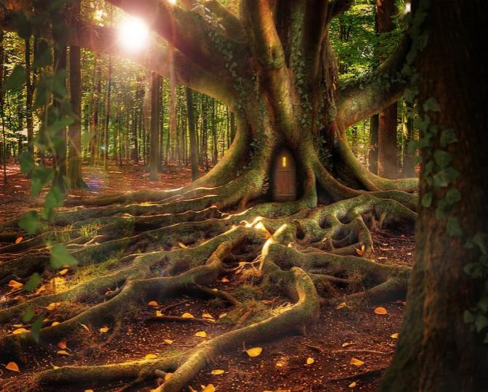  Writing – Imaginative  Imagine you are walking alone in the forest and you come across this tree. You go through the door…what do you find? What adventures are on the other side? Write a story with a beginning, middle and end all about what happens on the other side of this door. | Money  Ask an adult if you can borrow some coins to sort into amounts like in this picture:  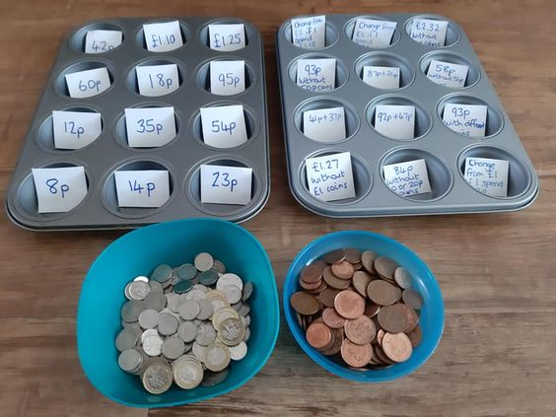 | PE  Complete a ‘PE with Joe Wicks’ workout. Click here to take you to a list of videos to choose from.  *Challenge: Create your own workout for your family to try.
Writing - Recipe  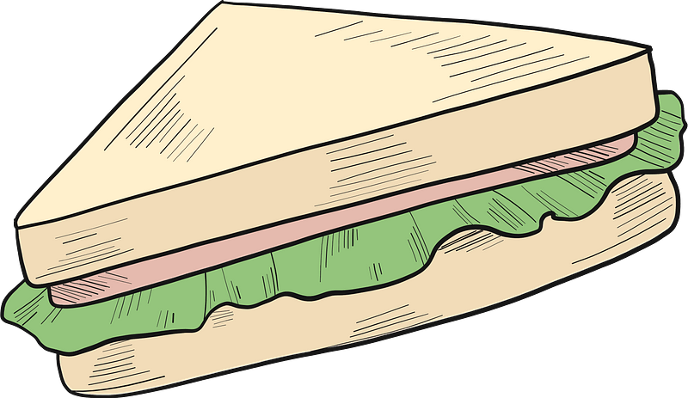  Make a sandwich or something similar for your lunch. Write step by step instructions for how to make it. With a recipe, you should also include a list of ingredients at the top. Now enjoy your sandwich! | Have a go at these challenges!  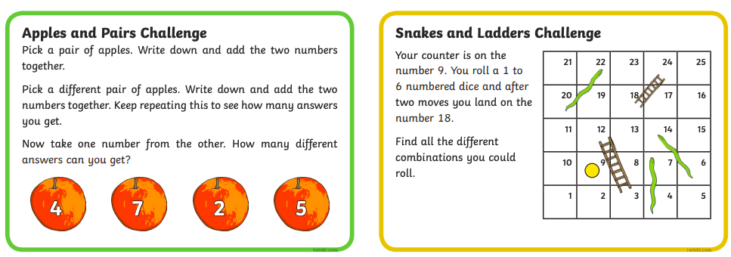 | 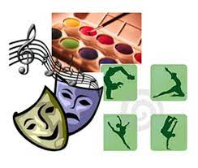  Health and Wellbeing  Think about all the qualities you have which make you special. What skills do you have?  *Challenge Can you do a talent show for an adult?
Reading and Grammar  Read a book with someone in your family. Make a list of all of the nouns (things) and adjectives (describing words).  Challenge: Can you make 5 new sentences using the nouns and adjectives from your list? | 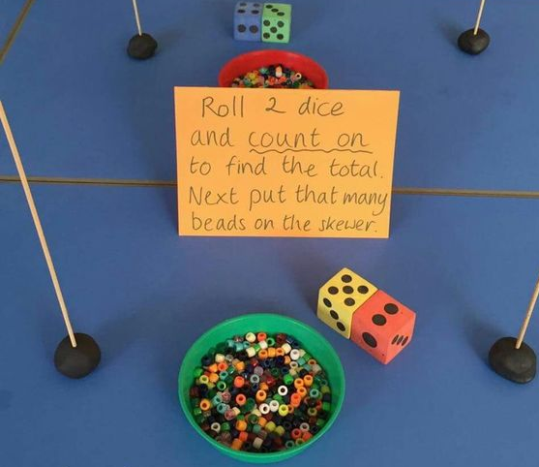  Set up a piece of spaghetti in a blob of play dough or blue tac. Use beads or cheerios to keep score. Try playing this game with someone in your house, who can reach the top first? For extra challenge, try multiplying the numbers together instead of adding – you might need a couple of poles for those big numbers! | STEM Challenge  Make a marble run.  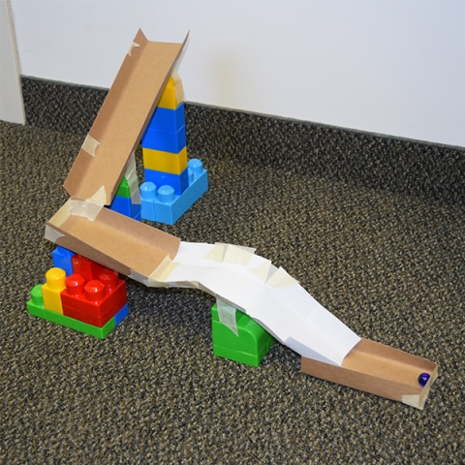  You could use lego to make a flat one, or you could use bottles and tubes to make one on a door or you can use anything else at all! Be creative!
Spelling  Can you think of any compound words – these are words that are made of 2 words joined together. For example cupboard, classroom, doorway. How many more compound words can you think of? | Have a go at these challenges!  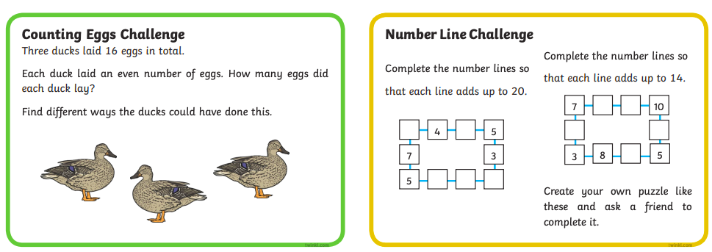 | PE  How long can you run on the spot for?  *Challenge: Can you make your own obstacle course and try it out?  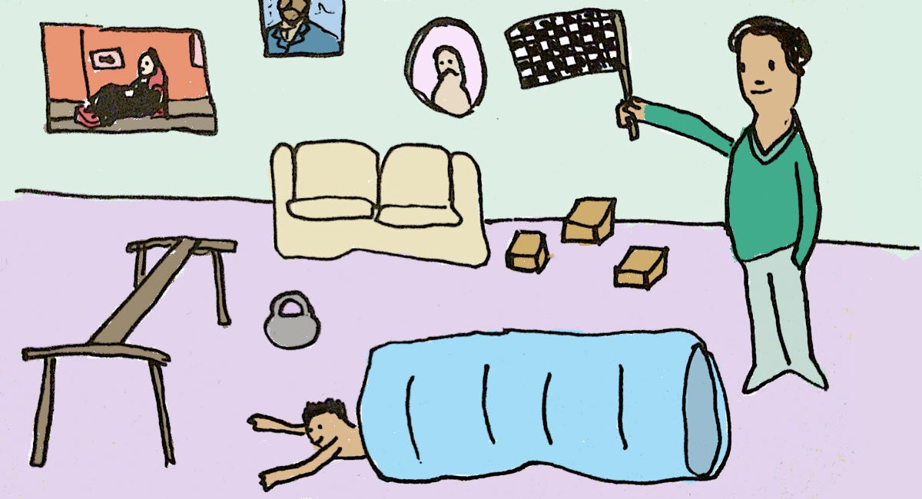
Research  Who is your hero? Is it a celebrity, a family member, someone you know from the community? It could even be a book or film character. Think about what makes them your hero.  Find out as much information as you can about your hero. Write down your top 5 facts about them or make a poster to show what you have discovered. | Have a go at these challenges!  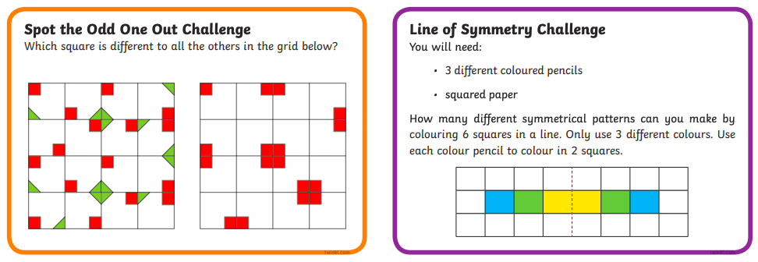 | 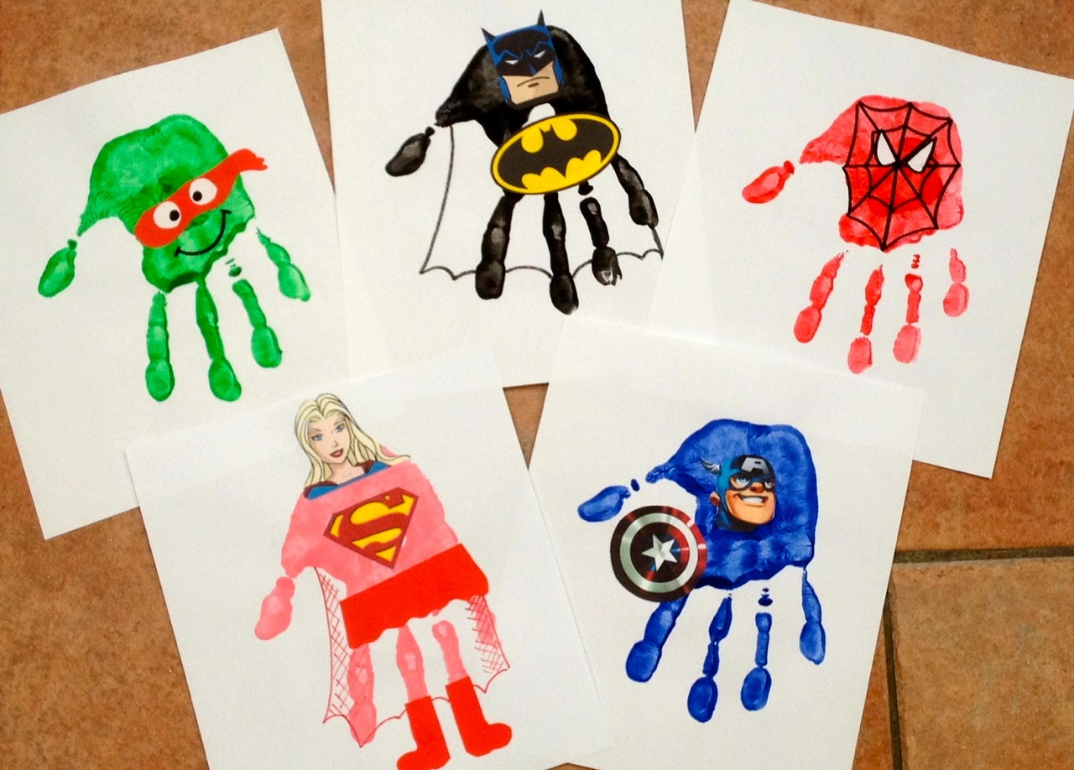  Art  Make a superhero handprint – it could be with paint or you could draw round your hand.  *Challenge: On each finger of the hand, write an adjective that describes you as a stay home superhero. Maybe your first one could be ‘brave’ or ‘creative’. Can you think of a different word for each finger on your handprint?
Please complete a minimum of 15 minutes per day reading. If you don’t have any books at home, try reading magazines, cookbooks, comics or online books via Bug Club. https://www.activelearnprimary.co.uk/ Your child should have their own log in.
Children have a log in for Espresso & Education City, which cover all areas of the curriculum https://www.educationcity.com/ (ask your child’s teacher if they don’t know their log in) https://online.espresso.co.uk/espresso/login/
Oxford Owls have a library of free books: https://www.oxfordowl.co.uk/
Free audiobooks for children: https://www.storynory.com/
Lots of free maths games: https://www.topmarks.co.uk/
Learn, create and play through exploring Scotland’s history and heritage: https://www.historicenvironment.scot/learn/
STEM (Science, Technology, Engineering & Maths) with Mr N: https://www.youtube.com/channel/UCxziq4omrQP-EKSLilOIPhw

Week 2
Literacy | Numeracy | Other
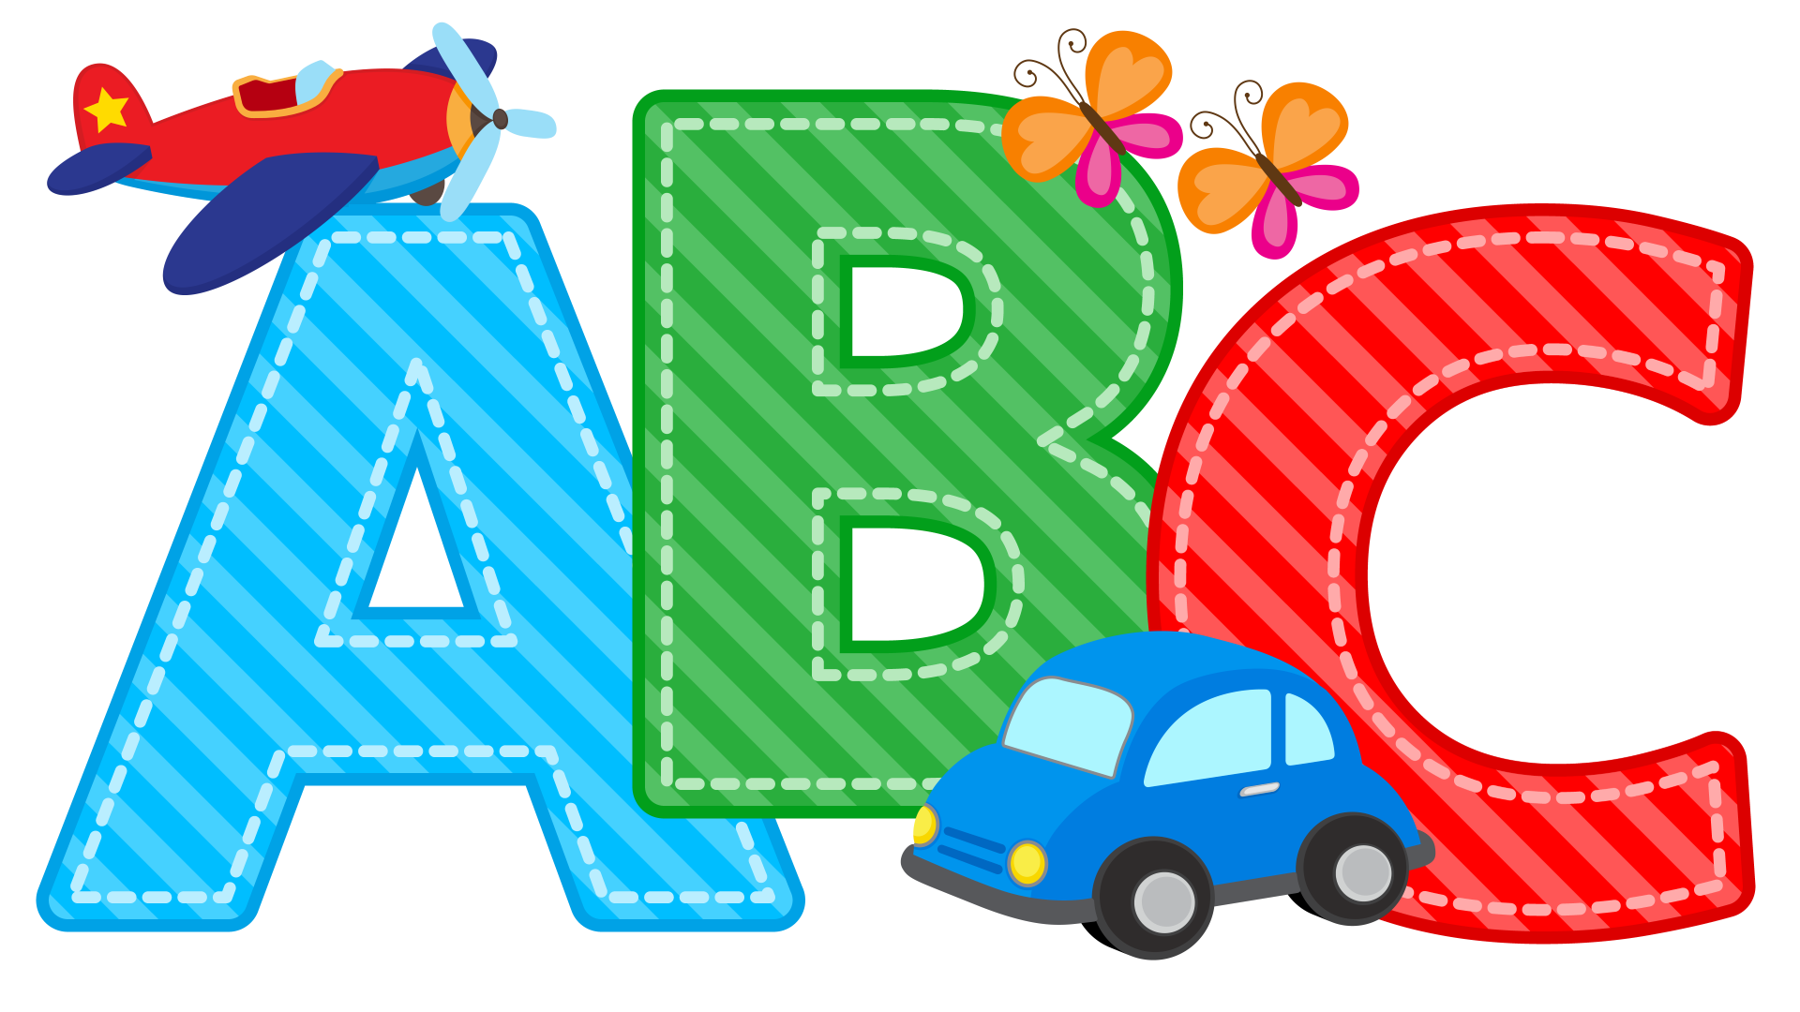  Make a wordsearch with the names of all of the people in your family. You can do this on paper or online here | 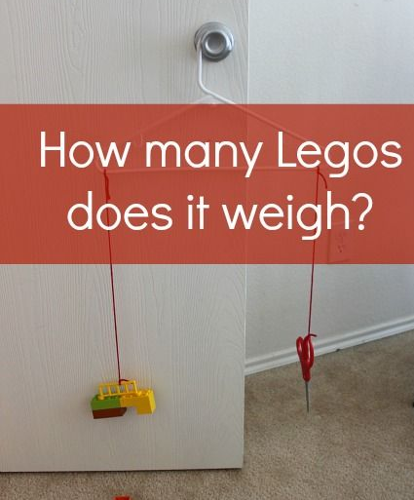  Weight and Measure  Make a balance scale using string, a clothes hanger, and lego pieces – like the picture. Choose some small objects to weigh – how many lego pieces weigh the same? Now use your kitchen scales to check if they really are the same weight! | 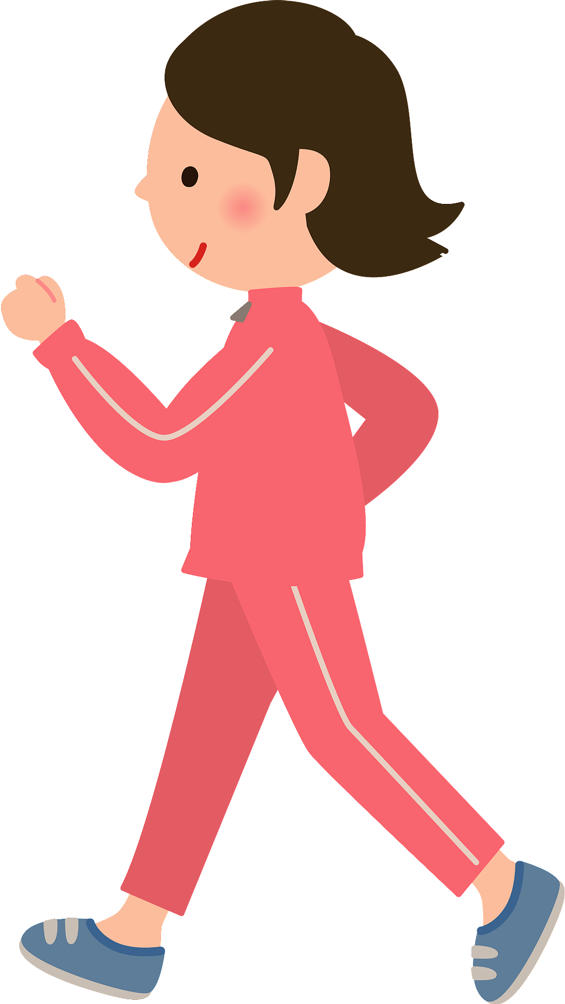  PE  Count yourself taking 200 steps around your house. Can you touch every wall in the house?
Writing  Write a letter to someone special. It could be a friend, a family member or even a famous person that you admire.  Start the letter with your address and the date in the top right corner.  Use paragraphs to write in sections. Your first paragraph could be about what makes them special to you.  If you have an address for the person then you could keep it to post to them where you are able to, or you could send it on an email. | 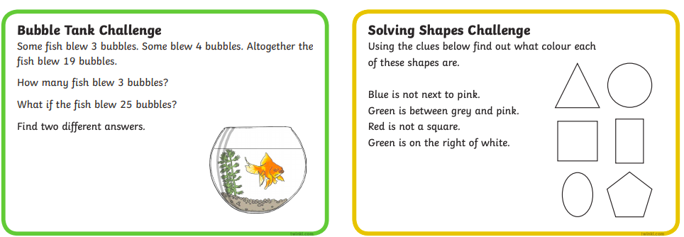  Have a go at these challenges! | 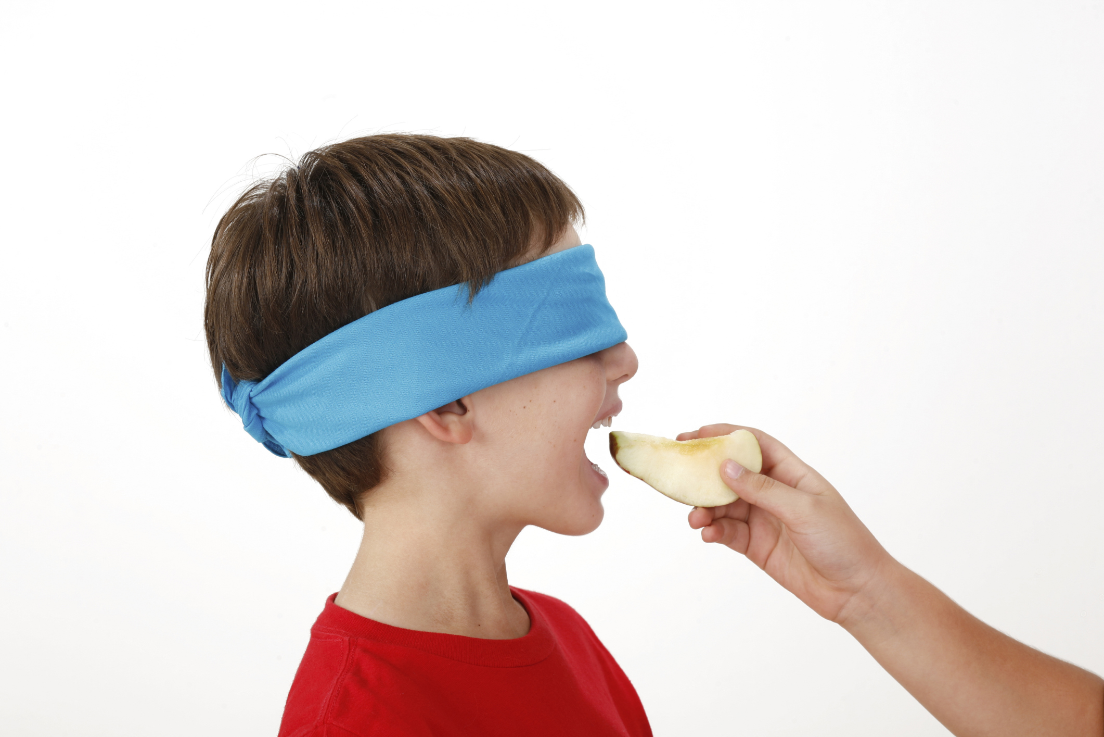  Senses Challenge  Ask an adult to prepare a few different foods for you to taste.  Try tasting them with a blindfold on, and guess what the food is. Taking away your sense of sight makes you focus only on using your sense of taste. Why not try doing this with different smells as well.
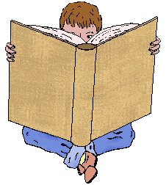  Reading Challenge  Read a book from your house or choose one from Bug Club.  Design a new front cover for the book.  *Challenge: write a different ending for the story | 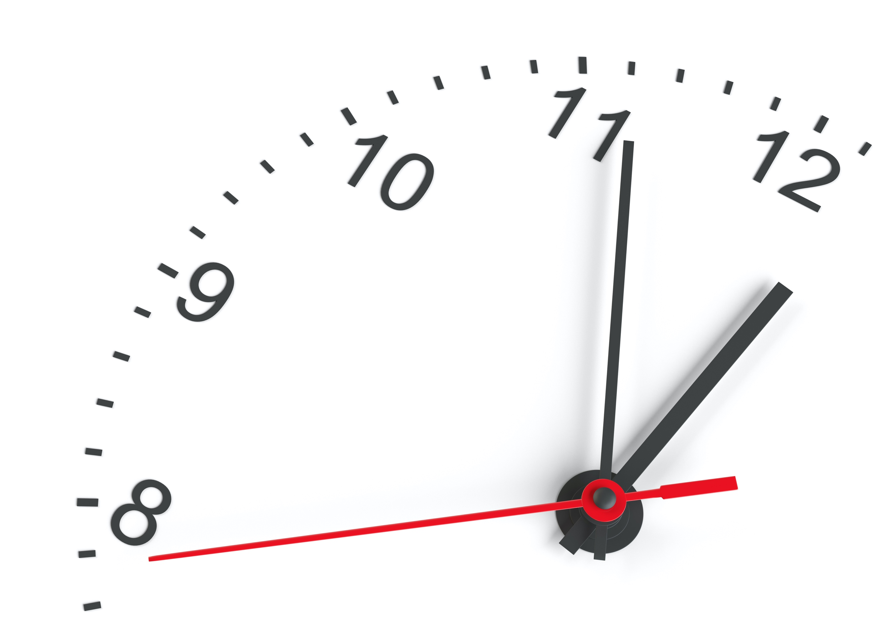  Time  Keep a diary of your day.  Think about: What time do you get out of bed? What time do you have lunch? When did you start home learning? When did you finish? How long did you spend on it? What time do you go to bed? How long is left until bedtime?  Make a note of all the activities that you do today and what time you do them at. | STEM Challenge  Build a ramp for a toy car to go down. Measure the distance the car travels.  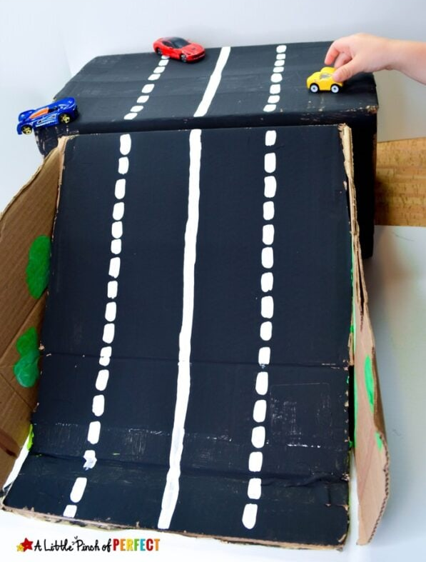  Can you make the car travel further by changing the angle of the ramp?  What happens when you change the texture of the surface?
Writing – Imaginative  Write a story with one of these as the title: | Have a go at these challenges!  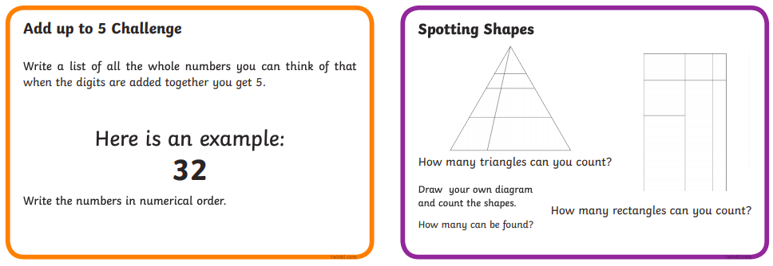 | PE  Have a go at dancing to some of your favourite songs with Just Dance!  Try some from here to get started.
Reading Challenge  Read a book from your house or choose one from Bug Club. Use 3 adjectives to describe the main character. Complete these sentences: The story is mainly about _______________.  The story was given its title because _______. | Have a go at these challenges!  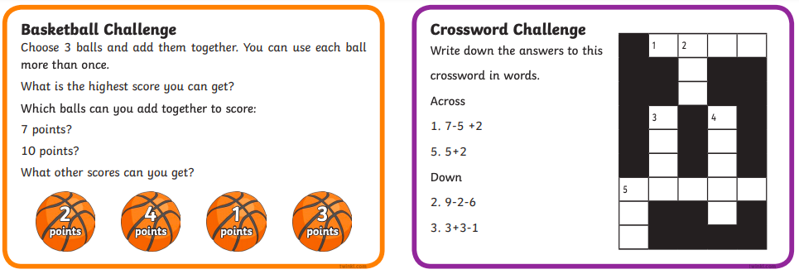 | 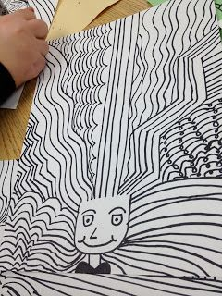  Art  Create a crazy hair day portrait!  Draw a U-shape near the bottom of the paper. Choose about 5 different types of line to ‘grow’ out of the U shape. Repeat each line at least 5 times. Continue to add lines until the space is filled. Add a neck, shoulders and a face for a crazy hair day!
Please complete a minimum of 15 minutes per day reading. If you don’t have any books at home, try reading magazines, cookbooks, comics or online books via Bug Club. https://www.activelearnprimary.co.uk/ Your child should have their own log in.
Children have a log in for Espresso & Education City, which cover all areas of the curriculum https://www.educationcity.com/ (ask your child’s teacher if they don’t know their log in) https://online.espresso.co.uk/espresso/login/
Oxford Owls have a library of free books: https://www.oxfordowl.co.uk/
Free audiobooks for children: https://www.storynory.com/
Lots of free maths games: https://www.topmarks.co.uk/
Learn, create and play through exploring Scotland’s history and heritage: https://www.historicenvironment.scot/learn/
STEM (Science, Technology, Engineering & Maths) with Mr N: https://www.youtube.com/channel/UCxziq4omrQP-EKSLilOIPhw

