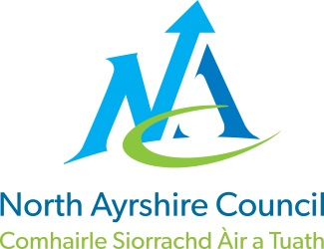
EDUCATION DIRECTORATE
Head of Service (Education): Andrew McClelland
Cunninghame House, Irvine KA12 8EE
Tel: 01294 310000
www.north-ayrshire.gov.uk

AUCHENHARVIE ACADEMY
Head Teacher: Calum Johnston BED (Hons)
Saltcoats Road
Stevenston
KA20 3JW
Tel.: (01294) 605156
E-mail: auchenharvie@ea.n-ayrshire.sch.uk

13th January 2026

Dear Parent/Carer

As you know Auchenharvie Academy have been using parentsportal.scot since Monday 3rd November 2025 and although the uptake has been steady we are hoping more parents sign up. We are hoping in the next few months to have pupil reports available for parents to see and download through this application. By using Parentsportal for pupils’ reports the school saves on average £400 per year which is one of the reasons we are opting for this method of delivery. The other reason is from a GDPR point of view in that paper reports can be mislaid by pupils in school or on the way home whereas viewing through the portal is 100% secure. Can I ask that you please support us and sign up to the app, instructions on how to do this are below.

Parentsportal.scot is the new digital service to help replace the traditional ‘school bag run’ by providing direct communication to parents and carers through a growing suite of online services. Through parentsportal.scot parents and carers will be able to grant permissions for school trips, view attendance, complete the annual data check, apply for NEC cards for free bus travel and link directly to iPayImpact to make payment for school meals, to name but a few.

To access parentsportal.scot go to https://parentsportal.scot/home/ . If you have a mygovscot my account (MyNAC), click the link to Sign In or if you do not have a mygovscot my account click the link to register.

Once registered you will be prompted to Link Your Child. To be able to link your child you will be asked to provide details relating to your child, the school they attend and your relationship with them. Once the details are found and matched you will be sent a security code to either your mobile number or email address registered in the school. The security code is to provide additional security before your child’s record is linked. Your request to link your child will then be sent to your child's school for approval. You will then be notified of the decision to approve the link on your email.

Once your child/children are linked to their school you will start to receive communications from the school via parentsportal.scot and over time will become your one-stop-shop to everything to do with your child and their school.

Yours faithfully

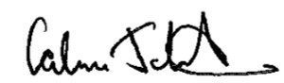

Calum Johnston
Head Teacher
