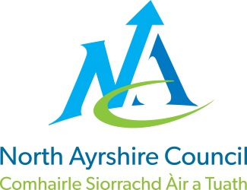
EDUCATION DIRECTORATE
Head of Service (Education): Andrew McClelland
Cunninghame House, Irvine KA12 8EE
Tel: 01294 310000
www.north-ayrshire.gov.uk

AUCHENHARVIE ACADEMY
Head Teacher: Calum Johnston BED (Hons)
Saltcoats Road
Stevenston
KA20 3JW
Tel.: (01294) 605156
E-mail: auchenharvie@ea.n-ayrshire.sch.uk

Dear Parent/Carer

North Ayrshire Council is starting the roll out of parentsportal.scot from Monday 3rd November 2025 in your child’s education establishment.

Parentsportal.scot is a new digital service to help replace the traditional ‘school bag run’ by providing direct communication to parents and carers through a growing suite of online services. Through parentsportal.scot parents and carers will be able to grant permissions for school trips, view attendance, complete the annual data check, apply for NEC cards for free bus travel and link directly to iPayImpact to make payment for school meals, to name but a few.

To access parentsportal.scot go to https://parentsportal.scot/home/ . If you have a mygovscot my account (MyNAC), click the link to Sign In or if you do not have a mygovscot my account click the link to register.

Once registered you will be prompted to Link Your Child. To be able to link your child you will be asked to provide details relating to your child, the school they attend and your relationship with them. Once the details are found and matched you will be sent a security code to either your mobile number or email address registered in the school. The security code is to provide additional security before your child’s record is linked. Your request to link your child will then be sent to your child's school for approval. You will then be notified of the decision to approve the link on your email.

Once your child/children are linked to their school you will start to receive communications from the school via parentsportal.scot and over time will become your one-stop-shop to everything to do with your child and their school.

Yours faithfully

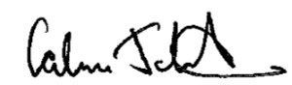

Calum Johnston
Head Teacher
