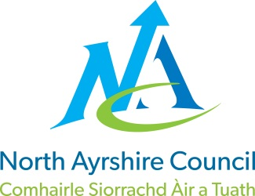**EDUCATION DIRECTORATE**

**Head of Service (Education): Andrew McClelland**

**Cunninghame House, Irvine KA12 8EE**

**Tel: 01294 310000**

[**www.north-ayrshire.gov.uk**](http://www.north-ayrshire.gov.uk)

*{Date}*Auchenharvie Academy,

Head Teacher: Calum Johnston BED (Hons)

Saltcoats Rd, Stevenston, KA20 3JW

Telephone: 01294 605156 E-mail: [auchenharvie@ea.n-ayrshire.sch.uk](mailto:auchenharvie@ea.n-ayrshire.sch.uk)

Date: 17.09.25

**Dear Parent/Carer,**

At **Auchenharvie Academy**, we care deeply about the wellbeing and progress of every young person. Sometimes, to make sure we’re offering the right support, staff may chat informally with other professionals within education, like our Educational Psychologist — to share ideas and explore ways to help.

These conversations are simply about problem-solving together. They don’t involve any direct work with your child, and no personal information is passed on unless it’s absolutely necessary. If we ever feel that more direct support could be helpful, we would always speak with you first and ask for your permission.

If you’d prefer that your child isn’t included in these kinds of discussions, just let us know.

Thank you for your continued support.

Yours sincerely

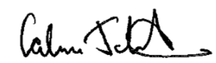

Mr C Johnston

Head Teacher

*{Date}*

*{Name}*