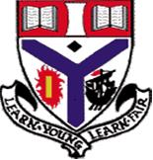



**School Vision**

**Trauma Informed**

**Wellbeing Indicators**

**ACEs**

**L&T**

**Whole School Values**

**Rights Respecting Schools**

**Whole School Nurture**

**Restorative Practice**

Auchenharvie Academy is actively pursuing a positive ethos, within a nurturing environment, which makes our young people aware of the options open to them and the natural and logical consequences of their actions.

Health and wellbeing is at the heart of establishing a positive and purposeful learning environment for children and young people. The quality of relationships between staff and learners is crucial and should be considered first and foremost.

**Launched August 2017**

**Reviewed August 2018**

**Reviewed August 2019**

**Reviewed January 2024**

**In Auchenharvie Academy** Positive Relationships and the school’s values are at the heart of the school and are seen as underpinning all successful learning and teaching. This is a whole school policy which aims to promote positive relationships throughout the school and with its partner agencies.

**This links in with:**

* **Auchenharvie Academy’s Vision**
* **Auchenharvie Academy’s Values**
* **Whole School Nurturing Approach and Practice**
* **Trauma Informed Practice**
* **Repairing Positive Relationships/Restorative Practice**
* **Wellbeing Indicators**
* **Right Respecting Schools – United Nations Convention on the Rights of the Child**
* **Adverse Childhood Experiences ACEs**
* **Whole School Learning and Teaching Policy**
* **LGBTQ+**

**Auchenharvie Academy’s Vision:** To provide an equitable and excellent learning environment for ALL pupils which enables them to achieve their potential and supports them into appropriate positive and sustained destinations

**Auchenharvie Academy’s Values:**

**Respect** – strong relationships based on mutual respect. Every member of our school must respect each other’s rights to feel safe, be treated with courtesy and consideration and have the right to learn and work.

**Equality** – all members of the school community should be valued and supported equally. All young people must be treated fairly and equally, and in turn are expected to treat others in the same way.

**Determination** – all members of the community should work as hard as they can to achieve the highest possible outcomes.

**Whole School Nurturing Approach and Practice**

A whole school ‘nurturing’ approach is key to ensuring that every young person feels valued, cared for, listened to and respected within the pillars of nurture (Care & Challenge). All members of staff have a responsibility for ensuring that every classroom provides a safe, welcoming and nurturing environment where positive behaviour and relationships based on trust and respect are promoted. Research shows us that when children have safe and secure relationships with staff in schools, learning is optimised. Better Relationships, Better Learning, Better Behaviour (Scottish Government, 2013).

**Trauma Informed Practice**

Trauma-Informed Practice is a strengths-based approach, which seeks to understand and respond to the impact of trauma on people's lives. The approach emphasises physical, psychological, and emotional safety for everyone and aims to empower individuals to re-establish control of their lives.

The Five Guiding Principles are; safety, choice, collaboration, trustworthiness and empowerment. Ensuring that the physical and emotional safety of an individual is addressed is the first important step to providing Trauma-Informed Care. Next, the individual needs to know that the provider is trustworthy.

**Repairing Positive Relationships/Restorative Practice**

When there has been a breakdown in positive relationships within our school community we seek to reset and repair these relationships. This process is called ‘Repairing Relationships’ (RR) and is based on Non Violent Resistance techniques (NVR is a new approach, which has been specifically developed for responding effectively to aggressive, violent, self-destructive and controlling behaviour in children, adolescents and young adults), North Ayrshire BPR and nurturing principles. The aim is to develop a positive relationship between our young people and staff that continues despite resistance and allows the class teacher to lead the repairing process with the support of their FH.

**Wellbeing Indicators**

The indicators are used by staff, young people and partner agencies to assess progress as well as the supports needed for people to feel safe, happy and successful in school.

**Rights Respecting School - United Nations Convention on the Rights of the Child**

In our school children's rights are promoted and realised, adults and children work towards this goal together. There are four key areas of impact for children at a Rights Respecting school; wellbeing, participation, relationships and self-esteem. Within this policy there will be reference to the Rights Respecting Schools Charter and where it links in with the charter.

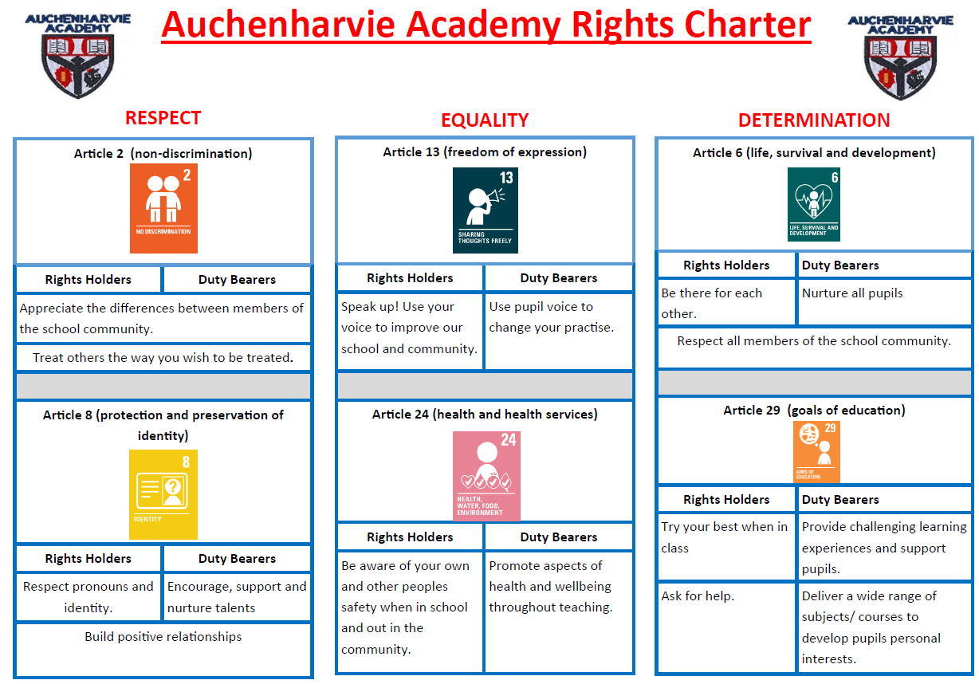

**Adverse Childhood Experiences ACEs**

The ACEs acronym is used to describe a broad range of **adverse childhood experiences** that can be stressful or traumatic events that children and young people can be exposed to.

**What are ACEs?**

ACEs are adverse childhood experiences that harm children’s developing brains and lead to changing how they respond to stress and damaging their immune systems so profoundly that the effects show up decades later. ACEs cause much of our burden of chronic disease, most mental illness, and are at the root of most violence.

**Whole School Learning and Teaching Policy**

Auchenharvie Academy is committed to excellence and equity through the provision of the highest quality of experiences for all our pupils.  The ethos and culture of our school reflects a commitment to children’s rights and positive relationships. Our children and young people are eager and active participants who are fully engaged, resilient, highly-motivated and interact well during activities. Learners’ experiences are appropriately challenging and enjoyable and well matched to their needs and interests. Learners exercise choice, including the appropriate use of digital technology, and take increasing responsibility as they become more independent in their learning. They understand the purpose of their learning and have opportunities to lead the learning. Our learners are successful, confident and responsible. They contribute effectively to the life of the school and wider community in a range of well-planned activities. They know that their views are sought, valued and acted upon.

**LGBTQ+ (Article 2 of RRS – see chart above)**

* We strive to make Auchenharvie Academy a safe and inclusive place for all where diversity is not only respected but celebrated. Schools have a duty to promote the safety and wellbeing of all children and young people in their care, including lesbian, gay, bisexual and transgender pupils and those experiencing homophobic, biphobic or transphobic (HBT) bullying.
* We are committed to promoting a positive and diverse culture in which all people are valued and supported to fulfil their potential irrespective of their age, disability, race, religion or belief, gender-reassignment, sex or sexual orientation.
* We recognise our obligations under the Equality Act 2010 and are committed to promoting the equality and diversity of all those we work with including our employees, learners/young people and visitors.
* We oppose all forms of unlawful and unfair discrimination, bullying and harassment and will make every effort to comply with the requirements of the Act and its subsequent provisions.

Equality Act 2010

* Schools are required to eliminate discrimination on the grounds of sexual orientation and gender reassignment. This includes tackling HBT (homophobic, biphobic and transphobic) bullying. Schools are also required to advance equality of opportunity and foster good relations. This means that schools should go beyond tackling HBT bullying and take proactive steps to promote respect and understanding of LGBT people and issues.

The school aims…

* To provide an inclusive environment in which LGBT pupils, families and staff are valued and respected;
* To promote understanding of and support the needs of LGBT pupils, families and staff;
* To “normalise” LGBT awareness and issues through the provision of an inclusive curriculum;
* To monitor and tackle homophobic, biphobic and transphobic language and bullying.

Our Positive Relationships Policy has **3 main elements**:

**Expectations and Building Positive Relationships (Article 2 of RRS)**

* Young people, parents/carers and staff accept a shared set of expectations. These expectations are based on mutual respect. A key expectation is we will build relationships with each other as a community supporting our young people. We follow the Building Positive Relationships/Non Violent Resistance vision of ‘Resist, Persist, Unite, Repair.

**R**esist- We work together to resist damage to relationships. We resist reacting rather than responding.

**P**ersist-We persist in trying to build a positive, secure relationship through common strategies.

**U**nite- We are united together as a community in embedding expectations, celebrating successes and challenging anything that damages our community.

**R**epair-We work together to use strategies to repair relationships.

**Celebrating success**

As part of persisting in building and maintaining positive relationships we have a wide variety of ways to celebrate success of our young people. We all play a role in celebrating success with our young people. An assembly programme for all year groups. Recognising achievements in and out of school using Auchenharvie Achievers process. House Team events/challenges throughout the year.

**Consequences and Challenge**

We are united in having a range of consequences in our determination to repair and maintain relationships.

Challenge and consequences are part of an escalated system:

A key element in embedding consequences and challenge is working with our young people, parents/carers & partner agencies. This is to reinforce positive behaviour so that high quality learning and teaching can take place.

**Expectations**

A positive ethos is essential and will only be successful if this is promoted by our **routines and interactions with all pupils.** To achieve this we have clear expectations for everyone in Auchenharvie Academy.

|  |  |
| --- | --- |
| **Expectations of ALL**   * Arriving to school and class on time, fully prepared to participate both individually and as part of the wider school; * Modelling appropriate behaviour at all times, in all areas of the school; * Meeting our high expectations in everything that we do; * Communicate in a polite and respectful manner; * Respect the rights of others to learn and the whole learning environment; * Expect to be listened to and listen to others in return | **Expectations of Young People**   * Being kind to each other – even people who are not your friends * Supporting and including each other * Encouraging each other to do good things * Be aware that everyone is different * Follow the SLIPP model when learning * All food (including chewing gum) will be eaten during breaks and lunches * Mobile phones will be put in bags during lessons * Electronic devices (including air pods) will be in bags during lessons and only used at break time * Only water allowed out in class * Outdoor clothing removed in class * Follow HT procedures relating to bathroom breaks |
| **Expectations of Staff**   * Follow SLIPP model as per L&T policy * Differentiate making use of CIRCLE & nurture resources when considering social environment, physical environment, motivation and routines. * Be aware of pupil’s needs and plan accordingly for these (use the ASN overview) * Celebrate success-praise, display recent classwork, issue house points, awarding Harvie Heroes * Allow young people to reflect and re-engage after difficult situations * Open communication and understanding when each other have had a bad day * Staff motivating pupils to try their best * When staff see potential in pupils and tell them * Not punishing everyone for 1 person’s actions | **Expectations of Parents/Carers**   * Working in partnerships with staff to help address the needs of the young person and develop strategies for ensuring high levels of success, * Expect to receive regular information on their child’s progress, be consulted on any decisions and be treated as a partner in their child’s education, * Ensure that their child arrives at school on time, appropriately dressed, equipped and ready to benefit from the day at school, * Make sure their child attends regularly and communicate with the school if their child is absent, * Support their child and the school to help them understand how distressed behaviours can negatively impact other young people and staff; * Communicate with the school regarding anything which may affect their child's education or welfare; * Encourage and support their child to take pride and interest in his/her work at home as well as at school; |

**Building Relationships**

At Auchenharvie we seek to build positive relationships with everyone in our community. Our strategies are detailed below:

Parental Communication

**We build relationships with our parents/carers by communicating openly with them by:**

Relational Gestures

**Relational gestures will help build a connection with our young people. They can be easier to accept than words and can be more discrete than public praise. We these small gestures with our young people to show them we care and value** **them. These include:**

The Golden Thread

**CIRCLE is our Golden Thread that runs throughout the whole school and offers young people consist routines, motivation, and supportive social & physical environments. Examples of our Golden Thread include:**

**Celebrating Success**

An integral part of the Positive Relationships Policy is celebrating success and recognising the everyday achievements of our young people.

|  |  |
| --- | --- |
| Class Teacher-Celebrating Success   * **Merits**: In Auchenharvie Academy we will use Merits as one of the ways to celebrate learners’ successes and efforts in class. A young person will be awarded a merit to recognise their effort, progress and positive attitude during each lesson. If a child is in danger of not achieving their merit there needs to be a sensitive conversation around this with a clear explanation of why. Not achieving a merit should not be used as a threat and always used in a positive way. * **Harvie Heroes:** This is clearly linked in with our Rights Respecting Schools Charter. Monthly newsletters are shared showing which faculties/department are focusing on. Quarterly updates about the charter areas and how they can be reflected in the classroom. * **Praise Postcards/texts/displays throughout the school eg WOW walls:** Regular contact with home to celebrate achievements. Parents like to get this but would like their child’s name on the text as it makes it more meaningful * **Auchenharvie Achievers:** This is used to celebrate success outwith the classroom which includes attendance at clubs in and out of school. Involvement in activities outwith the school. | Faculty/Department Subject - Celebrating Success   * **Faculty/subject Ambassadors**: To promote leadership throughout the school by appointment ambassadors to take ownership of activities/tasks within faculties and departments. Pupil’s like the importance of wearing a badge. * **Praise Postcards/texts/displays throughout the school:** Regular contact with home to celebrate achievements. To make sure it is personalised then the young person’s name must be on the text as it makes it more meaningful. * **Faculty/Subject Trips/outings:** To celebrate a particular topic or area covered within a subject. * **Monthly Celebrating Success events within the Faculty:** Faculty/department/subject uses a theme or term to advertise this eg Science Superstars |
| Whole School - Celebrating Success   * **House Team Rewards:** Faculty/subject challenges. House Team Leaders to collate points gained and arrange activities for House winners each term. * **Prize Giving:** BGE and Senior Phase prize giving to celebrate successes across the whole school relating to in school and outwith school achievements * **Auchenharvie Achievers:** This is to celebrate achievements outwith the classroom and the school. Staff will submit registers for those who have attended clubs within the school or to recognise a child’s involvement and success outwith school. Staff can also complete pro-formas to celebrate children’s achievements outwith school. This is celebrated at year group assemblies and young people can achieve Bronze, Silver, Gold and Platinum Awards. This is shared on social media. | |

**Consequences and Challenge**

Code Summary

**Strike while the Iron is Cold:**

This means taking action or making a decision when the timing is right and conditions are favourable, rather than rushing into something without proper preparation or thought. It suggests that sometimes it's better to wait for the right moment to act, rather than acting impulsively. When you learn to "hit the **iron** when it is **cold**", you come back later, when you're calm.

**Restorative Approaches**

Authoritative discipline lies at the heart of both a nurturing and restorative approach. The term discipline should not be confused with the term punishment. Discipline refers to an approach where learning about impact occurs and it is relational. A restorative approach uses authoritative discipline to promote accountability and seeks to repair any harm caused in a situation. Restorative approaches also help schools to create peaceful learning environments for children and young people in order to help them to become successful learners, confident individuals, responsible citizens and effective contributors. Children and young people require the opportunity to hear about and face up to the harm and distress that they have caused others. This has been found to be a more effective response than traditional punishments. Restorative approaches can change the emotional atmosphere in a school and lead to more positive relationships between pupils and between pupils and staff.

Class Teacher-consequences & challenge

**Relationship Repairing Cycle (RED) Guide**

**It is important that young people receive a consistent experience from class teachers when responding to poor choices and distressed behaviours. Class teachers and young people will be fully aware that each lesson is a fresh start. Restorative approaches must be used at all levels – see Appendix 2 and refer to lanyard**

Class Teacher-consequences & challenge

Faculty Head/PT -consequences & challenge

**Relationship Repairing Cycle (RED) Guide**

Senior Leadership Team Consequences & Challenge

**Relationship Repairing Cycle (RED) guide**

* **Exclusion-this is a last resort and will be in consultation with the HT**

**Appendix 1**

**Awarding a Merit** is one of the ways for teachers and faculties to regularly celebrate learners’ successes and effort.

Merits will also allow the school to track success areas for our young people and will be part of the tracking and monitoring process.

A merit is an electronic record of a success or achievement for a learner. It is recorded on SEEMIS. We use merits in Auchenharvie Academy to:

* Encourage learners to want to do well in their learning and to make responsible choices with regards to their behaviour.
* Celebrate the everyday success and achievements of our learners.
* Support a range of celebrating success initiatives.
* Demonstrate school values

**Issuing a Merit:** Young People within our school were very clear that they want to earn a merit and it should not be automatically awarded. If a young person does not demonstrate the school values, a code is called, does not put in the effort and time to complete their work. It is important young people know when they have lost their merit and why, this should include advice for ensuring they achieve at the next lesson. Young people who are achieving their merits must be acknowledged and celebrated.

**Merit Plus**: Additional merits can be awarded for a range of reasons. Pupils who are excelling in showing school values or meeting their individual goals or targets can be awarded with further merits.

Merits achieved will be collated each term and House Team Rewards based on this. Pupils with 90% of their merits at the end of each term with receive a House Team Reward. This will be displayed on the success boards outside DHT offices and a personalised text will be sent home recognising this achievement.

**Appendix 2**

Restorative practice should be part of everyday interactions with children, young people and adults in line with the positive ethos and values promoted throughout Auchenharvie Academy.

Restorative Conversation: A restorative conversation can be conducted at any time using a simple set of questions such as

* ‘What happened?’
* ‘How has this affected you and others?’
* ‘What do you need to happen now to be able to move forward?’

This type of approach can often resolve any conflict by responding to the needs of both parties without necessitating the need for a more formal approach.

Restorative approaches can also include more formalized, facilitated contact, which supports constructive dialogue between a person/s harmed and a person/s who caused harm (whether this be an adult, a child, a young person) following on from an incident. This type of contact allows the person harmed the chance to meet, or communicate with, the relevant people who have harmed them and to explain the impact their behaviour has had on their lives. This has the potential to help the person harmed by giving them a voice within a safe and supportive setting and giving them a sense of closure.

Restorative approaches should always be considered as an entirely voluntary process for both the person harmed and person who has harmed, which can be discontinued at any time.

More formal Restorative conversations and meetings can help when:

* it is the right time,
* participants have been prepared,
* a professional judgement has been made about the readiness and willingness of all parties to participate in the process.

The process should be flexible enough to adapt to individual needs. The outcomes will vary depending on the context.

There are some aspects of the restorative approach that may be unmanageable for children still experiencing the impact of trauma, who may need an adapted approach.

A restorative meeting can be a helpful practice following an exclusion as a means of re-establishing relationships at a pre –return meeting, rather than seeking guarantees or writing a contract. Again, this should be a voluntary process and only used if those involved are ready and willing to participate.