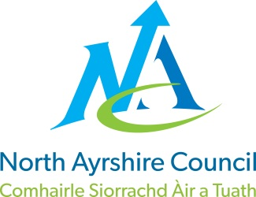**EDUCATION DIRECTORATE**

**Head of Service (Education): Andrew McClelland**

**Cunninghame House, Irvine KA12 8EE**

**Tel: 01294 310000**

[**www.north-ayrshire.gov.uk**](http://www.north-ayrshire.gov.uk)

*{Date}*Auchenharvie Academy,

Head Teacher: Calum Johnston BED (Hons)

Saltcoats Rd, Stevenston, KA20 3JW

Telephone: 01294 605156 E-mail: [auchenharvie@ea.n-ayrshire.sch.uk](mailto:auchenharvie@ea.n-ayrshire.sch.uk)

Date: 13.02.25

Dear Parent/Carer,

Your child as part of their S6 school based options can consider an online Advanced Higher Course.

The courses available are noted on the website below. This details the courses, times and requirements for entry.  The application form is at the bottom.

**Courses:**[**https://sway.cloud.microsoft/qASElYdfFxBWqIQk**](https://sway.cloud.microsoft/qASElYdfFxBWqIQk)

**Action Required:**

1. If you would like your child to apply for a school college course as part of their S6 timetable, we would ask you to contact the school via email to confirm that they would like to apply.  **Please do this by 28th Feb. Please give your child’s full name and year group.**

Please email:   [auchenharvie@ea.n-ayrshire.sch.uk](mailto:auchenharvie@ea.n-ayrshire.sch.uk)

2. In addition if you wish to continue exploring an application we would ask you and your child to provide some information on the link below in order for us to support and process their application for consideration. **(Apply Link Here)**

2025/26 Application Form <https://forms.office.com/e/1CQU8ujw6B>

Please contact the school for Mr Herd if you require any support/assistance with the application or have any questions.

The closing date for online Advanced Higher Course applications is 21st March 2025.

Yours sincerely

*Mr J Herd*

Depute Head Teacher

*{Date}*

*{Name}*