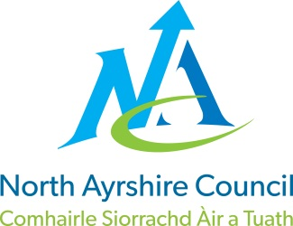**EDUCATION DIRECTORATE**

**Head of Service (Education): Andrew McClelland**

**Cunninghame House, Irvine KA12 8EE**

**Tel: 01294 310000**

[**www.north-ayrshire.gov.uk**](http://www.north-ayrshire.gov.uk)

*{Date}*Auchenharvie Academy,

Head Teacher: Calum Johnston BED (Hons)

Saltcoats Rd, Stevenston, KA20 3JW

Telephone: 01294 605156 E-mail: [auchenharvie@ea.n-ayrshire.sch.uk](mailto:auchenharvie@ea.n-ayrshire.sch.uk)

Your Ref:CJ/YR Our Ref: LTED24/25001

If contacting please email: [ema@north-ayrshire.gov.uk](mailto:ema@north-ayrshire.gov.uk)*{Name & Extension}*

**June 2024**

FAO Students and their Parents/Carers

EMAs are Scottish Government grants of £30 per week to encourage young people to remain in full-time education.

If a young person’s date of birth falls between 1 March 2005 and 28 February 2009 and they are intending to remain in full-time education at a North Ayrshire Council school from August 2024, they may be eligible for financial assistance.

To qualify, the income thresholds are £24,421 for households with one dependent child and £26,884 for households with more than one dependent child.

Young people must also normally have been resident in Scotland for a period of 3 years at the start date of the academic session, although exceptions may apply.

In addition, young people must also have an acceptable EMA Learning Agreement in place, and satisfy the terms of this agreement in order to receive any EMA award they may be entitled to. For our North Ayrshire Schools the timetable held on the school records will be the Learning Agreement equivalent, and the young person must be completing at least 21 hours of guided learning per week (some exceptions may apply).

Further information and details of how to apply will be available online from **3 June 2024** by visiting [www.north-ayrshire.gov.uk/EMA](http://www.north-ayrshire.gov.uk/EMA). Some documentation must also be submitted, and further information on this is detailed online as part of the application process.

The online application is quick and easy to complete. You will, however, require a MyNAC account before you can apply (see information below).

*{Date}*

Where young people are intending to move to full-time education at college, they may still be eligible to receive an EMA award and should contact that establishment directly for an application for financial assistance.

Please see enclosed an electronic copy of the EMA leaflet for your information.

I hope that you find this information helpful, however, if you require further information, please contact the EMA team by email: [ema@north-ayrshire.gov.uk](mailto:ema@north-ayrshire.gov.uk)

## Yours sincerely

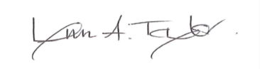

Lynn Taylor

**Senior Manager (Resources and Infrastructure)**

Encs

*{Date}*

**IMPORTANT INFORMATION - MyNAC**

We have launched MyNAC, which is our new customer account. This uses the national MyAccount to create your account and to sign in. You can use this account to automatically fill in your details on forms, view your history of service requests and view the status on current requests.

Students will need to create a MyNAC account to submit their Education Maintenance Allowance application. To create a MyNAC account students will need to have a MyAccount. If they already have a MyAccount that they created to access another service like National Entitlement Card they can sign in with that and then opt into the MyNAC account.

If students do not have a MyAccount they can select ‘Create an account’ on the MyNAC sign in page. To create a MyAccount students need to provide their name, gender, date of birth, email address and home address. They can also optionally provide their telephone number. These details are then passed to the Council when they consent to create their MyNAC account.

*{Name}*

*{Name}*