AUCHENHARVIE ACADEMY
Head Teacher: Calum Johnston BED (Hons)
Saltcoats Road, Stevenston, KA20 3JW
Tel.: (01294) 605156
E-mail: auchenharvie@ea.n-ayrshire.sch.uk
Date: 25th August 2023
Dear parents / carers,

As we move closer to Monday and the return of S4 pupils to our host school, Kilwinning Academy, I thought I would provide some additional information for your awareness and understanding.

I hope that this information assures you that this interim arrangement is very much in hand and that significant cross school work has taken place to maximise the experience of our pupils during these challenging times.

Pupils who require transport should arrive at Auchenharvie Academy for 8.45am as busses will leave at 8.55am. Pupils not travelling by bus should aim to arrive at Kilwinning Academy between 9am and 9.15am but not before 9am to avoid an overlap with our host school.

All pupils should be dropped off within the car park of Ayrshire College where we will have a staff presence and pupils will make the very short walk into the Kilwinning Academy grounds from here via the astro-turf pitch at the back end of the school. The astro-turf pitch will also be the muster point in the event of a fire evacuation. This is due to significant ongoing roadworks immediately outside the Kilwinning Academy entrance.

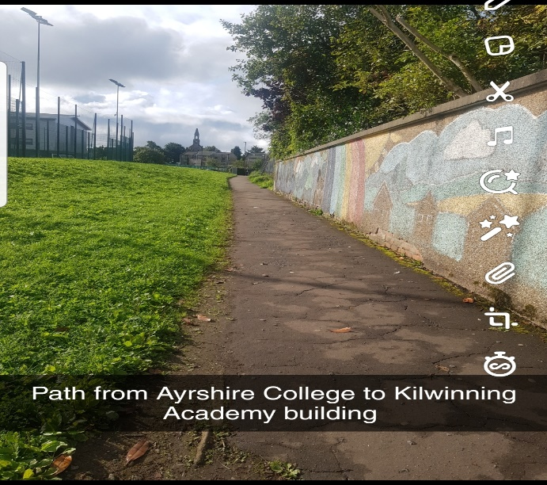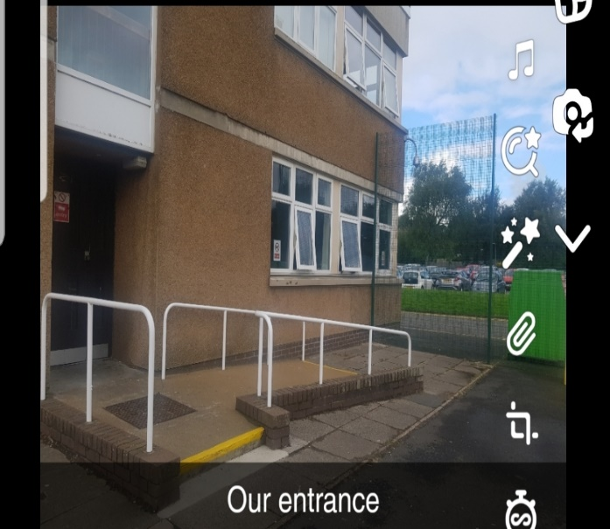

During our time in the school we will be working from 3 separate areas all of which are in close proximity to each other with very convenient toilet access for pupils. We also have a smaller room which we can use as a break out space as required.

All pupils will be issued with work on a daily basis using the GLOW platform and Microsoft Teams. Physical copies of the work will be available however we ask all pupils to bring the devices they have been using this week to make this easier. One of the rooms we are using has access to 30 computers and we will have an additional supply of Chromebooks available.
Pupils will be supported by Auchenharvie teaching staff and we have strategically deployed our teachers based on the school timetable whilst balancing out our commitment to continuing the education of all other year groups.

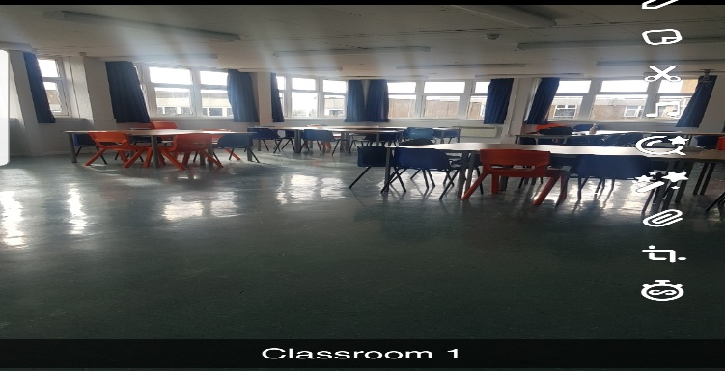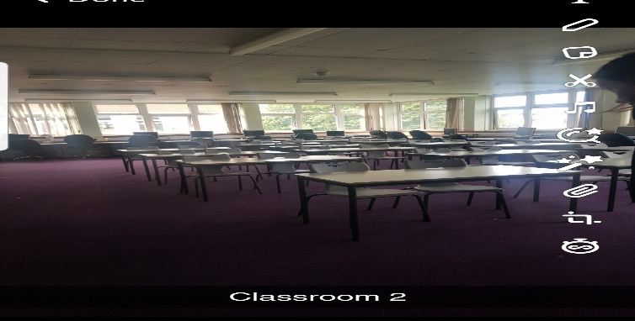

The school week will operate as follows:

Monday and Tuesday ( long days)
Session 1 - 9.15am -11am
Interval - 11am-11.15am (separate to Kilwinning)
Session 2- 11.15 -1.20pm
Lunch - 1.20-2pm (separate to Kilwinning)
Session 3- 2pm -3pm (pupils using NAC busses depart)
3.15pm for all other pupils

Wednesday-Friday (short days)
Session 1 - 9.15am -10.20am
Interval - 10.20am-10.35am (separate to Kilwinning)
Session 2- 10.35 -11.50am
Lunch - 11.50 -12.30pm (separate to Kilwinning)
Session 3- 12.30pm -2pm ( pupils using NAC busses depart)
2.15pm for the others

Our pupils will also be given use of the school canteen for interval as well as lunch however many will want to go out into the community for lunch. Pupils must stay onsite at interval. Pupils who do leave the school grounds at lunchtime and return late for afternoon sessions will be prevented from doing leaving school at lunchtime for the remainder of our time at Kilwinning Academy. Your support in reinforcing this is greatly appreciated. As previously intimated interval and lunch will be provided free of charge to all pupils throughout our time at Kilwinning Academy.

Kilwinning Academy have been great in accommodating us and they also plan to let us know what times the astro-turf would also be free for us to use for wellbeing activities and to allow pupils out in the fresh air if required.

Please be assured that arrangements are in place for any pupils who normally require the administration of medicines during the school day or indeed an EVAC chair in the event of a fire alarm.
Can I please ask that if you are collecting pupils at the end of the day that you do so from the Ayrshire College car park to avoid the inconvenience of getting held up in the roadworks.
Thanks again for your ongoing support and I am more than happy to chat to you in regards any queries you may have using the contacts above.

Yours faithfully

Calum Johnston
Head Teacher

