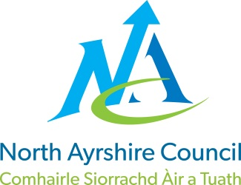
COMMUNITIES & EDUCATION DIRECTORATE
Executive Director: Audrey Sutton
Cunninghame House, Irvine KA12 8EE
Tel: 01294 310000 www.north-ayrshire.gov.uk

Auchenharvie Academy,
Head Teacher: Calum Johnston BED (Hons)
Saltcoats Rd, Stevenston, KA20 3JW
Telephone: 01294 605156 E-mail: auchenharvie@ea.n-ayrshire.sch.uk
Date: 21st April 2023

Dear Parent / Carer,

Changes to Parkend House arrangements.

I hope this communication finds you all well after the Easter break and ready to get started in Term 4, a hugely important term for all pupils whether they are sitting exams or preparing to change timetable in the middle of May.

I write to advise you that prior to the Easter holidays John Herd (Depute Head Teacher of Parkend House) was appointed on a two day permanent basis to Lockhart Campus. The two days will be Thursday and Friday and this arrangement will commence on Thursday 4th May 2023.

Following interview, the two day vacancy for DHT will be undertaken on a fixed term basis by Mr Stephen Gilmour. This arrangement will also take place from Thursday 4th May 2023. I know that both colleagues will work very well in this job share scenario and I do not foresee any issues with the quality of service offered to pupils or parents / carers in Parkend house. Mr Gilmour, as you know, recently completed a twelve month secondment in exactly this position and consequently is very well known to all pupils and many parents / carers in the Parkend house.

Mr David Marwick will take on the backfill two days of Principal Teacher Raising Attainment and Achievement and this will commence on the same date as above.

Pupils have been advised of this arrangement in school this week.

Thanks for your ongoing support and as ever please feel free to contact me should you wish to discuss this matter or any other matter pertaining to your child’s education.

Yours sincerely,

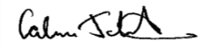
Calum Johnston
Head Teacher

