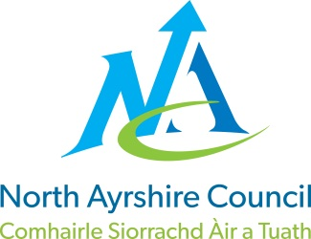
COMMUNITIES & EDUCATION DIRECTORATE
Executive Director: A McClelland
Cunninghame House, Irvine KA12 8EE
Tel: 01294 310000 www.north-ayrshire.gov.uk

Auchenharvie Academy,
Head Teacher: Calum Johnston BED (Hons)
Saltcoats Rd, Stevenston, KA20 3JW
Telephone: 01294 605156 E-mail: auchenharvie@ea.n-ayrshire.sch.uk
Date: 21st March 2023

Auchenharvie School Improvement Planning 2023-24

Dear Parent/Carer,

It's that time of year again when attention turns to the evaluation of the current School Improvement Plan (SIP) and to the identification of priorities for, and the construction of, the SIP for school session 2023/24.

As ever, I am very keen that the SIP is developed and written by representatives of all stakeholders (staff, pupils, parents/carers and partners), and therefore I write to you to seek parent/carer representation to form the Auchenharvie SIP working group for 2023-24. It is unlikely that the full group would meet as one and more likely that individual stakeholders would meet as separate groupings as all parties will have unique perspectives on what should be included in the SIP and previous experience tells me it is much more productive to meet with stakeholder groups separately.

All parent/carer SIP group meetings, likely to be three, will take place after the school day and I hope that this helps to increase numbers from previous years. I am happy to facilitate meetings virtually and in the evening if this is the preferred option. All meetings will take place between early May and the middle of June and each meeting will last approx. 1 hour.

Ideally, the group would have representation from a wide range of parents/carers to offer a holistic view from our school community. This will include parents/carers from all year groups and from all geographical areas within the community we serve.

If you are interested in being involved in the important decisions about what will be included in our SIP 2023-24 please let me know either by reply email or by telephone. I would be looking to convene the first meeting early May 2023 so I would appreciate if you could let me know before school finishes up for the Easter break on 31/3/23 if you would like to be involved.

Thanks in advance for taking the time to consider your involvement in this really important process. It really does set the school agenda for the coming session and it is essential that the work we do is developed alongside, and in tandem with our school community.

If you would like further information prior to signing up I am happy to speak to any parent/carer.

Yours sincerely,

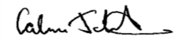
Calum Johnston
Head Teacher

