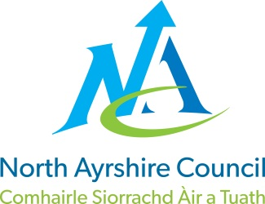
COMMUNITIES & EDUCATION DIRECTORATE
Executive Director: Audrey Sutton
Cunninghame House, Irvine KA12 8EE
Tel: 01294 310000 www.north-ayrshire.gov.uk

Auchenharvie Academy,
Head Teacher: Calum Johnston BED (Hons)
Saltcoats Rd, Stevenston, KA20 3JW
Telephone: 01294 605156 E-mail: auchenharvie@ea.n-ayrshire.sch.uk
Date: 2nd December 2022

Dear Parent / Carer,

Drama Prelim Examination.

You will be aware of the planned strike action by colleagues in the Scottish Secondary Teachers Association (SSTA) and the National Association of Schoolmasters Union of Woman Teachers (NASUWT) planned for Wednesday 7th December. As previously intimated this will mean that Auchenharvie Academy will be closed for normal lessons for all pupils in S1-6 on this day. I apologise for any inconvenience that this may cause.

I have been consulting with colleagues at North Ayrshire Council along with teaching staff in school to consider what opportunities there are to have some pupils in school on the strike day. I am therefore pleased to advise you that we will be opening the school for the scheduled Drama prelim at National 5, Higher and Advanced Higher on this day.

All arrangements will be shared with pupils prior to the strike day including arrangements for entering and exiting the school building away from any potential Trade Union picket lines.

Arrangements for the prelim examinations are as follows:

National 5 Drama- Plan for Performance section - 10am – 11am – ICT suite

National 5 Drama- Question Paper – 11.15am – 12.45pm – Assembly Hall

Higher Drama- Question Paper – 11.15am – 12.45pm – Assembly Hall

Advanced Higher- Question Paper – 11.15 – 12.45pm – E75

Pupils sitting the National 5 prelim are asked to arrive at school any time after 9.40am and all other pupils from 11am.

Once again, I apologise for any inconvenience caused by the industrial action and I look forward to continuing to work in collaboration with you.

Yours sincerely,

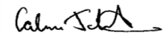
Calum Johnston
Head Teacher

