**Auchenharvie Academy p7 to s1 Transition Calendar 2022 - 2023**

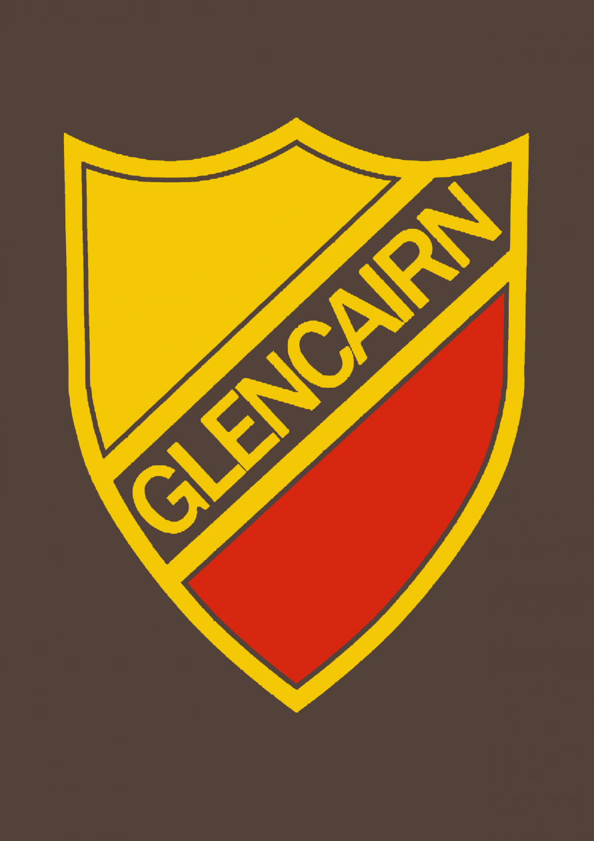

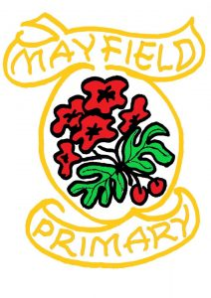



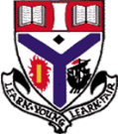





**Tuesday 11th October**

Mrs Booth, Ms Davis and Mrs Gall Primary visit P7 classes

**Friday 28th October**

Challenge Day 1 – Virtual (Science and English)

**Wednesday 23rd November**

Challenge Day 2 Auchenharvie (Expressive Arts)

**Wednesday 23rd November**

P7 Open Night – Showcase

# October 22

# November 22

# September 22

# August 22

# December 22

# March 23

# February 23

# January 23

**Week beginning 6th February**

P7 Information Sharing meetings

**Faculty Spotlight**

**October** - Science

**November** – Expressive Arts

**December** – Family Learning/Modern Languages

**January** – Technical

**February** – P.E.

**March** – Comp, Business &Admin

**April** – Maths

**May** – Social Subjects & RMPS

**June** - English

# June 23

# May 23

# April 23

**Friday 9th June**

P6 Challenge Day Auchenharvie (STEM)

**Tuesday 13th June**

P7 Parent Info Session

**Wednesday 14th& Thursday 15th June**

P7 2day visit

**Friday 16th June**

Tracking Info and Profiles due

**Proposed Enhanced Transition Dates**

* Group 1 – Week beginning 6th March, 13th March, 20th March and 27th March
* Group 2 – Week beginning 17th April, 24th April, 1st May and 8th May