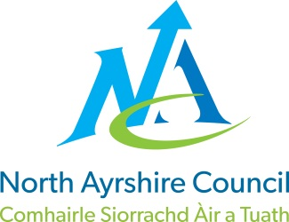
COMMUNITIES & EDUCATION DIRECTORATE
Executive Director (Interim): Caroline Amos
Cunninghame House, Irvine KA12 8EE
Tel: 01294 310000 www.north-ayrshire.gov.uk

Auchenharvie Academy,
Head Teacher: Calum Johnston BED (Hons)
Saltcoats Rd, Stevenston, KA20 3JW
Telephone: 01294 605156 E-mail: auchenharvie@ea.n-ayrshire.sch.uk
Date: 19th April 2022

Dear Parent/Carer,

I hope this letter finds you all healthy and relaxed following the Easter break. It has been great to welcome our pupils back to school this morning for what will be a busy term to end the school year.

I would like to start by thanking you all for your support with our efforts to improve late-coming and school uniform. The standards in school today have been very high and I look forward to working with you all to ensure this continues.

S4/5/6 SQA Study Leave and Estimates.
As previously intimated study leave will commence on Monday 25th April 2022 for all pupils in S4/5/6. Some pupils may be required to attend school during this time to complete coursework but pupils will be contacted individually where this is the case. We had originally planned for senior pupils to return to school on Monday 23rd May 2022 however North Ayrshire Council have asked all secondary schools to finish study leave at the same time. Pupils in S4/5/6 will now return to school on Monday 30th May 2022. SQA assemblies will be held this week to inform pupils of all arrangements pertaining to the upcoming examination diet.

Throughout this school week teachers will also be sharing with pupils the estimated grades which we are required to submit to the SQA as part of the examination process. These estimated grades are important for the purposes of appeals. Teachers have an obligation to submit estimates based on the physical evidence that they have, demonstrating a pupil’s level of work in their subject. These are not based on teacher judgement. Further information on estimates will be issued to parents/carers in a separate communication through our SQA coordinator, Mrs Riddell.

Change of Timetable- S1/2/3
Pupils who are currently in S1/2/3 will change timetable on Monday 23rd May 2022. This will mean that pupils will move up one year and commence their new subjects on this date. I am pleased to be able to change the timetable early as I feel it provides a focus for students prior to the summer break.

Change of Timetable S4/5
Pupils who are currently in S4/5 and are returning to school will change timetable on Monday 30th May 2022 when they return from study leave.

Holiday dates Term 4-
Please note the following holidays during Term 4 for your information.
Monday 2nd May 2022 – school holiday
Friday 27th May 2022 – In-service day
Thursday 2nd June 2022 – school holiday – Platinum Jubilee
Friday 3rd June 2022 – school holiday – Platinum Jubilee

Yours sincerely,
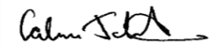
Calum Johnston
Head Teacher

