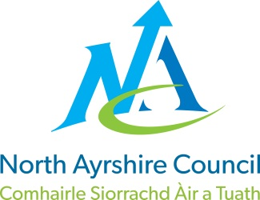
COMMUNITIES & EDUCATION DIRECTORATE
Executive Director (Interim): Caroline Amos
Cunninghame House, Irvine KA12 8EE
Tel: 01294 310000 www.north-ayrshire.gov.uk

Auchenharvie Academy,
Head Teacher: Calum Johnston BED (Hons)
Saltcoats Rd, Stevenston, KA20 3JW
Telephone: 01294 605156 E-mail: auchenharvie@ea.n-ayrshire.sch.uk
Date: 21st March 2022

S1/2 Continuity of Learning

Dear Parent/Carer,

I hope this letter finds you and your families safe and well during this very difficult and challenging time.

I regret to inform you that due to significant staffing issues related to the ongoing COVID- 19 pandemic that we are asking pupils in S1/2 to learn from home on Thursday 24th March and Friday 25th March. Work will be provided for all pupils in all timetabled subjects through a combination of teachers in classes this week, GLOW email accounts and the Teams platform. Pupils should return to school as normal on Monday 28th March.

Please be assured that I am keeping this highly regrettable situation under constant review and I sincerely hope that there will be no further disruption to learning for S1/2 pupils. I am genuinely very sorry about this matter and for any inconvenience this will cause. Before now, the same arrangement has been applied to S3 on two separate occasions, hence my decision to move to alternative year groups.

This decision has not been taken lightly and all avenues have been explored to try and prevent this outcome. We have been sending in excess of 140 classes per week out to cover over the last 2/3 weeks, and this week we are facing the possibility of well over 230 classes requiring cover. Until now, very often, classes have been with multiple other classes working in one area of the school supervised by senior staff but this situation is not sustainable hence this regrettable decision.

A small number of S1/2 pupils who may benefit from an in-school hub, have been identified and they will be contacted by their Depute Head Teacher over the next few days to confirm their intention to come to school on Thursday / Friday or otherwise.

Please accept my apologies for the inconvenience I have no doubt this will have caused, and I thank you in advance for your patience and support during this very challenging time.

Yours sincerely,

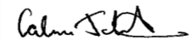
Calum Johnston
Head Teacher

