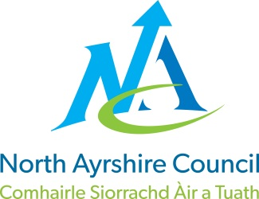
COMMUNITIES & EDUCATION DIRECTORATE
Executive Director (Interim): Caroline Amos
Cunninghame House, Irvine KA12 8EE
Tel: 01294 310000 www.north-ayrshire.gov.uk

Auchenharvie Academy,
Head Teacher: Calum Johnston BED (Hons)
Saltcoats Rd, Stevenston, KA20 3JW
Telephone: 01294 605156 E-mail: auchenharvie@ea.n-ayrshire.sch.uk
Date: 15th March 2022

Dear Parent/Carer,

I hope this letter finds you and your families safe and well during this very difficult and challenging time.

I regret to inform you that due to significant staffing issues related to the ongoing COVID- 19 pandemic that we are asking pupils in S3 to learn from home on Friday 18th March. Work will be provided for all pupils in all timetabled subjects through a combination of teachers in classes this week, GLOW email accounts and the Teams platform.

Please be assured that I am keeping this highly regrettable situation under constant review and I sincerely hope that there will be no further disruption to learning for S3 pupils. I am genuinely very sorry about this matter and for any inconvenience this will cause.

This decision has not been taken lightly and all avenues have been explored to try and prevent this outcome. We have been sending in excess of 140 classes per week out to cover over the last 2/3 weeks, very often with multiple classes working in one area of the school supervised by senior staff but the situation is not sustainable hence this regrettable decision.

A small number of S3 pupils who previously used our school hub for their remote learning have been identified and they will be contacted by their Depute Head Teacher over the next few days to confirm their intention to come to school on Friday or otherwise.

Please note that any pupil who normally works with Ayrshire College in school on a Friday morning completing the Developing Young Workforce Innovative Schools Projects should attend school as normal for these periods then return home for the remainder of the school day. A separate message will be sent to the parents / carers of these pupils to provide further details by Miss Morton, PT DYW.

Please accept my apologies for the inconvenience I have no doubt this will have caused, and I thank you in advance for your patience and support during this very challenging time.

Yours sincerely,

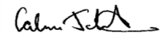
Calum Johnston
Head Teacher

