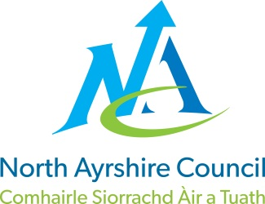
COMMUNITIES & EDUCATION DIRECTORATE
Executive Director (Interim): Caroline Amos
Cunninghame House, Irvine KA12 8EE
Tel: 01294 310000 www.north-ayrshire.gov.uk

Auchenharvie Academy,
Head Teacher: Calum Johnston BED (Hons)
Saltcoats Rd, Stevenston, KA20 3JW
Telephone: 01294 605156 E-mail: auchenharvie@ea.n-ayrshire.sch.uk
Date: 7th January 2022

Dear Parent/Carer,

I hope this communication finds you all safe and well during these concerning and challenging times.

I write to inform you of a minor change of plan which effects pupils in S5 and S6 on Wednesday 12th, Thursday 13th and Friday 14th January next week.

As you may know, we have been unable to reopen school to pupils in S3 this week for in-school learning and they have been working at home using online platforms over the past few days. This is because we currently have 15 (27%) of our teaching staff isolating under Scottish Government COVID-19 isolation rules.

While this number decreases from Monday 10th January, I still expect a minimum of 8 (15%) teaching staff to remain in isolation well into next week. This does not include any new positive tests over the weekend.

I have therefore taken the decision that the following arrangements will be in place for pupils in S5/6 for next week only. Thereafter, on Monday 17th January pupils in S5/6 should revert to the original plans for their learning during the prelim examination diet.

Monday 10th and Tuesday 11th January – all S5/6 pupils should be in school and following their normal timetabled classes. Learning will continue as normal during this time and pupils will be signposted to / provided with additional resources/materials over these two days.

Wednesday 12th, Thursday 13th and Friday 14th January – all S5/6 pupils will work from home. They will have been signposted to and/or provided with materials earlier in the week to support their learning at home to prepare them for the prelim exams which start on Wednesday 12th January. Pupils should continue to follow the prelim examination timetable during these days and attend school for examinations as planned.

Please note that this is not study leave and pupils are expected to continue learning from home during the three days using the work provided by staff.

During this time pupils who attend courses delivered by Ayrshire College should continue to attend their lessons. This arrangement only applies to Auchenharvie Academy.

All S5/6 pupils who are in school today have been advised of this arrangement through pupil gatherings this morning.

Once again, I thank you all for your patience and support during this very challenging time. Please be assured that I have not taken this decision lightly and that we are all working our hardest to make the best of a very difficult set of circumstances.

Yours sincerely,

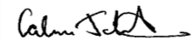
Calum Johnston
Head Teacher
