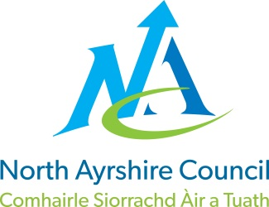
COMMUNITIES & EDUCATION DIRECTORATE
Executive Director (Interim): Caroline Amos
Cunninghame House, Irvine KA12 8EE
Tel: 01294 310000 www.north-ayrshire.gov.uk

Auchenharvie Academy,
Head Teacher: Calum Johnston BED (Hons)
Saltcoats Rd, Stevenston, KA20 3JW
Telephone: 01294 605156 E-mail: auchenharvie@ea.n-ayrshire.sch.uk
Date: 7th January 2022

Dear Parent/Carer,

I wanted to thank you all for your support over the past few days in keeping S3 pupils at home to learn online due to the significant number of staff (27%) that we currently have isolating under Scottish Government COVID-19 isolation rules.

I am pleased to advise that all S3 pupils should return to in-school learning with effect from 0845am on Monday 10th January 2022.

Please accept my apologies for the inconvenience that I know this arrangement will have caused this week.

Once again, I thank you all for your patience and support during this very challenging time.

Yours sincerely,

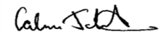
Calum Johnston
Head Teacher
