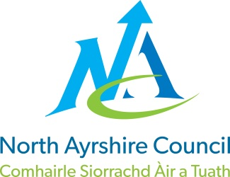
COMMUNITIES & EDUCATION DIRECTORATE
Executive Director (Interim): Caroline Amos
Cunninghame House, Irvine KA12 8EE
Tel: 01294 310000 www.north-ayrshire.gov.uk

Auchenharvie Academy,
Head Teacher: Calum Johnston BED (Hons)
Saltcoats Rd, Stevenston, KA20 3JW
Telephone: 01294 605156 E-mail: auchenharvie@ea.n-ayrshire.sch.uk
Date: 6.01.22

Dear parents/carers,
S2 Virtual Parents’ evening
I hope you and your families have had a restful and safe Christmas break and may I take this opportunity to extend my wishes to you all of a healthy and prosperous 2022.
As you will be aware, due to the current Covid 19 restrictions, face to face parents’ evening will not be permitted. However, we will be holding a virtual parents’ evening on Tuesday 18th January 2022 between 4.15pm and 6.15pm, using an online platform called Parents Booking. You can access the system easily using your phone, a tablet, iPad, a laptop or Chrome book. This will give you an opportunity to ask any questions you may have regarding your child’s report that you received before the end of term.
To allow you to book your child’s teachers’ appointments, simply type in the address below:
The link to access the portal is: www.parents-booking.co.uk/auchenharvie.
You will then be asked to include the following details:

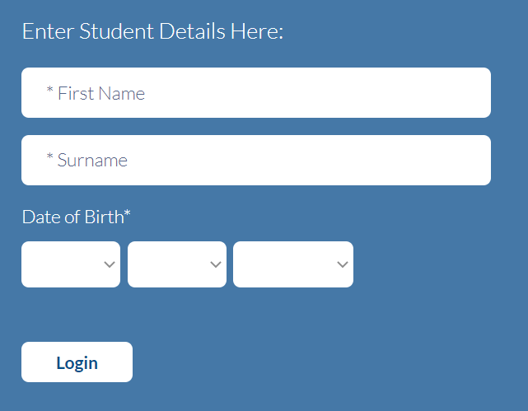
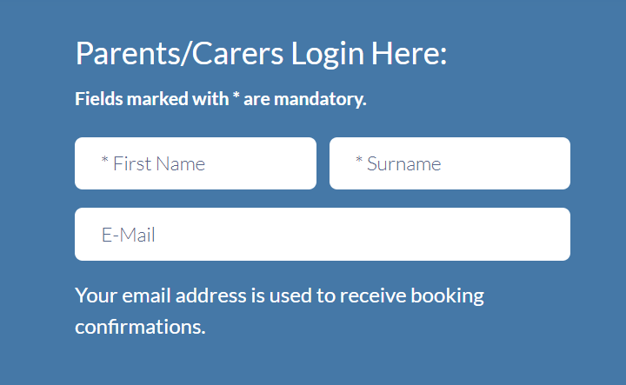

In your next screen, you will be able to click on the option suggested teachers’ bookings for me. This option is the quickest way to book all of your child’s appointments consecutively. Once this option has been selected, and you have booked your appointments, a joining link will be sent to the email that you entered during the log in process. This email should be the same as the one that the school normally uses to communicate with you.
The link generated is what you will need to access all of your video calls with your child’s teachers on the day. Please note that you will be able to book appointments from Friday 7th January 2022 at 6pm. Each appointment will last seven minutes. Please note that teachers will not have the option to extend the appointment time and that after seven minutes, the call will be terminated by the system. Our staff are aware of this and will ensure strengths and next steps are shared with you, as well as given you the opportunity to ask any questions. Should you have any additional questions that our staff are unable to answer on the evening, we encourage you to get in touch with your child’s Pastoral Care Teacher in the first instance by contacting the school at your earliest convenience.

If you have any issues with booking appointments, please contact the school office on 01294 605156 and we will be happy to assist you.

As always, may I take this opportunity to thank you for your continued support.

Yours faithfully,

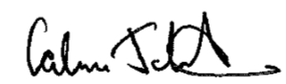

C Johnston
Head Teacher

