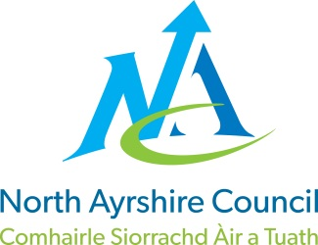
COMMUNITIES & EDUCATION DIRECTORATE
Executive Director (Interim): Caroline Amos
Cunninghame House, Irvine KA12 8EE
Tel: 01294 310000 www.north-ayrshire.gov.uk

Auchenharvie Academy,
Head Teacher: Calum Johnston BED (Hons)
Saltcoats Rd, Stevenston, KA20 3JW
Telephone: 01294 605156 E-mail: auchenharvie@ea.n-ayrshire.sch.uk
Date: 5th January 2022

Dear Parent/Carer,

I hope this letter finds you and your families safe and well during this very difficult time.

I regret to inform you that following the Christmas holidays we are unable to return all pupils in S3 to normal classes as planned on Thursday 6th January and Friday 7th January 2022.

In line with Scottish Government protocols for COVID-19 we currently have in excess of 20% of our teaching staff isolating. This has put extreme pressure on our ability to resume our normal education provision. Pupils in S3 will therefore be provided with work to complete from home on Thursday 6th and Friday 7th January 2022. This work will be set through GLOW email and/or Microsoft Teams. Pupils will be contacted directly by teachers.

Please be assured that I am keeping this highly regrettable situation under constant review and I will be in contact with you again on Friday 7th January to confirm a full return on Monday 10th January 2022.

This decision has not been taken lightly and all avenues have been explored to try and prevent this outcome.

A small number of S3 pupils who previously used our school hub for their remote learning have been identified and they will be contacted by their Depute Head Teacher later today to confirm their intention to return to school as normal tomorrow.

Please accept my apologies for the inconvenience I have no doubt this will have caused, and I thank you in advance for your patience and support during this very challenging time.

Yours sincerely,

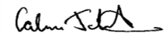
Calum Johnston
Head Teacher
