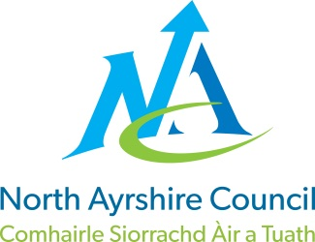
COMMUNITIES & EDUCATION DIRECTORATE
Executive Director (Interim): Caroline Amos
Cunninghame House, Irvine KA12 8EE
Tel: 01294 310000 www.north-ayrshire.gov.uk

Auchenharvie Academy,
Head Teacher: Calum Johnston BED (Hons)
Saltcoats Rd, Stevenston, KA20 3JW
Telephone: 01294 605156 E-mail: auchenharvie@ea.n-ayrshire.sch.uk
Date: 16th November 2021

Dear Parent/Carer,

I write to you all in the hope that as we continue through this global pandemic that you and your families are all safe and well.

Many of you will know Depute Head Teacher for Parkend house, John Herd. John is a long serving member of staff at Auchenharvie Academy and has, over many years, built up excellent working relationships with pupils and their wider families. He has also formed some outstanding partnerships with a significant number of local partners who help to support us in delivering a flexible curriculum and in enhancing pupil’s overall school experience allowing us to support them into positive post school destinations.

I write to advise you that John has been approached by North Ayrshire Council to take up an Acting Depute Head Teacher post at Lockhart Campus where he will support their leadership team in matters directly relating to the Senior Phase of their curriculum.

John will commence his post on Monday 22nd November and this is likely to last until June 2022 when the school session ends.

Pupils have been informed of this arrangement today and I am sure you will join me in wishing John the very best of luck in his new post.

Yours sincerely,

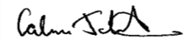
Calum Johnston
Head Teacher

