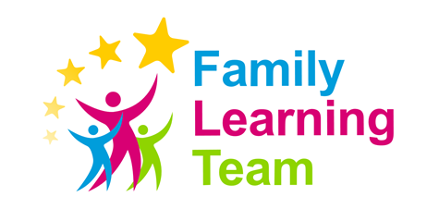
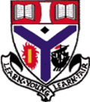
Transition after School Club
Parent/Carer and Child Questions

Child Questions

How long do we get for break and lunch time?
- Morning interval is 15 minutes long which will be similar to what you get just now at Primary School. Lunch time is 40 minutes long. On a Monday and Tuesday morning internal is at 11.20-11.35am and lunch is 1.20-2pm. On a Wednesday, Thursday and Friday morning interval is at 10.35-10.50am and lunch is 12.30-1.10pm.

If we are a packed lunch do we need to sit outside in the rain?
- Is you are a packed lunch you can sit in our junior canteen to have your lunch. Last year when the covid restrictions were much stricter we had to limit the amount of pupils we had inside, this resulted in some pupils having to spend lunchtime outside.

How many classes do we have in the one day?
- Every day starts with 10 minutes of registration from 8.45-8.55am. On a Monday and Tuesday you will have another 7 50 minute periods and on a Wednesday, Thursday and a Friday another 6 periods.

Are there different clubs for us to join?
- We are delighted to be able to offer both lunchtime and after school clubs again. We have a wide variety of clubs to suit all pupils. If there is a particular club you would like then please don’t hesitate to speak to a member of staff.

What do I do if I get bullied?
- We have 4 amazing Pastoral teachers at Auchenharvie. They would be your first port of call if you were experiencing any difficulties. We take bullying very series at Auchenharvie so you don’t need to worry.

Will the work be really hard for me to do?
- The transition team spend a lot of time meeting with staff at your Primary school to find out all about you. We make sure that the work that is set is tailored to your ability. If you are finding the work too easy or too hard speak with your class teacher who will be able to help.

Is there pizza on the school lunch menu?
- The canteen provides a wide variety of both hot and cold meals each day. Similarly to Primary the menu runs on a 2 weekly basis and changes every day. The current lunch menu can be found at:
https://www.north-ayrshire.gov.uk/Documents/EducationalServices/SchoolMeals/lunch-menu-secondary.pdf

Parent/Carer Questions

Will my child be in a class with their best friends?
- There are many factors that determine what classes pupils go into. Unfortunately we can’t guarantee they will be in with their best friend. We do ensure that they will not be the only one from a Primary school in the one class.

Will my child get to meet the pupils in their new S1 class before they start in August?
- When you child comes up for their 2 day visit in June 2022 they will be put into their new classes and will follow their S1 timetable to give them a flavour of some of the subjects they will get in S1.

How is homework issued?
- This year at Auchenharvie we have begun to use Microsoft Teams. We have set up a Transition page this year so you have experience using it before you join us in August 2022. When your child starts with us their class teachers will set up a Teams page for all your different subjects. They will use this to post homework on as well as any class notes.

Can my child come to school Saturday and Sunday?
- Unfortunately this is something that we do not offer at Auchenharvie.

Is my child allowed to leave the school grounds at break and lunchtime?
- No pupils are allowed to leave the school grounds at break time. At lunchtime pupils are allowed to leave the school grounds but must stay with a designated perimeter.

If my child does not gel with their teacher can I request a class change?
- We always look to resolve any potential issues through restorative conversation involving the young person, class teacher and the faculty head. In the unlikely event that this does not work, a class change may be considered a possibility.

