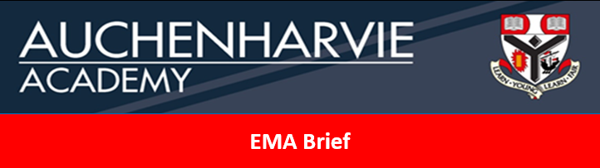

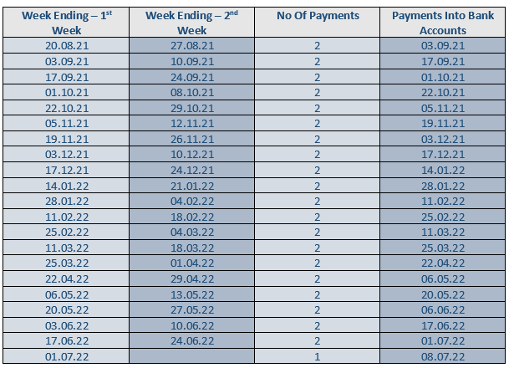
- If pupils are absent from school, then must report to Mrs Wallace in the MI room to obtain a self cert to be filled out. These completed self certs must be returned ASAP to Mrs Wallace. Pupils are allowed 5 full days or 10 half days off in a year due to sickness.
- If self certs are not handed in before the payment run, the money will be added into the next payment run.
- It is up to individual pupils to keep a check on their attendance to make sure it is updated.
- If a pupil has any queries regarding their EMA, they must speak to their Pastoral Teacher.
More information on EMA can be found at:
Education Maintenance Allowance (EMA) (north-ayrshire.gov.uk)

