**Auchenharvie Academy**

**Visitors Guide to Child Protection**

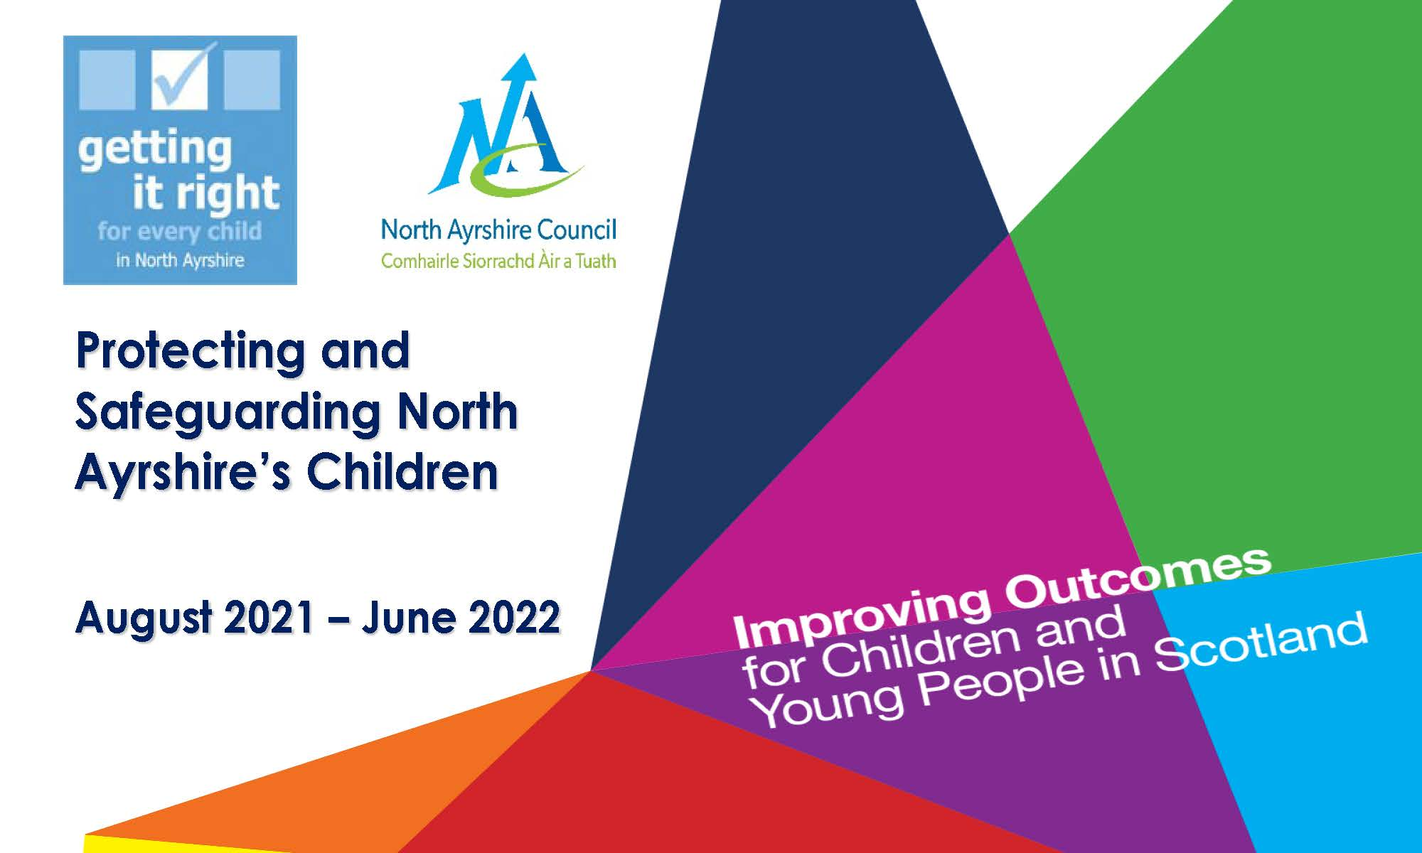

**Visitors Guide to Child Protection in Auchenharvie Academy**

Should you be concerned about any child within Auchenharvie Academy please ensure you pass your concerns on to our **Child Protection Co-ordinator**, Miss Linda Davis immediately or at your earliest convenience. Should they be unavailable, you can contact any member of the Senior Management team within the school or Philip Gosnay, Senior Manager at Education HQ on 01294 324740 (Office) or 07798 577355 (Mobile).

Within this booklet you will find information on areas of Significant Harm that some of our children may be subject to. Please take time to read over this booklet; it will help you to be more aware of the ‘small things’ around us. Should you have any concerns please do not hestitate to speak with the Head Teacher.

