Auchenharvie Academy

WHAT IS CHILD PROTECTION?

- “Child Protection” means protecting a child from child abuse or neglect
- Abuse or neglect need not have taken place; it is sufficient for a risk assessment to have identified a likelihood or risk of significant harm from abuse or neglect
(National Guidance for Child Protection in Scotland 2014)
- Standard circular L3 should be followed for all CP and Welfare/Safeguarding concerns

Guidelines for Child Protection/ Safeguarding
Session 2020/2021

Child Protection & Safeguarding Children & Young People
Is Everyone’s Responsibility

All Education & Youth Employment staff and those working in establishments and/or with children and young people must be:
- Aware of arrangements for protecting children
- Alert to children’s needs
- Clear about their own role in ensuring the safety of all children

Our responsibility goes beyond the narrow definition of Child Protection
We have a responsibility to:
- Provide education to children and young people to help them to protect themselves
- Ensure all staff play a part in the prevention of child abuse and neglect via the curriculum by:
- Raising pupil awareness of risks
- Developing skills which will help them to keep themselves safe
- Helping them recognise behaviours in others which may place them at risk and
- Teaching them how to respond in order to keep themselves safe
Always take into consideration that:
- Children’s circumstances are unique
- Some forms of neglect and abuse cut across all sectors of society eg sexual abuse
- Statistically neglect can be linked to parents who are experiencing or have experienced particular challenges
- Not all children of parents who experience additional issues will be neglected or abused

The Wellbeing Indicators provide the broad framework for identifying a child’s needs.
They do so under eight headings, which should form the basis for planning around the child:
Safe Healthy Achieving Nurtured Active Respected Responsible Included

Different Forms of Abuse or Neglect
The following definitions show some of the different ways in which a child can be abused but are not exhaustive as individual circumstances of abuse will vary from child to child:
- Physical Abuse – being hit, kicked or punched
- Sexual Abuse – inappropriate sexual behaviour or language by an adult towards a child
- Emotional Abuse – constantly criticised, ignored, humiliated
- Neglect –persistent failure to meet a child’s basic or psychological needs: not being properly fed, clothed or cared for or poor hygiene

Additional areas of concern which you should ensure you are aware of and know the signs to look for:
- Exposure to Domestic Abuse
- On line exposure
- Children displaying sexually harmful or problematic behaviours
- Female Genital Mutilation
- Honour based or forced marriages
- Child Trafficking
- Child Sexual Exploitation
- Radicalisation
All Staff Should Be Alert to:
- Unexplained but significant changes to patterns of attendance, attainment or behaviours
- Something the child or young person says, discloses or chooses to confide. Children and young people often take time to seek out and test adults to whom they wish to disclose abuse/neglect
- Concern raised by other children
- Children and young people living with domestic abuse are at increased risk of significant harm both as a result of witnessing abuse and being abused themselves

Staff with Concerns:
Where there is concern about child abuse, neglect or exploitation the staff member should:
- Discuss his/her concerns with the Child Protection Co-ordinator immediately. The Child Protection Co-ordinator will decide on an appropriate course of action. The CP Co-ordinator in the school is Miss Linda Davis, Depute Headteacher
- Establish with the C.P. Co-ordinator when and how concerns should be recorded/shared including, if and when this information should be shared with parents/carers
- Ensure they are clear with regards to the establishment policy and procedures
- Formalise with the Child Protection Co-ordinator what further support the child is likely to need and how best this can be met

Responding to Disclosure/Allegations:
Whoever receives the information from the child or other person should:
- Listen carefully, let the child speak
- Not guarantee confidentiality, whilst explaining the reasons for this
- Not show disbelief or panic
- Take the allegation seriously and reassure the child / person
- Avoid expressing views on the matter
- Explain that she / he will have to share this information with the Child Protection Co-ordinator

Do not question the child – this is the responsibility of agencies trained to carry out investigative interviews of children. Questions inappropriately phrased could be thought to be suggestive and then lead to evidence being held as inadmissible in possible future criminal proceedings.

NEVER

Carry out an investigation or gather any photographic evidence into the allegation – this is not your role.

Reporting Disclosure/CP Concerns

All instances of disclosure/ CP concern should be reported to the school’s Child Protection
Co-ordinator without delay. The CP Coordinator in the school is Miss Linda Davis, Depute Headteacher.

Staff members should not discuss these concerns with colleagues.

If the Child Protection Co-ordinator, Linda Davis or Head Teacher, Calum Johnston is not available, seek advice from any of the other Depute Head Teachers (John Herd and Lety Riddell). If they are unavailable, the Head of Service (Education & Youth Employment) Caroline Amos – 01294 324416 or 07398991597 or the Senior Manager (Inclusion) Philip Gosnay 01294 324740 or 07798577355 or Gail Nowek, Principal Psychologist 01294 324589 should be contacted as a matter of urgency.

If any member of staff receives information or hears an allegation of abuse or inappropriate conduct against another member of staff, the head of establishment must be informed immediately.

If establishment based staff are unavailable please refer to the Child Protection Presentation Phone Tree slide for authority contact details or the Contact Numbers slide detailing Social Services and Police phone numbers. This presentation is available on the CP Safeguarding staff noticeboard which is located in the staffroom, main office and in Public – Staff Information – Child Protection

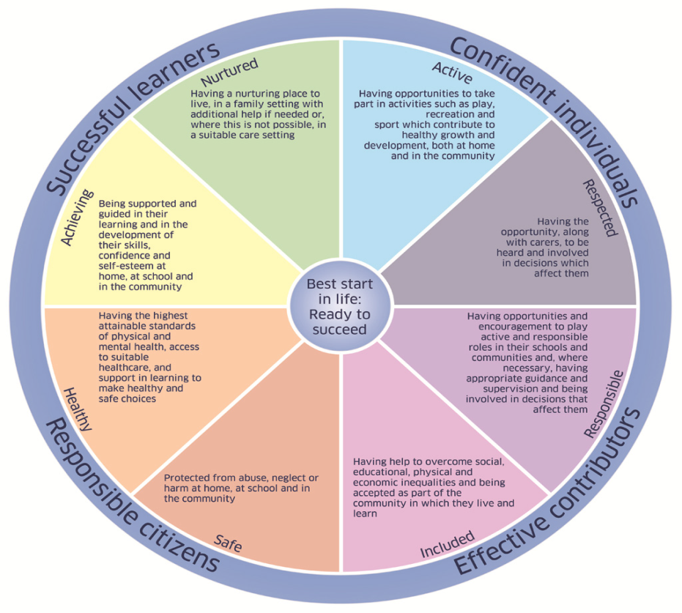l

CHILD PROTECTION CONTACT LIST
If you have any concerns about a pupil please contact Linda Davis, Child Protection Co-ordinator. If unavailable, please see the Headteacher, any member of SLT or any member of the Pastoral Care Team.

Child Protection Coordinator
Miss Linda Davis (Warner House)
Ext No 291

Child Protection Coordinator
Miss J House
Ext 208

Head Teacher
Calum Johnston
Ext No. 207

Warner House
Claire Scott, PTPC
Ext No 215

Parkend House
John Herd, DHT
Ext No. 210

Helen Shaw PTPC
Ext No 216

Ashgrove House
Lety Riddell, DHT
Ext No 290

Amanda Lynch, Acting PT PC
Ext No 217

It is everyone’s responsibility to ensure all our children & young people are:
- SAFE
- HEALTHY
- ACTIVE
- NURTURED
- ACHIEVING
- RESPECTED
- RESPONSIBLE
- INCLUDED

Child Protection North Ayrshire – www.childprotectionnorthayrshire.info/cpc/
North Ayrshire GIRFEC website - www.girfecna.co.uk

Child Protection Children and Young People – www.childprotectionnorthayrshire.info/cpc/children-and-young-people/
www.unicef.org/crc/ Unicef – UN Rights of the child
www.cpckids.co.uk
www.cpcteens.co.uk

Child Protection Professionals –
- North Ayrshire Child Protection Committee www.childprotectionnorthayrshire.info
- Barnardos – www.barnardos.org.uk (Child Sexual Exploitation material)
- CEOP – www.ceop.police.uk/safety-centre/
- Female Genital Mutilation – www.forwarduk.org.uk/key-issues/fgm
- North Ayrshire GIRFEC – www.girfecna.co.uk
- National Child Protection Guidance – www.gov.scot/Resource/0045/00450733.pdf
- National Risk Framework – www.gov.scot/Resource/0040/00408604.pdf
- Pan Ayrshire GIRFEC – www.girfec-ayrshire.co.uk/
- Shakti Women’s Aid – www.shaktiedinburgh.co.uk
- UNICEF – UN Rights of the Child – www.unicef.org/crc/

Other documentation
- Supporting Vulnerable Young Person’s Guidance 2018.
- North Ayrshire Anti Bullying policy 2018
- The National Action Plan on Internet Safety for Children and Young People (April 2017)

