AUCHENHARVIE ACADEMY
Head Teacher: Calum Johnston BED (Hons)
Saltcoats Road, Stevenston, KA20 3JW
Tel.: (01294) 605156
E-mail: auchenharvie@ea.n-ayrshire.sch.uk
Date: 23rd April 2021

Dear parents/carers,

I wanted to thank you all for your ongoing support during our first full week back. Pupils have been very settled and are working well. We have had no positive cases of COVID-19 this week and I would encourage all pupils to take advantage of the Lateral Flow Device test kits available upon return of consent form from the main school office.

School Improvement Planning (SIP) 2021-22.

Thank you very much to all of the parents/carers who have already replied to say that they would like to be involved in the working group which will write the SIP for next session. I will be in touch over the next couple of weeks and plan our first meeting to be during Wb 10th May 2021.

I completely understand that many of you will not be able to participate in the SIP group but it is still important to me that everybody has the opportunity to have their say on our priorities for Auchenharvie next session.

I have therefore attached a pro-forma which details our 4 key overarching priorities. I would ask that you identify from within each of these priorities what you think we should be focussing on. I am currently in the process of asking all pupils, staff and partners the same question and will collate all of this to ensure the SIP group creates a finalised plan which reflects the needs of our school and our community.

Clearly a significant aspect of our SIP will be about education recovery post COVID-19 but I am sure it will also be forward looking and proactive in response to the needs of our pupils.

I would be grateful if you could return this either electronically or in paper copy to the main school office by Friday 7th May 2021.

Once again, thank you for your continued support and if you would like to chat about any aspect of this please contact me on the details above.

Yours faithfully

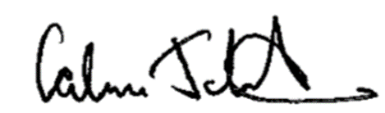

Calum Johnston
Head Teacher

