AUCHENHARVIE ACADEMY
Head Teacher: Calum Johnston BED (Hons)
Saltcoats Road, Stevenston, KA20 3JW
Tel.: (01294) 605156
E-mail: auchenharvie@ea.n-ayrshire.sch.uk
Date: 21st April 2021

Dear parents/carers,

This week all our pupils have returned to full time education and we have been delighted to see them all back ready to learn.

As you know, this week our senior pupils have begun completing in class assessments for the SQA Alternative Certification Model. Both the April and May assessment blocks have been designed to offer our senior pupils the opportunity to complete further evidence to inform teachers’ judgements on the candidates’ provisional grades for this session.

As SQA states, school must use a wide range of evidence completed under SQA assessment conditions to ensure the integrity of the qualifications and a fair certification process.

We hope our candidates will perform well both in our April and May assessment blocks. However, evidence completed from August to December 2020 will also be considered and therefore, we do not want candidates to fall into a false sense of security leading them to think that no matter their previous performances, should they achieve a great score in these latest assessments, these would automatically translate into excellent grades. Provisional grades for each candidate will be derived using a wide range of assessment evidence completed throughout the session that has been rigorously quality assured against the SQA standards at whole school level. A single performance in one single assessment cannot and will not be used to derive a provisional grade in any senior phase subjects.

I hope this letter adds further clarity to the current extraordinary situation we find ourselves in due to the Covid-19 pandemic and I hope you will continue to support us in emphasising this to your child.

Once again, thank you for your continued support.

Yours faithfully

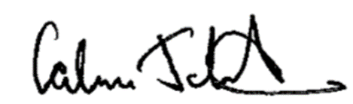

Calum Johnston
Head Teacher

