AUCHENHARVIE ACADEMY
Head Teacher: Calum Johnston BED (Hons)
Saltcoats Road, Stevenston, KA20 3JW
Tel.: (01294) 605156
E-mail: auchenharvie@ea.n-ayrshire.sch.uk
Date: 12th March 2021

Dear Parent/Carer,

As we reach the end of the final week in this phase of remote learning I again wanted to thank you all for your ongoing help and support with pupils during their study from home over the past 9 weeks. I am again delighted to advise you that over the course of the last week there have been no senior pupils or staff who have returned any positive tests for COVID-19 following the introduction of the Lateral Flow test kits a number of weeks ago.

Attached to this communication and available as always on our website are the following documents for your information:

S1-2 weekly work overview for parental info.

Update on return to school
Earlier this week I wrote to all parents / carers to provide more detail on the return to school of pupils from Monday 15th March. This included pupil groupings, days in/out of school, arrangements for remote learning and also for the distribution of Lateral Flow test kits to S4/5/6 pupils. Assemblies were also held for all year groups on Wednesday this week to go through this information and to answer any questions. If you missed this communication then please refer to our website where all communications are available or contact the school directly for information. It is essential that all pupils know which group they are in from Monday and understand how school will operate upon pupil return. Please remember that the arrangements starting on Monday 15th are for the period through to the Easter holidays. Thereafter, it is anticipated that all pupils will return to school fulltime through to the summer break.

S1/2/3 Lateral Flow Testing
You may have noticed in the media this week that the Deputy First Minister announced that Lateral Flow test kits were to be made available to all pupils in s1/2/3 in addition to their peers in the senior school. This arrangements has to be in place for pupils returning after the Easter break. Over the next couple of weeks I will communicate specifically with parents / carers in these year groups with a view to issuing test kits during the last week of term. This will allow pupils to test the night before they return to school following the Easter break, and twice a week thereafter. Please note that the Lateral Flow tests are not mandatory but in the interests of safety we would encourage all pupil who are able to take the test to do so to provide their own personal assurance that they are free from COVID-19.

Youth Participatory Budgeting
As you know we submitted a bid on behalf of the middle school pupil council to the NAC Youth Participatory Budgeting initiative. This was for £1000. Auchenharvie Academy also submitted two other bids both of which were related to sport and physical activity. Voting commenced on 8th March to decide which groups will be successful in their bids. Everyone can vote for their three favourite bids – this includes all pupils, parents/carers and extended family/ friends and we would be delighted if you would use all of your votes for the three Auchenharvie bids. To vote you can either log on to www.menti.com and use the code 12 36 99 8 or alternatively you can vote on facebook at:

https://www.facebook.com/44861837918/posts/10157942500697919/?d=n

Senior Pupil's wellbeing
We understand that our senior pupils, in particular, are overwhelmed with assessments pending for their National qualifications.
The following sessions have been organised for senior pupils in order to support their wellbeing:

Donna Shillinglaw, from a New Chapter Coaching, has very kindly offered virtual sessions to support our senior pupils, as shown below:
Tuesday 16th March at 2pm - "Sort out your sleep pattern"
Tuesday 23rd March at 2pm - "Simple techniques to help anxiety"
Tuesday 30th March at 2pm - "Coping with feeling overwhelmed"

Donna is an ex-pupil of Auchenharvie Academy and is keen to support our pupil's wellbeing which is greatly appreciated.

All senior pupils will be sent the link via e-mail today. Those at home can login at home and take part in the sessions and those in school will be logged in by their class teacher so they can also take part in the sessions.

The sessions will last for 30 minutes: 20 minutes on the topic with a 10-minute question and answer session at the end. Pupils can e-mail questions to Donna prior to the sessions and can keep their camera and microphone off for the duration of the session if they wish.

Wellbeing/Interhouse Calendar
The Inter-house team are meeting next week to plan the next steps for our Wellbeing/Inter-house calendar.
A huge thanks to all of the pupils, staff and siblings who have become involved with the activities!
An updated version of the Wellbeing/Inter-house calendar will be shared soon after consultation with our young people.

Auchenharvie Step Challenge
The only activity which will remain as of next week is the Auchenharvie Step challenge.
Please remember to record your steps for this week by midnight this Sunday using the following link:
bit.ly/2XWefu3 - house points to be earned

DrEAM Step Challenge Results
In addition to two members of our staff making it onto the NA leaderboard as shared in last week's communication, our school was in 1st place for overall winner in the challenge!
So huge well done to all of our pupils, staff, parents and family members who took part in the challenge!
Overall winner leaderboard:
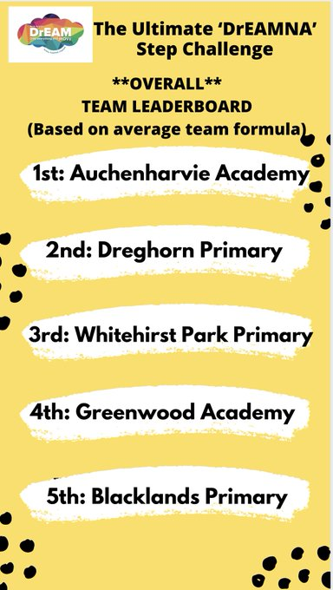
As winners of the DrEAM Step Challenge, the staff, pupils, parents and family members of Auchenharvie have accumulated just under 12 million steps. The prize was to be a bag of equipment, however, instead of NA Active schools ordering equipment on our school's behalf which might go to waste, our Active School's Co-ordinator Leanne McPhail will work with the FH of Physical Education to order equipment our school needs.
#teamharvie

Science Inter-house Challenge Day
The Science department have arranged an Inter-house Challenge day for all Science pupils on Friday 19/3/21.
The challenge is to complete the Quiz which will be sent out on the day by pupil's Science teachers for pupils who should be in Science on that day.
House points will be allocated based on the quiz results/time to complete quiz.

Extra House Points can be earned by pupils sending a picture of them wearing their house colour on the challenge day either to their Science teacher or tagging the school's Twitter account:
@auchenharvie.
Ashgrove - red
Warner - green
Parkend - blue

House Points
Please see below for the most up to date House points.
Huge congratulations to Parkend pupils and staff who continue to hold on to the top spot!
Can Ashgrove or Warner make a comeback next week? Let's see.
House points are earned by participating in the Wellbeing/Inter-house calendar activities.

Place | House | Points Total
1st | Parkend | 920 points
2nd | Warner | 847 points
3rd | Ashgrove | 837 points

House hoodies
Our House system aim is to promote well-being and provide a sense of community and belonging to our young people and all members of our school community.
There are House hoodies available. Pupils and staff are encouraged to wear House hoodies on Inter-house Challenge days to promote House identity. During all other school days, pupils will be asked to remove their House hoodies in class in line with the school uniform policy.
Costs
House hoodies are £12 each + P&P and include personalisation on the back of the hoodie.
The link to purchase House hoodies can be found on our school's website.
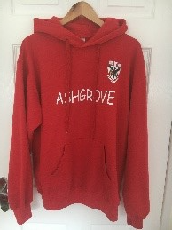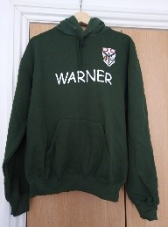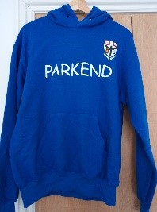

Contacts for Pupils/Parents and Carers During Lockdown
If parents/carers or pupils have any questions and/or issues during the upcoming period of remote learning, then please use the following e-mail addresses to contact pupil's designated House team:

Ashgrove
gw16lynchamanda@glow.sch.uk
gw10congiuletizia2@glow.sch.uk

Warner
gw09scottclaire4@glow.sch.uk
gw09davislinda@glow.sch.uk

Parkend
gw09shawhelen@glow.sch.uk
gw09herdjohn@glow.sch.uk

I hope you find this information useful and I will continue to provide you all with weekly updates as we work together through this difficult time. As ever, please do not hesitate to get in touch on the details above if you would like help, support or further information on any aspect of the information above. Thanks again for everything you are doing to support us- we really appreciate it.

Yours sincerely,

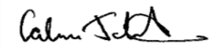
Calum Johnston
Head Teacher
Auchenharvie Academy

