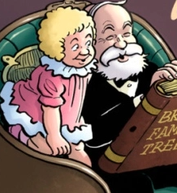
Big Bairns’ Book Club!
Research by the Open University has shown that teacher and family knowledge of contemporary children's books makes a big difference when it comes to instilling a love of reading in pupils.
In North Ayrshire, we’d like to start a Book Club for Practitioners and Parents/Carers with a focus on reading children’s and young adults’ literature.
Our Libraries can supply up to 500 titles through Borrowbox.
Exploring books together will mean we can:
- make informed and tailored recommendations
- introduce pupils to a diverse range of formats and genres
- add interest to school projects
- create a support network across our whole school reading communities

If you are interested in joining us, please e-mail:
librarysupport@north-ayrshire.gov.uk
Entitle your e-mail Big Bairns’ Book Club

