Auchenharvie Academy Parents/Carers Feedback 18th- 22nd January 2021 on remote learning
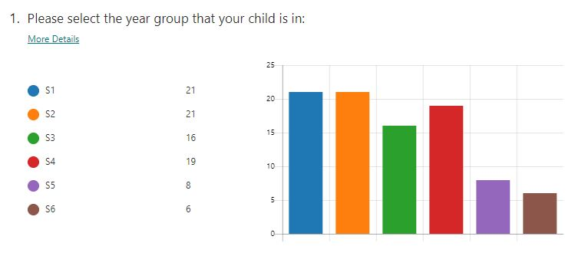
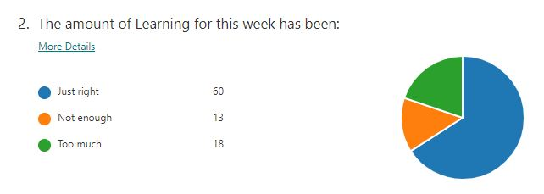

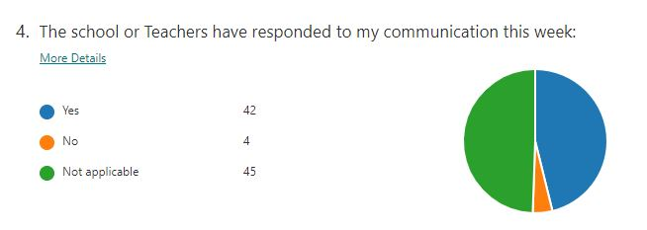
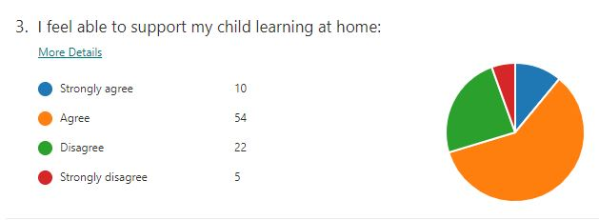

What is working well?
The feedback has been extremely positive and has highlighted the following strengths:

- Regular and appropriate volume of work is allowing young people to be in a routine.
- The quality of the work issued is varied with a wide range of resources being used. Some parents described the resources as “Incredible”.
- Teachers making themselves available on Vscene, Teams or Google Meet is extremely helpful to both young people and parents/carers.
- The volume of work has been well received- with many parents/carers appreciating the weekly planner issued to keep them informed and provide a sense of direction without overwhelming pupils.

How could things be improved?
Some parents felt that there was a limited range of subjects on offer on a weekly basis. | All subjects are covered on a weekly basis and the details is included in our weekly planners which are published on our school website. We will promote the weekly planners and will use a range of platforms to alert parents and carers when these are published.
Some parents have highlighted the need for stationery | Mrs Hopton collated a list of resource needs from parents/carers and generated a click and collect service which will be available on a fortnightly basis.
Some parents highlighted the need for a more reliable online platform | Given the technical issues experienced, we are encouraging all our teaching staff to use a wider range of digital platforms such as Google meet and Microsoft Teams. Staff have and will continue to regularly email pupils to ensure there is regular contact.
Some parents felt better access to extension tasks would be helpful | There is a wide range of additional platforms where appropriate extension work can be accessed such as: BBC Bitesize, Scholar and Sgoil. We will advertise these on our social platforms. Moving forward, teaching staff will also include extension tasks focusing on wellbeing.
Some parents would like to see more regular contact with teachers throughout the week | We are exploring the possibilities of opportunities for daily check ins and we have started a programme of virtual fortnightly assemblies.

