AUCHENHARVIE ACADEMY
Head Teacher: Calum Johnston BED (Hons)
Saltcoats Road, Stevenston, KA20 3JW
Tel.: (01294) 605156
Fax: (01294) 604806
E-mail: auchenharvie@ea.n-ayrshire.sch.uk
Date: 22nd January 2021

Dear Parent/Carer,

As we reach the end of the second full week of remote learning I again wanted to take time to thank you all for your continued support during this very difficult and challenging time. My staff and I really appreciate how much time and effort parents/carers are spending to help support their children with the work being set by their teachers. I also wanted to take time to provide you with an update of the current situation and to provide some further links to support you all.

Attached to this communication and available as always on our website are the following documents for your information:

S1-6 weekly work overview for parental info.
S1/2 weekly distribution of work.
Auchenharvie Academy online etiquette.
Information from the National Parent Forum for Scotland to support you during lockdown.

Update from Scottish Government.
You may have heard earlier this week that the First Minister announced that the current period of remote learning will continue until at least the middle of February. This is to be reviewed and a further announcement made on Tuesday 2nd February. This therefore means that our current arrangements for schooling will continue. As soon as I have any further information about any aspect of the current arrangements I will of course communicate this to you.

Pupil Check-ins and Assemblies.
Starting wb 25th January we will be holding virtual assemblies for pupils in S1/2. These will be held as follows and i would encourage all pupils to join in and take the opportunity to see friends and peers that perhaps they haven’t seen for a while. Links to join these assemblies will be sent through pupil GLOW email accounts on Friday 22nd January.

S1 Year group assembly – Monday 25th January 11.30am
S2 Year group assembly – Tuesday 26th January 11.30am

Pupils in S3/4/5/6 will start each day with a check in from their class teacher which will focus on their wellbeing and their general engagement and experience during lockdown 2.

S3 Pupils.
S3 pupils in Auchenharvie will change to an alternative method of schooling as from Monday 25th January. As per my communication earlier this week pupils in S3 will now replicate pupils in S4/5/6 by following their normal timetable each day and joining their classes on a period by period basis. As part of the PSE lessons next week Pastoral Care teachers will be ensuring that all pupils continue to have access to their full timetables. The only exception to this will be for S3 pupils who study Hospitality. These pupils will continue to have their weekly work issued through GLOW and Google Classroom.

Feedback Surveys.
This week we have launched a broad suite of surveys to gather feedback on our remote learning offering. We have sent surveys to parents/carers, to pupils and to staff. We have also commenced a whole school evaluation of our practices as compared to the recently published Education Scotland guidance on remote learning. In addition we have sent a link to all parents/carers who may require support with stationary and resources. From next week will essentially be offering an Auchenharvie Click and Collect model for stationary and resource support. Please take time to complete the relevant surveys so that we can continue to improve the service we offer you and our pupils during this period of home schooling.

Support for Parents/Parent Drop-in Sessions.
Over the next couple of weeks we will be offering virtual drop in sessions for parents/carers to help and support you with remote learning. These sessions will take place on Thursday 28th January at 4pm and again on Monday 1st February at 10.30am. You should already have received information on how to sign up for these and I look forward to speaking to you all at these virtual events.

Furthermore, I have attached to this communication the latest guidance from the National Parent Forum of Scotland to help and support you during lockdown. This forum has published some really useful advice and support for parents/carers and I would encourage you to take a look at this information and to access their website for more information.

Accessing Pupil Work.
It has come to our attention that e-mails from teachers to pupils are sometimes being placed in the "other" tab within the pupils GLOW e-mail account, please see picture below.

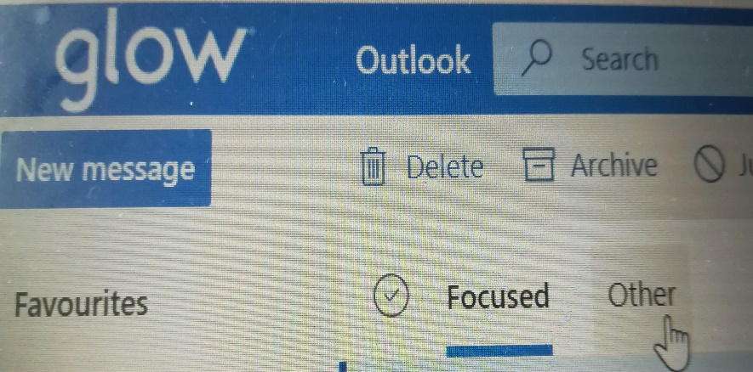

We would be grateful if parents/carers could ensure that their young person is checking both the "focused" and "other" tab within their e-mails daily as they may be missing tasks that teachers are sending.

Please contact the school if your child is having any difficulties in accessing online learning.

Class Registers/Attendance at Class.
Attendance at classes during remote learning is hugely important for all pupils. For pupils in S1/3 it is essential so that they continue to develop their knowledge and skills and it will also help ensure that when we do return to school that any gaps in learning are minimised. For S4/6 pupils the same applies but in addition teachers are setting tasks and activities that will allow them to make decisions and judgements which in the next few months will contribute to SQA estimate grades and predictions.
So far during lockdown our staff have been keeping a close eye on who has been engaging with their school work and identifying pupils who have not been logging on and participating. Starting from Monday 25th January registers will be taken for all classes. These will be taken in a variety of different ways dependant on the style of delivery for each lesson. Pupils who are not engaging with their work will be contacted directly by a member of our Extended Leadership Team. In addition, I am also very keen to reward pupils who do diligently log on and engage in their learning and we are looking at some ways of recognising such positive work. I will keep you posted as this progresses.

Online Etiquette.
Over the past couple of weeks the overwhelming majority of our pupils have conducted themselves brilliantly on the various online and face to face platforms we have been using. We have however had a couple of very minor issues where pupils have not always represented themselves to a high standard. To help drive standards and improve the quality of the overall experience for all pupils we will be taking a few moments at the start of next week to remind all pupils of our expectations for online etiquette. I have attached an information graphic for your perusal which links our school values of Respect, Equality and Determination to our online expectations. Your help in ensuring that pupils are following these expectations continues to be greatly appreciated.

Further Support for Pupils.

Free Printing Service for Pupils - we have been made aware of a company in Ardrossan who are providing a free printing service for all school pupils during this period of lockdown. This may help pupils if they are unable to come to school to collect any resources provided by their teachers.
https://www.ardrossanherald.com/news/19010890.ardrossan-community-centre-offers-free-printing-help-schoolchildren/

Extra Learning Resources - as previously intimated and to further enhance the availability of materials for pupils to study during this latest period of lockdown I would encourage all pupils to take advantage of the following additional resources:

Crosbymathsrevision on Facebook and Instagram is an English Maths teacher who is kindly offering two online live tutor sessions a week to help GSCE pupils in lockdown. A lot of the GSCE Maths topics overlaps with Nat 5 Maths topics. For any pupil or parent/carer who is interested, search this on Instagram or Facebook. The tutor sessions take place live on Microsoft Teams at 7pm at night, after the school day is over, so that there are no clashes with online teaching from school. The link to the Microsoft Teams page is on the bio on Instagram. Hopefully you may find this useful. She also has another Facebook page called "Maths 4 kids" which some of the primary school pupils may find useful too.

https://your-way.org.uk/creating-a-positive-routine-and-planning-your-days-during-lockdown/ - during our pupil check-ins we are increasingly finding that some pupils are having issues providing structure and routine to their school day. This link will help pupils to organise themselves during the day and hopefully allow them to engage more in their school work and support their mental wellbeing.

https://scholar.hw.ac.uk - Pupils can access the SCHOLAR resource using their GLOW login which will provide them with access to materials for 41 SQA NQ certificated courses. This is aimed primarily for senior pupils.

www.e-sgoil.com
- Pupils can also access this free online platform specifically designed to help during remote learning. There are a multitude of resources and live lessons are also streamed to support pupils. This resource is suitable for all pupils.

www.bbc.co.uk/bitesizerevison - This is a resource for primary and secondary pupils with online resources and interactive videos to support learning.

Contacts for Pupils/Parents and Carers During Lockdown.
If parents/carers or pupils have any questions and/or issues during this period of remote learning, then please use the following e-mail addresses to contact pupil's designated House team:

Ashgrove
gw16lynchamanda@glow.sch.uk
gw10congiuletizia2@glow.sch.uk

Warner
gw09scottclaire4@glow.sch.uk
gw09davislinda@glow.sch.uk

Parkend
gw09shawhelen@glow.sch.uk
gw09herdjohn@glow.sch.uk

School Office.
Just a reminder that given the Government instructions on essential journeys and working from home where possible, our school office is not currently being staffed. Please contact the school using the email address provided at the top of this communication for all general enquiries where office staff, working from home, will deal with all requests. For all specific enquiries please use the house team email addresses provided above.

I hope you find this information useful and I will continue to provide you all with weekly updates as we work together through this difficult time. As ever, please do not hesitate to get in touch on the details above if you would like help, support or further information on any aspect of the information above.

Yours sincerely,

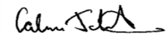
Calum Johnston
Head Teacher
Auchenharvie Academy

