Auchenharvie Academy
School Handbook
2021-22

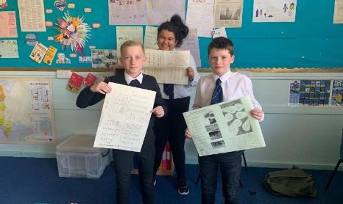
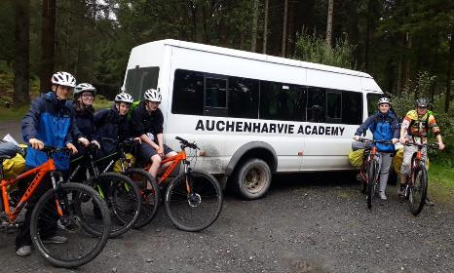

Respect

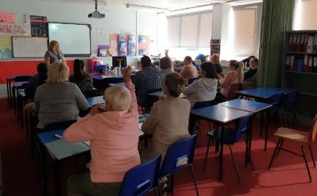
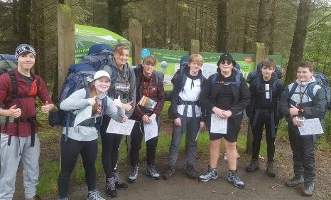

Equality

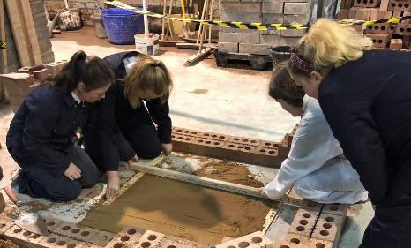
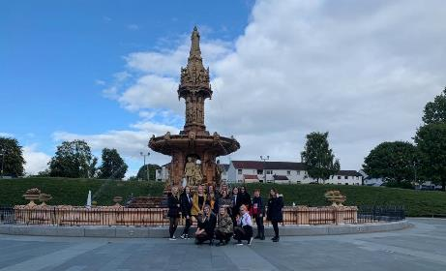

Determination

CONTENTS

Head Teacher Introduction 4
School Captains Introduction 5
Education and Youth Employment Directorate……………………………………………………………………….
- Directorate Aims, Values and Priorities 6
Section 1: School Information …………………………………………………………………………………………………
- School Aims, Values, Ethos 7
- School Contact Details (Address, Telephone, Email, Fax) 8
- School Staff 9
- Pastoral Care Team 10
- Area Inclusion Worker 11
- School Holidays 12
Section 2: School Procedures ……………………………………………………………………………………………………
- School Security 15
- Positive Relationships 15
- Absence from School Premises at Breaks 15
- School Dress Code 16
- Personal Belongings 17
- Mobile Phones 17
- Information in Emergencies 18
- Listening and Learning 18
Section 3: Footwear, Clothing, Free School Meals and Transport………………………………………..
- Footwear and Clothing Grants 19
- Free School Meals 19
- School Transport Policy 19
Section 4: School Registration, Enrolment and Attendance……………………………………………………
- Registration and Enrolment 20
- Attendance at School 21
- Structure of Classes 21
Section 5: Curriculum for Excellence...................................................................
- Curriculum for Excellence 22
- The Capacities 23
- The Curriculum 24
- Assessment and Reporting 25
- Homework 27
- Extra-Curricular Activities 28
- Family Learning 32
- Nurture 32

Section 6: School Improvement………………………………………………………………………………………….

- S&Q Report/Improvement Plan 33

Section 7: Support for your Child……………………………………………………………………………………….

- Equalities 33
- Equality Act 2010 33
- Child Protection 34
- Inclusion 34
- Additional Support for Learning 35
- Dispute Resolution Procedures 37
- Further Support 37
- GIRFEC 37
- Psychological Services 38
- Data Protection 39
- Medical and Health Care 39
- Action Against Bullying 40
Section 8: Parental Involvement ……………………………………………………………………………………….

- Parental Engagement and Involvement 40
- Report to parents 40
- Home School Links 41
- Parent Council 42
- School Committees 42
- Parent Zone Scotland 43

Section 9: Pupil Data Collection and Protection Policies…………………………………………………

- Why we need your data 44
- Your data protection rights 45
- Concerns 45

Appendix 1: Important Contacts 45

WELCOME FROM THE HEAD TEACHER

I would like to take this opportunity to welcome you as a prospective parent of next session’s First Year at Auchenharvie Academy.

The move to secondary school, whether it is the transition from primary or indeed a change of school, is undoubtedly one of life’s milestones and an event that is looked forward to with much excitement and at times a little trepidation by children and their parents. This handbook is designed to give as much information as possible about the school, its aims and the opportunities which we hope to offer your child to help them develop into a confident and successful young adult.

Our key goal is the valuing of each pupil individually and equally. All pupils are individuals with different needs and we recognise this through the courses taught, the teaching approaches used, the supportive guidance system and the range of extra curricular activities. Only by recognising pupils as individuals with different needs can we assist them to reach their full potential.

Pride, confidence and success in a school comes from students, parents/carers and staff having a shared understanding of what we are trying to achieve. The teaching staff will demand a high level of participation and effort from all students. We value your involvement in the education of your child, and I am a strong advocate of positive relationships between home and school in supporting our young people in their learning.

Together, I believe that we can work towards the highest standards for our young people during their time at Auchenharvie Academy. Our school has an excellent reputation and a splendid record of success and achievement in many fields. Recognising these achievements is an essential part of our school ethos.

Auchenharvie Academy is a six year non-denominational comprehensive school which serves the towns of Stevenston and Saltcoats (south) and is situated between the two. The school roll currently stands at 660 pupils. We have been fortunate to have quite substantial refurbishments of many classrooms over the last five or six years and are currently working with NAC on further refurbishment works to our school, resulting in very good facilities being made available to our pupils. The school is very well equipped and I am confident this environment is well placed to encourage, inspire and motivate the pupils and staff on a daily basis.

We hope that your child will enjoy the years that are ahead and that he or she will gain, both academically and socially, from being a pupil here.

In June there will be a meeting of all parents coming into S1 next session. I look forward to meeting you then and to many years of successful partnership with you.

I hope this handbook will give you an insight into what will soon be your child’s school and answer any questions that you might have. However, should you wish further information please do not hesitate to contact me directly.

Calum Johnston

Head Teacher

WELCOME FROM THE SCHOOL CAPTAINS

Nathan Joyce Nathan Downer

Hello, and welcome to Auchenharvie Academy, our school of the last six years, and hopefully the school of your child for the next six years to come. We are all honoured and privileged to be School Captains for this year.

It feels like yesterday that we were in the same position that your child is in currently with their transition from primary to secondary school, and we can relate to the feelings of anxiousness and worry that they may have right now. However, we can assure you that your child has nothing to worry about and they will be welcomed into our school community, by teachers and pupils alike, with open arms. Your child will be challenged to the best of their ability on an academic level, with teachers contributing to ensure that every child meets their full potential in the classroom, building positive relationships with them in the process. They will also have the chance to develop themselves on a social level, as they will meet new classmates from other primary schools and pupils further in their school career.

In addition to academic subjects, the school also offers many extra-curricular opportunities to suit any passion your child may have. These range from opportunities in Music, PE, Science and many outwith traditional subjects such as our LGBTQ+ group, there truly is something for everyone. These additional opportunities would allow your child to develop their confidence and make new friends who share their interests.

We hope this give you an insight into the great school environment present here at Auchenharvie Academy. We hope that this has encouraged you to send your child to our school and hope that they will be part of the next generation of school pupils to enjoy a fantastic education at Auchenharvie Academy.

Nathan Downer & Nathan Joyce
_________________________

COMMUNITIES DIRECTORATE (EDUCATION SERVICE)

What we want to achieve
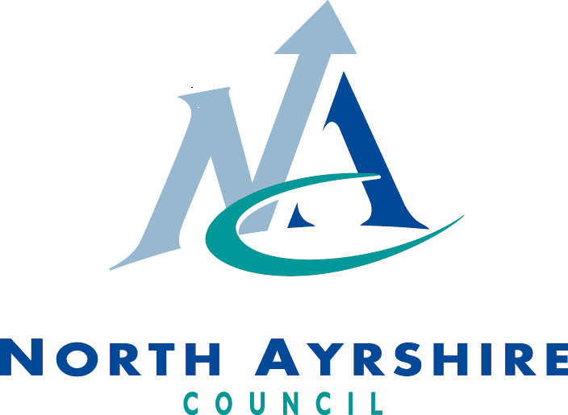

Our Overall Aim
Ensuring people have the right skills for learning, life and work.

Our Priorities

- We are reducing inequalities and delivering improved outcomes for children and young people
- High quality learning and teaching is taking place in our establishments
- Self-evaluation and performance improvement are embedded throughout our schools and central support teams
- Levels of attainment and achievement are improving for all learners
- High numbers of our young people are entering positive and sustained post-school destinations

SCHOOL VISION AND VALUES

Auchenharvie Academy

Our Vision/Aim is…

To provide an equitable and excellent learning environment for ALL pupils which enables them to maximise their full potential and supports them into appropriate positive and sustainable destinations.

Our Values

Respect Equality Determination

SECTION 1: SCHOOL INFORMATION

Auchenharvie Academy Saltcoats Road, Stevenston, KA20 3JW

Telephone Numbers School Office /Absence 01294 605156
School Fax 01294 604806

e-mail address auchenharvie@ea.n-ayrshire.sch.uk

website address www.auchenharvieacademy.com

twitter feed @auchenharvie

SCHOOL ROLL

The present school roll is 660 pupils.

Year Group | S1 | S2 | S3 | S4 | S5 | S6
No. of Pupils | 110 | 145 | 124 | 120 | 92 | 69

The agreed capacity of the school is 820.

ASSOCIATED PRIMARY SCHOOLS

Ardeer Primary School, Clark Crescent, Stevenston, KA20 3LZ
Head Teacher: Mrs A Surgenor Telephone Number: 01294 469785

Caledonia Primary School, Campbell Avenue, Saltcoats, KA21 5AF
Head Teacher: Mrs L Moran Telephone Number: 01294 472092

Glencairn Primary School, New Street, Stevenston, KA20 3HQ
Head Teacher: Mrs S Johnstone Telephone Number: 01294 464376

Hayocks Primary School, Lumsden Place, Stevenston, KA20 4HG
Head Teacher: Ms P McCann Telephone Number: 01294 465283

Mayfield Primary School, Kenilworth Drive, Saltcoats, KA21 6HS
Head Teacher: Mr D Faulds Telephone Number: 01294 465576

STAFF LIST
SLT PASTORAL CARE
Mr Calum Johnston Head Teacher Ms Helen Shaw Principal Teacher Pastoral Care
Miss Linda Davis Depute Head Teacher Mrs Claire Scott Principal Teacher Pastoral Care
Mr John Herd Depute Head Teacher Miss Amanda Lynch (Acting) Principal Teacher Pastoral Care
Mrs Letizia Riddell Depute Head Teacher 0.8
FACULTY OF SOCIAL & RMPS
FACULTY OF ENGLISH & LITERACY Mrs Paula Cook Faculty Leader
Mrs Miranda McDade Faculty Leader Mr Gordon Adam
Ms Helen Shaw Principal Teacher Pastoral Care Mrs Kirsty Wilson
Mrs Carolyn Forrest 0.6 Mr John Herd Depute Head Teacher
Mrs Ynez Stuart Miss Kayleigh Morton
Miss Lucy Kelman Miss Jenna Smith
Mr Adam Carpy Mr Stuart Sheriffs
Mr Stephen Gilmour PT Raising Attainment
Mr Iain O’Donnell
FACULTY OF EXPRESSIVE ARTS
Mrs Suzy Hands Faculty Leader FACULTY OF TECHNOLOGIES
Mrs Allison Hopton PT Family Learning 0.6 Mr Paul Keaveny Faculty Leader
Miss Lorna McConnell Mr Ian Middleton
Mrs Claire Galvin 0.4 Mr David Marwick
Mr Kris Coburn Miss Ashleigh McKeown
Mr Kenneth Brown 0.6
Miss Laura McCourt FACULTY OF
Mrs Emma Shaw 0.8 Mrs Nina Nicholls Faculty Leader (acting)
Mr Ross Ritchie
FACULTY OF MATHEMATICS & NUMERACY Mr Colin Oattes
Mrs Maureen Fletcher Faculty Leader Miss Linda Davis Depute Head Teacher
Mr Kris Denny Mrs Michelle McCormack 0.6
Mrs Fiona Eagleson Mrs Nicola Bell 0.7
Mrs Claire Scott Principal Teacher Pastoral Care Mrs Anne Christine Kirkwood 0.6
Mr Andrew Hosie
Mrs Nicola Garry 0.6 FACULTY OF HEALTH & WELLBEING
Mrs Anna McNay 0.4 Ms Fiona MacDonald Faculty Leader
Miss Lauren Findlay Mr Steven McDougall
Mrs Julie Stewart 0.6
FACULTY OF SCIENCE Mr Ryan Gilmour
Miss Kirsty Scott Faculty Leader Mrs Marion Stewart
Mrs Elizabeth McColl
Mrs Letizia Riddell Depute Head Teacher SUPPORT FOR LEARNING
Ms Catherine Nicol Mrs Lauren McCrindle Principal Teacher
Mr David Lodge Mrs Suzi McSkimming
Miss Katy Lavelle Mrs Shonagh HamiltonMiss Amanda Lynch Principal Teacher Pastoral Care (Acting)
Dr Stephanie Brien Principal Teacher Learning & Teaching
Dr Lois Field PT TRANSITION & INTERVENTIONS
Mrs Laura Booth
NURTURE BASE
Mrs Hazel McColl
Mrs Tracey Small

OFFICE | SCIENCE TECHNICIAN | CLASSROOM ASSISTANTS
Mrs Carlyn Jamieson (EBO) | Mrs Mahri Cochrane | Mrs Louise MacKellar
Mrs Senga Bland | TECHNICAL TECHNICIAN | Mrs Karen Conlan
Mrs Linda McBride | Mr Gordon Burns | Mrs Dorothy Taylor
Mrs Maureen Wallace | IT TECHNICIAN | Mrs Etta Mounce
Miss Leanne Crombie | Mr Craig Douglas | Mrs Christine McMillan
Mrs Claire Paparakis | SCHOOL NURSE | Mrs Elaine Reid
LIBRARIAN | Miss Laura Nicol | JANITORS
Miss Suzanne Walker (Mon, Wed, Thu) | CATERING MANAGER | Mr John Wardrop
AREA INCLUSION WORKER | Mrs Sheila Brandon | Mr Jon Gilmour
Mrs Angie Gall | SCHOOL COUNSELLOR | CAMPUS POLICE OFFICER
Miss Hollie Tait | Miss Stephanie Belshaw | Mrs Karen Barlas
YOUTH WORKER | FAMILY LEARNING | MCR PATHWAYS CO-ORDINATOR
Mr Norrie Brown | Mrs Lauren Young | Miss Stephanie Craig

PASTORAL CARE TEAM

However well we prepare our young people for life at secondary school, there will be times when they need a little extra help. Whether the problem is as simple as a forgotten or lost bag or as complex as a fall out with classmates, it’s good to know that our pupils and parents have somewhere to turn. There are many forms of support and help available to the pupils when they arrive in the school.

PRINCIPAL TEACHERS OF PASTORAL CARE

Three principal teachers have the responsibility for the pastoral support of all pupils in S6 and in addition, manage the 24 pastoral support teachers of S1-S5. They are Ms Shaw, Mrs Scott and Miss Lynch. Where a new pupil is experiencing very specific difficulties which require additional supports, the principal teacher will work with the pastoral support teacher to ensure everything possible is done to meet the needs of the pupil concerned.

Mrs C Scott
Warner House
Miss A Lynch
Ashgrove House
Ms H Shaw
Parkend House

AREA INCLUSION WORKER

There is an Area Inclusion Worker based in every school cluster in North Ayrshire. At Auchenharvie Academy, this person is Mrs Angie Gall. The authority explains its intentions below:

‘Our aim is to provide an early intervention service for children and young people and to support improved communication between school and home.
We do this by working in partnership with other agencies to help children to become successful learners, confident individuals, responsible citizens and effective contributors.’

Mrs Gall works with staff from throughout the cluster of schools to:

- identify children who may need some support
- provide support for parents/carers in groups or individually
- deliver group work to both children and adults

There are a number of reasons that a child might be referred for support either on a short or long term basis. Possible reasons might include: raising self-esteem, peer relations, improving social skills, behaviour in class and/or at home, new to the area or behaviour in the community.

Once a pupil has been identified and referred to Mrs Gall, she is then able to coordinate a wide range of supports which include:

- a drop-in lunchtime facility
- group work for children – healthy relationships / self-esteem etc
- individual programmes – behaviour / anger management / keeping safe / counselling
- transition programme – Primary 7 into first year

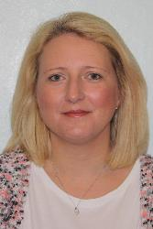

Mrs A Gall
Area Inclusion Worker

IMPORTANT TIMES AND DATES FOR 2020/21

AUCHENHARVIE ACADEMY SCHOOL DAY

Monday and Tuesday | Wednesday, Thursday and Friday

Registration | 8.45 am to 8.55 am | Registration | 8.45 am to 8.55 am
Period 1 | 8.55 am to 9.45 am | Period 1 | 8.55 am to 9.45 am
Period 2 | 9.45 am to 10.35 am | Period 2 | 9.45 am to 10.35 am
Period 3 | 10.35 am to 11.25 am | Interval
Interval |  | Period 3 | 10.50 am to 11.40 am
Period 4 | 11.40 am to 12.30 pm | Period 4 | 11.40 am to 12.30 pm
Period 5 | 12.30 pm to 1.20 pm | Lunch
Lunch |  | Period 5 | 1.10 pm to 2.00 pm
Period 6 | 2.00 pm to 2.50 pm | Period 6 | 2.00 pm to 2.50 pm
Period 7 | 2.50 pm to 3.40 pm

SCHOOL HOLIDAYS AND IN-SERVICE DAYS FOR 2021/22

Tuesday 17 August In-Service Day
Wednesday 18 August Pupils Return
Monday 20 September In-Service Day
Monday 11 October – Friday 15 October Holiday
Thursday 18 November In-Service Day
Friday 19 November Local Holiday
Monday 22 November Local Holiday
Thursday 23 December – Tuesday 5 January Holiday
Thursday 6 January Pupils Return
Friday 11 February Local Holiday
Monday 14 February Local Holiday
Tuesday 15 February In-Service Day
Wednesday 16 February Pupils Return
Monday 4 April – Monday 18 April Holiday
Monday 19 April Pupils Return
Monday 2 May May Day Holiday
Friday 27 May In-Service Day
Monday 30 May Local Holiday
Thursday 30 June – Wednesday 17 August Holiday
Thursday 18 August Pupils Return

SECTION 2: SCHOOL PROCEDURES

School Security
North Ayrshire Council has introduced procedures to ensure the safety and security of children and staff when attending or working in a school. A number of security measures are used including the use of a visitors’ book, badges and escorts while visitors are within the school building. Anyone parent/carer or visitor at a school for any reason will be asked to report to the school office. The school staff will then make any necessary arrangements in connection with the visit to the school.

It is the policy of the school that any member of staff will approach a visitor and ask for verification of identity. This measure ensures that children work in a safe and protected environment. We appreciate your support in carrying out all of the above measures.

Positive Relationships
The school is committed to developing a nurturing approach and promoting positive relationships. Like every community, our school is built on the relationships within it, across it and its connections with others. Every member of staff is responsible for establishing and maintaining positive relationships with each other, with parents and with partners and most importantly with the young people in their care.

Our expectations of behaviour for children and young people are high. Some children may require additional support in relation to their behaviour, and the school will work positively with the young person and the parents, and other partners, as appropriate, to ensure positive outcomes are achieved.

North Ayrshire Council is committed to the principles of restorative practices. This is a solution-focused approach to managing behaviour and resolving difficulties and which promotes healthy relationships that enable better behaviour and better learning.

The school has a code of conduct to ensure the safety and well-being of all and parents are asked to support the school fully in this matter.

Absence from school premises at breaks
Schools have a duty to look after the welfare of their pupils. This means that the staff should take the same care of pupils as a sensible parent would take, and this includes taking reasonable care of pupils' safety during intervals and lunchtimes.

It is the policy of North Ayrshire Council that pupils should not leave the school grounds at intervals. S1 pupils should only leave school grounds at lunchtimes when they are going home for lunch with their parents' agreement. Parents should put this request in writing to the Head Teacher. Pupils will leave and return through main entrance door of the school.

Parents should encourage their children to follow these rules in the interests of safety.

SCHOOL DRESS CODE
Stained Glass
Art Project

School Dress Code
It is the policy of North Ayrshire Council to support the introduction of a reasonable and flexible dress code in schools in its area. The Council encourages each school to adopt its own code, after consultation with parents, pupils and the Parent Council.

The Council believes that establishing a school dress code has many benefits. These include improvements in safety, security, positive behaviour and community spirit and a decrease in bullying and in expense for parents.

The Council will support schools in encouraging and helping pupils to conform to the chosen dress code. Some types of clothing will not be allowed at school in any circumstances, for reasons of safety, decency or wellbeing.

Types of clothing which will not be allowed include:

- Clothes which are a health or safety risk
- Clothes which may damage the school building
- Clothes which may provoke other pupils
- Clothes which are offensive or indecent
- Clothes which encourage the use of alcohol or tobacco

All items of clothing should be clearly labelled with the child's name in case of loss.

Year Groups S1 – S6
White shirt/blouse and school tie

Plain black jumper, zipper, cardigan, tank top

Footwear
Black shoes or boots

Outdoor Clothing
Jacket /coat

- No logos on jumpers
- Hooded tops, including black ones, are not acceptable as school uniform.
- Plain white polo shirts should not show any other logo on them.
- White training shoes are not acceptable as school uniform.
- Hooded tops and track suit jackets will not be encouraged as jackets / coats. Where they are worn they must be removed when pupils are in the school building.
A school blazer is available for all year groups.
All pupils will be expected to bring a bag to school each day.
PE Kit – Plain white T-shirt, plain black shorts/plain black jogging bottoms and trainers.

SCHOOL UNIFORM: SOME EXAMPLES

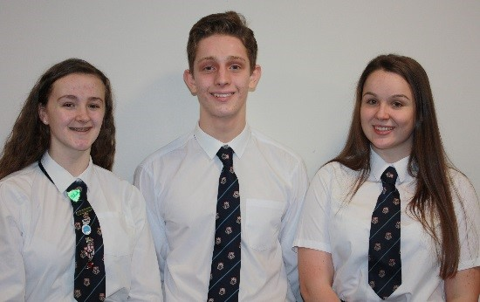

Personal Belongings
It is appreciated that parents and pupils may be distressed over the occasional loss of pupil’s clothing and/or personal belongings. Parents are asked to assist by ensuring that valuable items of clothing or personal belongings are NOT brought to school.

Parents should note that the authority does not carry insurance to cover the loss of such items.

School Meals
Meals are served daily from the multi-choice cafeteria. The meals are planned to offer a healthy diet for the children. Please inform us if your child has any specific allergies.

Mobile Phones
While the benefits of mobile phones are recognised, they can be a serious distraction to work. Pupils whose mobile phones disrupt lessons can have them confiscated until the end of the school day. Repeated disruption may result in phones being retained until uplifted by a parent.

Inappropriate use of text messages and/or photographs/recordings (video and audio) whilst in school may be treated as a breach of the school’s code of conduct or a serious incident, which could be referred to the police.

Information in Emergencies
We make every effort to maintain a full educational service but on some occasions circumstances arise which lead to disruption. Schools may be affected by, for example, severe weather, and temporary interruption of transport, power failures or difficulties of fuel supply. In such cases, we shall do all we can to let you know about the details of closure or re-opening. We will keep you in touch by using letters, e-mails and texts (where possible), NAC website, notices in local shops and community centre’s, announcements in the press and West FM.
Should you have doubts about deteriorating conditions during the day, it may be advisable to contact the school. Parents should ensure that the school is aware of the emergency arrangements made for their child and have responsibility to update us with contact numbers.

Listening and Learning
It is the policy of North Ayrshire Council to try to encourage feedback on the education service from parents and pupils. This is part of our overall commitment to giving the best possible service and to working in partnership.

We are therefore very interested in feedback of all kinds, whether it is compliments, suggestions or complaints. If you wish to register a comment of any type about the school you can do this by writing, telephoning or making an appointment to see someone. All feedback is welcome and helps us keep in touch.

If, in particular, you have a complaint about the school please let us know. It is better that these things are shared openly and resolved fairly, rather than being allowed to damage the home/school relationship. There will be no negative consequences arising from making a complaint and we will deal with the issue as confidentially as possible. If we have made a mistake we will apologise quickly and clearly and try to put things right.

There are some things which you should take note of in relation to making a complaint:

- It is helpful if complaints are made initially to the Head Teacher. This makes sure that the school knows what is going on and has an opportunity to respond and resolve the issue.
- We will try to respond as quickly as possible, but often issues are complex and need time to investigate. It is therefore helpful if you can give some details of the issue and ask for an early appointment to discuss it.
- If you are not satisfied with our response then you still have the right to take up the matter further with the Executive Director of Education and Youth Employment at Cunninghame House, Irvine KA12 8EE (01294 324400).
- You should also note that you have the right to raise unresolved concerns with your local councillor MSP/MP.

- Parent Councils have an important role in developing links between the school and the wider parent body and can often be helpful in helping to deal with issues of general concern. However parents are advised that individual, more personal complaints are not appropriate for raising via parent councils due to the need for appropriate confidentiality.

SECTION 3: FOOTWEAR, CLOTHING, FREE SCHOOL MEALS AND TRANSPORT

Footwear and Clothing Grants
Parents receiving Universal Credit will normally be entitled to grants for footwear and clothing for their children. Universal Credit claimant’s monthly income must not exceed £610.00, however, some parents earning more than this may still be eligible. Parents who still receive Income Support, Income based Job Seeker’s Allowance, any income related element of Employment and Support Allowance, Support under part V1 of the Immigration and Asylum Act 1999, Child Tax Credit only (with income under £16,105) Working Tax Credit or Housing Benefit may also still be entitled to grants for footwear and clothing for their children.

Parents who may be unsure whether they can apply should contact the Council’s Welfare Reform Team on 0300 99 4606 or the Council Contact Centre on 01294 310000 for further advice.

Information and application forms may be obtained from schools.

Free School Meals (FSE)
Children of parents receiving job seeker’s allowance or income support are entitled to a free midday meal. Parents and Carers should contact 01294 310000 for further information. Please note that pupils in receipt of FSM will also have additional money placed on their account to cover the cost of breakfast prior to the school day.

School Transport Policy
North Ayrshire Council has a policy of providing free transport to all primary pupils who live three miles or more from their catchment area school by the recognised shortest suitable walking route or through the link attached below:

https://www.north-ayrshire.gov.uk/Forms/EducationalServices/free-school-transport.doc

These forms should be completed and returned before the end of February for those pupils beginning school in August to enable the appropriate arrangements to be made.

Applications may be submitted at other times throughout the year but may be subject to delay while arrangements are made. The appropriate officer has discretion in special circumstances to grant permission for pupils to travel in transport provided by the authority, where places are available and no additional costs are incurred.

Where free transport is provided it may be necessary for pupils to walk a certain distance to the vehicle pick-up point. Walking distance in total, including the distance from home to the pick-up point and from the drop-off point to the school in any one direction, will not exceed the Council's limits (see above section). It is the parents’ responsibility to ensure that their child arrives at the pick-up point on time. It is also the parents’ responsibility to ensure that their child behaves in a safe and acceptable manner while boarding, travelling in and leaving the vehicle. Misbehavior can result in children losing the right to free transport.

Please see attached link to the Council’s School Transport Policy:
https://www.north-ayrshire.gov.uk/Documents/EducationalServices/school-transport-policy.pdf

SECTION 4: SCHOOL REGISTRATION, ENROLMENT AND ATTENDANCE

Registration and Enrolment
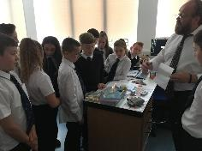
Parents of pupils who have moved to the area or wish their child to transfer to the school should contact the school office for information about appropriate procedures and to arrange a visit to the school.

In the case of pupils transferring from associated primary schools, parents will receive the appropriate information from the Head Teacher of the primary school.

The school works in partnership with all associated primaries to ensure a smooth transition. This includes the sharing of information and teachers visiting the primaries to work with the pupils prior to their arrival. In addition, the pupils will visit the school in November of their Primary 7 year and return in June, where they follow their new timetable for two days. There is also an opportunity for pupils and their families to attend our Open Evening where all departments show the facilities on offer and answer any questions that arise.
All parents are most welcome to visit the school and discuss any concerns they may have. A telephone call first will ensure that the most suitable time for a meeting can be arranged.

Any of the following people will be happy to assist:

Head Teacher Mr Calum Johnston

Depute Head Teachers Miss Linda Davis (Warner)
Mrs Letizia Riddell (Ashgrove)
Mr John Herd (Parkend)

Principal Teachers of Pastoral Care Mrs Claire Scott (Warner)
Miss Amanda Lynch (Ashgrove)
Ms Helen Shaw (Parkend)

Attendance at School/Lateness
It is the responsibility of parents of children of school age to educate their child(ren). Most do this by ensuring that their child(ren) attend(s) school regularly.

Attendance is recorded twice a day, morning and afternoon. Absence from school is recorded as authorised, unauthorised or temporarily excluded.

Parents are asked to inform the school by letter or telephone if their child is likely to be absent for some time, and to give the child a note on his or her return to school, confirming the reason for absence. If there is no explanation from a child’s parents, the absence will be regarded as unauthorised.

Every effort should be made to avoid family holidays during term time as this both disrupts the child’s education and reduces learning time. Parents should inform the school by letter, before going on holiday, of the dates. Such absence will be authorised only where certain and very specific family circumstances exist. The majority of family holidays taken during term time will be categorised as unauthorised absence.

Parents may request that their children be permitted to be absent from school to make an extended visit to relatives. Only written requests detailing the destination, the duration and the provision that will be made for their continuing education will be granted. Such extended absences will be recorded separately from the normal attendance and absence information.

Structure of Classes

Ashgrove Parkend Warner

1A1 1P1 1W1
2A1 1P2 1W2
2A2 2P1 2W1
3A1 2P2 2W2
3A2 3P1 3W1
4A1 4P1 3W2
4A2 4P2 4W1
5A1 5P1 5W1
6A 6P 5W2
6W

SECTION 5: CURRICULUM FOR EXCELLENCE

Curriculum for Excellence is the national curriculum for Scottish schools for learners from age 3 to 18. It aims to raise standards, prepare our children for a future they do not yet know and equip them for the jobs of tomorrow in a fast changing world.

Curriculum for Excellence enables professionals to teach subjects creatively, to work together across the school and with other schools, to share best practice and explore learning together. Glow, Scotland’s unique, world-leading, online network supports learners and teachers in this and plans are already in place for parents across the country to have access to Glow.

Teachers and practitioners will share information to plan a child’s “learning journey”
from 3-18, ensuring children continue to work at a pace they can cope with and with challenge they can thrive on.

Curriculum for Excellence balances the importance of knowledge and skills. Every child is entitled to a broad and deep general education where every single teacher and practitioner will be responsible for literacy and numeracy – the language and number skills that unlock other subjects and are vital to everyday life. There is emphasis too on health and wellbeing – to ensure that the school is a place where children feel safe and secure.
Curriculum for Excellence develops skills for learning, life and work to help young people go on to further study, secure work and navigate life. It brings real life into the classroom, making learning relevant and helps young people apply lessons to their life beyond the classroom.

It links knowledge in one subject area to another helping children understand the world and make connections. It develops skills so that children can think for themselves, make sound judgements, challenge, enquire and find solutions.

There are new ways of assessing progress and ensuring children achieve their potential. Ultimately, Curriculum for Excellence aims to improve our children’s life chances, to nurture successful learners, confident individuals, effective contributors, and responsible citizens, building on Scotland’s reputation for great education.

A Curriculum for Excellence aims to enable young people to meet the four capacities listed overleaf.

Curriculum for Excellence: The Capacities

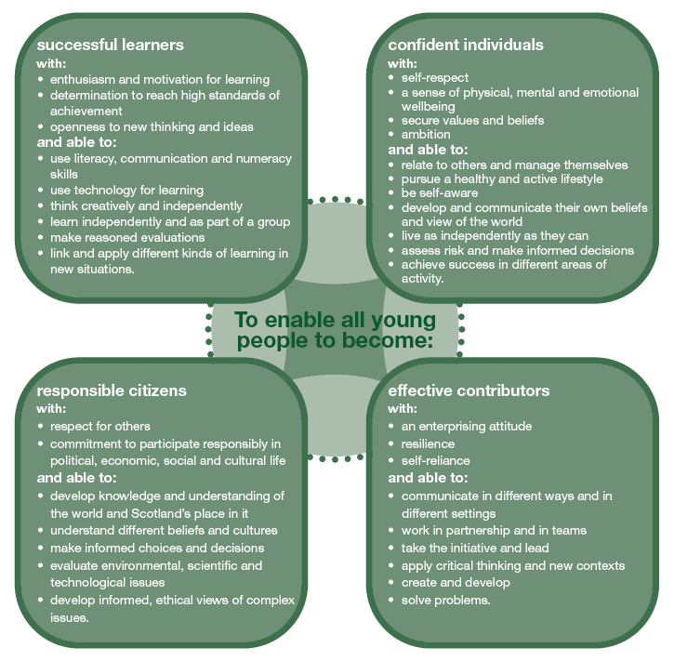

Further Information about Curriculum for Excellence and the Experiences and Outcomes can be found on the Curriculum for Excellence website.

www.educationscotland.gov.uk/thecurriculum/whatiscurriculumforexcellence.

THE CURRICULUM

S1 – S3 Broad General Education – BGE

S1 and S2 CURRICULUM

In S1-S2 pupils will continue the Broad General Education commenced at Primary School, giving them the opportunity to continue and progress prior learning, as well as developing skills and knowledge in new subject areas.

The subjects offered are:
English, Literacy, Maths, Modern Languages, Social Subjects, Science, Hospitality, Art & Design, Physical Education, Music, Technical, Digital Literacy, Drama, Personal and Social Education and Wider Achievement.

In addition, after application and a selection process, some pupils have the opportunity to participate in the School of Rugby which is run in partnership with the Scottish Rugby Union and Ardrossan Rugby Club.

S3 CURRICULUM

S3 is the final year of the Broad General Education with students continuing to study across all 8 curricular areas:
- Language and Literacy
- Mathematics and Numeracy
- Social Studies
- Sciences
- Religious and Moral Education
- Health and Wellbeing
- Expressive Arts
- Technologies

Towards the end of S3, students will make an informed option choice, in full consultation with teachers and parents, to take 6 subjects through to presentation in S4.

Assessing Children’s Progress in the Broad General Education (BGE) Early Years – end of S3
Assessment is a central part of everyday learning and teaching for children and young people. Evidence of progress is gathered on an ongoing and informal basis through asking questions, observing children working together and making formative comments on their work. Children may also assess their own work or that of their class mates; this is called self and peer assessment. Some assessment is more formal such as projects, investigations and standardised assessments.

The assessment of children’s progress throughout the BGE (Early – S3) is based on teachers’ views: their professional judgement. Teachers draw on their professional knowledge and understanding of the child; on the benchmarks for literacy and numeracy, which provide clear information about what children and young people should be able to do and demonstrate by the end of a Curriculum for Excellence Level; and on a wide range of assessment information.

Teachers of P1, P4, P7 and S3 are asked at the end of every school year whether children have achieved the relevant Curriculum for Excellence level for their stage in reading, writing, talking and listening (literacy), and their ability to understand and work with numbers (numeracy). Most children are expected to have achieved the early level by the end of P1, first level by the end of P4, second level by the end of P7 and third or fourth level by the end of S3.

The government has also introduced new national standardised assessments which cover some aspects of reading, writing and working with numbers. These assessments are completed online and are automatically marked by the online system giving teachers immediate feedback to help plan next steps and support children’s progress.

Teachers remain best placed to know how the children in their class are progressing. Their professional judgement will continue to be the most important way of assessing your child’s progress at school.

As a parent, you continue to have a key role in helping your child to learn. Your child’s teacher will keep you informed about how your child is progressing. Please contact us if you have any concerns about their learning, assessment or for more information on how you can support your child’s learning at home.

S4 – S6 Senior Phase

S4 marks the beginning of the Senior Phase (S4-S6) for our students and like the Broad General Education our provision over these year groups will evolve as the updated National Qualifications are revised and improvised. Since May 2014, new qualifications (known as ‘Nationals’) have been introduced. The table below offers a comparison between the Nationals and the previous qualifications Standard Grade and Intermediate I and II.

National Qualifications

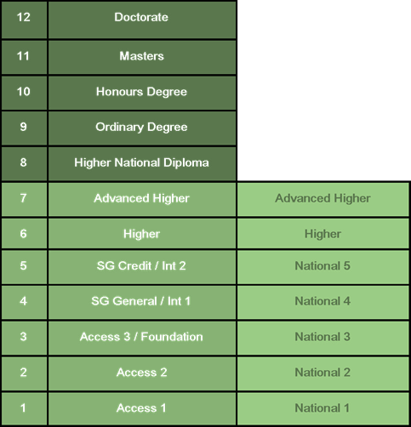
A wide range of courses are offered from across the curriculum from National 3 to Advanced Higher.

Courses at national 3 are not graded and assessed as pass/fail. Courses from National 5 to Advanced Higher are graded A-D or ‘No Award’.

The appropriate level of presentation in National courses will be determined on the basis of ongoing assessment throughout the S1-3 Broad General Education and performance during Fourth Year. Parents will be involved in this decision.

At Auchenharvie Academy we revise both our BGE and Senior Phase curriculum regularly to best meet the needs of our leavers and to maximise their chances of employment through effective labour market intelligence.

More details on National Qualifications can be found on the SQA website at: www.sqa.org.uk

The Senior Phase continues for our students through S5 and S6. Pupils who return to the Fifth Year will have the opportunity to be prepared for a range of National Qualification courses. In S5 National 4 and 5 courses will still be available in addition to Higher courses.

Progression in the Senior Phase

Pupils Attaining National Qualifications National Qualifications

National 3 National 4

National 4 National 5

National 5 Higher

Higher Advanced Higher

Homework
Parents have a very important role in helping their children to get the best out of school and it is important that they take an active interest in their child's progress at school. This can be done by:

- Encouraging hard work and high standards at all times
- Stressing the importance and relevance of what is learned at school
- Supporting the school's policy on homework and discipline

From time to time pupils are given assignments and Personal projects which may involve research, investigation, preparing a speech, learning a poem or a similar activity.

We really appreciate the involvement of parents and are very grateful to those parents who so faithfully sign reading markers and jotters to confirm that they have overseen each piece of work.

Enhanced Curriculum

Sixth Year pupils are expected to follow an enhanced curriculum enabling them to develop a greater responsibility and to play an active part in wider school life. This involves activities such as helping younger pupils in classes, organising events for younger pupils and assisting at school functions. This, we believe, will help further develop the leadership capabilities within our young people.

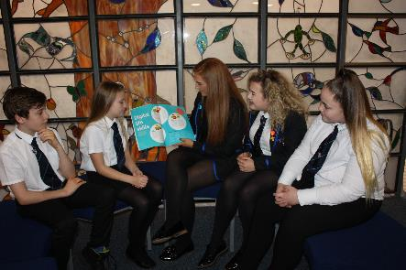

EXTRA-CURRICULAR ACTIVITIES

SPORT

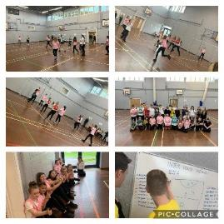
You may be aware of increasing press and media coverage regarding the health and general fitness of people in our country and in particular with our young people. Studies and research show us that young people are not participating in enough physical activity but it has been conceded that they do not always have access and opportunity to be involved in organised sporting activities.

At Auchenharvie Academy, we are taking a leading role within the community in reversing this trend by offering all our pupils access and opportunity to organised sport both during and after the school day.

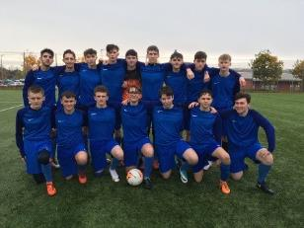
The PE department ensure that a wide variety of extra-curricular sports and activities are offered to all our pupils and your child will be encouraged to get involved when they come to the school. The activities currently on offer include football, basketball, rugby, badminton, fitness, gymnastics, trampoline, dodgeball, and zumba.

The school have a number of teams for pupils to be part of giving them the opportunity to compete in local and national leagues and competitions, with a good level of success in previous years. At present we have teams in football, netball, rugby and dance.
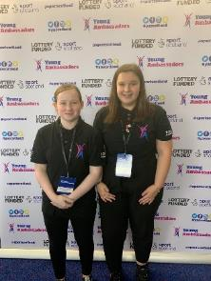
In S1, the pupils will experience a range of activities as part of their core provision of PE. These include many of the activities listed above as well as others such as volleyball, social dance and athletics.

MUSIC

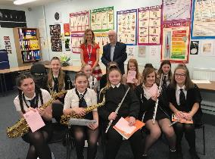
Our Music department offers a wide range of musical opportunities for all pupils of all ability levels. This ranges from learning to play new instruments in the classroom to representing the school and the authority both in the community and even abroad. The department actively encourages all pupils to become involved in one or more areas which may be of interest to them. The department, which is led by Mrs Hands, has 3 further teaching staff and 9 different instrumental instructors.

In addition to the department’s core business of teaching our pupils during the day, there is a strong emphasis on extra-curricular activity. A whole range of activities currently offered are shown below:

S1 & S2 Girls Singing Club S3- S6 Girls’ Singing Club

Boys & Senior Girls Singing Club Saxophone Group

Flute Group Concerts and Shows

Senior Band
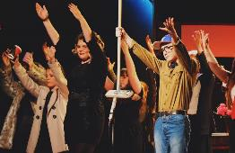
The department work with pupils throughout the year, with the opportunity given to perform at the Winter and Spring Concerts along with the Next Generation Concert in June. In addition to this, many of our pupils and groups represent the school within the local and wider community.

A number of our pupils, through continued practice, are able to become skilled musicians and go on to represent the school in competitions with a number of recent successes. Competitions entered include: the North Ayrshire Young Singer, Musician and Traditional Young Musician of the year and the Rock and Pop Musician of the Year.

Pupils have had the chance to also perform abroad in Belgium, France and Holland where successful concerts were performed. This is an excellent way of allowing our pupils to broaden their horizons and promote themselves and the school to a wider audience. Trips to London are also on offer when pupils have the chance to take part in dance and vocal workshops given at Pineapple Studios and experience West End Shows.

In June 2019 we travelled further afield when an Expressive Arts Trip was organised to New York! Forty three pupils and 4 members of staff flew over the Atlantic and experienced 2 Broadway Shows, a visit to the Metropolitan Art Gallery and of course managed to squeeze in some sightseeing and shopping!

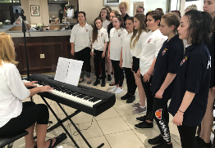
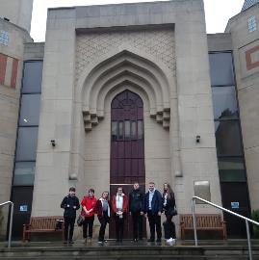
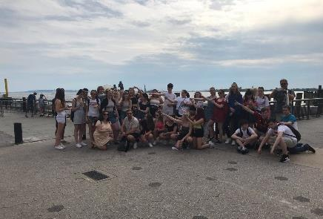

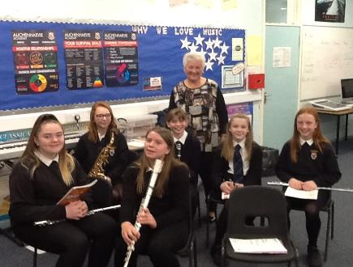
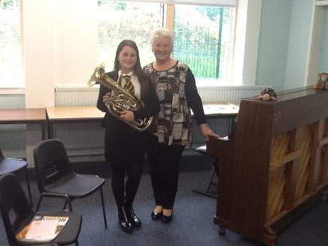
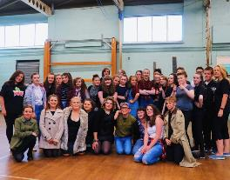

EXTRA CURRICULAR ACTIVITIES

Foreign holidays and residential trips broaden the minds of our pupils and develop some of the skills learned in the school. In recent years, examples of this include the Music department trip to France and Holland, the Modern Languages trips to the WW1 Battlefields in Belgium and to Paris, visits to Krakow, including spending time at Auschwitz and Schindler’s Museum with the Social Subjects faculty;

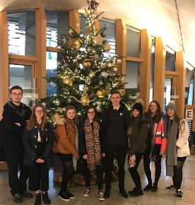
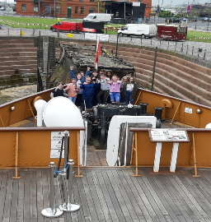
Social Subject pupils had a trip to the Titanic Experience in Belfast, as well as the Modern Studies trip for seniors to the Scottish Parliament. Senior pupils were taken to Edinburgh as part of the faculty reward scheme. Whilst there; depending on the subjects studied, they visited: Edinburgh Castle; The Scottish Parliament; Edinburgh Mosque as well as having a tour of the city.

Other outings during term time include:- Geography & Science Field Trips, History trips to historical sites, Theatre Outings, Art Gallery Visits, University College Open Days and the incentive scheme trip to Blackpool Pleasure Beach.

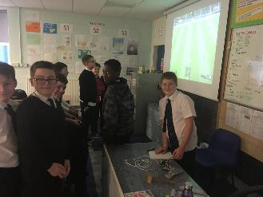

OTHER CLUBS AND ACTIVITIES

Many departments offer activities and homework clubs for pupils at lunchtime throughout the week. In addition to this, pupils are rewarded for good behaviour, attendance and effort throughout the year. This includes incentive afternoons, trips and entry to school parties.

The school also involves itself fully in fund-raising activities which support the school itself as well as local, national and international charities.

NEW INITIATIVES

Family Learning

The Auchenharvie Family Learning team have been working together since May 2017. The team include Mrs Allison Hopton (Principal Teacher), Mrs Angie Gall & Miss Holly Tait (Area Inclusion Worker) and Mrs Lauren Young (Family Learning Worker).

Parents in Partnership Programme

We are now on year 4 of this programme and the group have achieved a wide range of qualifications and various experiences. Most importantly, our parents/carers are really incorporated into the school community and play an active role in the life of the school. The group have achieved national 5s in literacy, numeracy, volunteering, wellbeing accreditation and barista customer service awards. The focus last year was on paired reading, Modern Studies and PC Passport.

NA Plus

We are delighted to have launched our New and preloved uniform store in Auchenharvie which will be run by parent/carers. The idea behind this is to allow pupils to access uniform all year round with no obligation to pay, swap or donate. The room also has a wide range of toiletries and sanitary products.

Nurture

‘A nurturing school sees emotional well-being as central to the development needs of its pupils.’

The Nurture Team - Mrs McColl, Nurture Teacher and Mrs Small, Nurture Assistant.

‘The View’

The name is linked with posititve horizon, building resilience and working throught issues so that children can be the best they can be.

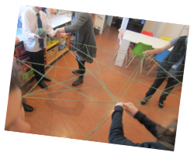
The nurture approach is a feature across the whole school but with a focus on 1st and 2nd year pupils. Access to this support will require a referral by DHT, Pastoral Care or Class Teachers and then if agreed a Boxall Profile will be completed. The Nurture input will be 5 periods a week for S1 and 4 periods a week for S2. Indivudual input varies on a weekly basis and this allows the Nurture team to focus on areas through group and individual work.

SECTION 6: SCHOOL IMPROVEMENT

S&Q Report/Improvement Plan

Schools in North Ayrshire follow a Quality Improvement process designed to highlight strengths and identify areas for improvement. The process is based on the school’s self-evaluation process with Heads of Service and Senior Managers involved in at least three formal validation visits each session.

This validation process involves talking to pupils, staff and parents about learning and improvements made by the school. This results in actions for improvement for the school to take forward in their planning process.
In addition, themed reviews are undertaken from time to time e.g. to look and report on the quality of the Broad General Education (3-18) and Senior phase Education within secondary schools. This process is based upon standards and expectations contained within the following National Standards documentation:

- National Improvement Framework
- How Good is Our School? 4
- How Good is Our Early Learning and Childcare?

A Standards and Quality Report and School Improvement Plan are produced on an annual basis by every school and centre. Staff, Parents/ Carers, Young People and School Partners will play an active role in the development of these key school documents.

Copies of the School Improvement Plan and Standards and Quality Report can be found on the school website.

SECTION 7: SUPPORT FOR YOUR CHILD

Equalities
In line with North Ayrshire Council policy, educational provision is open to all pupils, regardless of sex, age, religion, race, disability or any other potential barrier and all reasonable measures will be taken to ensure that the curriculum is available to every child. Schools also have a duty to promote equality and to eliminate racist and other discriminatory behaviours.

Equality Act 2010
The Equality Act 2010 has been drawn up to tackle inequality and prevent discrimination against people on the basis of ‘protected characteristics’. It brings together several existing laws and aims to make understanding the law simpler and also introduces a new single public sector equality duty, which requires public bodies to actively advance equality

The duties set out in Chapter 1 of Part 6 of the Equality Act apply to all schools. These provisions protect pupils at the school and in the case of admissions, those applying or wishing to apply for admission. Former pupils are also protected from discrimination or harassment.

Guidance on the Act and its requirements for schools in relation to the provision of education can be accessed here:

http://www.gov.scot/Publications/2012/02/7679/3

Child Protection
The Education and Youth Employment Directorate has a fundamental duty to contribute to the care and safety of all children and young people in North Ayrshire. In fulfilling this duty, the service must engage in close partnership with parents/carers and relevant agencies, primarily the Health and Social Care Partnership and where appropriate the Scottish Children’s Reporter’s Administration. The Service will work in partnership with a number of levels within the establishment or school within the cluster or local area and through Integrated Children’s Services and Community Health Partnership.

The Standard Circular entitled, “Protecting and Safeguarding North Ayrshire Children” provides guidance for policy and practice within all educational establishments. The Council is one of the key partners in the North Ayrshire Child Protection Committee, a multi-agency group which takes the lead role in ensuring that our children and young people are cared for, protected from harm and grow up in a safe environment.

Each school has a named Child Protection Co-ordinator who is the main point of contact for school staff and for external agencies seeking contact with the school on child protection matters. There is an extensive staff-training programme available to staff and, in addition, at the beginning of each school session all staff receive an update on child protection policies, safeguarding and procedures.

Inclusion
North Ayrshire Council is committed to the well-being and educational development of all learners. The process of inclusion requires all involved in the business of learning and teaching to demonstrate commitment, innovation and flexibility in order to ensure that all children and young people have access to quality learning opportunities and experiences. Our Inclusion Strategy states that:

- An inclusive approach to education supports an ethos of achievement and high expectation, recognises difference, respects these differences and sees differences between learners as opportunities for learning.
- An inclusive approach to education promotes tolerance and a positive understanding of diversity.
- An inclusive approach to education alleviates the barriers to learning, supports the achievement of all and has positive relationships at its heart.
Only in exceptional circumstances would it be deemed lawful to proceed to consider alternative educational planning for a child or young person.

The Education (Disability Strategies and Pupils’ Educational Records) (Scotland) Act, October 2002, requires local education authorities to prepare and implement accessibility strategies to improve, over time, access to education for young people with disabilities. Access covers:

- The physical building and grounds
- The curriculum (both formal and informal)
- Information on any educational planning that might affect the child’s/young person’s education
The Education (Additional Support for Learning) (Scotland) (2009) Act sets out certain duties on local education authorities and confers certain rights on children and their parents. These duties include the need to:

- Identify, assess and address the need for additional support for any child or young person failing to benefit from school education, for whatever reason
- Seek and take account of the views of the child or young person on issues relating to their education
- Engage in helpful partnership working with parents/carers and staff from other agencies
These are the various pieces of legislation that support the right to inclusion and that define the main features of that right.

Additional Support for Learning
Any child who needs more or different support to what is normally provided in schools or pre-schools is said to have ‘additional support needs’. This includes children who may need extra help with their education as a result of issues arising from social and emotional difficulties, bullying, physical disability, having English as an additional language, a sensory impairment or communication difficulty.

The Additional Support for Learning Act
The Education (Additional Support for Learning) (Scotland) Act 2004 came into force in November 2005. In June 2009, the Act was amended. These amendments form the Education (Additional Support for Learning) (Scotland) Act 2009 and came into force on November 2010.

Main provisions of the Act
- The Act provides the legal framework underpinning the system for supporting children and young people in their school education, and their families.

- This framework is based on the idea of additional support needs. This broad and inclusive term applies to children or young people who, for whatever reason, require additional support, long or short term, in order to help them make the most of their school education and to be included fully in their learning.
- The 2009 Act automatically deems that all looked after children and young people have additional support needs unless the education authority determine that they do not require additional support in order to benefit from school education.

- In addition, education authorities must consider whether each looked after child or your person for whose school education they are responsible requires a co-ordinated support plan.

Duties under the ‘Additional Support for Learning’ legislation
North Ayrshire must assess any pupil with additional support needs and provide with any support necessary for them to benefit fully from their education. All the evidence says that it is best to intervene early to prevent any difficulties developing and taking root. For example by making sure reading is very well taught and that all pupils get encouragement and support at home we can hopefully reduce later difficulties.

Whatever the type of challenge that arises, it is important to detect it early, develop a shared understanding of what is needed (the school may request extra specialised help to do this) and take action to help the pupil achieve. Whenever we start this process for any child or young person, we will always explain to them and to their parents/carers what our concerns are and what we will do to help.

The school can get support from a range of visiting professionals including Educational Psychologists. These professionals are regularly in all schools and teachers and others will ask for informal advice on supporting pupils for example on the best ways to support a pupil who is having difficulties with reading. If the school wants more detailed individual help then they would talk to you about formally involving the Education Psychologist. The Educational Psychologist can only be involved in consultation, collaborative assessment and planning interventions for your child after you agree to this.

For a few children and young people their needs are so complex that professionals from two or more agencies need to work together over a significant length of time to enable the child to benefit from school education.

The authority approach to staged intervention has been updated to ensure it is in line with the CYP (2014) and ASL (2004) (amended 2009) Acts. The aim is to ensure children and young people get the right support at the right time.

Where a child or young person has additional support needs, extra planning is required every time there is a move to a new class, new school or college. How far ahead this transition planning needs to start depends on the particular type of needs but for most children and young people with Additional Support Needs transition planning should start at least one year before the date of the planned move.

Detailed advice on transition planning is provided in the Supporting Children’s Learning Code of Practice, which can be accessed at the following link:

http://www.gov.scot/resource/doc/348208/0116022.pdf

Dispute Resolution Procedures
If you feel that things are not being done properly to support your child then the Council has a range of ways to work with you to resolve any issues. You can ask at any time for a copy of the booklet called ‘Resolving Disagreements’. This booklet will give you ways to make sure your concerns are listened to and addressed.

Further Support
The following organisations are able to provide advice, further information and support to parents of children and young people with ASN.

- Enquire: Scottish Advice and Information Service for Additional Support for Learning
Website: http://enquire.org.uk/
Helpline: 0345 123 2303
Email: info@enquire.org.uk

- Scottish Independent Advocacy Alliance
Website: http://www.siaa.org.uk/
Telephone: 0131 260 5380
Email: enquiry@siaa.org.uk

- Scottish Child Law Centre
Website: http://www.sclc.org.uk/
Telephone: 0131 667 6333
Email: enquiries@sclc.org.uk

Getting It Right for Every Child – Ensuring their Wellbeing
The Children and Young People (Scotland) Act 2014 puts children and young people at the heart of planning and services and ensures their rights are respected across the public sector. It seeks to improve the way services work to support children, young people and families.

- The act ensures that all children and young people from birth to 18 years old have access to a Named Person.

- The act puts in place a single planning process to support those children who require it.

- The act places a definition of wellbeing in legislation.

- The act places duties on public bodies to coordinate the planning, design and delivery of services for children and young people with a focus on improving wellbeing outcomes, and report collectively on how they are improving those outcomes.

Taking a ‘Getting it Right for Every Child’ approach to supporting every child is a priority within our school and we aim to assist every child in our school to reach their potential. The wellbeing of children and young people is at the heart of Getting it right for every child. The approach uses eight areas to describe wellbeing in which children and young people need to progress in order to do well now and in the future.

The eight indicators of wellbeing (SHANARRI)

Safe | Healthy | Achieving | Nurtured
Active | Respected | Responsible | Included

Why we have to get it right for every child
Education and Youth Employment must safeguard, support and promote the wellbeing of all children and young people and address need at the earliest opportunity. These functions are the responsibility of schools and establishments and those who work in them and with them. All who work in Education and Youth Employment and in partnership with Education and Youth Employment have a responsibility to ensure the wellbeing of North Ayrshire’s children and young people.

For more information on Getting it Right for every Child in North Ayrshire go to www.girfecna.co.uk

Psychological Services
The Educational Psychology Service in North Ayrshire is part of and contributes to the aims of Education and Youth Employment by improving outcomes for children and young people. Educational Psychologists work together with teachers, parents, and other professionals to help children and young people achieve their full potential, within
educational settings and the wider community. Educational Psychologists are involved in working with individuals, but also have a significant role in offering training, support and consultation to education establishments on a wide range of issues.

Your child’s school/Early Years Centre already has a system of staged intervention for identifying, assessing, monitoring and reviewing the ongoing progress of all children and young people. As part of this wider system of support, each school and authority early years centre has a link Educational Psychologist.
When concerns arise about a particular pupil, the school takes action to address these concerns. If the concerns continue, the school/ early years may have an informal discussion with the Educational Psychologist and ask about general advice.

If needed, a consultation meeting involving the Educational Psychologist can then be arranged. This will be discussed with you beforehand. This may be a one off, or may lead to longer term involvement. Through this process the Educational Psychologist can, if required, contribute to the ongoing assessment and support for your child. The Educational Psychologist will be involved while there is a specific role for them within the collaborative assessment process.

Find out more:
http://www.northayr-edpsychs.co.uk/

Data Protection
Personal data is required to be collected by North Ayrshire Council in order to deliver education services. It is necessary to collect personal data regarding pupils, parents, carers and other individuals to enable us to carry out our duties under the Education (Scotland) Act 1980 and the Education (Scotland) Act 2016.

The Data Protection Act 2018 sets out the legal basis for processing data. You can refer to our privacy notice for details of the different basis under which we may process individuals’ data.

https://www.north-ayrshire.gov.uk/Documents/EducationalServices/eye-privacy-policy.pdf

We may also share or receive an individual’s personal data with the following:

- Scottish Government & Education Scotland
- Private Nurseries’
- Strathclyde Passenger Transport
- Scottish Children’s Reporter Administration
- Social Work Services
- Scottish Public Services Ombudsman

Where we are required we will also made disclosures required by law and may also share information with other bodies responsible for detecting/preventing fraud or auditing/administering public funds.
Individuals’ have legal rights under the data protection legislations including the right of access. Further details can be found in the Council’s Privacy Policy at:

https://www.north-ayrshire.gov.uk/privacy-policy.aspx

Medical and Health Care
Medical examinations are carried out at various times during a child’s primary school years. Parents are given notice of these and encouraged to attend. Vision and hearing tests and dental examinations, which parents need not attend, are also carried out and parents informed of any recommended action or treatment. All examinations are carried out by Ayrshire and Arran Health Board staff.

If a pupil takes ill or has an accident at school, which requires that the child be sent home or for treatment, First Aid will be provided and parents or carers contacted immediately. In the event of a serious illness or accident, a member of staff will accompany the child to a doctor or hospital and parents/carers will be notified immediately.

For this reason it is important that the school has contact details for parents/carers and an additional contact person in case parents/carers cannot be reached. It is also important that the school is kept fully informed and updated with regards to any medical condition.

It is the parent’s responsibility to notify the school and keep medical information
updated as required.

Children will not be sent home unaccompanied.

ACTION AGAINST BULLYING

Like all schools, Auchenharvie Academy is fully committed to addressing the problem of bullying. We believe that bullying is not a serious difficulty in the school due to our whole school approach to the issue.

All staff have a major role to play in promoting a school which is 'bully-proof’. The topic is addressed at assemblies, in skills development classes and in other areas of the curriculum. We have tried to develop a caring culture within the school where pupils are encouraged to report all instances of bullying, regardless of the form it may take. In addition, our senior pupils work with and support any youngsters who feel threatened.

We deal sensitively with all reported incidents and offer maximum support to any victim. While it is necessary to punish the 'bully', we recognise these young people also require support, often in the form of counselling.

There may be times when your child feels bullied. It is most important that parents/carers who are concerned about possible bullying should contact the school at the earliest opportunity to discuss the problem. The discussion will focus on the action which will be taken and how your child can be supported. Bullying is a problem which cannot be stopped by pupils, parents/carers or teachers acting alone, and parents/carers should, therefore, not hesitate to seek the advice and support of the school, if the need arises.

SECTION 8: PARENTAL INVOLVEMENT

Parental Engagement and Involvement

North Ayrshire Council Positive Family Partnership Strategy

NAC Parental Involvement Strategy

All schools have clear systems in place for communicating with everyone in the parent forum. Communications with parents are clear, jargon-free, specific and easily accessible. A variety of methods and approaches are used by schools to communicate with the parent forum including face to face, traditional communication methods and digital media e.g. Twitter, Facebook. Considerations will always be given when communicating with parents who have literacy, language and communication challenges.
Schools ensure that parents know who to contact when they wish to discuss their child’s learning or wellbeing and will seek to provide a private space for such discussions and make sure parents are given adequate time and support. Consideration will be given to family circumstances.

Parents are welcome to contact the school at any time to arrange an appointment to discuss any matter with the class teacher, Depute Head, Heat Teacher or Head of Centre. New families are welcome to contact the school and request a suitable visiting time at any point throughout the session.

Parents are given opportunities to understand the way learning and teaching takes place in the classroom. This may be in the form of class visits to take part in the learning experience alongside their child or attending events which share the learning. Frequent invitations are issued to parents to participate in school activities such as open days, class assemblies, workshops and to assist with outings and visits, sports and concerts. There will be a series of early meetings for the parents of Primary 1 pupils and parents are kept informed of events with a range of newsletters, website updates, texts, invitations and social media sites.

A variety of methods will be used to ensure information about your child’s progress is shared. Schools are encouraged to provide parents/carers with information on their children’s progress at regular intervals throughout the year through a range of activities. There is an expectation that part of this will be in a written format.

Reporting Examples:
Individual Learners | Groups of learners
Written reports/ tracking reports | Assemblies
Learning conversations with pupil/ teacher/ parent/ carer | Open day events
Pupil reflections on their learning in logs | School concerts/shows
Parent/ carer consultation/ Parents’ Meetings involving parent/ teacher/ pupil, as appropriate | Social media
Home/ school diaries | Curriculum workshops led by children and young people and staff
Profiling activities | Parent Council meetings
Learning walls and displays | School / class newsletters

Home School Links
Parents are invited, informally or by letter, at least twice a year to visit the school in order to view their children's work and discuss progress with the teacher and members of the Senior Leadership Team.

Parents are welcome to contact the school at any time to arrange an appointment to discuss any matter with the Pastoral Teacher, Depute Head or Head Teacher. New families are welcome to contact the school and request a suitable visiting time at any point throughout the session.

Parent Forum and Parent Council
The Scottish Schools (Parental Involvement) Act 2006 aims to encourage and support more parents to become involved in their child’s education.

The main aims of the act are to:

- Help parents become more involved with their child’s education and learning
- Welcome parents as active participants in the life of the school
- Provide easier ways for parents to express their views and wishes

To help achieve these aims, all parents are automatically members of the Parent Forum at their child’s school and are entitled to have a say in selecting the Parent Council (the representative body) to work on behalf of all parents at the school.

The objectives of the Parent Council are:

- To work in partnership with staff to create a welcoming school which is inclusive for all parents
- To promote partnership between the school, its pupils and all its parents
- To develop and engage in activities which support the education and welfare of the pupils
- To identify and represent the views of parents on the education provided by the school and other matters affecting the education and welfare of pupils
- To be involved in the recruitment process for appointing the Head Teacher and Depute Head Teachers of the school

Auchenharvie Academy has a Parent Council:

Chairperson: Mrs June Murphy

Secretary: Mrs Dolores Laird

Treasurer/Vice Chair: Ms Fiona Gibson

Members: Mr William Simson
Mrs Carrie Davidson Miss Elizabeth Winters

Contact details: Mrs June Murphy (juneandjohnmurphy@yahoo.co.uk)

Any parent or carer of a child at the school can volunteer to be a member of the Parent Council. The Head Teacher is the professional adviser to the Parent Council and has a right to attend and speak at Parent Council or Parent Forum meetings.

Please Note: The Scottish Schools (Parental Involvement) Act 2006 is currently being reviewed.

School Committees
- Eco –committee
- Rights Respecting School committee
- LGBTQ+ group
- Charities
- Pupil Council
- Digital Leaders
- House Ambassadors
- Pupil Parliament
- Sports Leader

Parentzone Scotland is a unique website for parents and carers in Scotland, from early years to beyond school. The website provides up-to-date information about learning in Scotland, and practical advice and ideas to support children’s learning at home in literacy, numeracy, health and wellbeing and science.

Information is also available on Parentzone Scotland regarding additional support needs, how parents can get involved in their child’s school and education. Furthermore, the website has details about schools including performance data for school leavers from S4-S6; and links to the national, and local authority and school level data on the achievement of Curriculum for Excellence levels.

Parentzone Scotland can be accessed at https://education.gov.scot/parentzone.

SECTION 9: PUPIL DATA COLLECTION AND PROTECTION POLICIES

The Scottish Government and its partners collect and use information about pupils through the Pupil Census to help to improve education across Scotland. This note explains why we need this information, how we use it and what we do to protect the information supplied to us.

Why do we need your data?
In order to make the best decisions about how to improve our education service, Scottish Government, education authorities and other partners such as the SQA and Skills Development Scotland need accurate, up-to-date data about our pupils. We are keen to help all our pupils do well in all aspects of school life and achieve better examination results.

Accurate and up-to-date data allows us to:

- plan and deliver better policies for the benefit of all pupils
- plan and deliver better policies for the benefit of specific groups of pupils
- better understand some of the factors which influence pupil attainment and achievement
- plan and implement targeted approaches to reducing the poverty-related attainment gap
- share good practice
- conduct teacher workforce planning
- target resources better
- enhance the quality of research to improve the lives of young people in Scotland
- provide a window on society, the economy and on the work and performance of government by
- publishing statistical publications and additional tables about School Education
- providing school level information

Data policy
Information about pupils’ education is collected through our statistical surveys in partnership between the Scottish Government and Local Authorities through the ScotXed Programme which aims to help schools and Local Authorities by supporting efficient collection, processing and dissemination of statistical information. The Scottish Government then provides analysis of the data to support research, planning, management and monitoring of education services as well as to produce National Statistics publications.

Education data within Scottish Government is managed effectively by secure systems on secure servers and is exploited as a valuable corporate resource, subject to confidentiality restraints. As part of its data policy, Scottish Government will not publish or make publicly available any information that allows individual pupils to be identified, nor will data be used by Scottish Government to take any actions in respect of individuals. Data is held securely and no information on individual pupils can or would be made publicly available by Scottish Government.
The individual data collected by Scottish Government through the Pupil Census is used for statistical and research purposes only.

Your data protection rights
Any sharing or linkage of data will be done under the strict control of Scottish Government, and will be consistent with their data policy and the National Data Linkage Guiding Principles. Decisions on the sharing or linkage of data will be taken in consultation with relevant colleagues and individuals within and outwith Scottish Government as part of a Data Access Panel. At all times the rights of the individual (children or adults) under the GDPR and other relevant legislation will be ensured. Further information can be found on:

https://www2.gov.scot/topics/statistics/scotxed/schooleducation/ESPrivacyNotices

Concerns
If you have any concerns about the ScotXed data collections you can email the Data Protection & Information Assets Team on dpa@gov.scot or the Head of Education Analytical Services, Mick Wilson, at mick.wilson@gov.scot or by writing to Education Analytical Services, Area 2A-North, Victoria Quay, Leith, EH6 6QQ. Alternative versions of this page are available, on request from the ScotXed Support Office, in other languages, audio tape, Braille and large print.

Alternatively complaints may be raised with the Information Commissioners Office at casework@ico.org.uk

APPENDIX 1: IMPORTANT CONTACTS

Head of Service
Caroline Amos
North Ayrshire Council
Cunninghame House
IRVINE
KA12 8EE
01294 324416

Head of Service
Andrew McClelland
North Ayrshire Council
Cunninghame House
IRVINE
KA12 8EE
01294 324413

