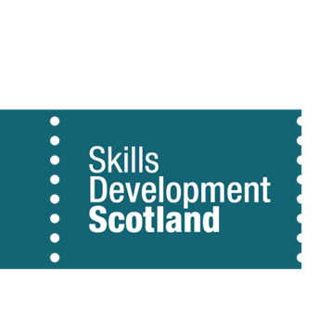
Auchenharvie Academy

School Support

Lesley Niven (Careers Adviser) – In school Tuesday, Wednesday, Thursday & Friday. 9.00am-3.00pm
Contact lesley.niven@sds.co.uk or 07917200965

Christine Strain (Work Coach) – In school Monday.
Contact christine.strain@sds.co.uk or 07766087074

Appointments can be organised via your pastoral teacher or by contacting Lesley or Christine directly.

Post School Support
SDS North Ayrshire, Ardrossan Hub - 82-84 Glasgow Street, Ardrossan, KA22 8EH. Tel 01294 475671.
Our centre may be closed but our service is OPEN! Due to Covid restrictions, currently, our centre remains closed, but our post school team are still here to help! If you have left school and require an appointment to explore your options, please contact Christine Strain in the first instance (details below).
Christine Strain (Work Coach) contact christine.strain@sds.co.uk or 07766087074
Shona Brown (Personal Adviser) contact shona.brown@sds.co.uk or 07900222713

Stevenston Hub 1 Main Street, Stevenston KA20 3AB 01294 464 834.
2pm-4pm Thursdays or by appointment. (currently closed)

www.myworldofwork.co.uk - The web service for all your work, skills and learning needs.

