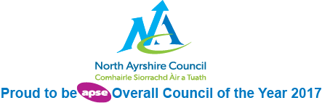

**Education and Youth Employment**

**Auchenharvie Academy**

**Improvement / Recovery Plan 2020-21**



School logo?

**Vision, Values and Aims**

 ***Auchenharvie Academy*** 

***Our Vision/Aim is…***

***To provide an equitable and excellent learning environment for ALL pupils which maximises their full potential and supports them into appropriate, positive and sustainable destinations.***

***Our Values***

***Respect Equality Determination***

**Council Priorities:**

The Council strategic priorities for 2019-24 are detailed below:

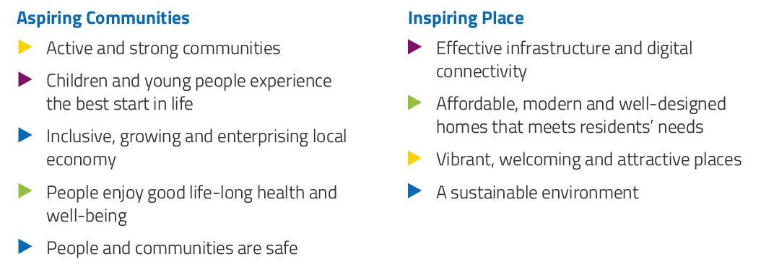

**National Improvement Framework:**

The National Improvement Framework for Education is designed to help us deliver the twin aims of excellence and equity; galvanising efforts and aligning our collective improvement activities across all partners in the education system to address our key priorities. These priorities remain as:

* Improvement in attainment, particularly in literacy and numeracy
* Closing the attainment gap between the most and least disadvantaged children
* Improvement in children and young people’s health and wellbeing
* Improvement in employability skills and sustained, positive school-leaver destinations for all young people

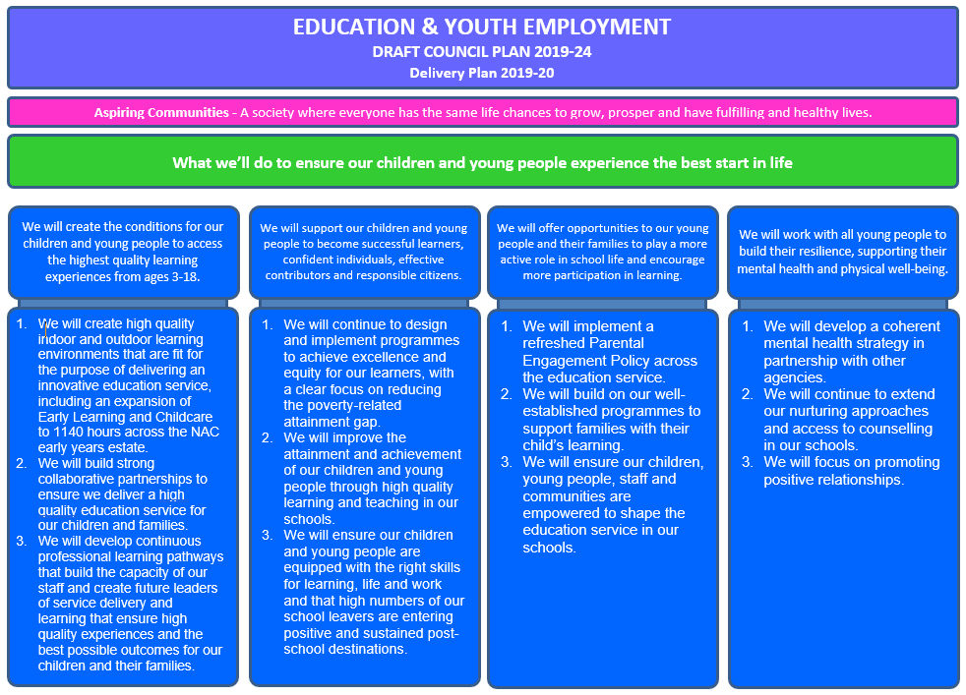

**Strategic Plan 2020-21: Auchenharvie Academy**

|  |  |  |  |  |  |
| --- | --- | --- | --- | --- | --- |
| **School Priorities** | **Create the conditions for our children and young people to access the highest quality learning experiences from ages 3-18** | **Supporting our children and young people to become successful learners, confident individuals, effective contributors and responsible citizens.** | **Offering opportunities to our young people, their families and staff to play a more active role in school life and encourage more participation in learning.** | **Work with all young people to build their resilience, supporting their mental health and physical well-being.** | **To maximise attainment in the BGE and Senior Phase for all pupils.** |
| **High Level Objectives** | ***To review our ASN provision to ensure equitable and efficient allocation of resource with maximum impact.***  ***To adopt a whole school Nurturing approach in all areas of the school.***  ***Transitions to include key faculties working more directly with the children*** | ***Improve the quality and consistency of Learning and Teaching for our pupils.***  ***Develop opportunities for young people to be better informed and prepared for the World of Work.*** | ***To support and improve the holistic wellbeing of staff so they can better support the wellbeing of pupils.***  ***To support targeted families with all aspects of school life following the impact of COVID-19.***  ***To strengthen the impact of the pupil voice across all areas of Auchenharvie Academy.*** | ***To strengthen and embed targeted approaches to well-being across the school.***  ***Embed a focus on equality and human rights in line with our school values.*** | ***To renew existing moderation practices within the BGE and the Senior Phase***  ***Recovery, renewal and implementation of Senior Phase and BGE attainment Strategies*** |

**Strategic Plan 2020-21: AUCHENHARVIE ACADEMY**

Here is an overview of how we intend to use our Pupil Equity Funding to support improvement during 2020-21:

**Detailed Action Plan 2020-21: AUCHENHARVIE ACADEMY**

|  |  |  |  |  |  |  |  |
| --- | --- | --- | --- | --- | --- | --- | --- |
| **School Strategic Priority:** | | **Create the conditions for our children and young people to access the highest quality learning experiences from ages 3-18** | | | | | **Linked to Directorate Priority: 1** |
| **High Level Objectives** | | * **To review our ASN provision to ensure equitable and efficient allocation of resource with maximum impact.** * **To adopt a whole school Nurturing approach in all areas of the school** * **Transitions to include key faculties working more directly with the children** | | | | |  |
| **Tasks** | **HGIOS 4**  **HGIOELC**  **NIF** | **Supported through PEF?**  **Y/N** | **How will I achieve this?** | **Timescale / Assigned to:** | **Pupil Outcomes** | **Measurement** | |
| To establish a system of ASN support within the school which impacts positively on the learning experiences of all of our children.  Strengthen the Transition programme with a focus on curricular input and wellbeing  To apply Nurturing approaches across the whole school | **HIGIOS**  1.1  1.2  2.1  2.5  3.1  **NIF**  1  2  3  **WBI**  **Safe**  Achieving  Included | N | * Support for Learning Handbook issued to all staff * Faculty meeting input to share vision * Overview Spreadsheet detailing all ASN within the school. This is to be shared with all staff during the in-service day 12 October * Increasing targeted interventions, trial classes to ensure effective use of Classroom Assistants. * Core Transition team meeting fortnightly to update the programme. * Regular virtual meetings with P7 teacher * GLOW blog to communicate with pupils * Setting up an S1 Transition Ambassadors group to take forward the Challenge Day as well as communicating with current P7 pupils. * Virtual events to involve parents * Calendar of curricular input throughout the year. * All staff to complete the Nurture Recovery Units throughout the session * In-service day focus on whole school approach which includes using Education Scotland Checklists and critical professional reading sessions * Trial classes for nurturing classroom to share experience and good practice * Pupil input during PSE and focus groups organised to get feedback. Use Education Scotland prompt questions. | Session 20-21  L Davis  L McCrindle  Session 20-21  L Davis  L Booth  C Scott  A Gall  Session 20-21  L Davis  H McColl | * Young people participate positively in their learning and experience a pace and challenge that is right for them. * Young people are in an environment that does not overwhelm them and they feel supported to do their best. * Young people are supported and included to engage in their learning. * Young people and parents/carers feel that their needs are understood and being met. * Young people are involved in transition process and feel confident with the move into S1 * S1 feel empowered to make a difference to their peers arriving in school * Young people are more familiar with key staff in school. * Pupils are supported and ready to learn * Pupils are supported to manage stress and be more resilient | * Tracking and monitoring updates reflect progress and participation in their learning. * Reports detailing pupil’s progress and next steps shows a better understanding of pupils needs. * Focus group work with targeted pupils and parents to get their views on impact and process. * SfL assistants completed evaluation tool from Education Scotland to evaluate practice. * Evidence of GLOW blog feedback which reflects engagement in their transition year * Evidence which reflect evaluation of events which include, teacher/parent and pupil feedback * Uptake in new S1 increases * Completed self evaluation of nurturing classroom which allows Nurture Team to focus on key areas in the school * Peer Observation feedback to confirm self- evaluation or look at next steps. | |

|  |  |  |  |  |  |  |  |
| --- | --- | --- | --- | --- | --- | --- | --- |
| **School Strategic Priority:** | | **Supporting our children and young people to become successful learners, confident individuals, effective contributors and responsible citizens.** | | | | | **Linked to Directorate Priority: 2** |
| **High Level Objectives** | | * **Improve the quality and consistency of Learning and Teaching for our pupils.** * **Develop opportunities for young people to be better informed and prepared for the World of Work.** | | | | |  |
| **Tasks** | **HGIOS 4**  **HGIOELC**  **NIF** | **Supported through PEF?**  **Y/N** | **How will I achieve this?** | **Timescale / Assigned to:** | **Pupil Outcomes** | **Measurement** | |
| Improve the quality of L&T for our pupils  Develop opportunities for young people to be better informed and prepared for the World of Work | **HGIOS**  1.2  1.3  2.2  2.3  2.4  **NIF**  1  2  **WBI**  **Achieving**  **Included**  **Responsible** | **Y**  **Y**  **N**  **N**  **N**  **N**  **N**  **N**  **N**  **Y**  **N**  **N**  **N**  **N**  **N**  **N**  **N**  **N** | * Appointment of a PT of L&T. * PT L&T and L&T WG to work with the PLA on developing the school’s Visible Learning Strategy - Strand 4 “Effective Feedback: The Power of Feedback.” * Auchenharvie will work to implement *Lesson Study Model*. * Implementation of a thematic CLPL L&T programme to be run over 2020/21 INSET days. Identification of appropriate CLPL themes to be gained from the schools CoT model which was developed via staff consultation last session. (see Staff CPD/INSET programme) * SLIPP model videos and resources will be used as part of Student/NQT and new staff inductions. A link to the resources to be placed in regent handbook. * SWAN Model will be used to guide staff/pupils on H&S and adapted teaching methods re Covid environment. * The “Circle of Teaching” model will be implemented in the refreshed L&T policy. It will also be used in conjunction with the GTCS SfR for lesson observations with students/NQTs within the school. * IDL Covid Programme in BGE. * L&T Ambassadors. Representatives from S1 to S6 have volunteered to provide pupil voice on L&T issues. * Implementation of revised arrangements for current use of registration to incorporate greater pupil engagement in personal learning. Phased in throughout session. * DYW streams - S3/S4 – Smoothie Bar and Construction DYW strands introduced, including SQA units and other associated accreditation. Expand existing DYW stream accreditation to include Prince’s Trust achieve units via PSE. * Careers and Positive Destinations activities, events and inserts timetable created for session 2020-21. Widen and deepen relationships with businesses to offer positive destination advice and give pupils greater opportunity to engage with employers directly. Faculties as appropriate to increase employer engagement, raise aspirations and enhance curriculum. * S4 pupils to experience an online work experience placement agreed as valuable to their future career aspirations. * Work with PT L&T/SDS CA to embed skills for life and work within the curriculum in all subjects from BGE to senior phase. * Provide a range of WA/college/consortium courses to pupils. * Creation of a Db using MS Access to track subject options & pathways/DYW/ Work Exp/ Destination activities. * WA Mental Health supports. Introduction of Mental Health and Wellbeing course in S5/6 as a WA option. * School/College transition programme. | All - from Aug 20 until June 21  L&T PT/WG  L&T PT/WG  JH/FL HWB/R Gilmour  L&T PT/WG  L&T PT  L&T PT  L&T PT  L&T PT  L&T PT/ PT Transitions  L+T PTWorking Group  JH/PT DYW  PT DYW  PT DYW  PT DYW/PT L&T/ SDS CA  JH/ PT DYW  JH/ PT DYW/ PT RA  JH/ PT DYW/ PT RA JH/ PT DYW/ PT RA | * Staff knowledge and confidence will improve with respect to L&T strategies. Pupils will experience a higher quality and consistency of learning and be better engaged in their learning. * The school will work to develop the expertise, consistency and delivery of levels of feedback, the importance of feedback, making feedback effective, peer and pupil to teacher feedback. * Increased staff confidence in use of Lesson Study model. Pupils will experience a richer learning environment within departments. * Greater opportunities/increased staff confidence to use/develop L&T strategies will enhance classroom experience for pupils. * Increased staff confidence to use L&T strategies will enhance the consistency of classroom experience for pupils. * Increased staff confidence to use L&T strategies will enhance the safety of classroom experience for pupils. * Increased staff confidence to use L&T strategies will enhance the consistency of classroom experience for pupils. * Learners across the school will have opportunities to explore and develop their understanding of the impact of the Covid pandemic. This will be across a range of subjects in the BGE. * Learners in the BGE will have the opportunity to develop and enhance their reading skills across all curricular activities. * Pupils will provide feedback on L&T matters from CoT model to provide pupil voice on L&T developments. * Pupils adopt a greater greater responsibility for matters relating to all aspects of their education through personal reflection each day. * Greater opportunities for pupils to develop skills for life, learning and work and gain specific qualifications to support them to a positive destination. * Learners across the school will have opportunities to explore and develop their understanding and experience of vocational pathways/potential destinations and careers, across curricular areas and beyond. Pupils will be better able to make informed decision regarding their transition to a positive destination. * Appropriate model for senior phase work experience utilised (online), leading to Increasing number of pupils taking part in work experience across senior phase and reporting positive experiences. * This will allow pupils to have a better understanding of the skills they use within lessons and how this can be transferred to the world of work. * Learners across the school will have opportunities to explore and develop their understanding and experience of vocational/wider achievement/level 7 courses and pathways. * Learners across the school will have their options guided to support their attainment. They will be given opportunities to explore and develop their understanding and experience of DYW pathways and work experience. They will be supported into a positive destination. * Learners across the school will have opportunities to explore and develop their understanding of mental wellbeing. * S5/6 pupils who have indicated they are leaving for a college destination will experience a programme to support their understanding of college supports/finance and application to courses. Pupils who have ASN requirements which includes care experienced will be linked with the college student support team as part of a hand over. | * PT L&T PRD/ Evaluation of CPD/INSET delivery outcomes. * Evaluate impact of VL school by a questionnaire/focus group after implementation one year. * Trial department (HWB) to feedback and tailor model for wider implementation within Auchenharvie Academy. FL (HWB), R Gilmour and DHT will present model and make resources available to staff at ELT meetings Sept. All departments will carry our LS and feedback will be collated for review. R Gilmour will take lead role in this. * Staff CPD evaluations proforma. * Staff L&T observations evaluations. * Staff CPD evaluations proforma. * Staff L&T observations evaluations/CPD evaluations/Feedback on L&T policy. * Examples of pupil work/displays. * Examples of pupil work/displays.   Pupil questionnaire.   * Decreased late-coming data. * Improved motivation based on pupil and staff feedback * Number of DYW stream pupils achieving a range of SQA units, awards and other accreditations through relevant DYW stands/PSE. * Number of learners participating in careers/destinations curricular initiatives/events. Feedback through focus-group/survey. Employer engagement partner list/sample employer feedback. * Number of pupils experiencing work experience/pupil feedback through focus-group/survey. * Pupil/staff feedback. * Number of pupils achieving a range of SQA units, awards and other accreditations through relevant vocational/ wider achievement/consortium strand. * Number of pupils achieving a range of SQA units, awards and other accreditations. Work experience pupil feedback. Destination activities and leavers data. * Number of pupils achieving SQA units, Pupil feedback on course. * Leavers data, pupil feedback on course. | |

|  |  |  |  |  |  |  |  |
| --- | --- | --- | --- | --- | --- | --- | --- |
| **School Strategic Priority:** | | **Offering opportunities to our young people, their families and staff to play a more active role in school life and encourage more participation in learning.** | | | | | **Linked to Directorate Priority: 3** |
| **High Level Objectives** | | * **To support and improve the holistic wellbeing of staff so they can better support the wellbeing of pupils.** * **To strengthen the impact of the pupil voice across all areas of Auchenharvie Academy.** * **To support targeted families with all aspects of school life following the impact of COVID-19.** | | | | |  |
| **Tasks** | **HGIOS 4**  **HGIOELC**  **NIF** | **Supported through PEF?**  **Y/N** | **How will I achieve this?** | **Timescale / Assigned to:** | **Pupil Outcomes** | **Measurement** | |
| Continuation of Staff wellbeing / ethos group to enhance staff mental / emotional / physical wellbeing.  To enhance existing approaches to capturing the pupil voice leading to greater ownership of decisions made relating to school life.  Opportunities for family participation across the community leading to school improvement | **HIGIOS**  **1.2**  **1.3**  2.6  3.1  **NIF**  1  3  **WBI**  Achieving  Included  Healthy  Respected | N  N  Y  Y | **Staff.**  Continue Staff Wellbeing and Ethos Working Group to develop a post Covid-19 lockdown programme that supports all staff to feel included, respected and engaged in the life and work of the school community. Implement range of online support structures including clear sign-posting of external supports.  **Pupils.**  Continue to develop our social media presence and keep website up to date, subject showcases through parents' night and in newsletter.    Continue with and add to our current extra-curricular clubs. Ask all pupils what clubs they would like to be offered at lunchtime and after school.    Continue with pupil parliament but include S5 in the process to ensure longevity. Pupil ambassadors within subjects or curricular areas to be introduced.  More aware of opportunities and events in school. Create a stronger sense of community  Pupils develop skills not linked to class learning. Staff and pupil relationship improved. Pupils feel more included in their school community.  Develop pupils’ citizenship and sense of ownership of the school.  **Parents / Carers.**  Create a variety of virtual events using Facebook live on the new Auchenharvie Family Learning Facebook page to engage with our parents/carers including primary parents/carers  Offer twilight study skills sessions for families to learn together  Offer ‘how to’ computing sessions for families to access google classroom and GLOW  Link with HT to share Faculty course plans to share a termly update with parents/carers about what is being taught in each subject across the school | **Ongoing**  Ongoing, all staff  Ongoing, all staff  Ongoing, FHs  Ongoing, all staff  Ongoing, all staff  Ongoing, FHs  *Ongoing*  A Hopton  *TBC*  A Hopton, I Middleton  *TBC*  A Hopton, N Nicholls  *Ongoing*  A Hopton  C Johnston | Through empowering staff, learners will continue to have increased opportunities across the curriculum and beyond to develop skills for learning, life and work.  More aware of opportunities and events in school. Create a stronger sense of community  Pupils develop skills not linked to class learning. Staff and pupil relationship improved. Pupils feel more included in their school community.  Develop pupils’ citizenship and sense of ownership of the school.  Monitor interactions on social media e.g followers, comments etc Feedback from parents’ nights.  Attendance at school clubs, bullying incidents reduced, attendance at school, feedback eg questionnaires, focus groups.  Achievements of pupil parliament  Engagement with pupil parliament  Focus groups.  Increased parental engagement with school leading to better support at home.  Improved parental awareness / involvement leading to greater understanding and support for pupils | Creation of staff wellbeing group is having a positive impact on staff morale and whole school ethos strengthening positive relationships within the school community.  Monitor interactions on social media e.g followers, comments etc Feedback from parents’ nights.  Attendance at school clubs, bullying incidents reduced, attendance at school, feedback eg questionnaires, focus groups.  Achievements of pupil parliament  Engagement with pupil parliament  Focus groups.  Improvements in targeted pupils literacy / numeracy HWB based on monitoring and tracking.  Pupils and parent voice highlights greater understanding and increased levels of home support in education. | |

|  |  |  |  |  |  |  |  |
| --- | --- | --- | --- | --- | --- | --- | --- |
| **School Strategic Priority:** | | **Work with all young people to build their resilience, supporting their mental health and physical well-being** | | | | | **Linked to Directorate Priority:** 4 |
| **High Level Objectives** | | * **To strengthen and embed targeted approaches to well-being across the school.** * **Embed a focus on equality and human rights in line with our school values.** | | | | |  |
| **Tasks** | **HGIOS 4**  **HGIOELC**  **NIF** | **Supported through PEF?**  **Y/N** | **How will I achieve this?** | **Timescale / Assigned to:** | **Pupil Outcomes** | **Measurement** | |
| To review in its entirety the current Positive Relationships policy  Re-establish the LGBT group within the school.  The tracking and interventions for wellbeing are embedded  Development of House Ethos building programme.  To achieve silver status as a Rights Respecting School | **HIGIOS**  1.1  1.2  2.1  2.5  3.1  **NIF**  1  2  **WBI**  Safe  Health  Nurtured  Included | N  N  N  N  N | * Working group established to consider views of all stakeholders in refreshing and updating existing policy national and research based best practice. * Identify staff and pupils who will lead this and re-establish the group. * Identify a space and time each week. * Plan how this will be promoted within school and what the programme for children will look like. * Wellbeing indicator assessment and review processes and procedures in place. * The data will be analysed, interventions agreed and impact measured. * Timeline agreed and followed by all staff involved. * House system that reflects values and positive relationships. * Provide young people with opportunities to lead. * Inter house calendar involving every faculty * Strengthen house identity through house hoodies and all staff being allocated to a house * To work with all staff, gather evidence to ensure that all outcomes for this status are being achieved. | Session 20-21  PR WG  Session 20-21  PT PC  School Counsellor  MCR Pathways  Session 20-21  PT PC  Session 20-21  Senior Pupils  Working Group  Session 20-21  Working Group | * Improved pupil and teacher relationships. * Improved pupil and staff understanding of range of appropriate consequences in line with restorative practices and Nurturing principles. * Young people feel supported and are able to discuss issues or topics that affect them. * Strengthen the feeling of equality across the school. * Young people’s wellbeing is supported and interventions are supportive and have an impact * Young people feeling a sense of ownership and pride in their House identity which contributes to whole school ethos. * Young people are confident about what their rights are. Staff are fully aware of what it entails. Staff and young people know what their role is in this process. | * Working group established and produce revised PR policy which has been implemented following full staff consultation. * Informal and formal feedback from staff and young people * Whole school events and input at assemblies increases. * Analysis of wellbeing data which is shared and discussed. * Feedback from TAC reviews * Parent and pupil’s views * House events calendar produced and implemented * Celebration of success events and most pupils experiencing this. * Tracking and monitoring of targeted pupils to reflect improvement and better choices * Silver status is achieved during session 2020/21 | |

|  |  |  |  |  |  |  |  |
| --- | --- | --- | --- | --- | --- | --- | --- |
| **School Strategic Priority:** | | **To maximise attainment in the BGE and Senior Phase for all pupils.** | | | | | **Linked to Directorate Priority: 1 AND 2** |
| **High Level Objectives** | | * **To renew existing moderation practices within the BGE and the Senior Phase** * **Recovery, renewal and implementation of Senior Phase and BGE attainment Strategies** | | | | |  |
| **Tasks** | **HGIOS 4**  **HGIOELC**  **NIF** | **Supported through PEF?**  **Y/N** | **How will I achieve this?** | **Timescale / Assigned to:** | **Pupil Outcomes** | **Measurement** | |
| Renewing confidence in teachers’ judgements through effective moderation of the BGE within school, at cluster level and within other NAC/ SWEIC secondary establishments as per national expectation. | **HGIOS**  1.2  1.3  2.2  2.3  2.4  **NIF**  1  2  **WBI**  Achieving | **N** | Reconnecting by evaluating original BGE Moderation Strategy implemented in session 17-18.  Launching of the renewed BGE Strategy 2020-2023.  Recovering by implementing BGE Moderation calendar for session 20-21 as per agreed WTA.  Implementing a 4 stage assessment model used for assessing and reporting progress using the new Progress & Achievement module in SEEMIS.  Offering training sessions for staff on the use of the new SEEMIS module to build capacity.  Continuing to offer Cluster moderation opportunities with selected departments prioritising Literacy and Numeracy.  Participating in any NAC or SWEIC moderation opportunities which may be offered virtually during the course of this session.  Carrying out S3 SNSA as early as possible within new session to allow learning recovery plans to be shaped at Faculty level. | Session 2020-2021  L Riddell  Faculty Leaders  PT Raising Attainment & Achievement  PT Transitions & Interventions | Throughout lesson study observation programme and monitoring & Tracking data, young people will be better engaged in their learning, thus making significant progress within and through each CfE level.  Higher number of young people across the BGE will be making consistent progress across each CfE level, thus converting into higher presentation numbers for NQs in the senior phase | CfE Level progress within faculties and whole school tracking & monitoring data will be analysed.  Number of candidates’ presentation for SQA NQs to increase proportionally to % of CfE levels achieved by end of S3.  SLT attendance at moderation sessions to evidence appropriate moderation approaches being fully implemented during collegiate sessions.  Evaluation of impact of renewed strategy post implementation in June 2021. | |
| Renewing strategic approaches to improve whole school literacy, numeracy and health and wellbeing experiences and outcomes for all learners.  Review of universal and targeted intervention approaches, leading to the development of a BGE and Senior Phase attainment strategy aiming to maximise attainment across the Broad General Education and Senior Phase for all learners.  Implementing recovery approaches to learning, allowing practitioners to identify learning gaps caused by lockdown and implement appropriate universal and targeted supports in the class.  Renewing staff capacity in the effective use of data to lead excellent and equitable learning experiences for all learners, thus reducing the poverty related attainment gap.  Review of assessment practices within the Senior Phase to further inform estimates in light of any further Covid 19 disruption to exam diet 2021  Tracking  Participation of all young people in the wider life of the school, thus increasing a focus on equitable opportunities for achievement. |  |  | **New Literacy Strategy amended and launched in 2019-2020. Literacy strategy focus for 2020-2021:**  Creation of a Literacy Pupils Ambassador Programme.  Development of literacy newsletter, created by the literacy working group and sent out to all stakeholders termly.  Implementation of whole school initiative word of the week.  A focus in moderating the talking element within the BGE for greater consistency.  Establish cluster links to moderate and improve literacy across the curriculum.  Reconnecting by creating a Parent in Partnership book group.  **Numeracy Strategy originally implemented in session 2017-18. This will be evaluated this session and renewed for session 2020-21 with a particular focus on:**  Working collaboratively within other faculties in moderating Level 3 resources to further strengthen teachers’ judgements.  Offering all S1 a new course to reflect importance of numeracy within the applications of maths course.  Introduce Numeracy newsletter termly to all stakeholders.  Offering S6 learners the opportunity to become Numeracy Ambassadors.  Engage with cluster moderation  Hold numeracy magic at assemblies/on virtual platforms.  **Health & Wellbeing Strategy for 2020-21 to be developed, tailored to the current climate of Covid-19 pandemic in collaboration with Pastoral care, SfL, extended support services, parents/carers, pupils and staff.**  SLT working closely with PT RAA and PT Transitions & Interventions to develop and implement a system of tracking universal and targeted interventions across the school in order for departments to focus on measured impact.  BGE and Senior Phase attainment strategy to be developed and launched, encompassing new intervention system.  There will be variations in young people’s experiences of learning since March 2020 and that will impact on their progress in different areas of the curriculum. Therefore, All Faculty will assess pupils using a wide range of approaches produced in class to identify any gaps and plan any targeted class based intervention to ensure all pupils’ needs are met.  Staff focus on what the young people can do to build in confidence and resilience as the young people return to school.  SNSA for current S3 to be completed by January 2021 to further drive targeted interventions and improve attainment.  Staff to be fully aware of the BGE Assessment Guide for 20-21 Guidance published by Education Scotland.  Primary 7 Data to be shared with all colleagues on aspects of literacy and Numeracy for new S1.  PT Transitions & Interventions to carry out baseline testing for identified groups of learners to better plan targeted interventions for S1 and S2 pupils.  S1-S2 Reading ages to be assessed and outcomes shared with all staff to further support targeted and universal in class support.  Full implementation of the BGE and Senior Phase attainment meetings as per Tracking & Monitoring Policy.  Introduction of a newsletter outlining performance data and future plans for QI3.2 at whole school level, issued termly to all stakeholders.  Offer professional learning sessions virtually on effective use of data to drive continuous improvement during in service day and/or after school at targeted groups of staff, delivered by identified staff who show a very good level of competence and confidence in this aspect of their practice.  Faculty Leaders to ensure assessment standards are fully understood and implemented across all senior phase courses.  Staff to familiarise themselves with any SQA update relevant to any modification to future coursework submission for session 2020-2021.  Internal verification processes to be firmly embedded across all NQs.  Faculty meetings to be utilised for assessment standards calibration.  Participation tracker to be used (usage depending on extra-curricular opportunities being able to be delivered due to Covid 19 restrictions) and analysed termly by SLT and PTPC to identify learners who are not engaging and plan appropriate targeted interventions to promote pupils’ participation in the wider achievements in and out of school equitably. |  | Learners and staff to benefit from consistent literacy and numeracy approaches.  Learners to engage in more leadership opportunities across the school.  Learners to benefit from a renewed focus on mental health and wellbeing and aware of all supports available to them.  Learners will feel safe while navigating their way through this pandemic. They will experience L&T which focuses on resilience and positive and nurturing approaches across the school, leading to an improvement in their mental health.  All learners to gain more confidence in reflecting on their learning and to identify their strengths and next steps.  Improved curriculum access and learning experiences planned using data effectively.  Improved attainment over time.  Learners to benefit from a wide range of bespoken universal and targeted intervention leading to improved learners’ needs.  All young people will benefit for equitable learning approaches which aims to minimise the impact of Lockdown in session 19-20 and allowing them to experience success as they progress in session 20-21.  All learners to benefit from productive learning conversations using the GROW model and bespoken interventions at class, faculty and whole school level.  Staff’s competence in planning for improvement based on data triangulation to increase.  All learners will not be disadvantaged in light of any potential disruption to exam diet 2021  All staff to increase confidence in generating estimates for NQs based solely on a wide range of candidates’ evidence.  All learners will be actively engaged in the life  of the school regardless of their SIMD profile. | Increased learners’ attainment in aspects of literacy and numeracy across the curriculum.  Numbers of pupils update in the Ambassador’s Programmes.  Number of opportunities allowing staff to engage in literacy, numeracy and HWB moderation throughout the session.  Nurture observations data using materials from Education Scotland to audit whole school nurturing approaches.  Pupils’ questionnaire analysis HGIOURS HWB theme challenge questions and potential QIF visit 3 focus group questions will reveal the extent to which our recovery plans have supported and improved the health and wellbeing of our learners.  Copies of whole school and departmental spreadsheets highlighting information on identified learners and type of intervention.  Level of Faculty Heads engagement during attainment meetings.  Attainment over time data  Learners’ feedback on quality and frequency of learning conversations.  The study Lesson model to further evidence the impact of universal and targeted interventions.  Tracking Data for all year groups to measure progress over time  Reading ages before and after data  Baseline assessments before and after interventions programme.  Uptake of professional learning opportunities by staff.  Faculty meetings and SLT link discussions  Evidence portfolios present in each class for each candidate.  Data analysis by SIMD and other poverty related markers, across House groups and individual learners to monitor impact. | |