Standards and Quality Report 2019
Auchenharvie Academy
Our school vision is…
To provide an equitable and excellent learning environment for ALL pupils which maximises their full potential and supports them into appropriate, positive and sustainable destinations.
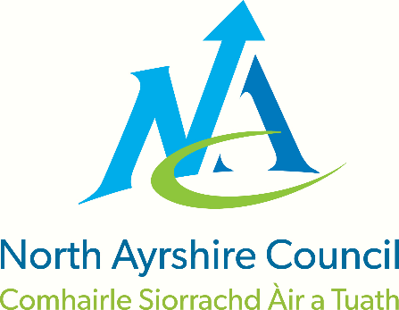
Our school values are…

Respect Equality Determination
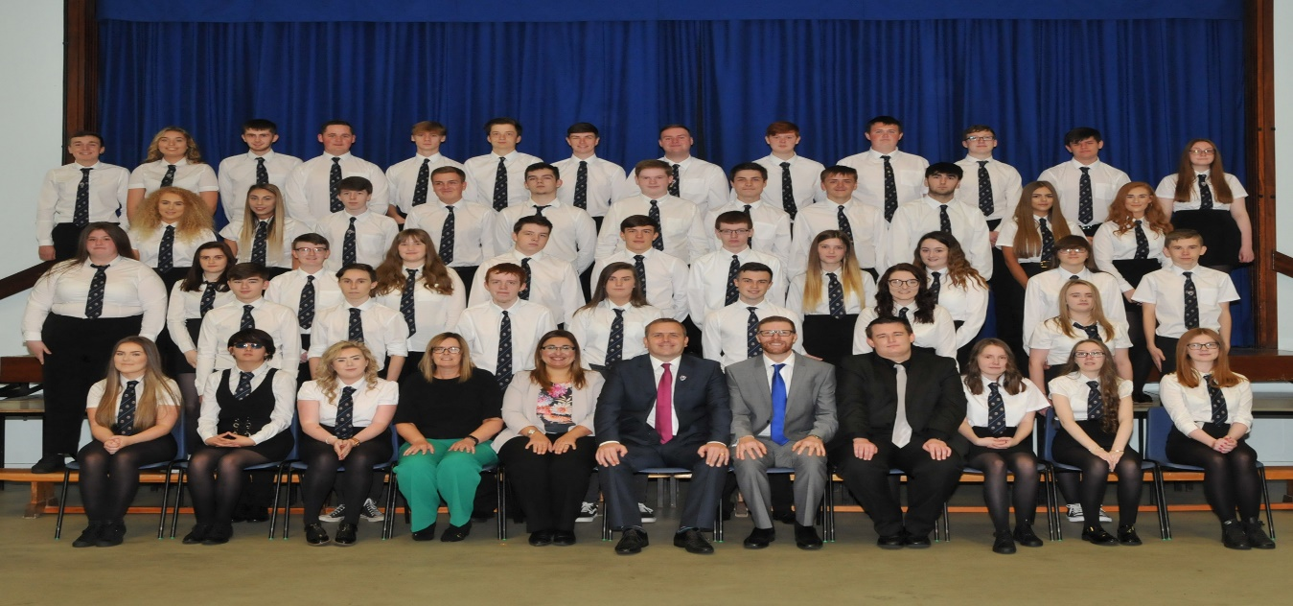

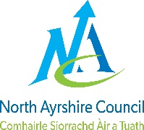 | North Ayrshire Council
 | Education & Youth Employment: Standards & Quality Report
 | Establishment: | Auchenharvie Academy | Session: | 2018-19

Our school:
Auchenharvie Academy is located in Stevenston and serves the communities of Stevenston and Saltcoats (South). We have 5 cluster primaries and in addition attract a small number of young people from other local primary establishments. We have worked hard to establish strong relationships with children, parents, carers and families as well as our links with the local community. We are working hard as a school to improve outcomes for learners and reduce inequalities for pupils and their families.

The school roll is currently 663 pupils. This is staffed by a Head Teacher, 3 Depute Head Teachers, 8 Curriculum Faculty Heads, 3 Principal Teachers of Pastoral Care, one Principal Teacher of Pupil Support and one Principal Teacher of Raising Attainment and Achievement and a total of 54.8 staff. We also have 6 classroom assistants who support learners effectively in class.

Auchenharvie Academy has benefitted from additional resources provided through the Scottish Attainment Challenge. We have appointed a ‘Data Coach’ and also a class teacher / classroom assistant who lead on Nurture provision in our school. We also work collaboratively with the North Ayrshire Council (NAC) Family Learning Team to support wider learning initiatives within our community.

Learning and teaching in the school is good or better in most cases however there is a need to move from good to excellent, to develop differentiation across all stages in order to develop learning at all levels and increase pace and challenge. Expectations for pupil attainment are improving with sound approaches to ensuring excellence and equity developing as part of our school culture. A significant number of new appointments have been made in the latter stages of this session and we have high hopes that this will continue to improve learning, teaching and overall attainment and achievement.

Throughout the course of this session Auchenharvie Academy has (in line with NAC policy) been involved in several local authority visits focussing on aspects of raising attainment and achievement, ensuring wellbeing equality and inclusion and teaching learning and assessment. These visits, whilst primarily very positive, have allowed for further external validation of future school improvement plan priorities.
Our priorities for school improvement throughout this session were devised in consultation with all teaching staff, identified groups of pupils and through open invitation to all parents. We have also worked with several partners in the construction of our school improvement plan priorities These are also in line with North Ayrshire Council priorities and seek to support using achieving our school vision.

Our Priorities for session 2018/19.
- To reduce inequalities and deliver improved outcomes for children
- To provide high quality learning and teaching
- To embed self-evaluation and performance improvement
- To improve levels of attainment and achievement for all learners
- High numbers of our young people are entering positive and sustained post-school destinations
Pupil Equity Funding 2018-2019
For the academic session 2018-19, Auchenharvie Academy was allocated £121,200 as the part of the Scottish Government’s Pupil Equity Fund (PEF). The PEF amounts were based on the number of learners (101) in receipt of Free School Meals at the time of allocation and for each pupil in receipt of Free School Meals the school was allocated an additional £1,200. In line with advice from the Scottish Government, existing policy (namely the National Improvement Framework) was reviewed and consultations with all stakeholders (pupils, parents, partners and staff) were held to identify key priorities. These priorities have become our ‘PEF Streams’ and fall within the broad areas of: literacy and numeracy; health and wellbeing; family learning and engagement; and Developing the Young Workforce. Further detail of our PEF spending can be found on our school website through our annual PEF report summary.

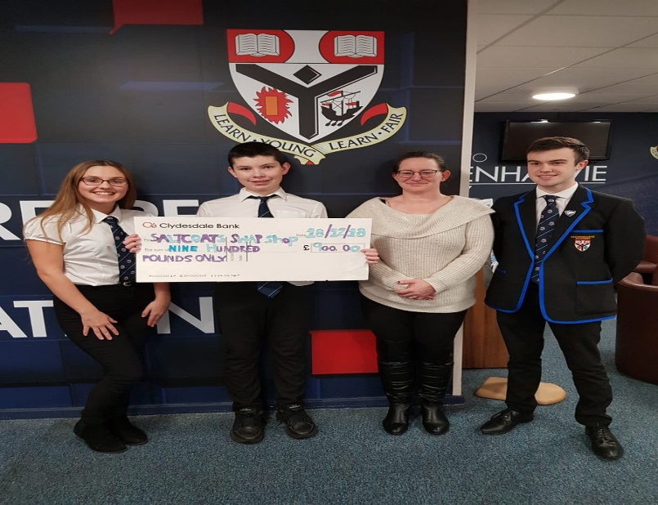

School Priority 1: We are reducing inequalities and delivering improved outcomes for children and young people.

National Improvement Framework Priority  - Improvement in attainment, particularly in literacy and numeracy  - Closing the attainment gap between the most and least disadvantaged children  - Improvement in children and young people’s health and wellbeing | How Good is Our School? (version 4) Quality Indicator  1.1, 1.2, 2.1, 2.5, 3.1, 3.2
To support the wellbeing of our young people and to help reduce the impact of inequalities we have taken a series of important steps this session. We aim to make sure that these improve outcomes for our pupils and their families.

Progress, impact and evidence:

We have:
- Streamlined our PSE programme to improve the quality of learning experienced by pupils.
- Implemented year 2 of our Family Learning / Parents in Partnership programme.
- Implemented year 2 of our Nurture provision focussing on the application of specific targets in class.
- Implemented celebrating success initiatives in line with our school Positive Relationships policy.
- Implemented our whole school attendance policy and further improved whole school attendance to above 90% this session.
- Developed a database to track and help improve pupil participation in the ethos and life of our school.
- Created an action plan aimed at achieving sliver status as a Rights Respecting School.
- Constructed tracking, monitoring and intervention systems specifically for Care Experienced and other potentially vulnerable young people.
- Revised and implemented our whole school Anti-Bullying policy.
- Worked closely with pupils to create inclusive approaches to improving house ethos activities.
- Completed a participatory budgeting exercise relating to the spending of finances allocated through the Pupil Equity Fund (PEF).
- Successfully participated in the ‘Cost of the School Day’ initiative, helping us to minimise the impact of poverty on accessing school life.
- Successfully participated in the ‘I am Jack’ teenage pregnancy initiative in collaboration with Queens University Belfast.
- We have reduced our school exclusions considerably to maximise the educational experience of our young people and include them in the life of our school.
 | School Total excl incidents | S1 | S2 | S3 | S4 | S5 | S6 |  | Attendance
2018/19 | 12 (24) | 3 | 4 | 1 | 3 | 0 | 1 |  | 90.61%
2017/18 | 26 (69) | 5 | 6 | 8 | 7 | 0 | 0 |  | 89.54%
2016/17 | 27 (70) | 5 | 8 | 6 | 6 | 1 | 0 |  | 87.55%
2015/16 | 38 (160) | 11 | 14 | 123 | 12 | 0 | 0 |  | 85.9%

Next Steps:

We will:

- Create a whole school HWB policy which has a key focus on mental wellbeing and mindfulness and incorporates all aspects of wellbeing and support in our school.
- Fully embed our Positive Relationships policy with a key focus on the use of merits and recognising positive achievements.
- Undertake a complete review of how effectively we use staff and other resources to support young people with additional support needs.
- Provide high quality professional learning to our staff to better support young people with additional support needs.
- Implemented targeted groups for Literacy and Numeracy for pupils in S1/2/3.
- Continue the journey for silver status as a Rights Respecting School.
- Develop the use of ‘go to spaces’ and ‘go to people’ within our school.
- Implement a house ethos building programme which allows for greater celebration and inter-house competition within Ashgrove, Warner and Parkend.
- Improve the use of our data base to track pupil inclusion/ participation in the ethos and life of our school.
- Implement year 3 of our Family Learning / Parents in Partnership programme whilst involving more parents/carers in previous learning.
- Continue to reduce our school exclusions and promote improved attendance.

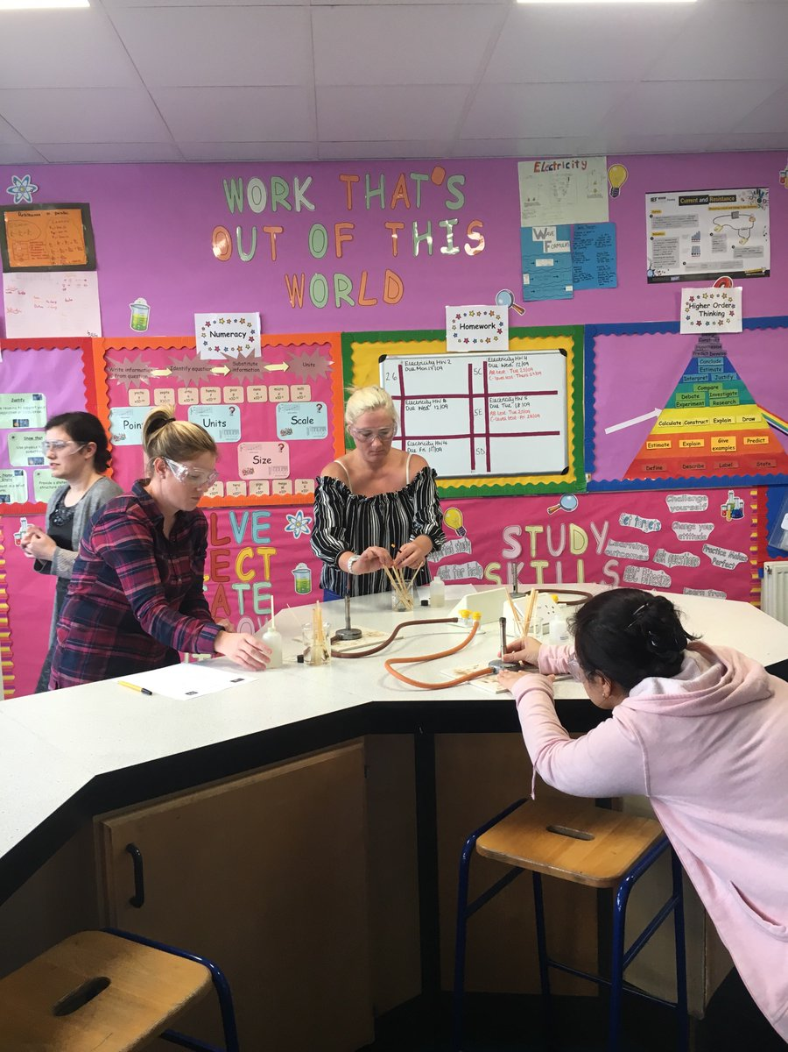

School Priority 2: High quality learning and teaching is taking place in our school.

National Improvement Framework Priority  - Improvement in attainment, particularly in literacy and numeracy  - Closing the attainment gap between the most and least disadvantaged children | How Good is Our School? (version 4) Quality Indicator  1.2, 1.3, 2.2, 2.3, 2.4
Progress, impact and evidence:

At Auchenharvie Academy we recognise that the single greatest factor in maximising pupils’ school experience is the quality of the teaching and learning they receive. We place great importance on this and proactively seek to improve the standard of teaching and learning in our school on a daily basis.

We have:

- Consulted with parents, pupils, partners and staff on the number of subjects which should be offered in S4 from academic session 2019/20 onwards.
- Implemented year 2 of our 4 year programme on the moderation of planning, learning, teaching and assessment in the Broad General Education.
- Implemented year 2 of our whole school literacy and numeracy strategies.
- Implemented year 2 of our whole school HWB and digital literacy strategies.
- Implemented year 1 of our whole school Sciences, Technologies, Engineering and Mathematics (STEM) strategy.
- Implemented our whole school Homework policy.
- Delivered staff training and shared best practice on the use of Higher Order Thinking Skills (HOTS) and differentiation as well as our whole school teaching and learning policy.
- Worked closely with schools out-with Ayrshire to share best practice in relation to teaching and learning.
- Collaborated with staff in the Professional Learning Academy to work on visible learning strategies - this year we have focussed on ‘what makes an effective learner at Auchenharvie Academy?’
- Improved the use of faculty meetings to ensure a greater focus on teaching and learning and improving outcomes for all pupils.

Next Steps:

We will:

- Develop our departmental moderation of planning, learning, teaching and assessment in the BGE to improve confidence in teacher judgements.
- Develop capacity in our faculty heads to take adopt greater responsibility for improving quality of teaching and learning. This will have a particular focus on differentiation.
- Improve the use of differentiation in classroom teaching and learning to ensure the needs of all learners are being met consistently.
- Implement year 2 of our STEM strategy to increase awareness /and improve experiences in the STEM subjects.
- Implement year 3 of our Literacy / Numeracy / Digital Literacy / HWB strategies.
- Continue our work on Visible Learning with our colleagues in the Professional Learning Academy.
- Pilot a ‘Lesson Study’ model to improve consistency in learning and teaching across subjects.
- Deliver a programme of staff training with a particular focus on teaching and learning.

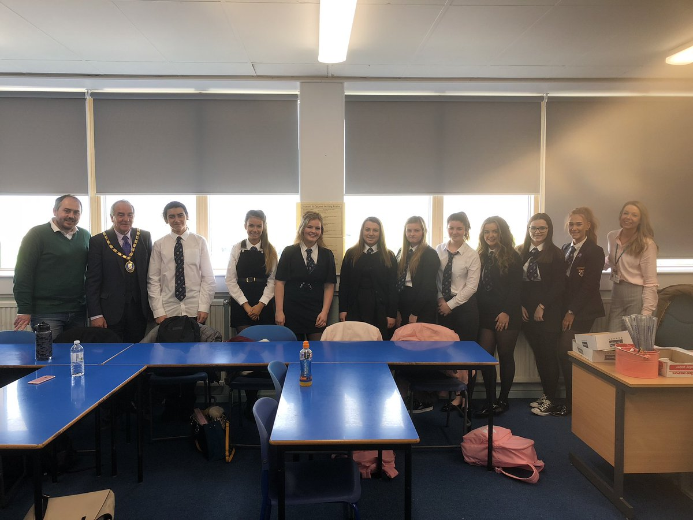

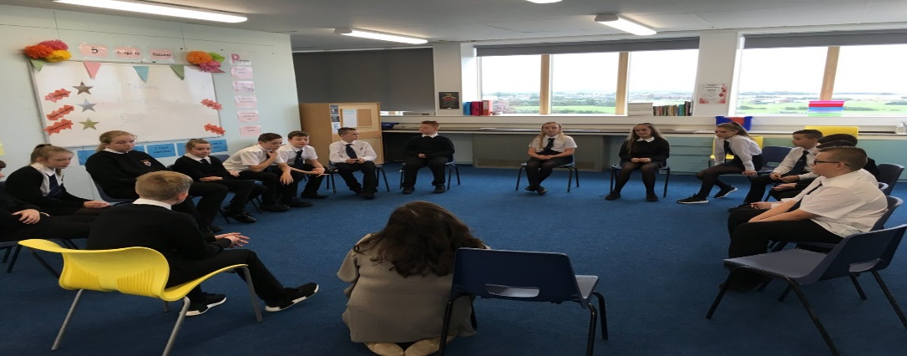

School Priority 3:Self-evaluation and performance improvement are embedded throughout our school.

National Improvement Framework Priority  - Improvement in attainment, particularly in literacy and numeracy  - Improvement in children and young people’s health and wellbeing | How Good is Our School? (version 4) Quality Indicator  1.1, 1.2, 1.3, 1.4, 2.3, 2.4, 3.2
A number of key steps have been taken to reintroduce and enhance aspects of self-evaluation to the culture and practices within our school. This will continue to be a strong focus of our improvement in the coming session.

Progress, impact and evidence:

The following opportunities have been implemented this session to increase the strength of the pupil voice within Auchenharvie Academy.
- Pupil Parliament has been established and lead by our senior student leaders. The parliament has 24 active members.
- Pupils have on multiple occasions been active participants in the recruitment and selection process for new posts within the school.
- Pupils have (as per SE calendar) participated in a wide range of departmental and whole school focus groups, surveys, learning walks and faculty health checks.
- All pupils participated in curriculum surveys to reconsider the S4 experience for the coming session.
- Pupils were actively involved with our work on visible learning to create ‘HARVIE’ – what makes an Auchenharvie Learner.
- Pupils have been actively involved in the Curriculum, Teaching and Learning and Positive Relationships working groups making decisions with staff to improve our school.
- Pupils have been active participants in the creation of the School Improvement Plan and in Departmental Improvement planning.

We have also:
- Improved the use of data by classroom teachers and middle leaders to ensure we are maximising outcomes and learning experiences for pupils.
- Set up collaborative partnerships with other schools out-with North Ayrshire for all subjects to support the moderation process in the BGE.
- Worked collaboratively with a secondary school in East Dunbartonshire to share best practice on the ‘Lesson Study’ model which we will be piloting next session.
- Undertaken faculty Health Checks in half of the subjects within the school and will continue with these evaluative procedures in the new session.

Next Steps:

We will:

- Continue to focus on strengthening the pupil voice as part of self-evaluation at all levels.
- Develop systems to further strengthen the staff voice as part of ongoing school improvement.
- Continue to improve the use of data by faculty heads leading to increased use by classroom teachers to enhance teaching and learning.
- Participate in cross school and sector moderation on planning, learning, teaching and assessment in the BGE.
- Continue with departmental health checks x4 annually as part of self-evaluation calendar to identify best practice and support priorities for improvement within faculties.
- Continue to look outwards at best practice nationally to improve the overall quality of our work at Auchenharvie Academy.

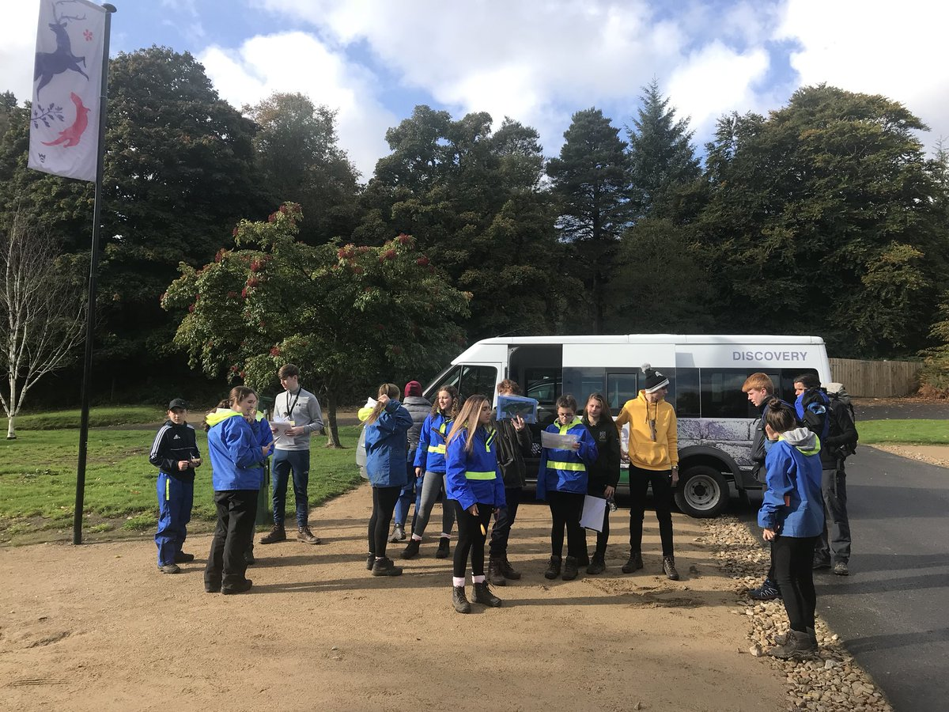

School Priority 4: Levels of attainment and achievement are improving for all learners.

National Improvement Framework Priority  - Improvement in attainment, particularly in literacy and numeracy  - Closing the attainment gap between the most and least disadvantaged children  - Improvement in children and young people’s health and wellbeing  - Improvement in employability skills and sustained, positive school-leaver destinations for all young people | How Good is Our School? (version 4) Quality Indicator  1.2, 1.3, 1.5, 2.2, 2.3, 2.4, 3.2
To enhance outcomes for all of our pupils a number of key steps have been taken this year. These will allow us to continue improving levels of attainment and achievement.

Progress, impact and evidence:
We have:
- Created a whole school raising attainment strategy for implementation in 2019/20.
- Further embedded our whole school tracking, monitoring and interventions policy incorporating learning conversations from S1-6..
- Further improved staff confidence in data analysis to improve the standard of teaching and learning.
- Improved moderation practices in literacy and numeracy across the school in the BGE.
- Appointed a Principal Teacher of Transitions and Interventions to specifically target pupils underperforming in literacy and/or numeracy.
- Introduced attainment mentors to support pupils highlighted through tracking as at risk of not achieving or underperforming.
- Reviewed our systems for monitoring vulnerable pupils including Care experienced and Young Carers.
- Made considerable improvements in literacy and numeracy levels both within the BGE and Senior Phase.

S3 Literacy @3rd Level –
Cohort Year & Numbers | Performance % in Reading | Performance % in Writing | Performance % in Listening & Talking
2015-2016 | 65% | 55% | 65%
2016-2017  Full roll 133  Assessed roll 120 | 96.2% | 93.2% | 94.0%
2017-2018  Full Roll 125  Assessed Roll 116 | 84.0% | 84% | 80.8%
2018/19  Full Roll 113  Assessed Roll 106 | 95.92% | 93.88% | 91.92%

S3 Numeracy ‘ 3rd Level-
Cohort Year & Numbers | Performance % Numeracy
2015-2016 | 55%
2016-2017  Full roll 133  Assessed roll 127 | 94.7%
2017-2018  Full Roll 125  Assessed Roll 119 | 94.4%
2018-19  Full Roll 113  Assessed Roll 106 | 89.42%

S4 Literacy and Numeracy – SQA levels 4 and 5-
 | Literacy @4 | Numeracy @4 | Literacy @5 | Numeracy @5
2019 /136pupils | 96.06% | 92.13% | 78.74% | 62.99%
2018 / 133 pupils | 96.2% | 97.7% | 87.9% | 65.2%
2017 / 99 pupils | 91.8% | 88.7% | 58.1% | 55.1%
2016 / 135 pupils | 93.3% | 81.4% | 77.7% | 40%
2015 | 95.6% | 87.9% | 78.4% | 32.7%
2014 | 94.2% | 76% | 67.7% | 33%
2013 | 64.8% | 72.5% | 19.8% | 19%
2012 | 71.6% | 69.2% | 24.1% | 30.7%

Next Steps:

We will:

- Implement year 3 of our BGE strategy
- Implement out whole school strategy for raising attainment and achievement.
- Strengthen our approaches to working with other schools, sharing best practice.
- Implement more targeted approaches to improving Literacy and Numeracy for targeted pupils.
- Improve our follow up intervention following periods of pupil tracking.
- Make more effective use of data on pupil participation in the wider life of the school.
- Make more effective use of the qualifications framework to further improve pupil attainment and achievement.
- Further improve staff confidence in using data to help close the poverty related attainment gap.

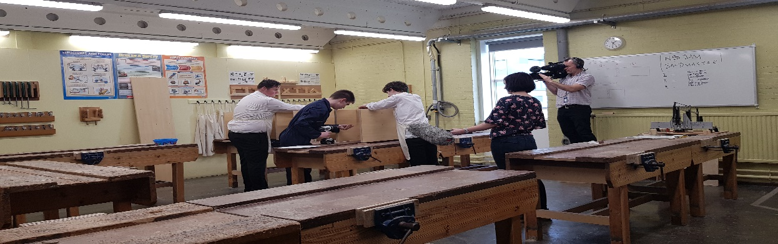

School Priority 5: High numbers of our young people are entering positive and sustainable destinations.

National Improvement Framework Priority  - Improvement in employability skills and sustained, positive school-leaver destinations for all young people | How Good is Our School? (version 4) Quality Indicator  1.3, 1.5, 2.2, 2.6, 2.7, 3.1, 3.3
Supporting our pupils into the most appropriate, positive and sustainable destinations is a key feature of our revised school vision and again a number of key steps have been taken this session to ensure that we are in as strong a position as possible to achieve this.

Progress, impact and evidence:

We have:

- In line with our school vision we continue to attain very good post school leaver’s destination figures.
Establishment | Year | % Candidate positive destinations | Number in cohort
Auchenharvie Academy | 2014/15 | 97.89 | 95
Auchenharvie Academy | 2015/16 | 90.53 | 95
Auchenharvie Academy | 2016/17 | 93.33 | 120
Auchenharvie  Academy | 2017/18 | 98.3 | 114
Auchenharvie Academy | 2018/19 | 98.4 | 125

- Targeted approaches to our work experience programme to make it more aligned to pupil interest/need and to align with the national Work Placement Standards.
- We have introduced several ‘Vocational Bursts’ into our S2 curriculum in conjunction with Ayrshire College.
- Implemented further Developing Young Workforce initiatives in to our curriculum in collaboration with Ayrshire College and The Princes Trust. We have added Cyber Security, Bike maintenance and Childcare to our existing customer services courses in Barista and Nail Bar into our S3 curriculum allowing pupils to achieve a multitude of industry standard qualifications.
- We have introduced an SQA course in Retail at National 4 and 5 level into our senior phase curriculum.
- Continued to offer Foundation Apprenticeships during S5/6. – 7 pupils are currently participating.
- Established curriculum DYW pathways for pupils from S1-6.
- Appointed a Principal Teacher of Developing Scotland’s Young Workforce to oversee all of our work in this area.

Next Steps:

We will:

- Maintain our outstanding school leavers’ destination figures through rigorous monitoring approaches.

- Develop new and enhance existing Developing Young Workforce (DYW) Initiatives and available streams, including: childcare, uniformed services and outdoor education activities.

- Deliver a careers week to further contextualise learning in the classroom.

- Work with colleagues at Ayrshire College to improve our DYW offer in S2 through ‘college bursts’.

- Further Implement the Career Education Standards (CES) and Work Placement Standards (WPS).

- Increase employer engagement in the BGE phase to further enhance opportunities for developing skills for learning, life and work.

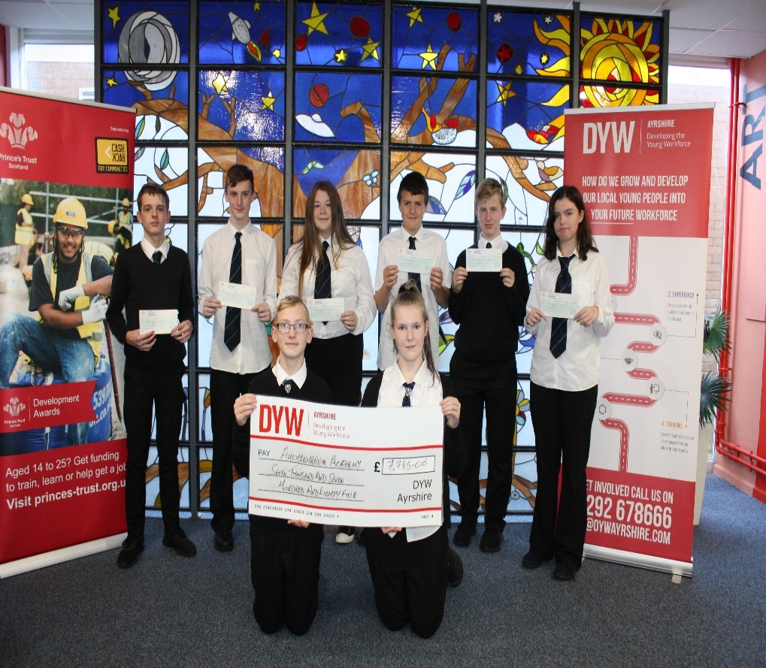

Overall Capacity For Improvement – strengths and next steps

Moving forward Auchenharvie Academy has significant capacity for continuous improvement and staff and pupils will work tirelessly with our community to continue to deliver both on our school vision and our improvement agenda.

The key areas for further school improvement at Auchenharvie Academy are:

- To review our ASN provision to ensure equitable and efficient allocation of resource with maximum impact.

- The creation of a Professional Learning Programme with a focus on ASN and L&T for all staff.

- To further improve the quality and consistency of Learning and Teaching for our pupils.

- To develop enhanced opportunities for young people to be better informed and prepared for the World of Work.

- To enhance staff participation and leadership of school improvement through a focus on wellbeing, ethos and staff voice.

- Through diverse approaches to transitions and parental engagement activities, motivate and support parents and families to become involved in their child’s learning and the wider life.

- To strengthen and embed targeted approaches to well-being across the school.

- To embed a focus on equality and human rights in line with our school values.

- To strengthen further existing practices in moderation within the BGE.

- The implementation of Senior Phase and BGE attainment strategies respectively.

Full details of how we will achieve these high level objectives can be found in our School Improvement Plan 2019/20 on our school website.

Quality Indicator | School’s Evaluation
1.3 Leadership of change | 5
2.3 Learning, Teaching and Assessment | 4
3.1 Ensuring wellbeing, equality and inclusion | 4
3.2 Raising attainment and achievement | 4

