SCHOLAR S4-S6
SCHOLAR is an online resource that supports independent study; students can use the materials to study anytime, anywhere, in school, college or home. Courses can fit around class schedules, with short activities, clear goals and engaging content to encourage students to progress independently.
Pupils can access Scholar via a tile on Glow. Pupils need to log on to Glow, click the home button (this is on the left of the screen and is a little house) to bring up a selection of tiles and click the tile below.

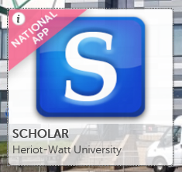

Please see below for details of coures avaiable.
Please note that pupils can work on the resources for courses online. Pupils can also click on the book icon next to the course and can download a PDF of the notes for that course to use offline. 