

**Education and Youth Employment**

**Auchenharvie Academy**

**Faculty of Health and Wellbeing**

**Improvement Plan 2019-20**



School logo?

**Vision, Values and Aims**

 ***Auchenharvie Academy*** 

***Our Vision/Aim is…***

***To provide an equitable and excellent learning environment for ALL pupils which maximises their full potential and supports them into appropriate, positive and sustainable destinations.***

***Our Values***

***Respect Equality Determination***

**Council Priorities:**

The Council strategic priorities for 2019-24 are detailed below:

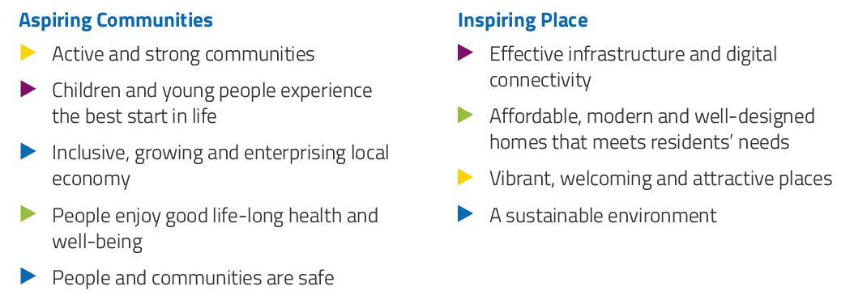

**National Improvement Framework:**

The National Improvement Framework for Education is designed to help us deliver the twin aims of excellence and equity; galvanising efforts and aligning our collective improvement activities across all partners in the education system to address our key priorities. These priorities remain as:

* Improvement in attainment, particularly in literacy and numeracy
* Closing the attainment gap between the most and least disadvantaged children
* Improvement in children and young people’s health and wellbeing
* Improvement in employability skills and sustained, positive school-leaver destinations for all young people

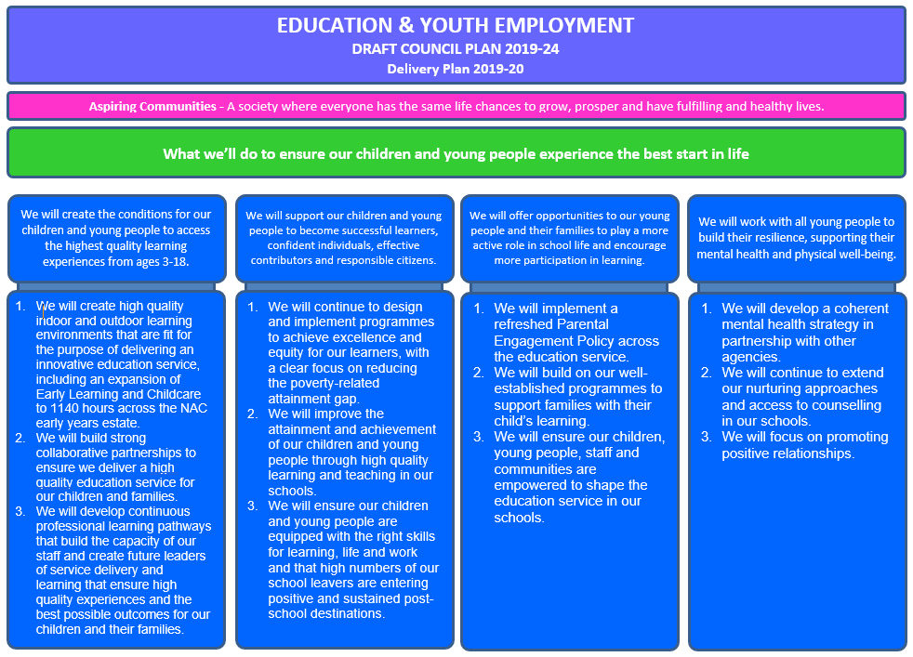

**Strategic Plan 2019-20: Auchenharvie Academy**

|  |  |  |  |  |  |
| --- | --- | --- | --- | --- | --- |
| **School Priorities** | **Create the conditions for our children and young people to access the highest quality learning experiences from ages 3-18** | **Supporting our children and young people to become successful learners, confident individuals, effective contributors and responsible citizens.** | **Offering opportunities to our young people, their families and staff to play a more active role in school life and encourage more participation in learning.** | **Work with all young people to build their resilience, supporting their mental health and physical well-being.** | **To maximise attainment in the BGE and Senior Phase for all pupils.** |
| **High Level Objectives** | **To review our ASN provision to ensure equitable and efficient allocation of resource with maximum impact.**  **Creation of a Professional Learning Programme with a focus on ASN and L&T for all staff.** | **Improve the quality and consistency of Learning and Teaching for our pupils.**  **Develop opportunities for young people to be better informed and prepared for the World of Work.** | **Enhance staff participation and leadership of school improvement through a focus on wellbeing, ethos and staff voice.**  **Through diverse approaches to transitions and parental engagement activities, motivate and support parents and families to become involved in their child’s learning and the wider life.** | **To strengthen and embed targeted approaches to well-being across the school.**  **Embed a focus on equality and human rights in line with our school values.** | **To strengthen further existing practices in moderation within the BGE.**  **Implementation and creation of Senior Phase and BGE attainment strategies respectively.** |

**Strategic Plan 2019-20: AUCHENHARVIE ACADEMY**

Here is an overview of how we intend to use our Pupil Equity Funding to support improvement:

**Detailed Action Plan 2019-20: Auchenharvie Academy**

**Faculty of Health and Wellbeing**

|  |  |  |  |  |  |  |  |
| --- | --- | --- | --- | --- | --- | --- | --- |
| **Faculty Priority:** | | **To strengthen further existing practices in moderation within the BGE and continue to ensure high quality teaching and learning is taking place across the faculty** | | | | | **Linked to School Priority : 2 & 5** |
| **High Level Objectives** | **HGIOS 4**  **HGIOELC**  **NIF** | **Supported through PEF?**  **Y/N** | **How will I achieve this?** | **Timescale / Assigned to:** | **Pupil Outcomes** | **Measurement** | |
| **Create the conditions for our children and young people to access the highest quality learning experiences from ages 3-18**  **To strengthen further existing practices in moderation within the BGE**  **Develop opportunities for young people to be better informed and prepared for the World of Work.** | **HIGIOS**  1.1  2.2  2.3  2.4  2.5  3.2  **NIF**  1  2  WBI  Healthy  Achieving  Active  Respected  Responsible  Included | N | * Updated schemes of work including level 2,3 and 4 benchmarks will be used by all staff in the planning and delivery of BGE lessons. * HE schemes still work in progress with regards to including benchmarks * FH will ensure that schemes of work are being used in this way through formal and informal observations * Use moderation cycle to build confidence in teacher judgements in order for consistency to be evident in assessing pupils * Lesson study exercises to be carried out by all staff within S3 elective class and S2 girls class. * S1 and S2 PE first block of work to be various activities to allow for classes to be split into groups of similar ability within a boys class, girls class and co-ed/nurture class.   .   * S3 PE pupils given a performance pathway to opt into. Classes to be split from these options   .   * S1 and S2 HE classes to be rotated after Xmas to ensure all S1 have access to HE curriculum and subject specialist * Continue to apply SLIPP model in lessons with a specific focus on differentiation in lessons and more use of HOTS * Numeracy booklet to be produced and delivered within fitness lessons. * Literacy reading homework tasks to be developed to be given out at end of football, gymnastics, fitness and basketball blocks that are appropriate to pupil reading ages. * Develop S3 sports leadership course to produce team of sports leaders that can start their leadership journey as that move up the school | Ongoing  All HWB staff  June’20  EM  Oct ‘19 and March’20  FM to lead  All HWB staff involved  Dec’19 All PE staff and CJ  Aug/Sept ‘19  FM/SM/RG  Aug/Sep’19  All PE staff  Aug’19 – April’20  FM/EM  Ongoing  All HWB staff  RG Feb’20  FM/SM/JS/RG  March’ 20  Ongoing FM/MM/RG/SM | * Pupils will be taught at the correct level and will find that they are being supported to achieve the next CFE Level. * Pupils be assessed through teacher observation, self and peer assessment and end of block quiz.. * Pupils will know what level they are working at and be able to say what their next steps in learning are * Pupils will have improved learning experiences through the collaborative approach to lesson planning by lesson study team. * Pupils will enjoy working in classes that will give them the appropriate challenge they need this should enhance skill development further. * Increase participation at lunchtime and extra- curricular clubs   Pupils in S3 should be more motivated and enjoying their PE as they have opted into a pathway that they have chosen.  Improvement in effort and skill development expected as well as attitudes being more positive towards PE.  Pupils taught key life skills in hygiene and cooking. They will develop organisation skills and time management skills.  S2 pupils will be given insight into S3 Hospitality programme to encourage subject uptake of this.  Pupils will be aware of routines and expectations within the faculty. They will achieve success more often and be given the opportunity to reach their full potential.   * Pupils will be able to use numeracy knowledge within their PE lessons and link these to their fitness activities * Pupils encouraged to read more and hopefully will be more engaged in this as it will be through a PE context * Pupils will enjoy a different type learning with the PE department * Pupils will develop confidence, communication and organisation skills * Pupils will learn how to lead young people in sports activities and how to educate them to stay health and active | * Increased consistency in T& L across the department.This will be evident through formal and informal classroom observations. * BGE T&M spreadsheet will be used to see each pupils progress * Progress of class is regularly discussed at Faculty meetings * Pupil voice through questionnaires and learning walks will used to gather views of pupils on these aspects   .   * Pupil interviews after lesson to discuss what they learned and their opinion of the lesson * Increased uptake in N4/5 PE next year. (particularly girls) * Classroom observation will show SLIPP model and differentiation. * Contribution to increased pupil numeracy levels * Contribution to increased pupil literacy reading levels * Team of S3 sports leaders established * Links with cluster primaries made * Successful completion of JSLA award by a number of pupils | |

**Detailed Action Plan 2019-20: Auchenharvie Academy**

**Faculty of Health and Wellbeing**

|  |  |  |  |  |  |  |  |
| --- | --- | --- | --- | --- | --- | --- | --- |
| **Faculty Priority:** | | **To raise attainment in N5/H PE and N5 Hospitality course** | | | | | **Linked to School Priority: 1,2 & 5** |
| **High Level Objectives** | **HGIOS 4**  **HGIOELC**  **NIF** | **Supported through PEF?**  **Y/N** | **How will I achieve this?** | **Timescale / Assigned to:** | **Pupil Outcomes** | **Measurement** | |
| **Create the conditions for our children and young people to access the highest quality learning experiences from ages 3-18**  **Improve the quality and consistency of Learning and Teaching for our pupils**  **To maximise attainment in the BGE and Senior Phase for all pupils** | HGIOS  1.3  2.2  2.3  3.2  NIF  1  2  WBI  Achieving  Nurtured  Respected  Responsible  Included. | N | * Discuss practice scripts from N5/H PE markers meetings * Staff to look at SQA performance information from understanding standards events * To write higher PE prelim in line with 2019 paper. * Notes for higher to be reviewed and updated * End of block tests for Higher to be produced * End of unit assessments for N4/5 Hospitality to carried out to help with pupil levels * End of block tests for N5 to be produced * To offer supported study for Nat 5 Portfolio and Higher from October * Staff to share good practice of lesson content pupils responding well to in both practical and theory lessons * N5 PE/HE and Higher moderation marking for question papers/ portfolios/timeplans to take place.   (EM to contact other school to get specialist moderation support with this)   * To produce a new scheme of work for Advanced Higher for next year   . | Oct/Nov 2019(FM/SM/RG/JS)  Nov 2019  (FM/SM)  Ongoing 2019/20  (FM/SM/RG)  Ongoing  2019  (EM)  Ongoing  2019  (FM/RG)  Ongoing  (FM/SM/RG)  Ongoing  All HWB staff  May’20  SM | * Pupils will be fully supported to do their best in both portfolio and N5 Hosp/PE and H exam * Pupils will confident of exam structure and will be aware of what to expect on the day of exams. * Pupils will be able to assess their progress and evaluate their strengths and areas for development. * Pupils to build knowledge and retain it due to regular testing leading to improved and more detailed answers allowing them to access more marks * Pupils to gain extra support on a 1 to 1 basis leading to improved and more detailed answers allowing them to access more marks   Teachers knowledge improved and confidence in delivery of all areas of these course and so this will help with pupil attainment. | * Pupil views will be sought through learning conversations on how they are feeling about their courses, progress and attainment * End of block tests and HE assessment scores will be recorded and monitored to highlight pupils progress, areas for development and next steps for exam preparation * Improved component mark scores in SQA analysis | |

|  |  |  |  |  |  |  |  |
| --- | --- | --- | --- | --- | --- | --- | --- |
| **Faculty Priority:** | | **To improve links with parents** | | | | | **Linked to School Priority: *3*** |
| **High Level Objectives** | **HGIOS 4**  **HGIOELC**  **NIF** | **Supported through PEF?**  **Y/N** | **How will I achieve this?** | **Timescale / Assigned to:** | **Pupil Outcomes** | **Measurement** | |
| **Offering opportunities to our young people, their families and staff to play a more active role in school life and encourage more participation in learning** | *HIGIOS*  *1.2*  *2.5*  *NIF*  *3*  *WBI*  Achieving  Nurtured  Respected  Responsible  Included | Y | * Numeracy workshops will be organised for parents * Numeracy resources and termly newsletter will be placed on the school website. * Parental surveys will be conducted at parents evenings * New Maths Instagram page will be developed and managed by Mr Hosie. Staff will take photographs of examples of good practice/ photograph homework exercises, inform parents of tests dates via the Instagram page. * Parents will be informed about the maths Instagram page by text message. Staff will encourage parents to use it at parents night. | Ongoing  (MF)  Ongoing(KD)  Ongoing  (AM)  Ongoing  Maths team  Sept(MF) | * Parents will be able to support their children at home. * Parents kept fully informed about Numeracy. * Department will implement suggestions from parents that improve the numeracy experience for their children. * Pupils and parents will be able to access homework via Instagram page. Parents kept up to date with what’s happening in the maths faculty. | * Parents will be asked their opinion about the numeracy workshop. * The number of people that look at the web site. * The collated responses from parents to be discussed at departmental meeting. * Number of followers will be monitored. | |