Auchenharvie Academy

Digital Working group Session 2019/20

Digital Learning within the classroom

N. Nicholls
R. Ritchie
A. McNay
S. McDougall
D. Lodge
D. Marwick

Table of Contents

Our rationale 3
What we deliver 4
Plickers 5
6
Quizlet 7
SumDog 10
Sway 11
Bit.ly 12
Glow Forms 13
Youtube 14
YouTube’s Advantages 14
Google Classroom 15

Our rationale

Auchenharvie Academy prides itself in our use of Digital Learning within the classroom.
We embrace technology and implement within our lessons. Digital Learning is not an ICT lesson every few weeks in the ICT base.

At Auchenharvie Academy we understand the importance of Digital Learning and the journey involved in ensuring our learners are ready for the world of work.

Our working group decided on the following objectives:

- develop the skills and confidence of teachers
- improve access to digital technology for all learners
- ensure that digital technology is a central consideration in all areas of curriculum and assessment delivery

What does digital learning actually look like?

- Enhanced learning experiences
- All students having access to the curriculum through appropriate differentiation using digital resources
- Unlimited online resources, content, and models of success.
- Times saved on material prep, progress monitoring, and grading.
- Positive impact on student learning

What we deliver

This handbook will outline key digital strategies used in our classrooms, the benefits and also the constraints of each.

Not all digital resources may be accessible in your department. Hopefully, this handbook will give insight in to what may work.

CPD will be offered throughout the year relating to each digital resource mentioned in the handbook. We also have the following staff members willing to assist in any way possible:

N. Nicholls gw14westnina@glow.sch.uk
R. Ritchie gw10ritchieross2@glow.sch.u
A. McNay gw16mcnayanna@glow.sch.uk
S. McDougall gw10mcdougallsteven@glow.sch.uk
D. Lodge gw10lodgedavid@glow.sch.uk
D. Marwick gw10marwickdavid@glow.sch.uk

Plickers
https://www.plickers.com/

What is Plickers?

Plickers is... Formative assessment, faster.
Plickers is... Instant feedback.
Plickers is… Interactive lessons.
Plickers is... Equity of voice.
Plickers is… Engaged students.
Plickers is... Empowered teachers.

Plickers is a revolutionary way to collect instant multiple-choice responses from your students, without requiring students to have clickers, computers or tablets.

By using a printed card with a design unique to each student, our IOS and Android apps allow teachers to scan student responses and respond in real-time.

By turning assessments or check-ins into opportunities for play, Plickers engages students by empowering them to share what they know. As a teacher, you can use student results to address misconceptions, tailor instruction, and inform long-term planning.

Plickers is data without devices.

How much does Plickers cost?

Plickers core functions are free for teachers! The basic Plickers packages gets you:

- Print cards for free
- Download the free mobile app
- Create Sets with up to 5 Questions
- Use layout tools to customize Content
- Access Reports and Scoresheet

There is a monthly subscription available. For this package you get:

- Create Sets with an unlimited number of Questions
- Add images to Questions using our built-in image search
- Share Content with other members of the Plickers Pro community using Packs

Plickers Pro comes in at a few pounds a month.

Does it work well within Auchenharvie?

Teachers need access to either 4G or Wifi. Depending on your network provider, depends on whether it can be used in class.

Teachers have used it without the phone and simply as multiple choice questions – this way will not record results.
Pupils DO NOT need technology for this – they simply need the downloadable cards.

Pupil Engagement – All pupils enjoy Plickers. It is a fun, interactive way to question pupils. All pupils engage with Plickers and the scoresheet gives you individualised feedback for each student.

Plickers can be used with all year groups for starters, plenaries, or as part of the main lesson.
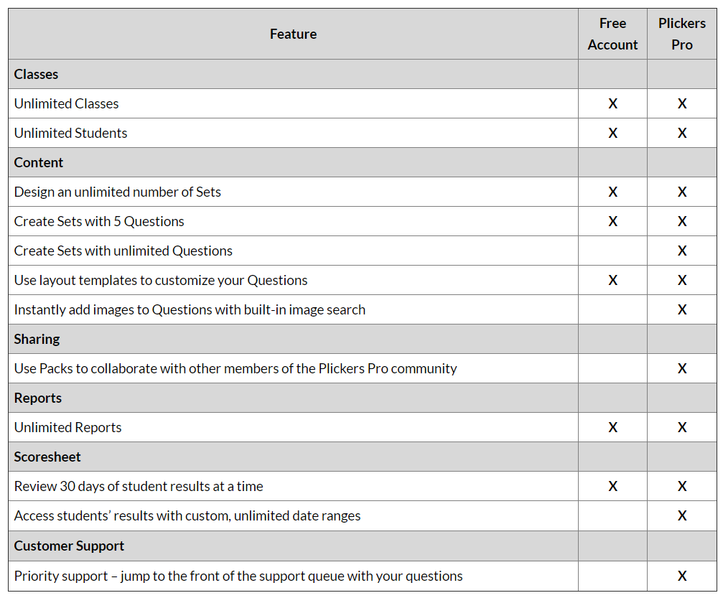

Quizlet

https://quizlet.com/en-gb

D. Marwick (Technical Dept)
“This resource is an excellent tool for providing the kids with an interactive learning experience. The pupils can mix between different testing and revising methods. They can even select a mode where they can challenge each other to be top of a leader board which creates a fun and competitive classroom challenge. For pupils that would prefer to revise on their own, quizlet offers a flash card game which enables kids to learn the meaning a key words within your subject. Quizlet does depend on access to ICT and it can be subject specific however one of the biggest advantages is that it can save the teacher time creating resources because even on a free account, you have access to thousands of pre made quizzes which have been created by other users from around the world.”

D.Lodge (Science)
“Along with the usual software used around the school, I look to use Quizlet for the production and resourcing of revision materials at both BGE and National levels.
The program offers several different user styles, games, matching exercise, flashcards ect and for the subjects I teach (Science and Chemistry) there are numerous, already produced resources. The version I use is the free one which does not allow for the register/ recording of pupil results but can be put onto several devises to be used jointly across a classroom. There are adverts but these are not too distracting.”

What Quizlet offers:

Easily find resources for any subject at any level on Quizlet. From any Key Stage to a Doctorate, your students will feel prepared to succeed.

Share study sets with your students, who can also use Quizlet for free to study, search for relevant sets and create their own.

Engage all of your students with our in-class game, Quizlet Live - or have them revise using another study mode on our website or mobile app.

Reinforce the curriculum:

Discover content for your classes amongst the millions of study sets on Quizlet.
SEARCH
Save time by finding study sets created by teachers like you that cover exactly what you and your students need.

CREATE
Create study sets to accompany your curriculum with terms and definitions, images and built-in text to speech audio.

CUSTOMISE
Make other teachers’ sets your own by saving a modifiable version to your account.

Keep students engaged

Choose from seven study modes and games to make exam revision and focused study time in class more fun!

QUIZLET LIVE
Play our exciting, team-based collaborative classroom game and get everyone involved.

RETENTION
Learn mode keeps track of what students need to spend more time reviewing so they can master material for the long term.

COMPETITION
Encourage your students to compete for the top score by playing Quizlet’s study games Match and Gravity in school or at home.

Quizlet Costs:

The above description is the free version, however there is also a paid subscription. This costs approx. £35 a year.

Does it work well within Auchenharvie?

This can work on the school network and no download is needed. There is no connectivity issues with Quizlet.

There are premade questions on all subject areas across our school. They can be useful for revision, starters and plenaries – but NOT open ended questions.

Pupil Engagement – Teachers have commented on pupil engagement being high when using quizlet. It has settled classes and allowed for learning to take place.

Examples of pre-made questions
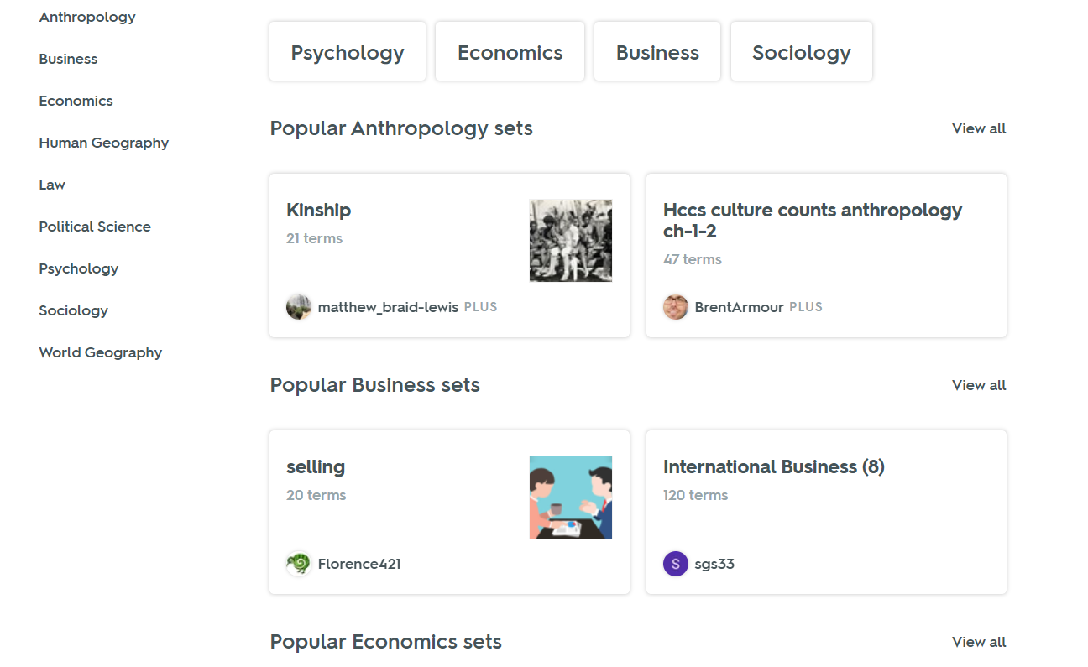

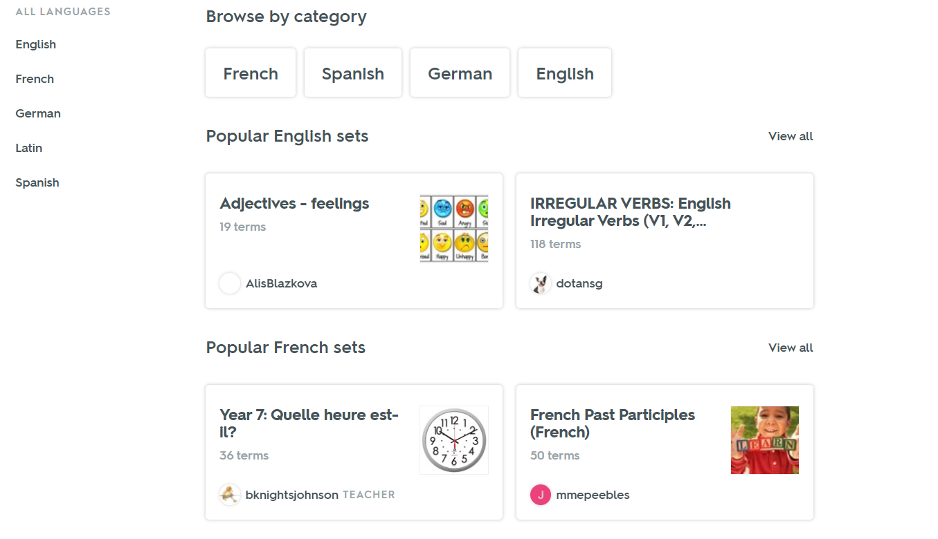
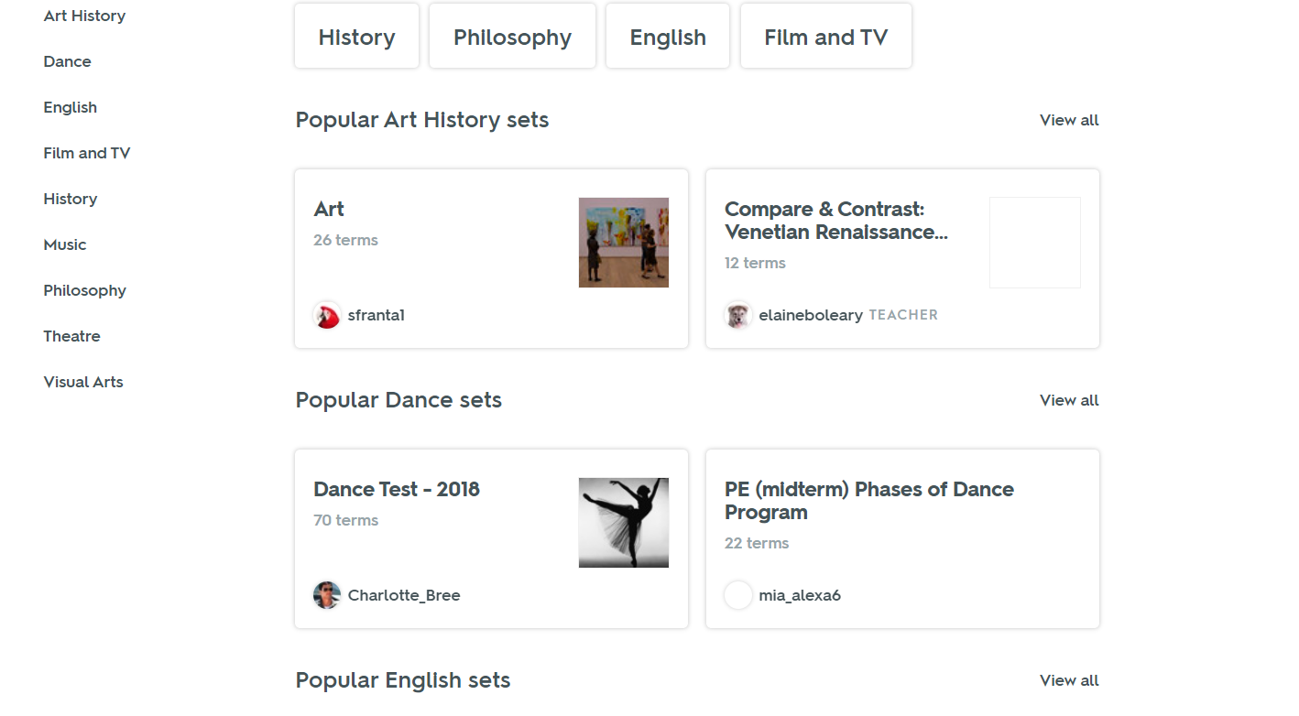
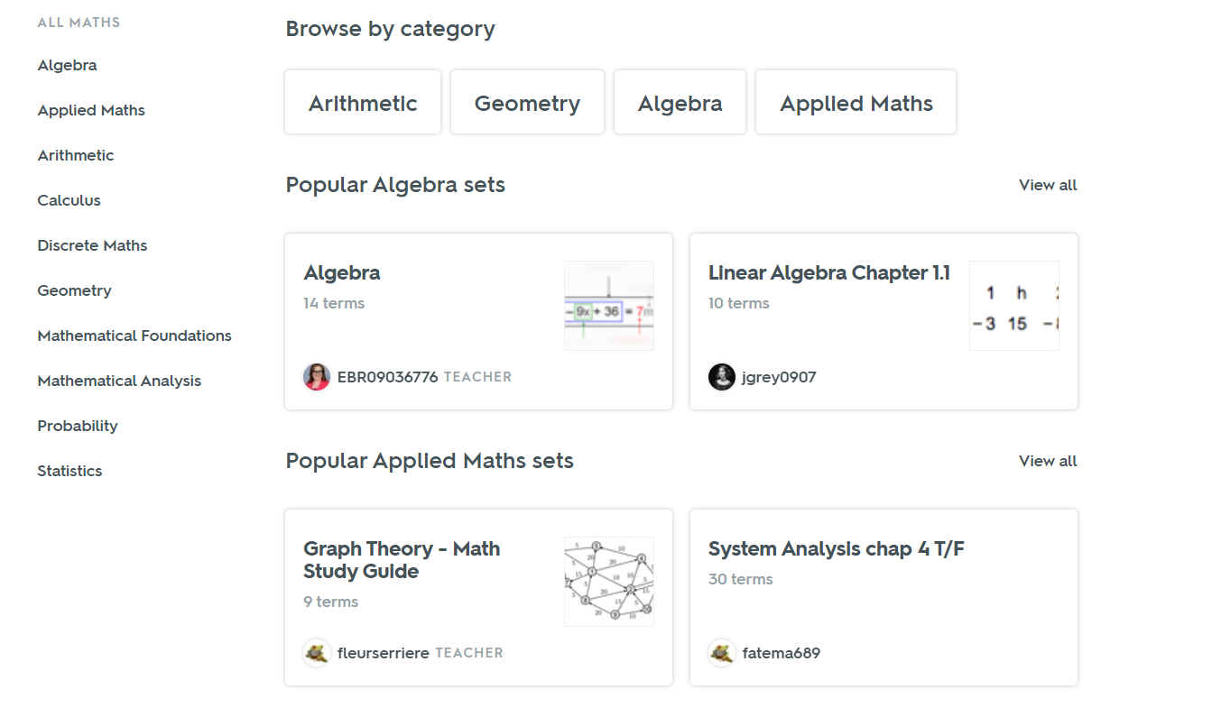
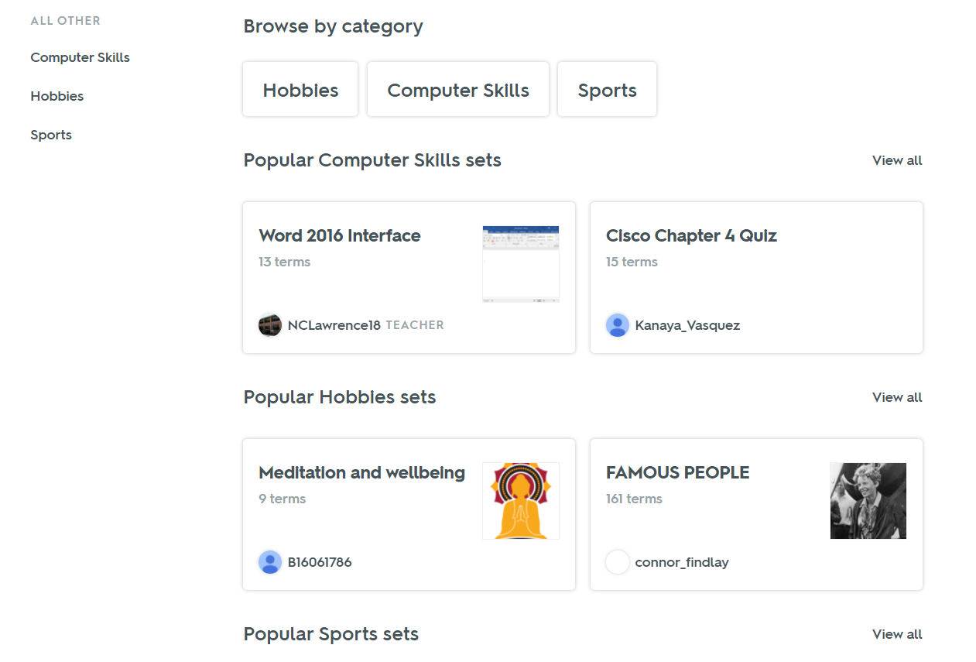

SumDog

Sumdog is a useful and interactive way the Mathematics Department assess and improve numeracy within S1-3. It is a website which assesses pupil ability through multiple choice questions and games.

Assessments and challenges can be set for different levels of ability and can be created to fit a given purpose. For example, if the topic of percentages was being taught in class, an assessment, of varying lengths, can be made on percentages. It can also be set to cover a number of topics.

The programme records individual pupil's results. This provides us with further evidence of how well a pupil is achieving at a given level/ topic.

Sumdog can be accessed at home, providing pupils an opportunity to practise and improve their numeracy skills out with school.

Curriculum-based
Easily evaluate progress against the curriculum.
Aligned to the National Curriculum & CfE

Targeted intervention
Target focused learning informed by teacher-friendly progress reports.
Set group or individual challenges for targeted intervention at home or at school.

Free login
Login free to Sumdog’s primary maths activities.
No cost. No time limit.
Simple subscriptions for enhanced reports and additional game options.

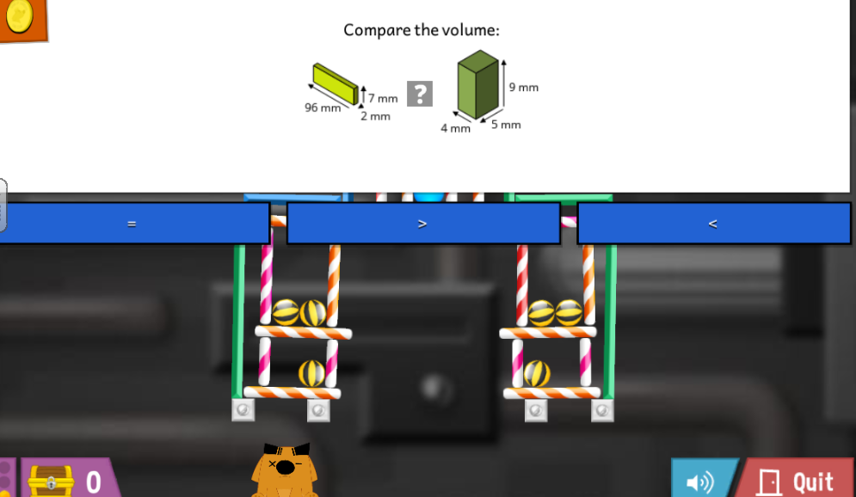
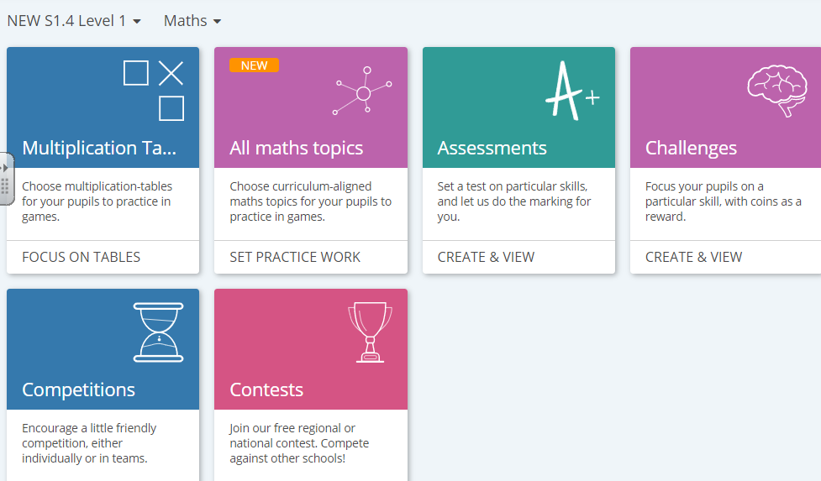

Sway

Sway is a new app from Microsoft Office that makes it easy to create and share interactive reports, personal stories, presentations, and more.

Start by adding your own text and pictures, search for and import relevant content from other sources, and then watch Sway do the rest. With Sway, you’re no longer limited to picking a pre-designed template that makes your presentations look like everyone else’s, and you don’t have to have any design skills to transform and showcase information in modern, interactive, and attention-getting ways.

With Sway, there’s no need to spend lots of time on formatting. Its built-in design engine takes care of making your creation look its best. If the initial design doesn’t quite match your taste or mood, you can easily apply another — or fully customize your layout to make it your own.

Sway is free to use for anyone with a Microsoft Account (Hotmail, Live, or Outlook.com). You can create more sophisticated Sways with more content when you use Sway as part of an Office 365 subscription.

What can be created with Sway?

Whether it’s a report, a presentation, a newsletter, a personal story, a photo album, or a visual trip report, there’s virtually no limit on what you can express creatively with Sway.

Does it work well within Auchenharvie?

Sway is already a big part of the Digital Literacy course. Pupils are taught how to use sway and how to share their work with each other and with their teachers.

Sway can also be used as a teaching tool instead of traditional powerpoints. Presentations are easy to make and more interactive.

Sway is free and comes as part of the Glow platform. Previous documents can be uploaded or you can create one from scratch.

Pupil Engagement: Whether pupils are creating their own sway or using it as a learning resource, it always enjoyed by pupils.

Ideas for sway can include:

- adding multiple videos in the one presentation that pupils can access.
- Uploading learning resources to sway and turning them into interactive presentations
- Asking pupils to create presentations or newsletters
- Pupils working collaboratively at home on presentations
- S1 digital profile create don Sway

Bit.ly

https://bitly.com/

This is handy resource that allows you to shorten URLS. If you are creating Sway presentations/Forms etc, it is very useful to shorten the URL.

An example would be to shorten this URL:

https://sway.office.com/AcpFPNny5jgUzOUc?ref=Link

To a URL like this:

Bit.ly/S1Sway_Unit1

As you can see, it is so much easier sharing the bottom one rather than the top one.

Bit.ly is free to use and you can create unlimited URL’s

Glow Forms

Glow Forms is used quite regularly at Auchenharvie. This is useful when collating information from surveys.

It can also be used for short multi choice quizzes for your class. The joy of using this for quizzes is that it can analyse your results.

Some departments have uploaded the quizzes from bbc bitesize for quick quizzes. These can be handy for HW (can be set where you do not need to mark it as it marks itself), starters, plenaries.

If there are any multichoice quizzes within your department it is worth uploading them to Forms.

Other uses would be to have pupils create surveys or quizzes that they can share with their class.

This is always a fun activity that pupils engage in.

Youtube

Students can learn a great deal just by watching technology in the classroom videos and learning from the thoughts, experiences, and demonstrations of others. In fact, they already are. Students are naturally watching videos that are interesting and relevant: From skateboarding to guitar playing to car driving to putting on makeup. YouTube has become the perfect place to find entertainment or knowledge – or both in the same video.

There are 4 main ways Youtube can help in the classroom:

Flipped Instruction. Do you want students to learn about something before coming to class the next day? Do you want to give students a resource they could use to learn outside of the class? Find (or create your own) videos on YouTube that address the material you need and give the links to your students.

Supplemental Information. Let’s say you want students to have some extra information that you don’t have class time to commit to. Share the interesting links with students. Students could benefit from some additional video resources to help them when they’re working outside of class.

Self-Directed Learning. Depending on your curriculum, you can direct students to YouTube as a resource to find the information interesting and relevant to them. If students are working on a more self-directed project or have an individual passion they want to explore, encourage them to take advantage of YouTube.

Classroom Enhancers. Videos can illustrate ideas and engage students far more substantially than textbooks, lectures, pictures, or other activities. When possible, turn to this free resource for building more effective lessons during class time.

YouTube is becoming a place where more and more professionals are uploading their free, awesome content. John and Hank Green, for example, are creating nearly three new videos a week for their Crash Course series covering literature, psychology, philosophy, history, and much more. Other experts and institutions, like Khan Academy, are creating excellent resources on math, science, and economics. New experts are contributing to YouTube every day, creating an ever-expanding onslaught of interesting educational videos.

With so many talented, knowledgeable people in the world, why should students strictly learn from only one teacher? Now we live in an era where the teacher doesn’t have to be the sole expert. Instead, the teacher can help students find resources that can help them the most.

YouTube’s Advantages
Here are some of the specific advantages to encourage YouTube in your classroom:

- A place for teachers to learn. Teachers can learn more about their content or their teaching practice from these resources too!
- Videos are interesting and engaging. There’s something about videos that make them easy hooks that get students interested in watching and learning more.
- A wealth of resources from experts. Although there are loads of cat videos, there are also loads of experts who are sharing their knowledge and perspectives for free.
- Visual and audible means of learning. The video medium helps students learn by both seeing and hearing, which helps understanding and retention.
- Watchable anytime and place. As long as students have Internet access, they can view the useful videos any time it’s convenient for them.
- Easily shared. As students themselves find useful content, they can easily share it with teachers, friends, and classmates.
- Student can contribute themselves. And don’t forget this is YOUTube … which means that students themselves can create original content and share their own expertise with viewers. This is a great way for students to develop an online presence and have a creative way to show what they know.

Google Classroom

Google Classroom enables teachers to create an online classroom area in which they can manage all the documents that their students need. Documents are stored on Google Drive and can be edited in Drive’s apps, such as Google Docs, Sheets, and so on. But what separates Google Classroom from the regular Google Drive experience is the teacher/student interface, which Google designed for the way teachers and students think and work.

Google Classroom sits between you and Google Drive and provides a teacher/student-friendly way of managing classroom documents. Here’s what you can do with Google Classroom:

Make assignments: The main thing you, as the teacher, will do with Google Classroom is making homework assignments for your students. When you create an assignment, you can upload the necessary documents for the students to read or work on. Students receive e-mail notification of new assignment. The students “turn in” the assignments when finished, and you can then grade the assignments.

Make announcements: If you have a quick announcement for the entire class, you can quickly type in the announcement, which is e-mailed to all your students in the class.

Store classroom materials: The materials you add to an assignment aren’t the only documents you can store. You can store any other necessary documents for students on Google Drive.

Allow students to interact: Students have the ability to comment on assignments and announcements, as well as e-mail each other through the Classroom interface.

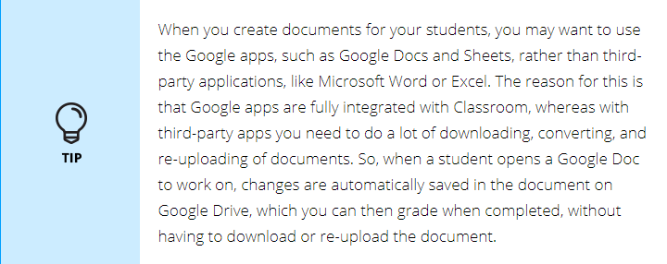

Does it work well within Auchenharvie?

Google Classroom/Google Drive is part of the Digital Literacy course delivered to our students. By 2025 all our students will be taught how to use these digital platforms and will be using them confidently withing the classroom and at home, where applicable.

S1 and S2 have experienced the new digital literacy course and this will continue. Students enjoy using the platform and confident using all aspects within the classroom.

CPD will be offered to staff to build their confidence using Google classroom and google drive.

