Auchenharvie Academy
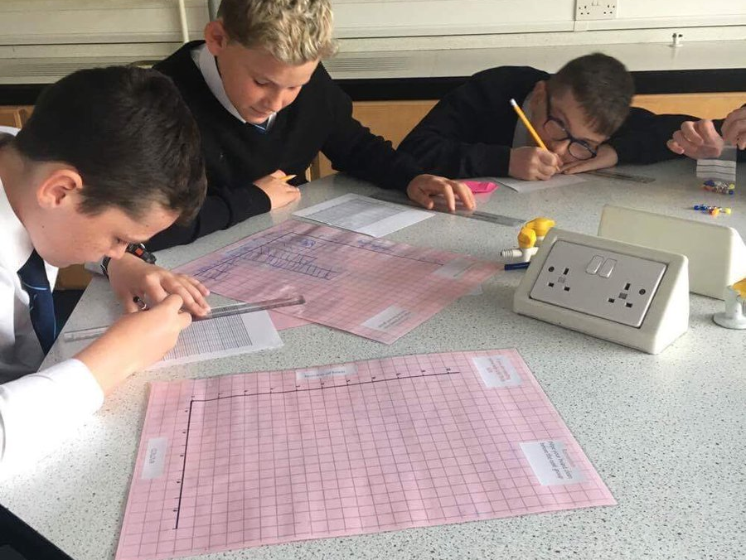

Study Skills

A guide for Pupils and Parents/Carers

How to Study
- Manage your time – make a weekly study schedule and devote a certain amount of time per day to studying.
- Pace Yourself – Find the best speed for you to study and adjust accordingly.
- Get enough sleep – make sure in your study schedule you set aside enough time to sleep. Studies have shown that sleep positively impacts tests and exams by improving memory and attentiveness.
- Clear your mind of anything that doesn’t have to do with the topic you’re studying – if you have a lot on your mind then write it down prior to studying to try and clear your mind.
- Eliminate electronic distractions – if you are easily distracted by Facebook, Twitter etc then download one of the available applications to instantly block notifications while you’re studying. You can turn this off once you’ve finished.
Creating Your Study Space
- Find a good study spot – you should choose somewhere where you feel comfortable so studying becomes enjoyable. Try not to be too comfortable though as you will risk falling asleep! Wherever you choose should be clear from distractions and relatively quiet.
- Choose background music carefully – Music can be beneficial to your studying by helping you to be calm, elevating your mood and motivating you. Stick to instrumental music – music without lyrics.
- Listen to background sounds – Natural sounds like waterfalls, rain and thunder can keep you focused and block out other sounds.
- Keep the television turned off – This can significantly distract you and make you focus on the tv show/film instead of your work.
- Snack smart – Eat healthy, nutritional foods while you study and drink plenty of water.

Coping With Exam Stress – SQA Guidelines
Exam season can be an overwhelming and tough time so here are some tips to handle exam stress.
- Be prepared
One of the best ways to relieve exam stress is to feel in control so:
- start revising well in advance
- study using official past papers
- create your own study plan
- Put it into perspective
It may feel like your whole life depends on your exam results but try not to worry too much. Focus on the task at hand and work to your best ability.
No matter the outcome of the exams, you'll have a lot of options to help you move forward.
- Keep yourself healthy
In the rush of exams and revision, remember to keep your mind and body healthy by exercising regularly - it's a well-known stress buster.
Snack on foods that help your brain function better and provide slow-releasing energy like wholegrain, fruit and nuts.
Coffee and energy drinks can help you feel more awake but too much can make you lose concentration and not get a good night of rest. Try to limit your intake and drink plenty of water to keep you hydrated.
We can only study properly for around 45 minutes at a time before we lose concentration and absorb less information so know when you need a break.
Get the most out of your revision by studying in small, focused chunks and take regular breaks when you get tired. Go for a walk or have a snack and get yourself energised for the next round of studying.
Effective Methods of Studying
Mind Map
Steps to Creating a Mind Map
- Create a Central Idea. The central idea is the starting point of your Mind Map and represents the topic you are going to explore
- Add branches to your map. The next step to get your creative juices flowing is to add branches
- Add keywords
- Colour code your branches
- Include images
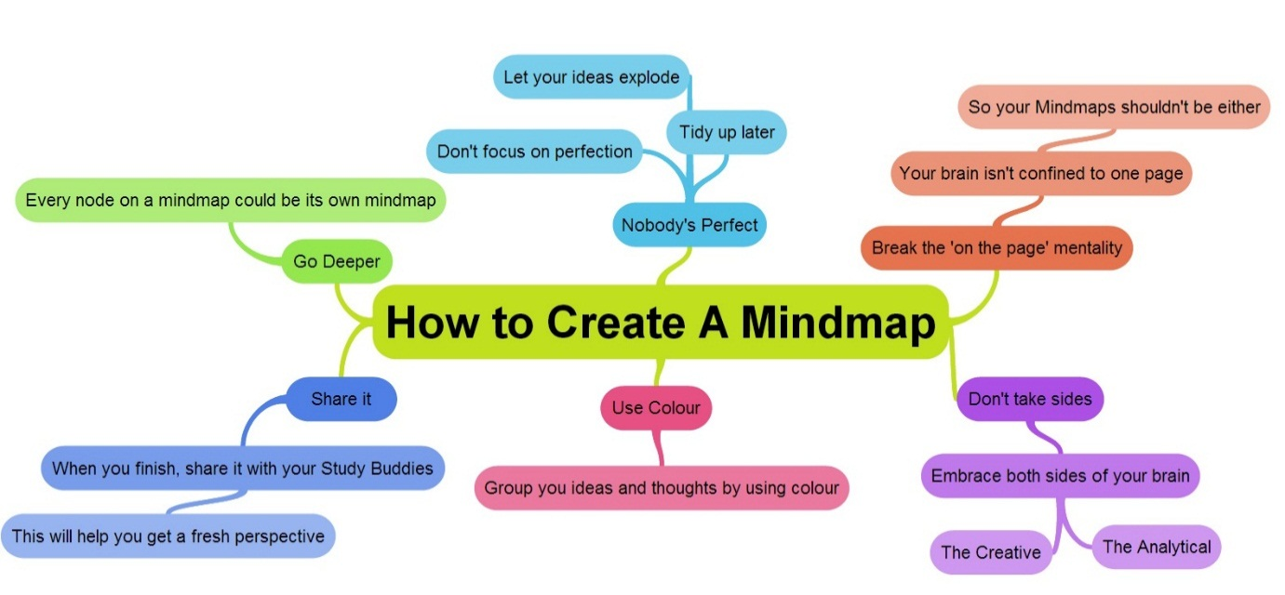
Spider Diagram
Spider diagrams are often used by teachers to help children make notes on a particular subject. A picture or word may be put in the middle of the page and then several 'legs' drawn radiating outwards. Children then need to write words or phrases about the object in the centre.
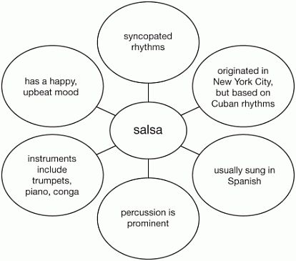

Summarising of Material
One good way to study is to write the material in your notes in your own words. That way you can think about it in your own terms instead of textbook language. This deepens the understanding of the work.

Making Flash Cards
Place a question, term or idea on one side and the answer on the opposite side. These can be carried around with you and used wherever is convenient.

Highlight important Details
Use a highlighter or underline the most important points in the body of the text, so that you can spot them more easily when you review the material. Be careful not to highlight everything – this defeats the purpose.

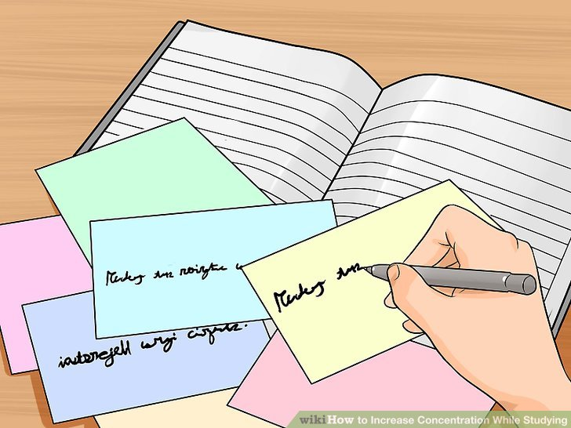

Faculty of Science

Suggested Revision Resources
Biology
Websites
http://www.bbc.co.uk/education/subjects/z3ykjxs - National 4 Biology
http://www.bbc.co.uk/education/subjects/zync87h - National 5 Biology
http://scholar.hw.ac.uk/ - Higher Human Biology (students require a log in, which they can obtain from their class teacher)
http://www.sqa.org.uk/pastpapers/findpastpaper.htm?subject=Biology&level=N5 – SQA link to National 5 Past Papers and Marking Schemes
http://www.sqa.org.uk/pastpapers/findpastpaper.htm?subject=Human+Biology&level=NH – SQA link to Higher Human Past Papers and Marking Schemes

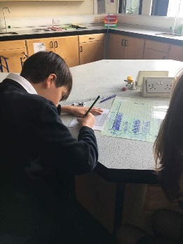
The books (listed below) are available at local libraries, school library and available from Amazon. Textbooks and student guides are available for use in school from the Science department at any additional supported study sessions.
National 5 Biology by James Torrance
How to pass National 5 Biology (How to Pass) by Graham Moffat
National 5 Biology (BrightRED Study Guide) by Margaret Cook
How to Pass Higher Human Biology by Graham Moffat
Higher Human Biology for CfE Textbook by Clare Marsh
Past Paper books are available for purchase through Amazon, however they can be downloaded free of charge from the SQA links above.

Chemistry
http://www.bbc.co.uk/education/subjects/zhvycdm - National 4 Chemistry
http://www.bbc.co.uk/education/subjects/zmnp34j - National 5 Chemistry
http://scholar.hw.ac.uk/ - Higher Chemistry (students require a log in, which they can obtain from their class teacher)
https://www.evans2chemweb.co.uk/ National 3 to Higher Chemistry. Requires a username and password, which can be obtained from their teacher.
http://www.sqa.org.uk/pastpapers/findpastpaper.htm?subject=Chemistry&level=N5 – SQA link to National 5 Past Papers and Marking Schemes
http://www.sqa.org.uk/pastpapers/findpastpaper.htm?subject=Chemistry&level=NH – SQA link to Higher Past Papers and Marking Schemes
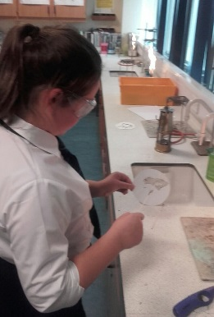
The books (listed below) are available at local libraries, school library and available from Amazon. Textbooks and student guides are available for use in school from the Science department at any additional supported study sessions.
How to Pass National 5 Chemistry by Barry McBride
National 5 Chemistry by John Anderson
National 5 Chemistry Success Guide by Bob Wilson
National 5 Chemistry Student Book by Tom Speirs
Higher Chemistry for CfE by Eric Allan
Higher Chemistry: Revision Notes and Questions by John Anderson
How to Pass Higher Chemistry for CfE by John Anderson
CfE Higher Chemistry (Bright Red Study Guide) by Archie Gibb and David Hawley William Beveridge
CfE Higher Chemistry Success Guide by Bob Wilson
CfE Higher Chemistry Grade Booster by Tom Speirs
Test your Higher Chemistry Calculations by John Anderson
Past Paper books are available for purchase through Amazon, however they can be downloaded free of charge from the SQA links above.
Physics
http://www.bbc.co.uk/education/subjects/znb39j6 - National 4 Physics
http://www.bbc.co.uk/education/subjects/z6fsgk7 - National 5 Physics
http://scholar.hw.ac.uk/ - Higher Physics (students require a log in, which they can obtain from their class teacher)
http://smarshallsay.weebly.com/ - National 4, National 5 and Higher Physics
http://mrmackenzie.co.uk/national-5/ - National 5 Physics
http://mrmackenzie.co.uk/higher-revision/ - Higher Physics
http://www.sqa.org.uk/pastpapers/findpastpaper.htm?subject=Physics&level=N5 – SQA link to National 5 Past Papers and Marking Schemes.
http://www.sqa.org.uk/pastpapers/findpastpaper.htm?subject=Physics&level=NH – SQA link to Higher Past Papers and Marking Schemes
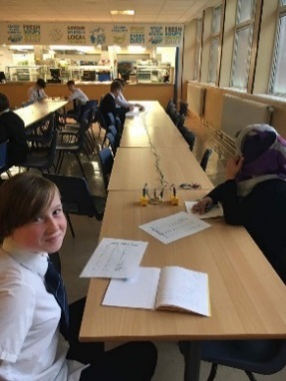
The books (listed below) are available at local libraries, school library and available from Amazon. Textbooks and student guides are available for use in school from the Science department at any additional supported study sessions.
How to Pass National 5 Physics by Paul Chambers
National 5 Physics Student Book by Steven Devine
National 5 Physics Success Guide by John Taylor
National 5 Physics by Arthur Baillie
National 5 Physics (BrightRED Study Guide) by Paul Van der Boon
Higher Physics CfE by Paul Chambers
How to Pass Higher Physics by Paul Chambers
CfE Higher Physics Grade Booster by John Irvine
CfE Higher Physics (BrightRED Study Guide) by John Taylor
CfE Higher Physics Success Guide by Michael Murray
CfE Higher Physics Student Book by David McLean
Faculty of Mathematics & Numeracy

Websites for National 5 Maths
www.national5maths.co.uk - best site to revise National 5 Maths. It has notes, practice papers, topic by topic worksheets.
BBC Bitesize – This website provides online resources for teaching and learning Mathematics.
BBC Skillswise Maths – A free to access website for Teachers, parents and pupils, with printable worksheets, factsheets and online games, videos and quizzes.

Websites for Higher Maths
www.mathsrevision.com - powerpoints on all higher topics
www.hsn.uk.net - Higher notes- practice papers
www.bbc.co.uk/bitesize/higher/maths/ - revision questions
www.allsaints-sec.glasgow.sch.uk - Exam questions topic by topic
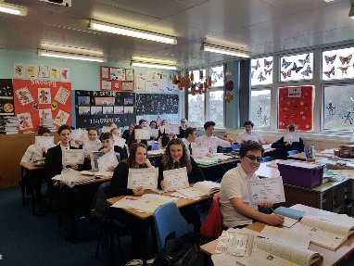

Faculty of Social Subjects & RMPS

Suggested Websites for Senior Phase:
For all certificate courses past papers can be found at: https://www.sqa.org.uk/pastpapers/findpastpaper.htm
Marking instructions can also be found to check answers/support revision.

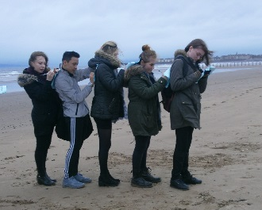
Geography
National
http://www.bbc.co.uk/education/subjects/znbw2hv
Higher
http://www.bbc.co.uk/education/subjects/zmhs34j

History:
National
http://www.bbc.co.uk/education/subjects/z2phvcw
http://thegordonschools.typepad.co.uk/history/national-54/
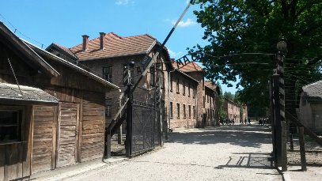
Higher/National
https://mrmarrhistory.wordpress.com/
Higher
http://www.bbc.co.uk/education/subjects/zxpfb9q

Modern Studies
National
http://www.bbc.co.uk/education/subjects/zxsnb9q
Higher
http://www.bbc.co.uk/education/subjects/ztsvr82

RMPS

National/Higher
https://learningrmps.wordpress.com/category/national-45/national-5-assignment/

National
http://www.bbc.co.uk/education/subjects/z2dmyrd

Higher
http://www.bbc.co.uk/education/subjects/z782fg8

Faculty of Technologies

All subjects within the Faculty would recommend using BBC bitesize - Simply search for the appropriate subject

All subjects within the Faculty would recommend using SQA WEBSITE - Simply search for the appropriate subject

These are subject specific ones:

Design & Manufacture

- http://www.sqa.org.uk/sqa/46005.html
- http://technologystudent.com
- http://www.ergonomics4schools.com/index.htm
- http://www.bbc.co.uk/schools/gcsebitesize/design/
- http://www.ltscotland.org.uk/stemcentral/index.asp
- www.designmuseum.org
- www.dyson.co.uk/education
- http://www.designcouncil.org.uk
- http://www.ellenmacarthurfoundation.org
- http://www.alessi.com/en/company/history

Business Education

- Business Studies online
- https://www.tutor2u.net/

Computing Science

- https://www.codecademy.com/
- https://www.w3schools.com/

Graphic Communication

- http://technologystudent.com
- http://designclass.co.uk/

Faculty of English, Literacy & Modern Languages

English
All levels
Reading for Analysis and Evaluation and Textual Analysis - BBC Bitesize website.
Critical Essay- Sparknotes and Shmoop have helpful notes and analysis. Searching the text on youtube can also provide video analysis of texts.
Pupils also have access to Scholar which is an online revision source for all elements of the exam.

Modern Languages
Helpful revision websites for National 5 and Higher:
www.languagesonline.org.uk
www.linguascope.co.uk
www.zut.or.uk
www.duolingo.com
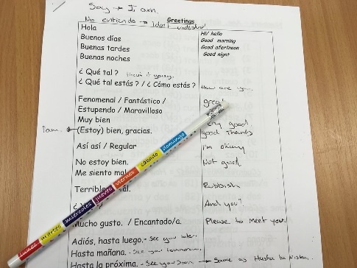

Faculty of Expressive Arts

Music
Understanding Music
National 5, Higher and Advanced Higher Pupils can access past papers and their marking schemes at www.sqa.org.uk/pastpapers
Final Understanding Music examinations for all levels take place in May.
Pupils can access the following online:
- mymusiconline.com
- logging onto Spotify and following teachers for their playlists
- Using concept dictionaries and looking for examples on YouTube
- Quizzes on Kahoot

Performance
Pupils are encouraged to attend supported study for additional practice on their instruments. This is on every lunch time and after school.
A reminder that National 5 and Higher final practical examinations take place in February/March.
Advanced Higher final practical examinations take place in May.
