MCR Pathways is a school-based mentoring programme that connects young people who need additional encouragement and support with caring, adult mentors. We recruit, train and support volunteer mentors who meet their mentees weekly, in school, for a minimum of a year.

Mentoring is at the core of the MCR Pathways Programme. Mentors are matched with a young person who they meet for an hour a week to listen and provide encouragement. Mentors help their young person engage with their education and build the self-belief they need to leave school to a positive destination. Before mentoring, only 54% of care-experienced young people left school to a job, college or university while in 2018, 86% of MCR’s mentored young people did.

In Auchenharvie Academy the Young North Ayrshire Talent programme helps young people through group work and relationship based 1:1 mentoring. Our school has a full-time Pathways Co-ordinator, Stephanie Craig, who develops, facilitates and oversees the individual requirements of each young person on the programme.
_________________________________________________________________________

Mentoring
Each young person is matched with their own mentor - who only works with them - from S3 onwards. Pupils meet with their mentor once a week for 50 minutes and receive guidance and support. Mentors build relationships, confidence and self-esteem, which are the prerequisite to helping young people find their talents.

“Just before lunch I always get tired, but then I remember my mentor is coming last period and it perks me up” - S3 Auchenharvie young person

“It gives me a break from all my classes and I like being able to talk about anything on my mind.” –
S6 Auchenharvie young person

Group Work
S1 and S2 young people work with their Pathways Coordinator and participate in weekly group work sessions. These are focused on building confidence and life skills, and also improving Literacy and Numeracy levels. This allows the Coordinator to build trust and an individual relationship with each young person, preparing them for mentoring when they reach S3.

“I like to come into group work and nobody will judge me. We can have big discussions all together.” S1 Auchenharvie young person

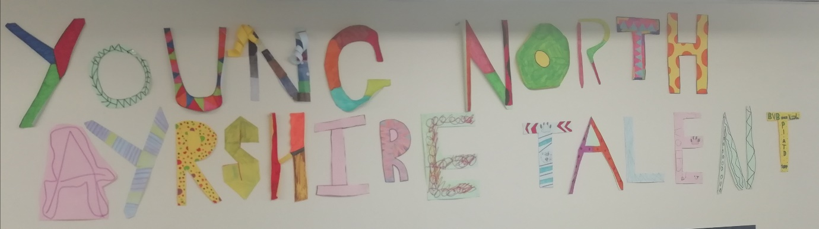

We are actively looking for mentors in North Ayrshire. If you are interested in becoming a mentor please visit our website to register for more information at www.mcrpathways.org

