Health and Wellbeing Strategy
Auchenharvie Academy
2017-2018

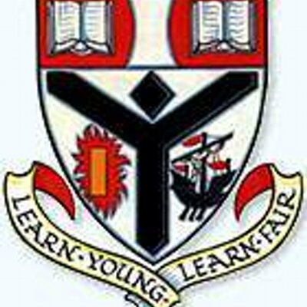

Auchenharvie Academy
Health and Wellbeing Across learning
2017-18

 | Good Practice across learning that links HWB E’s and O’s with GIRFEC principles and SHANARRI wellbeing indicators | Staff | Timescale | Intended impact | Monitoring progress
Pupils | Continue to work through Broad and varied BGE curriculum in PE/HE with assessment focused around benchmarks.  Pupil HWB council to encourage new members to get involved  Continue to deliver Scottish Diet programme in HE with assessment focused around benchmarks.  External agencies input in HE to continue eg Junkfood Roadshow and local chefs  Continue to deliver HWB unit of work in PSE lessons as well as wider topics covering Planning for Choice and Changes, Substance Misuse, Relationships, sexual health and parenthood.  HWB topics included in House assemblies  Participation in BNF Health Week Challenge link this with Whole school HWB event  Pupils complete PASS Survey  Rights respecting school award – Level 1  Auchenharvie Academy Eco School  HWB participation clubs (PEF)  S6 Buddy programme  Breakfast club for Nurture Group | All HWB staff  Active Schools and Young Ambassadors  All HE staff  FH HWB and HE staff  All PSE staff  FH/SLT/House Reps  All HWB staff/ whole school staff  Mr Scholes  Mr Scholes and steering group  Eco - committee  HWB FH/Active schools/ staff  SLT/ESB/probationer  Ms Davis/Pastoral Care | Jan’17 –Aug ‘17  Aug ’17 – June’18  Aug’17 – June’18  Feb/March ‘18  Aug’17 -April’18  Aug’17 –June’18  June ‘18  Aug’17 –June’18  Aug ’17 – June’18  Aug’17 – June ‘18  Aug ’17- March ‘18  Aug’17 – June’18  Aug’17 –June’18 | Pupils MESP wellbeing developed  Evaluate progress of impact of 2015/16 council  Pupils educated on healthy eating and taking this into later life  Pupils educated on healthy eating and taking this into later life. Pupils work with chefs to develop skills for life and work. Chef visit can also inspire pupils to follow career path in hospitality.  Importance of sleep, drinking water, healthy eating, staying active encouraged and re-inforced to all pupils  Speakers, coursework to engage pupils in thinking about their future.  Pupil awareness of whole school approach to HWB  Encourage pupils to evaluate their levels of physical activity and diet habits. Engage pupils in setting themselves new targets/trying something new.  Data to be collected and used to help delivering HWB across learning and topics for PSE lessons  Implement action plan and making good progress towards embedding the principles and values of UNCRC into the ethos and curriculum following the 4 RRSA standards  Eco code implemented showing the whole schools ambition and commitment to improve our school, learning and community environment  PEF pupils identified participate in clubs chosen by them. Improved activity and attendance levels and overall HWB.  Support for new S1’s others from nurture group  Pupils can come in, chat and have breakfast to give them a positive start to the day. | BGE assessment and Pupil Voice  Regular meetings and feedback shared with dept and whole school  BGE assessment and pupil conversations  Pupil knowledge/pupil destinations.  Pupil/staff feedback sheets completed  Pupils/staff evaluations  Collation of PASS Survey Data  Action plan, pupil voice, self –evaluation tasks, minutes of meetings  Pupil voice, self evaluation tasks, minutes of meetings  Pupil questionnaires/ data  Pupil/Staff feedback  Pupil feedback
Staff | HWB working group to plan and implement whole school HWB event to be held in Jun’18. Link with BNF Health Week  CPD opportunities for staff who are delivering specific HWB topics in skills/PSE  HWB Monthly Newsletter emailed every 3rd Monday | HWB working group staff/active schools/ outside agencies  Whole school staff  FH/HWB working group member | Jan ’18 – June’18  Ongoing  Aug’17 –June’18 | Whole school awareness of HWB across learning  Staff fully engaged with delivery of HWB across learning  Staff confident in the delivery of these topics  Staff awareness of whole school approach to HWB | Staff/pupil feedback  Staff/pupil feedback  Staff feedback
Parents/Carers | Parental HWB event (evening) run inconjuction with pupil HWB event  Parents have opportunity to engage in pupils HWB experiences through attendance at school sports fixtures and social media  Extra-curricular programme discussed and promoted at parents evenings and in reports | HWB working group/Outside agencies  Staff leading extra-curricular  HWB staff | Jan’18  Ongoing  Ongoing | Parental awareness of HWB topics delivered in school. Parents knowledge increased in these areas  Parental awareness of pupil opportunities provided  Parental awareness of pupil opportunities provided | Parent feedback/survey  Parental/teacher discussion  Parental/teacher discussion

