Auchenharvie Academy (Public)
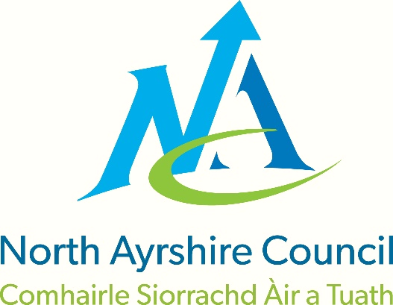
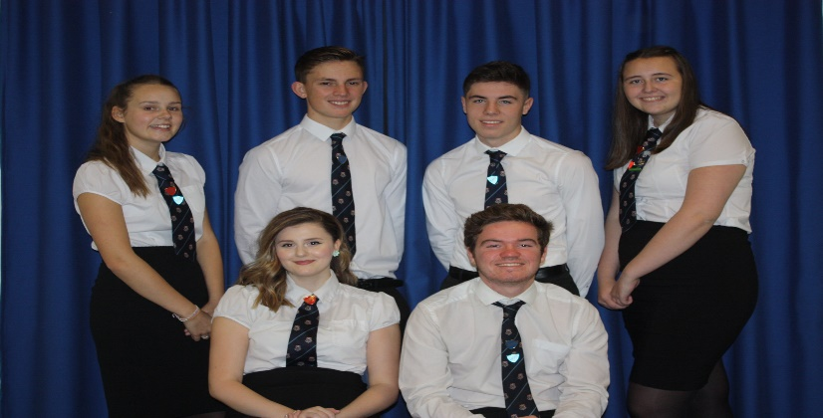

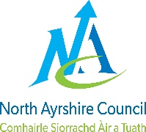 | North Ayrshire Council
 | Education & Youth Employment: Standards & Quality Report
 | Establishment: | Auchenharvie Academy | Session: | 2016-17

Our school:

Auchenharvie Academy is a comprehensive secondary school serving the towns of Stevenston and Saltcoats (south). With a school roll of 652 pupils we have 54.8 teaching staff and are well resourced with ASN staff throughout the school. Auchenharvie Academy has had eight Head Teachers in the past twelve years and four in the past five years. This has made long term strategic planning very difficult.
The priorities for school improvement throughout this session were devised in consultation with all teaching staff, identified groups of pupils and through open invitation to all parents.
All teaching staff were consulted on their vision for our school and through this professional dialogue key priorities emerged for short, medium and long term school improvement. Equally, pupil focus groups were convened to discuss how ‘life as a learner’ in Auchenharvie Academy could be improved. In addition, an open invitation was sent to all parents/carers to meet the new Head Teacher to discuss our school vision and aims and also the key areas for improvement. Strong cognisance of the NAC directorate plans was also considered in constructing the School Improvement Plan (SIP).
Following all consultation it became very clear that in order to maximise school improvement the key areas of focus would be: school ethos and positive relationships, high quality teaching and learning, approaches to self-evaluation, establishing consistent approaches to enhancing literacy and numeracy across the school and on making connections in learning which links classroom experiences to the world of work and employment opportunities.
Our Vision/Aim is…
To provide an equitable and excellent learning environment for ALL pupils which maximises their full potential and supports them into appropriate, positive and sustainable destinations.

Our Values
Respect Equality Determination

School Priority 1: We are reducing inequalities and delivering improved outcomes for children and young people.

National Improvement Framework Priority  - Improvement in attainment, particularly in literacy and numeracy  - Closing the attainment gap between the most and least disadvantaged children  - Improvement in children and young people’s health and wellbeing  - Improvement in employability skills and sustained, positive school-leaver destinations for all young people | How Good is Our School? (version 4) Quality Indicator  1.3 / 1.5 / 2.1 / 2.4 / 2.5 / 3.1 / 3.2
Progress, impact and evidence:
To support the wellbeing of our young people and to help reduce the impact of inequalities we have taken a series of important steps this session. We aim to make sure that these improve outcomes for our pupils and their families.

√ We have produced a Positive Relationships Policy to support all of our pupils in their learning.
√ Staff development in Nurturing Approaches and Restorative Practice.
√ Pupil led review of whole school values.
√ Appointment of Principal Teacher of Family Learning.
√ Appointment of additional Area Inclusion Officer.
√ Implementation of our ‘Parental Empowerment’ programme.
√ Preparation for implementation of the ‘Parents in Partnership’ programme in collaboration with CELCIS and the NAC Family Learning team.
√ Enhanced self-evaluation systems leading to improved data relating to the wellbeing needs of our pupils.
√ Revise approaches to pupil planning meetings now referred to as ‘Team Around the Child (TAC)’ meetings.
√ Appointment of a school counsellor.
√ Implementation of our school ‘House’ system allowing for more targeted approaches to all aspects of pupils pastoral welfare and progress in learning.
√ Participatory budgeting exercise relating to the spending of finances allocated through the Pupil Equity Fund (PEF).
Next Steps:
√ Implementation and constant evaluation of Positive Relationships Policy.
√ Working towards national accreditation as a Rights Respecting School.
√ Continue to work towards becoming a ‘Nurturing’ school through creation of Nurture base and continued staff development.
√ Improved focus on improving school attendance.
√ Implementation of our Family Learning strategy to increase capacity to support learning at home.
√ Creation of methods for tracking pupil participation/inclusion in the wider life of the school.
√ Expansion of House system to promote improved school ethos and greater pupil inclusion.
√ Review of PSE programme allowing a more data focussed approach to tackling local issues.
√ Creation and implementation of whole school Anti-Bullying policy.
√ Deliver on plans to utilise finances associated with the Pupil Equity Fund (PEF).

School Priority 2: High quality learning and teaching is taking place in our school.

National Improvement Framework Priority  - Improvement in attainment, particularly in literacy and numeracy  - Closing the attainment gap between the most and least disadvantaged children  - Improvement in children and young people’s health and wellbeing  - Improvement in employability skills and sustained, positive school-leaver destinations for all young people | How Good is Our School? (version 4) Quality Indicator  1.2 / 1.3 / 1.5 / 2.2 / 2.3 / 3.2
At Auchenharvie Academy we recognise that the single greatest factor in maximising pupils’ school experience is the quality of the teaching and learning they receive. We place great importance on this and proactively seek to improve the standard of teaching and learning in our school on a daily basis.
Progress, impact and evidence:
√ We have revised our whole school Curriculum Rationale in consultation with pupils, parents/carers, staff and partners and this provides the framework for all staff in the context of curriculum planning and development.
√ In order to improve the consistency of teaching and learning in our school we have provided internal and external training for all of our staff. This has looked at the use of data to enhance teaching and learning and about the fundamentals of teaching methodologies.
√ To increase pupils taking responsibility for their own learning we have introduced formal learning conversations for all pupils where they can sit and discuss progress and next steps with their teacher.
√ We have introduced formal opportunities for staff across our school to share best practice in teaching and learning and will continue to do so on a formal and informal basis.
√ Our staff have worked with colleagues in the North Ayrshire Professional Learning Academy on programmes for improving literacy and numeracy and these are being rolled out across our school.
√ We have given careful consideration to the best opportunities for wider achievement in our curriculum and will build this into our curriculum offering in session 2017/18.
√ To allow our pupil to contextualise their learning and apply their skills in a variety of contexts our staff have created programmes of Interdisciplinary Learning from S1-3.
√ A very wide range of leadership opportunities have been created for pupils in Auchenharvie. These relate directly to curriculum and extra-curricular activities and involve pupils from all stages of the school.
√ We have delivered a highly successful Science transition programme aimed at supporting colleagues in primary to better deliver aspects of the Science curriculum. This has involved strong collaboration between primary and secondary colleagues.
√ We have appointed a Principal Teacher of Data Analysis as part of the Scottish Attainment Challenge funding and he is helping to support staff to analyse data more efficiently to plan for more effective teaching and learning.
Next Steps:
√ We will create a whole school policy on learning and teaching which draws upon best practice locally and nationally and provides practical guidance on improving consistency in all areas of the school.
√ We will create a whole school homework policy which standardises the volume and complexity of homework issued to pupils at all stages of the school.
√ To further improve parental engagement we will purchase the ‘Show My Homework’ software which allows greater transparency between home and school in this important area of school life.
√ We will roll out year 1 of our whole school strategies on Literacy/Numeracy/HWB/ Digital Literacy.
√ Our staff will continue to develop their BGE Curriculum and will undertake significant moderation activity relating to planning, learning, teaching and assessment.
√ We will conduct a whole school audit of our BGE curriculum in relation to national experiences and outcomes. This will consider all contexts for learning and outdoor learning. This will allow us to plan for future curriculum developments.
√ To provide more inclusive approaches to STEM opportunities key staff will work towards the implementation of a whole school STEM strategy. This will take into consideration local and national guidance.
√ Our staff will undertake further training on the using of Higher Order Thinking Skills (HOTS) in their daily practice. This will help create more in class opportunities for independent and autonomous learning experiences.
√ We will continue to develop our interdisciplinary learning programme based on our experiences this session.
√ Continuing our work with Cluster colleagues, we will expand the work already underway in Sciences and include the Technologies into our collaborative work with primary colleagues.
√ We will explore the possibility of removing ‘Registration’ and replacing this with ‘personal support’ time where pupils will have specific time to work with a designated teacher on discussing and improving key aspects of their learning and school performance.

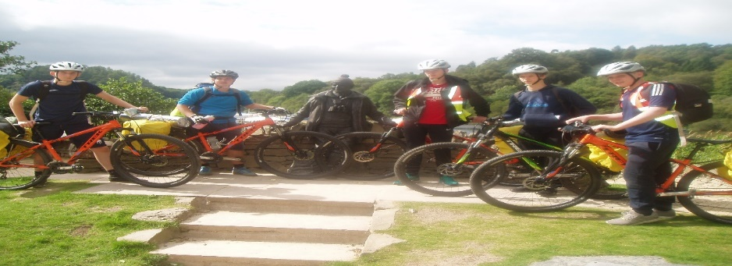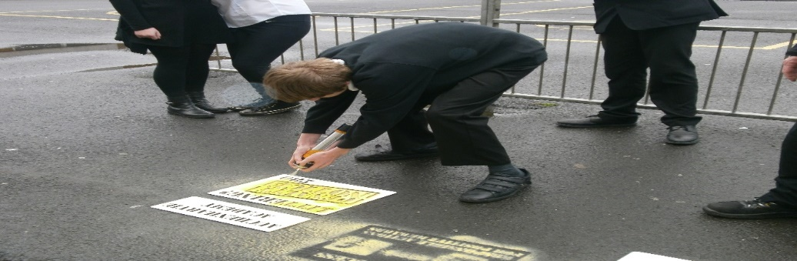

School Priority 3:Self-evaluation and performance improvement are embedded throughout our school.

National Improvement Framework Priority  - Improvement in attainment, particularly in literacy and numeracy  - Closing the attainment gap between the most and least disadvantaged children  - Improvement in children and young people’s health and wellbeing  - Improvement in employability skills and sustained, positive school-leaver destinations for all young people | How Good is Our School? (version 4) Quality Indicator  1.1 / 1.3 / 2.3 / 3.2
A number of key steps have been taken to reintroduce and enhance aspects of self-evaluation to the culture and practices within our school. This will continue to be a strong focus of our improvement in the coming session.

Progress, impact and evidence:
√ Creation and implementation of short term self-evaluation quality assurance calendar which focusses the evaluative work undertaken by staff from across the school.
√ Improved staff awareness of national documentation on self-evaluation (HGIOS4) and this is now being used to assist with evaluative activities and judgements across the school.
√ Increased use of pupil focus groups and Pupil Council to assist with identifying priorities for school improvement.
√ Implementation of measures to gather the views of parents/carers about school performance and priorities for school improvement.
√ Introduction of staff peer observation to enhance the consistency of teaching and learning across Auchenharvie Academy.
√ Facilitation of staff collegiate time to formally share best teaching practice and learn collaboratively from colleagues.

Next Steps:
√ Implementation of full year programme of quality assurance which incorporates key aspects of school improvement and focusses on equity and excellence in line with our school vision.
√ Creation and implementation of whole school policy on self-evaluation which incorporates the key features from HGIOS4.
√ We will consult upon and implement more rigorous approaches to the monitoring of teaching and learning including looking at intra and inter faculty learning rounds.
√ We will establish an internal staff Leadership Academy based upon data collected form self-evaluation including learning and teaching and staff professional development.
√ We will embed our revised approaches to equitable access to ASN resources based on rigorous evaluation.

School Priority 4: Levels of attainment and achievement are improving for all learners.

National Improvement Framework Priority  - Improvement in attainment, particularly in literacy and numeracy  - Closing the attainment gap between the most and least disadvantaged children  - Improvement in children and young people’s health and wellbeing  - Improvement in employability skills and sustained, positive school-leaver destinations for all young people | How Good is Our School? (version 4) Quality Indicator  1.1 / 1.2 / 1.3 / 1.4 / 2.3 / 3.2
To enhance outcomes for all of our pupils a number of key steps have been taken this year. These will allow us to continue improving levels of attainment and achievement.

Progress, impact and evidence:
√ Our staff have developed their capacity to analyse data through training in national tools such as INSIGHT, GL assessment and CAT testing.
√ We have introduced ‘learning conversations’ as part of our tracking and monitoring procedures to increase pupil involvement in their own learning.
√ We have developed 3 year strategies for literacy, numeracy, health and wellbeing and digital technologies. These feature work to be undertaken across the school with pupils/staff/parents/cluster primaries and will impact on attainment for all pupils.
√ Our staff have reviewed their Broad General Education curriculum courses for S1-3 in line with national experiences and outcomes and in light of experiences of the first few years of National Qualifications.
√ We have revised our systems for monitoring and tracking pupil progress. We have streamlined our procedures to allow teachers to focus on planning learning for specific pupils.
Next Steps:
√ We will produce a whole school policy on tracking, monitoring and interventions which allows staff to use data more effectively to better plan specific learning and teaching.
√ We will implement a whole school Homework policy which will standardise the quantity of homework at various stages and levels across the BGE and Senior phase. This will also consider the ‘Show My Homework’ toolkit that we will purchase using PEF funding.
√ We will continue to use internal and external providers to support staff development in using data intelligently to inform teaching and learning.
√ We will focus strongly on improving literacy and numeracy for all pupils. We will be clear with all stakeholders about the nature of the Auchenharvie Poverty Related Attainment Gap (PRAG)
√ A major focus of our work will be on standardising levels of work in the BGE. This will involve significant collaboration between staff during departmental and collegiate time.
√ We will be introducing a targeted mentoring programme for individual pupils based on data collected to maximise attainment in SQA examination results.
√ We will continue to expand the wider achievement opportunities available to pupils based on labor market intelligence and local community priorities.
√ We will continue to expand the existing wide range of leadership opportunities available to pupils. These will include Digital Leaders, Rights Respecting Schools and Language and Sports Ambassadors.

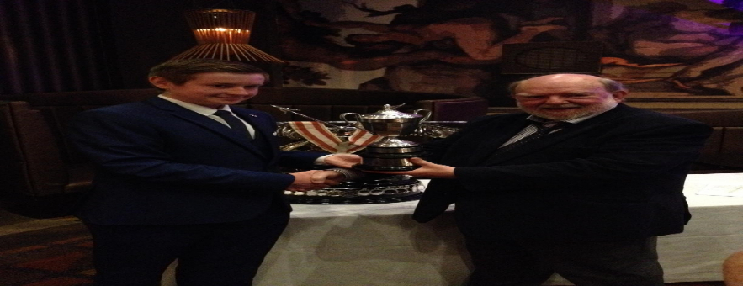
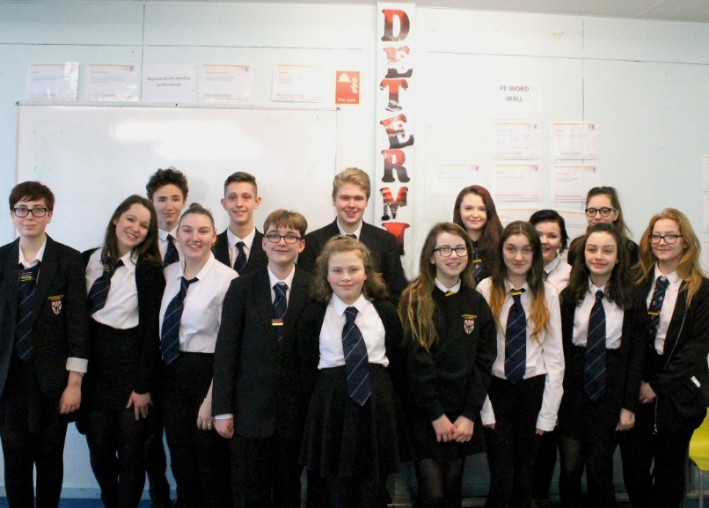
School Priority 5: High numbers of our young people are entering positive and sustainable destinations.

National Improvement Framework Priority  - Improvement in attainment, particularly in literacy and numeracy  - Closing the attainment gap between the most and least disadvantaged children  - Improvement in children and young people’s health and wellbeing  - Improvement in employability skills and sustained, positive school-leaver destinations for all young people | How Good is Our School? (version 4) Quality Indicator  1.5 / 2.2 / 2.7 / 3.3
Supporting our pupils into the most appropriate, positive and sustainable destinations is a key feature of our revised school vision and again a number of key steps have been taken this session to ensure that we are in as strong a position as possible to achieve this.

Progress, impact and evidence:
√ We have made considerable progress towards implementing the national Work Placement Standards (WPS) including a full review of our existing practice and a focus on pupils achieving credit for the work undertaken during their work placement.
√ We have provided considerable training to all staff on the new Careers Education Standard (CES) in collaboration with Skills Development Scotland.
√ All S6 pupils received a mock interview during this session from a local employer to help develop their employability skills.
√ As well as offering our own careers event attended by a host of external employers our pupils benefitted from a range of other local events allowing them to access a huge variety of employment links.
√ We delivered the first year of our Customer Service Programme in conjunction with Ayrshire College and Skillsforce and thanks to financial assistance from the Princes Trust. This involved S4 pupils achieving a variety of work based qualifications, including City and Guilds award, and the creation of our own ‘Higher Grounds’ coffee bar.
√ S4 pupils were also given the opportunity to apply for a Foundation Apprenticeship in either Engineering or Children and Young People. We have five pupils commencing this two year programme in session 2017/18 which will allow them to benefit from a strong programme of school and work based learning.
√ We have appointed a Principal Teacher of Developing the Young Workforce and he is working hard to build very strong links with local and national employers to make direct and sustainable links into our daily school curriculum.
Next Steps:
√ We will develop an action plan arising from our WPS evaluation which will allow us to make further progress in embedding this national expectation.
√ We are going to make alternative arrangements for the organisation and administration of work experience to allow for greater flexibility in finding ‘self-found’ placements.
√ We will ensure that there is a greater emphasis on monitoring pupil progress whilst on work placement. This will also help us to develop our relationships and contacts with the local employment market.
√ We will continue to embed the CES with a particular focus on individual departmental/subject input to curriculum activities.
√ All departments will develop a subject specific careers noticeboard and prepare a careers insert to be delivered to all pupils which contextualises the learning taking place in all areas of the school curriculum.
√ The Customer Service Programme will move into its second year with the ‘Higher Grounds’ coffee bar continuing. This year we will also add in a Nail Bar project which will continue to expand our offering in this area.
√ We will continue to support our pupils undertaking Foundation Apprenticeships and will again offer this exciting opportunity to pupils at the end of S4.

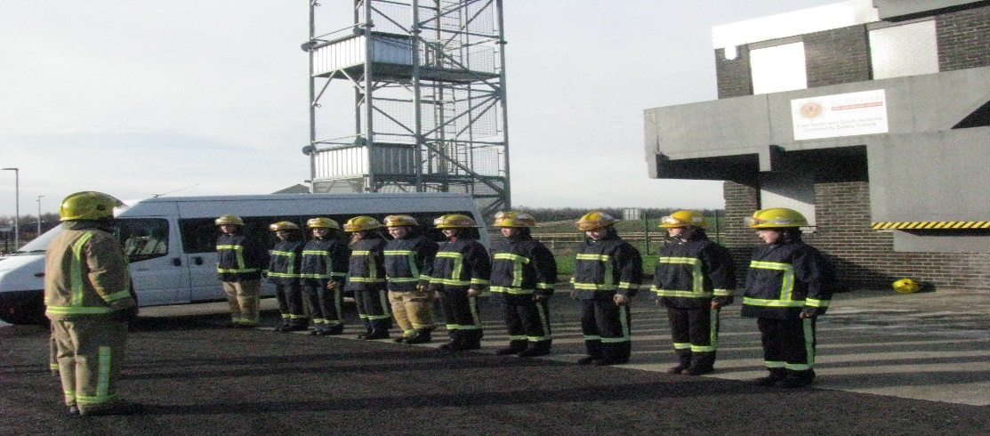

Overall Capacity For Improvement – strengths and next steps

Moving forward Auchenharvie has significant capacity for continuous improvement and staff and pupils will work tirelessly with our community to continue to deliver both on our school vision and our improvement agenda.

The key areas for medium and long term improvement at Auchenharvie Academy are:

- Developing our school ethos in relation to GIRFEC / Nurture / Restorative Practice.
- To continue to promote high quality teaching and learning particularly in literacy / numeracy / STEM areas.
- To develop whole school and departmental approaches to self-evaluation which are rigorous and robust and genuinely impact both on school improvement and on outcomes for our young people.
- To continue to raise attainment in both the BGE and the Senior Phase for ALL pupils.
- To fully embed the Work Placement Standards and the Careers Education Standards to enhance employability skills and increase sustainable pupil post school destinations.

