Standards and Quality Report 2018
Auchenharvie Academy
Our school vision/aim is…
To provide an equitable and excellent learning environment for ALL pupils which maximises their full potential and supports them into appropriate, positive and sustainable destinations.
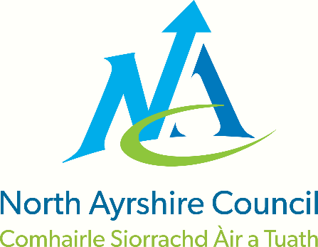
Our school values are…

Respect Equality Determination
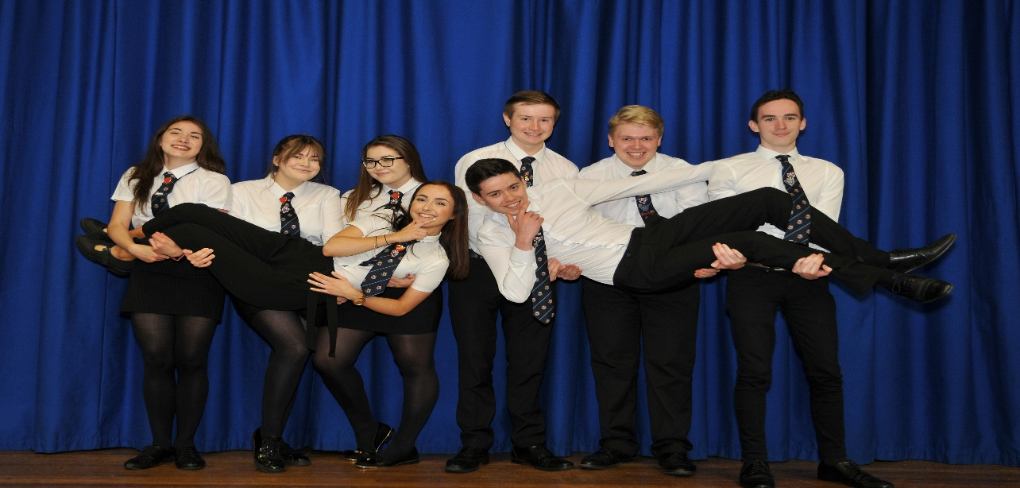

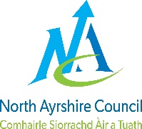 | North Ayrshire Council
 | Education & Youth Employment: Standards & Quality Report
 | Establishment: | Auchenharvie Academy | Session: | 2017-18

Our school:
Auchenharvie Academy is located in Stevenston and serves the communities of Stevenston and Saltcoats (South). We have 5 cluster primaries and in addition attract a small number of young people from other local primary establishments. We have worked hard to establish strong relationships with children, parents, carers and families as well as our links with the local community. We are working hard as a school to improve outcomes for learners and reduce inequalities for pupils and their families.

The school roll is currently 660 pupils. This is staffed by a Head Teacher, 3 Depute Head Teachers, 7 Curriculum Faculty Heads, 3 Principal Teachers of Pastoral Care, one Principal Teacher of Pupil Support and one Principal Teacher of Raising Attainment and Achievement and a total of 54.3 staff. We have also been allocated 6 classroom assistants who support learners effectively in class.

Auchenharvie Academy has benefitted from additional resources provided through the Scottish Attainment Challenge. We have appointed a ‘Data Coach’ and also a class teacher / classroom assistant who lead on Nurture provision in our school. We also work collaboratively with the North Ayrshire Council (NAC) Family Learning Team to support wider learning initiatives within our community.

Learning and teaching in the school is good or better in most cases however there is a need to move from good to excellent, to develop differentiation across all stages in order to develop learning at all levels and increase pace and challenge. Expectations for pupil attainment are improving with sound approaches to ensuring excellence and equity developing as part of our school culture, and pace and challenge is developing appropriately. A significant number of new appointments have been made in the latter stages of this session and we have high hopes that this will improve learning, teaching and overall attainment and achievement.

Throughout the course of this session Auchenharvie Academy has (in line with NAC policy) been involved in several local authority visits focussing on aspects of raising attainment and achievement, ensuring wellbeing equality and inclusion and teaching learning and assessment. These visits, whilst primarily very positive, have allowed for further external validation of future school improvement plan priorities.
Our priorities for school improvement throughout this session were devised in consultation with all teaching staff, identified groups of pupils and through open invitation to all parents. These are also in line with North Ayrshire Council priorities.

Our Priorities
- To reduce inequalities and deliver improved outcomes for children
- To provide high quality learning and teaching
- To embed self-evaluation and performance improvement
- To improve levels of attainment and achievement for all learners
- High numbers of our young people are entering positive and sustained post-school destinations

Pupil Equity Funding 2017-2018
For the academic session 2017-18, Auchenharvie Academy was allocated £127,200 as the part of the Scottish Government’s Pupil Equity Fund (PEF). The PEF amounts were based on the number of learners (112) in receipt of Free School Meals at the time of allocation and for each pupil in receipt of Free School Meals the school was allocated an additional £1,200. In line with advice from the Scottish Government, existing policy (namely the National Improvement Framework) was reviewed and consultations with all stakeholders (pupils, parents, partners and staff) were held to identify key priorities. These priorities have become our ‘PEF Streams’ and fall within the broad areas of: literacy and numeracy; health and wellbeing; family learning and engagement; and Developing the Young Workforce. Further detail of our PEF spending can be found on our school website.
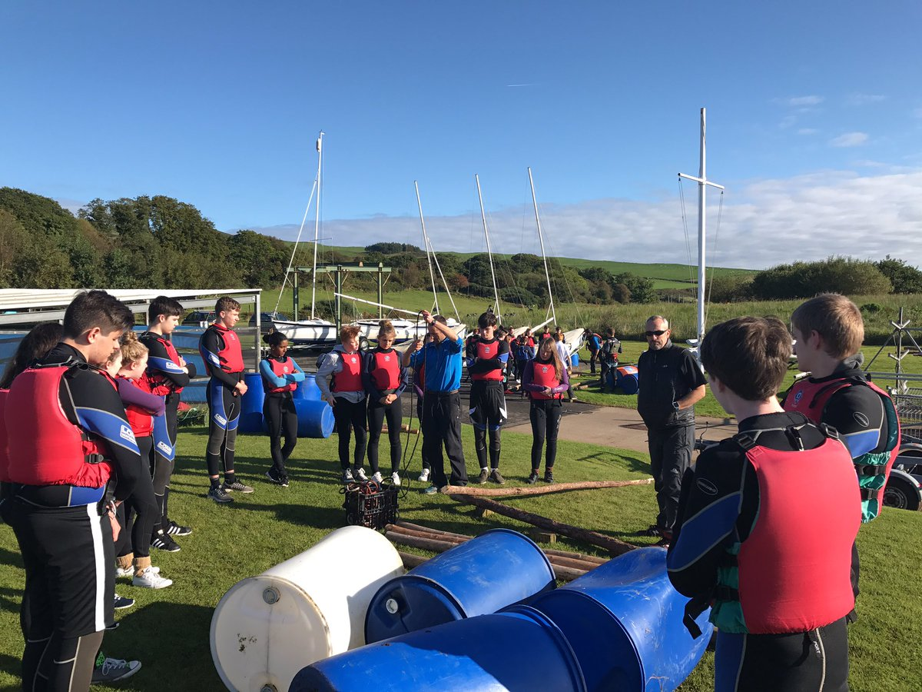

School Priority 1: We are reducing inequalities and delivering improved outcomes for children and young people.

National Improvement Framework Priority  - Improvement in attainment, particularly in literacy and numeracy  - Closing the attainment gap between the most and least disadvantaged children  - Improvement in children and young people’s health and wellbeing | How Good is Our School? (version 4) Quality Indicator  1.1, 1.2, 2.1, 2.5, 3.1, 3.2
To support the wellbeing of our young people and to help reduce the impact of inequalities we have taken a series of important steps this session. We aim to make sure that these improve outcomes for our pupils and their families.

Progress, impact and evidence:

We have:
- Implemented and evaluated our Positive Relationships policy focussing on choices and consequences.
- Implemented year 1 of our Family Learning / Parents in Partnership programme.
- Further enhanced our staff understanding of and improved our practices in nurturing approaches.
- Implemented our whole school attendance policy and improved whole school attendance by 2% this session.
- Developed a database to track pupil participation in the ethos and life of our school.
- Achieved the bronze level award for Rights Respecting Schools and are now working towards the silver award.
- Made significant progress in redeveloping our PSE programme.
- Completed a pupil self-evaluation of their own wellbeing and made appropriate interventions where required.
- Completed a participatory budgeting exercise relating to the spending of finances allocated through the Pupil Equity Fund (PEF).
- We have reduced our school exclusions considerably to maximise the educational experience of our young people and include them in the life of our school.
 | School Total excl incidents | S1 | S2 | S3 | S4 | S5 | S6
2017/18 | 26 (69) | 5 | 6 | 8 | 7 | 0 | 0
2016/17 | 27 (70) | 5 | 8 | 6 | 6 | 1 | 0
2015/16 | 160 | 11 | 14 | 123 | 12 | 0 | 0

Next Steps:

We will:

- Create a whole school HWB policy which has a key focus on mental wellbeing and mindfulness.
- Further embed our Positive Relationships policy with a key focus on the use of merits and recognising positive achievements.
- Establish an improved centralised information system that ensures that staff are fully informed about our young people and their needs.
- To continue to promote and progress Nurturing principles within the school through effective staff training.
- Commence the journey for silver status as a Rights Respecting School.
- Implement and launch of our whole school Anti-Bullying policy.
- Fully implement our revised policy and procedures to improve attendance.
- Develop a house ethos building programme which allows for greater celebration and inter-house competition within Ashgrove, Warner and Parkend.
- Improve the use of our data base to track pupil inclusion/ participation in the ethos and life of our school.
- Participate in the ‘Cost of the School Day’ initiative to help eliminate poverty from the educational experience of our pupils.
- Implement year 2 of our Family Learning / Parents in Partnership programme whilst involving more parents/carers in previous learning.
- Continue to reduce our school exclusions.

School Priority 2: High quality learning and teaching is taking place in our school.

National Improvement Framework Priority  - Improvement in attainment, particularly in literacy and numeracy  - Closing the attainment gap between the most and least disadvantaged children | How Good is Our School? (version 4) Quality Indicator  1.2, 1.3, 2.2, 2.3, 2.4
Progress, impact and evidence:

At Auchenharvie Academy we recognise that the single greatest factor in maximising pupils’ school experience is the quality of the teaching and learning they receive. We place great importance on this and proactively seek to improve the standard of teaching and learning in our school on a daily basis.

We have:

- We have continued to revise our whole school curriculum rationale in consultation with pupils, parents/carers, staff and partners and this provides the framework for all staff in the context of curriculum planning and development. We will continue to do this as we reflect on the effectiveness of our Senior Phase curriculum.
- Created and implemented and our whole school teaching and learning policy in line with educational research and in consultation with colleagues at North Ayrshire Council Professional Learning Academy.
- Implemented year 1 of our whole school numeracy strategy and partly implemented year 1 of our whole school literacy strategy.
- Implemented year 1 of our whole school HWB and digital literacy strategies.
- Delivered staff training and shared best practice on the use of Higher Order Thinking Skills (HOTS)
- Commenced a three year programme on the standardisation of planning, learning, teaching and assessment in the Broad General Education.
- Completed and audit of how experiences and outcomes are covered across our Broad General Education.
- Produced a whole school Sciences, Technologies, Engineering and Mathematics (STEM) strategy for implementation in 2018/19.
- Enhanced Inter-disciplinary learning within our Broad General Education curriculum.
- Discussed effective methods of incorporating Outdoor Learning within the Broad General Education curriculum.

Next Steps:

We will:

- Develop our departmental moderation of planning, learning, teaching and assessment in the BGE to improve confidence in teacher judgements.
- Develop capacity in our faculty heads to take adopt greater responsibility for improving quality of teaching and learning.
- Increase consistency in the use of Higher Order Thinking Skills (HOTS) in daily practice.
- Improve the use of differentiation in classroom teaching and learning to ensure the needs of all learners are being met consistently.
- In line with whole school policy we will increase consistency in the use of SLIPP model across our school to maximise pupil experiences.
- Implement and evaluate our whole school Homework policy.
- Implement year 1 of our STEM strategy to increase awareness /and improve experiences in the STEM subjects.
- Implement year 2 of our Literacy / Numeracy / Digital Literacy / HWB strategies.
- Participate in the national initiative ‘I am Jack’ within S3 PSE classes.

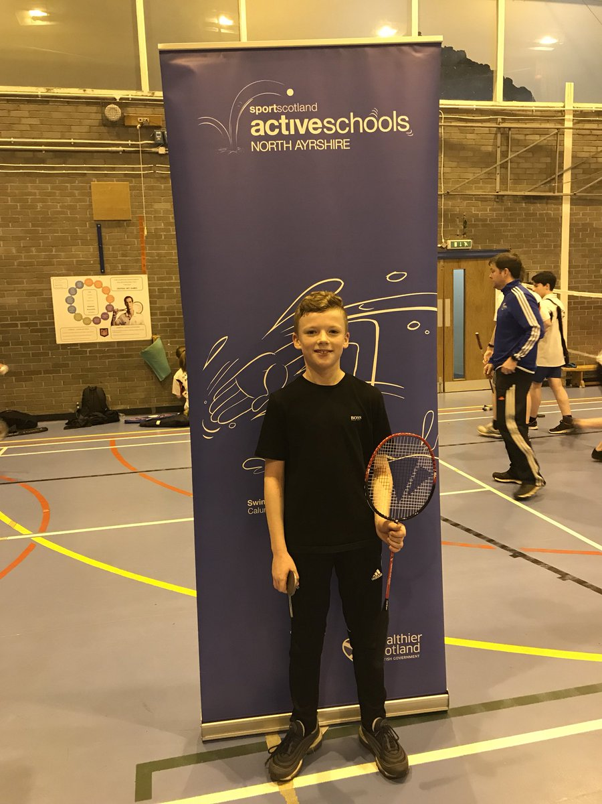

School Priority 3:Self-evaluation and performance improvement are embedded throughout our school.

National Improvement Framework Priority  - Improvement in attainment, particularly in literacy and numeracy  - Improvement in children and young people’s health and wellbeing | How Good is Our School? (version 4) Quality Indicator  1.1, 1.2, 1.3, 1.4, 2.3, 2.4, 3.2
A number of key steps have been taken to reintroduce and enhance aspects of self-evaluation to the culture and practices within our school. This will continue to be a strong focus of our improvement in the coming session.

Progress, impact and evidence:

We have:

- Implemented our full year self-evaluation/quality assurance calendar to improve the standard of our work.
- Created and launched our whole school self-evaluation policy which in line with our school vision focuses on excellence and equity.
- Created an in house leadership programme based on information from staff review and development.
- Reviewed our procedures to allow for more equitable access to our pupil support services.
- Provided in depth training for all middle and senior leaders on the effective use of the Scottish Government senior phase analysis tool INSIGHT.
- Increased opportunities for the pupil voice to be heard through initiatives such as the recently formed Pupil Parliament.

Next Steps:

We will:

- Increased our focus on strengthening the pupil voice as part of self-evaluation at all levels.
- Improve the use of data by faculty heads leading to increased use by classroom teachers to enhance teaching and learning.
- Explore opportunities for inter school moderation on planning, learning, teaching and assessment in the BGE.
- Implement departmental health checks x4 annually as part of self-evaluation calendar to identify best practice and support priorities for improvement within faculties.
- Implement classroom observations to evaluate equity in the classroom.
- Extend opportunities for formal/ informal classroom observation incorporating learning rounds and reciprocal visits.

School Priority 4: Levels of attainment and achievement are improving for all learners.

National Improvement Framework Priority  - Improvement in attainment, particularly in literacy and numeracy  - Closing the attainment gap between the most and least disadvantaged children  - Improvement in children and young people’s health and wellbeing  - Improvement in employability skills and sustained, positive school-leaver destinations for all young people | How Good is Our School? (version 4) Quality Indicator  1.2, 1.3, 1.5, 2.2, 2.3, 2.4, 3.2
To enhance outcomes for all of our pupils a number of key steps have been taken this year. These will allow us to continue improving levels of attainment and achievement.

Progress, impact and evidence:

We have:

- Created and implemented a whole school homework policy following consultation with stakeholders.
- Created and implemented a whole school tracking, monitoring and interventions policy.
- Improved staff confidence in data analysis to improve the standard of teaching and learning.
- Introduced a programme of targeted mentoring to improve the attainment of our highest performing 20% of pupils.
- Made considerable improvements in literacy and numeracy levels both within the BGE and Senior Phase.

S3 Literacy @3rd Level –

Cohort Year & Numbers | Performance % in Reading | Performance % in Writing | Performance % in Listening & Talking
2015-2016 | 65% | 55% | 65%
2016-2017  Full roll 133  Assessed roll 120 | 89%  99% | 87%  97% | 89%  99%
2017-2018  Full Roll 125  Assessed Roll 116 | 84%  90.5% | 84%  90.5% | 81%  87%

S3 Numeracy ‘ 3rd Level-
Cohort Year & Numbers | Performance % Numeracy
2015-2016 | 55%
2016-2017  Full roll 133  Assessed roll 127 | 94%  98%
2017-2018  Full Roll 125  Assessed Roll 119 | 94.4%  99.2%

S4 Literacy and Numeracy – SQA levels 4 and 5-
 | Literacy @4 | Numeracy @4 | Literacy @5 | Numeracy @5
2018 / 133 pupils | 96.2% | 97.7% | 87.9% | 65.2%
2017 / 99 pupils | 91.8% | 88.7% | 58.1% | 55.1%
2016 / 135 pupils | 93.3% | 81.4% | 77.7% | 40%
2015 | 95.6% | 87.9% | 78.4% | 32.7%
2014 | 94.2% | 76% | 67.7% | 33%
2013 | 64.8% | 72.5% | 19.8% | 19%
2012 | 71.6% | 69.2% | 24.1% | 30.7%

Next Steps:

We will:

- Work with faculty heads to improve approaches to quality assuring curriculum progress and evaluation.
- Implement year 2 of our literacy / numeracy / HWB / digital literacy strategies.
- Provide intensive staff CPD on Literacy / Numeracy national benchmarks and standards within the BGE.
- Improve our use of P7 transition data to inform teaching, learning and planning for S1.
- Provide staff CPD on the effective use of data from tracking and monitoring to impact on classroom practice including parental involvement.
- Have a forensic focus on Literacy/Numeracy data to close the attainment gap with particular focus on LAC and SIMD 1-2
- Increase pupil leadership through involvement in SIP priorities.

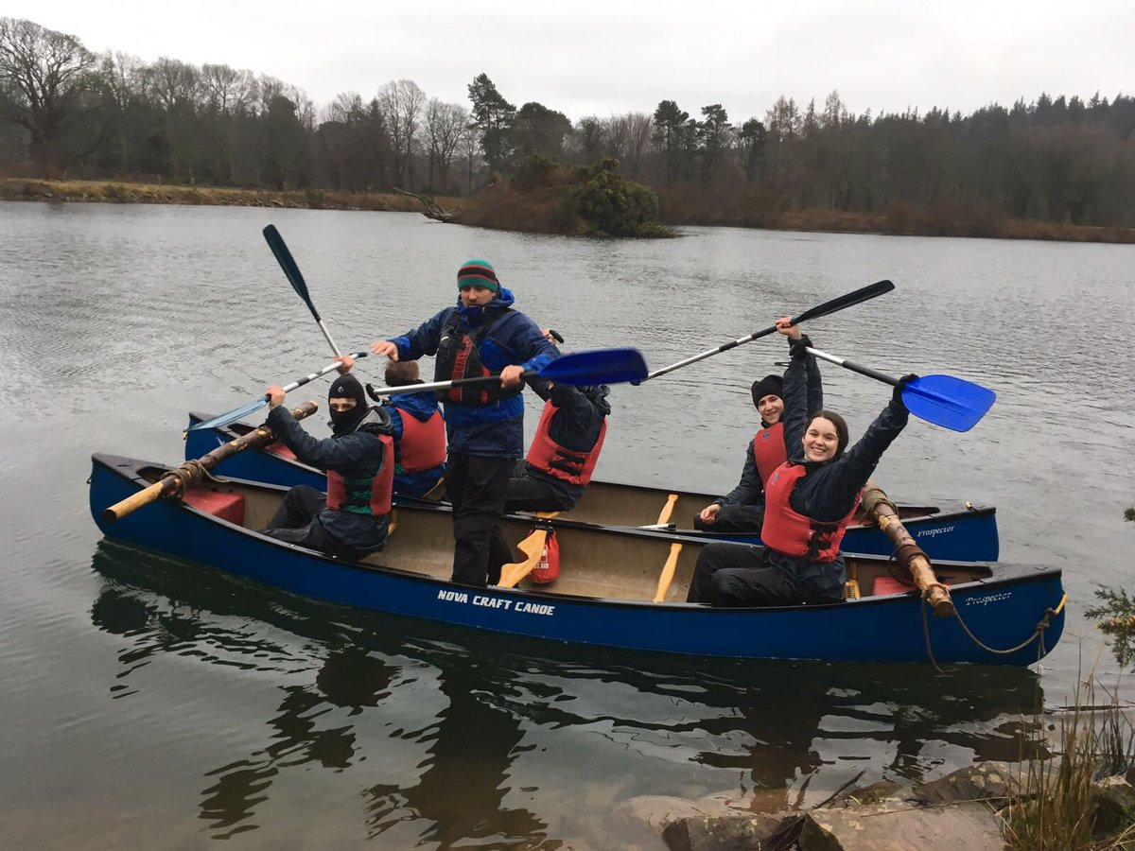

School Priority 5: High numbers of our young people are entering positive and sustainable destinations.

National Improvement Framework Priority  - Improvement in employability skills and sustained, positive school-leaver destinations for all young people | How Good is Our School? (version 4) Quality Indicator  1.3, 1.5, 2.2, 2.6, 2.7, 3.1, 3.3
Supporting our pupils into the most appropriate, positive and sustainable destinations is a key feature of our revised school vision and again a number of key steps have been taken this session to ensure that we are in as strong a position as possible to achieve this.

Progress, impact and evidence:

We have:

- In line with our school vision we have improved our school leaver’s destination figures from 93.3% to 99.2%.
Establishment | Year | % Candidate positive destinations | Number in cohort
Auchenharvie Academy | 2014/15 | 97.89 | 95
Auchenharvie Academy | 2015/16 | 90.53 | 95
Auchenharvie Academy | 2016/17 | 93.33 | 120
Auchenharvie  Academy | 2017/18 | 99.2 | 114

- Created a pathways database to track pupils intended post school destinations.
- Improved employer links in all subjects to enhance our school curriculum in the Broad General education and Senior Phase.
- Have improved the relevance of our work experience programme to make it more aligned to pupil interest and need.
- Developed staff understanding of the 3-18 Careers Education Standard with a view to further increasing our pupil’s employability.
- Introduced Developing Young Workforce courses in Barista and Nail Bar into our S3 curriculum allowing pupils to achieve a multitude of industry standard qualifications.
- Offered pupils the opportunity to undertake a Foundation Apprenticeship during S5/6 – 7 pupils are currently participating.

Next Steps:

We will:

- Maintain our outstanding school leavers’ destination figures through rigorous monitoring approaches.

- Develop new and enhance existing DYW Initiatives and available streams, including: Cyber Security; Bike Maintenance / Grow Eat Repeat.

- Further Implement the Career Education Standards (CES) and Work Placement Standards (WPS).

- Increase employer engagement in the BGE phase to further enhance opportunities for developing skills for learning, life and work.

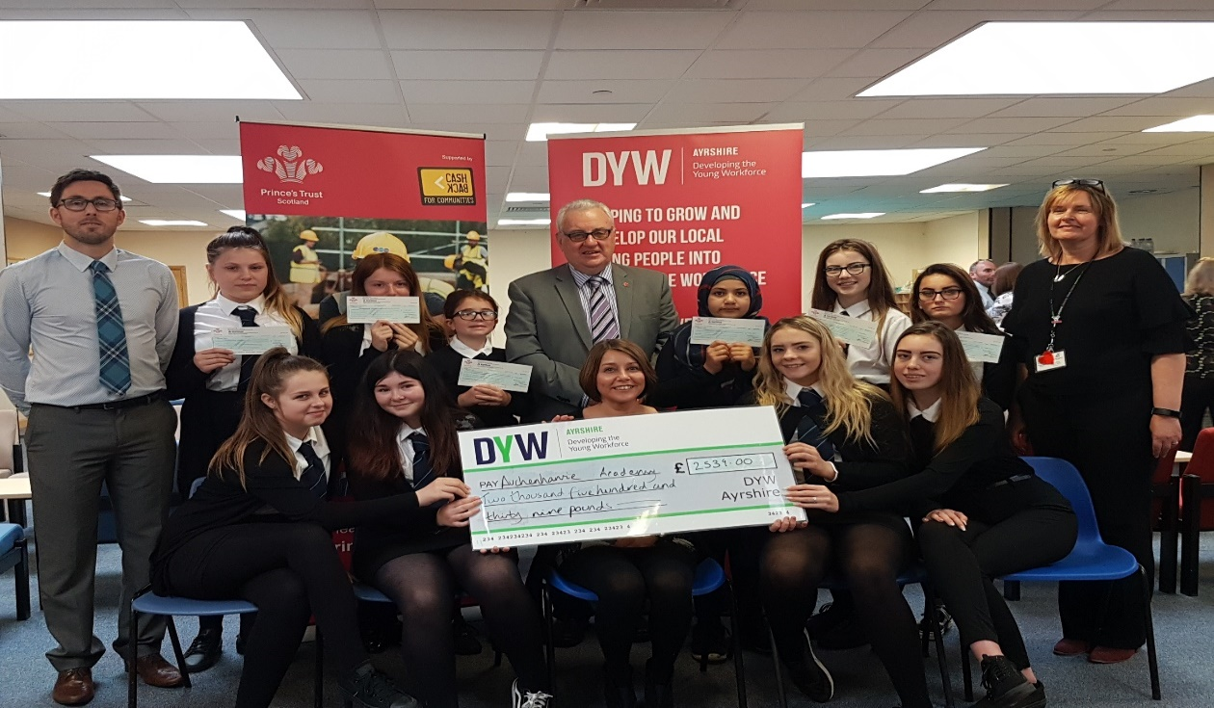

Overall Capacity For Improvement – strengths and next steps

Moving forward Auchenharvie Academy has significant capacity for continuous improvement and staff and pupils will work tirelessly with our community to continue to deliver both on our school vision and our improvement agenda.

The key areas for further school improvement at Auchenharvie Academy are:

- To enhance our school policy, procedures and practices to improve the HWB of our pupils.

- To increase pupil inclusion in the ethos and life of our school.

- To continue working positively with families and our community to tackle barriers to learning in and out of school.

- To further develop confidence in teacher judgements through effective moderation in the BGE.

- To further improve the quality and consistency of teaching and learning to improve outcomes for our pupils.

- To further implement strategic approaches to whole school responsibility of all areas.

- To increase the strength of the pupil voice leading to further school improvements.

- To improve staff confidence in the use of local and national data leading to improved learning experiences for pupils.

- To improve school self-evaluation procedures to further increase equity and minimise the impact of poverty in our school.

- To further review our approaches to curriculum change and adaptation.

- To increase opportunities for pupil leadership in all aspects of school life.

- To sustain our already outstanding school leavers’ destinations through rigorous monitoring approaches.

- To develop new and enhance existing DYW Initiatives and available streams, including: Cyber Security; Bike Maintenance / Grow Eat.

- To further Implement the Career Education Standards (CES) and Work Placement Standards (WPS)

- To Increase employer engagement in the BGE phase to enhance opportunities for developing skills for learning, life and work.

Full details of how we will achieve these high level objectives can be found in our School Improvement Plan on our school website.

