

**Education and Youth Employment**

**Auchenharvie Academy**

**Improvement Plan 2019-20**



School logo?

**Vision, Values and Aims**

 ***Auchenharvie Academy*** 

***Our Vision/Aim is…***

***To provide an equitable and excellent learning environment for ALL pupils which maximises their full potential and supports them into appropriate, positive and sustainable destinations.***

***Our Values***

***Respect Equality Determination***

**Council Priorities:**

The Council strategic priorities for 2019-24 are detailed below:

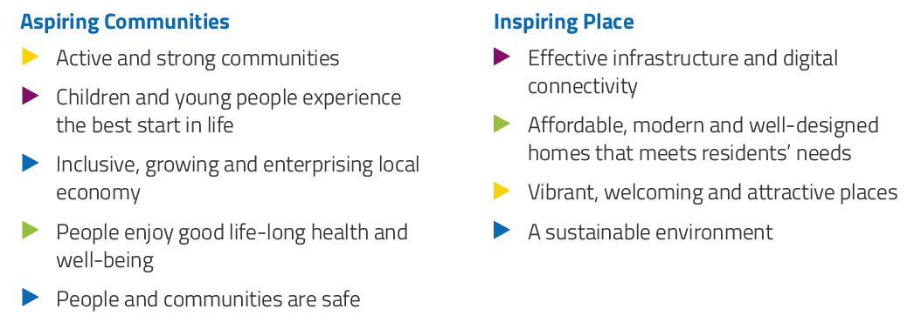

**National Improvement Framework:**

The National Improvement Framework for Education is designed to help us deliver the twin aims of excellence and equity; galvanising efforts and aligning our collective improvement activities across all partners in the education system to address our key priorities. These priorities remain as:

* Improvement in attainment, particularly in literacy and numeracy
* Closing the attainment gap between the most and least disadvantaged children
* Improvement in children and young people’s health and wellbeing
* Improvement in employability skills and sustained, positive school-leaver destinations for all young people

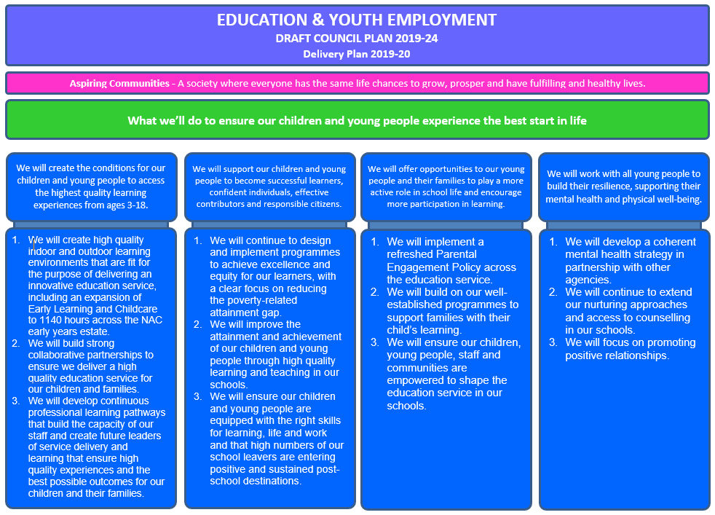

**Strategic Plan 2019-20: Auchenharvie Academy**

|  |  |  |  |  |  |
| --- | --- | --- | --- | --- | --- |
| **School Priorities** | **Create the conditions for our children and young people to access the highest quality learning experiences from ages 3-18** | **Supporting our children and young people to become successful learners, confident individuals, effective contributors and responsible citizens.** | **Offering opportunities to our young people, their families and staff to play a more active role in school life and encourage more participation in learning.** | **Work with all young people to build their resilience, supporting their mental health and physical well-being.** | **To maximise attainment in the BGE and Senior Phase for all pupils.** |
| **High Level Objectives** | **To review our ASN provision to ensure equitable and efficient allocation of resource with maximum impact.**  **Creation of a Professional Learning Programme with a focus on ASN and L&T for all staff.** | **Improve the quality and consistency of Learning and Teaching for our pupils.**  **Develop opportunities for young people to be better informed and prepared for the World of Work.** | **Enhance staff participation and leadership of school improvement through a focus on wellbeing, ethos and staff voice.**  **Through diverse approaches to transitions and parental engagement activities, motivate and support parents and families to become involved in their child’s learning and the wider life.** | **To strengthen and embed targeted approaches to well-being across the school.**  **Embed a focus on equality and human rights in line with our school values.** | **To strengthen further existing practices in moderation within the BGE.**  **Implementation and creation of Senior Phase and BGE attainment strategies respectively.** |

**Strategic Plan 2019-20: AUCHENHARVIE ACADEMY**

Here is an overview of how we intend to use our Pupil Equity Funding to support improvement:

**Detailed Action Plan 2019-20: AUCHENHARVIE ACADEMY**

|  |  |  |  |  |  |  |  |
| --- | --- | --- | --- | --- | --- | --- | --- |
| **School Strategic Priority:** | | **Create the conditions for our children and young people to access the highest quality learning experiences from ages 3-18**  **We will create the highest standards of** | | | | | **Linked to Directorate Priority:** 1 |
| **High Level Objectives** | | * **To review our ASN provision to ensure equitable and efficient allocation of resource with maximum impact.** * **Creation of a Professional Learning Programme with a focus on ASN for all staff.** | | | | |  |
| **Tasks** | **HGIOS 4**  **HGIOELC**  **NIF** | **Supported through PEF?**  **Y/N** | **How will I achieve this?** | **Timescale / Assigned to:** | **Pupil Outcomes** | **Measurement** | |
| To establish a system of ASN support within the school which impacts positively on the learning experiences of all of our children.  Creation of a Professional Learning Programme with a focus on ASN for all staff. | **HIGIOS**  1.1  1.2  2.1  2.5  3.1  **NIF**  1  2  3  **WBI**  Achieving  Included | N | * Evaluate how the Pupil Support areas are being utilised. * Explore how the resource can be used more efficiently and effectively to ensure that support enhances pupils learning experiences and impacts positively on the learning environment. * Agree on the role and input of Extended Outreach in ensuring our young people remain part of the school community. * Explore the use of space that allow all learners to be in an environment that supports their wellbeing. * Identify targeted groups for Literacy and numeracy interventions to allow all children to access the curriculum at their stage and level. * PRD/PPD feedback will be used to devise the input. Focus on practical strategies for within the classroom. * Planned slots during in-service days, collegiate and after school involving partner agencies. | Session 19-20  L Davis  PT PS  PT Transitions  Session 19-20  Term 1  L Davis  PT PS  Ed Psych | * Young people participate positively in their learning and experience a pace and challenge that is right for them. * Young people are in an environment that does not overwhelm them and they feel supported to do their best. * Young people are supported and included to engage in their learning. * Young people feel that their needs are understood and being met. | * Tracking and monitoring updates reflect progress and participation in their learning. * Focus group work with targeted pupils and parents to get their views on impact and process. * Informal/formal observations within the classroom and also within the targeted group work areas. * Discussion and feedback from Extended Outreach to measure impact of provision. * Evaluation feedback from step and impact of professional learning is gathered to allow next steps to be identified. * Tracking and monitoring reports detailing pupil’s progress and next steps shows a better understanding of pupils needs. | |

|  |  |  |  |  |  |  |  |
| --- | --- | --- | --- | --- | --- | --- | --- |
| **School Strategic Priority:** | | **We will support our children and young people to become successful learners, confident individuals, effective contributors and responsible citizens.** | | | | | **Linked to Directorate Priority: *2*** |
| **High Level Objectives** | | * **Improve the quality and consistency of Learning and Teaching for our pupils.** * **Develop opportunities for young people to be better informed and prepared for the World of Work.** | | | | |  |
| **Tasks** | **HGIOS 4**  **HGIOELC**  **NIF** | **Supported through PEF?**  **Y/N** | **How will I achieve this?** | **Timescale / Assigned to:** | **Pupil Outcomes** | **Measurement** | |
| Improve the quality of L&T for our pupils  Develop opportunities for young people to be better informed and prepared for the World of Work | **HGIOS**  1.2  1.3  2.2  2.3  2.4  **NIF**  1  2 | **N**  **Y** | * L&T WG to work with the PLA on developing the school’s Visible Learning Strategy - Strand 4 “Effective Feedback: The Power of Feedback.” * Auchenharvie will work in partnership with Douglas Academy to implement *Lesson Study Model* as a trial with two faculties, HWB and Technical. This will be evaluated for roll out to whole school for following session. * Staff CLPL programme on a range of areas to increase effective classroom L&T (see Staff CPD programme) * DYW streams - S3/S4 - Introduce Cycle Maintenance, Childcare, Uniform Services and Outdoor Education DYW strands, including SQA units and other associated accreditation. Expand existing DYW stream accreditation to include Prince’s Trust achieve units. * S2 pupils to experience a college delivered DYW careers burst to give them an insight into the vocational opportunities available as a career path. * Careers and Positive Destinations activities, events and inserts timetable created for session 2019-20, including experiences for all learners across all Faculties as appropriate to increase employer engagement, raise aspirations and enhance curriculum. * Senior Phase pupils to experience a work experience placement agreed as valuable to their future career aspirations. | From Aug 19 until June 20  L&T WG  Trial Departments – Technical and H&WB  L&T WG - JH/SB  JH/PT DYW | * The school will work to develop the expertise, consistency and delivery of levels of feedback, the importance of feedback, making feedback effective, peer and pupil to teacher feedback. Pupils will experience a higher quality and consistency of feedback and be better engaged in their learning. * Increased staff confidence in use of Lesson Study model. Pupils will experience a richer learning environment within these departments. * Greater opportunities/Increased staff confidence to use/develop L&T strategies will enhance classroom experience for pupils. * Greater opportunities for pupils to develop skills for life, learning and work and gain specific qualification to support them to a positive destination. * Opportunities for pupils to develop skills for life, learning and work to support them in future curricular choices regarding vocational pathways toward a positive destination. * Learners across the school will have opportunities to explore and develop their understanding and experience of vocational pathways/potential destinations and careers, across curricular areas and beyond. Pupils will be better able to make informed decision regarding their transition to a positive destination. * Appropriate model for senior phase work experience utilised (combined one week and flexible dependant on pupil requirement), leading to Increasing number of pupils taking part in work experience across senior phase and reporting positive experiences | * Evaluate impact of VL school by a questionnaire/focus group after implementation one year. * Trial departments to feedback and tailor model for wider implementation within Auchenharvie Academy. This will be done via lesson observations and feedback from a focus group of teachers and pupils involved. * Staff CPD evaluations proforma. * Number of DYW stream pupils achieving a range of SQA units, awards and other accreditations through relevant DYW stands.   Number of learners participating in DYW burst courses   * Number of learners participating in careers/destinations curricular initiatives/events. Feedback through focus-group/survey. * Number of pupils experiencing work experience/pupil feedback through focus-group/survey. | |

|  |  |  |  |  |  |  |  |
| --- | --- | --- | --- | --- | --- | --- | --- |
| **School Strategic Priority:** | | **We will offer opportunities to our young people, their families, our staff and our partners to play a more active role in school life and encourage more participation in learning.** | | | | | **Linked to Directorate Priority:** 3 |
| **High Level Objectives** | | * **Enhance staff participation and leadership of school improvement through a focus on wellbeing, ethos and staff voice.** * **Through diverse approaches to transitions and parental engagement activities, motivate and support parents and families to become involved in their child’s learning and the wider life of the school.** | | | | |  |
| **Tasks** | **HGIOS 4**  **HGIOELC**  **NIF** | **Supported through PEF?**  **Y/N** | **How will I achieve this?** | **Timescale / Assigned to:** | **Pupil Outcomes** | **Measurement** | |
| Creation of Staff wellbeing / Ethos group  Increased opportunities for staff / family participation leading to school improvement | **HGIOS**  **2.6**  3.1  **NIF**  1  3 | N  **Y** | Staff Wellbeing and Ethos Working Group to develop a programme that supports all staff to feel included, respected and engaged in the life and work of the school community.  Continue to use school-based consultation forums, including ‘collegiatea’ to gather and respond to staff voice.  Incorporate opportunities for staff to attend cluster primary parents’ evening and other relevant events into existing transitions programme to build and enhance relationships earlier and more regularly.  Develop our approach to parents’ evening through equitable approaches (potentially including: child-care and transport options) and also by incorporating ‘learning showcase’ events and other inserts relevant to learners and their families.  Continue to trial opportunities for increased parental involvement across the wider-life, including, for example: participation in interviews; participation in working groups; volunteering for school events and school trips.  Continue to embed our Family Learning programme across targeted and universal streams to develop approaches to home learning. | **Ongoing**  **Ongoing**  C Johnston  **Ongoing**  **Ongoing**  **Ongoing**  **June 2020**  A Hopton | Through empowering staff, learners will have increased opportunities across the curriculum and beyond to develop skills for learning, life and work.  Positive staff will ensure that learners will experience increasingly positive relationships with staff and further develop the inclusive ethos in the school.  Learners are increasingly aware of staffs’ roles across the school and are more confident in accessing learning and support as a result of well-established positive relationships.  Learners are supported holistically both at home and at school to access learning, participate and achieve as parents’ are increasingly confident and skilled in support young people navigate transitions throughout their learning. | Creation of staff wellbeing group is having a positive impact on staff morale and whole school ethos.  Pupil and staff feedback via focus groups and questionnaires will demonstrate increasingly positive outcomes in relation to positive relationships policy, nurture and wellbeing.  Attendance statistics in relation to school attendance and attendance at school-based events should both demonstrate increasing participation.  Positive Relationship monitoring (including: merits/demerits/referrals and exclusions) should demonstrate positive trends.  % of learners having a parent/carer attend parents’ evening should increase.  Focus groups, questionnaires and captured statements highlight positive impact. | |

|  |  |  |  |  |  |  |  |
| --- | --- | --- | --- | --- | --- | --- | --- |
| **School Strategic Priority:** | | **Work with all young people to build their resilience, supporting their mental health and physical well-being** | | | | | **Linked to Directorate Priority:** 4 |
| **High Level Objectives** | | * **To strengthen and embed targeted approaches to well-being across the school.** * **Embed a focus on equality and human rights in line with our school values.** | | | | |  |
| **Tasks** | **HGIOS 4**  **HGIOELC**  **NIF** | **Supported through PEF?**  **Y/N** | **How will I achieve this?** | **Timescale / Assigned to:** | **Pupil Outcomes** | **Measurement** | |
| Establish ‘go to’ areas within the school.  Further develop and support the role of the ‘go to’ person  Re-establish the LGBT group within the school.  The tracking and interventions for wellbeing are embedded  Develop the sharing and practical application of Nurture targets throughout the school  Development of House Ethos building programme.  To achieve silver status as a Rights Respecting School | **HIGIOS**  1.1  1.2  2.1  2.5  3.1  **NIF**  1  2  **WBI**  Safe  Health  Nurtured  Included | N  N  N  N  N  N  N | * Consultation with the wider support team and staff to identify the areas. * Agree on the activity/focus for each identified area. * Staff rota for each area. * Professional Learning programme for identified ‘go to’ people in school to ensure that they know and fully understand their role in this process. * Identify staff and pupils who will lead this and re-establish the group. * Identify a space and time each week. * Plan how this will be promoted within school and what the programme for children will look like. * Wellbeing indicator assessment and review processes and procedures in place. * The data will be analysed, interventions agreed and impact measured. * Timeline agreed and followed by all staff involved. * Nurture team have in-class input which is timetabled. * PL with classroom assistants to support this. * Focus is on practical approaches that allow targets to be focused on and achieved. * Sharing of what teachers can to support young person in achieving their target. * House system that reflects values and positive relationships. * Provide young people with opportunities to lead. * Celebrating success calendar to provide incentives for positive choices * Assembly programme in place to promote this * Agree on house point system and what is expected. * To work with all staff, gather evidence to ensure that all outcomes for this status are being achieved. | Session 19-20  Term 1  PT PC  Extended Support Team  Session 19-20  L Davis  PT PC  Session 19-20  PT PC  School Counsellor  MCR Pathways  Session 19-20  PT PC  Session 19-20  Nurture Team  Classroom Assistants  L Davis  Session 19-20  Senior Pupils  Working Group  Session 19-20  B McColl  WG | * Young people have areas that they can go to that suits how they are feeling and they do not feel isolated. * More opportunities for friendships to be established and wellbeing to be supported. * Young people feel supported by the people that they have identified. * Young people can access support when needed. * Young people feel supported and are able to discuss issues or topics that affect them. * Strengthen the feeling of equality across the school. * Young people’s wellbeing is supported and interventions are supportive and have an impact * Young people know that their needs are being met and supported. * Young people have a confidence that their teachers understand and are supporting them to achieve their agreed targets * Young people leading assemblies and contributing to assembly programme. Young people feeling sense of ownership and pride in their House identity * Young people are confident about what their rights are. Staff are fully aware of what it entails. Staff and young people know what their role is in this process. | * Wellbeing indicator feedback to reflect use of ‘go to places’. * Observations of the supervising staff * Analyse of the wellbeing data to reflect that our young people do have a safe base and feel better supported in their environment. * Wellbeing indicator data reflects that every child has a go to person and this has a positive impact on their wellbeing ratings. * Informal and formal feedback from staff and young people * Whole school events and input at assemblies increases. * Analysis of wellbeing data which is shared and discussed. * Feedback from TAC reviews * Parent and pupil’s views * Boxall reviews reflect progress with targets * Focus group feedback from young people and parents which reflect that there is an understanding and support of nurture targets across the school. * House events calendar * Celebration of success events and most pupils experiencing this. * Tracking and monitoring of targeted pupils to reflect improvement and better choices * Silver status is achieved | |

|  |  |  |  |  |  |  |  |
| --- | --- | --- | --- | --- | --- | --- | --- |
| **School Strategic Priority:** | | **To maximise attainment in the BGE and Senior Phase for all pupils.** | | | | | **Linked to Directorate Priority: 1 AND 2** |
| **High Level Objectives** | | * **To strengthen further existing practices in moderation within the BGE** * **Implementation and creation of Senior Phase and BGE attainment strategies respectively.** | | | | |  |
| **Tasks** | **HGIOS 4**  **HGIOELC**  **NIF** | **Supported through PEF?**  **Y/N** | **How will I achieve this?** | **Timescale / Assigned to:** | **Pupil Outcomes** | **Measurement** | |
| Strengthening confidence in teacher judgements through effective moderation of the BGE within school (within and across departments), at cluster level, within other NAC/ out with secondary establishments as per national expectation. | **HGIOS**  1.2  1.3  2.2  2.3  2.4  **NIF**  1  2 | **N** | * BGE Strategy for Auchenharvie Academy is in place (Year 3 implementation for 19-20 * FLs to continue to implement moderation activities as part of self-evaluation procedures. *(looking inwards*) * Whole school Moderation Calendar to be implemented for session 19-20. * Cluster moderation to take place for Numeracy and Literacy through Science. * FLs to engage in formal moderation activities within other NAC secondary establishments. * FLs to engage in formal moderation activities with their identified partner school out with NAC. | Session  19-20  L Riddell  Faculty Leaders  PT Raising Attainment & Achievement | * Throughout lesson observations and monitoring & tracking data, young people will be better engaged in their learning, thus making significant progress within and through each CfE level. * Higher number of young people across the BGE will be making consistent progress across each CfE level thus converting into higher presentation numbers for NQs in the Senior phase. | * CfE Level progress within dept and whole school monitoring & tracking system will be analysed. * Numbers of candidates’ presentation for SQA NQs to increase directly proportionally to % of CfE levels achieved by end of S3. * DM Minutes to show evidence of departmental time spent on moderation in a collegiate manner. * Evaluation of impact of moderation activities within cluster/within NAC/out with NAC activities | |
| Renewing strategic approaches to improve whole school literacy, numeracy and health and wellbeing experiences and outcomes for all learners.  Review of internal monitoring & tracking systems within the school.  Review of universal and targeted intervention approaches, leading to the development of a BGE attainment strategy aiming to maximise attainment across the BGE for all learners.  Strengthening staff capacity in the effective use of data to lead to excellent and equitable learning experiences for all learners, thus reducing the poverty related gap.  Effective use of SCQF framework to further improve attainment for all pupils at point of exit.  Tracking participation all young people in the wider life of the school thus increasing a focus on equitable opportunities for achievements. |  | **Y**  **N**  **Y**  **N**  **N**  **N** | * Due to the appointment of a new FL in English and Literacy in session 18-19 a new whole school literacy policy will be designed and implemented in session 19-20. * Numeracy strategy in year 3 of its implementation. * A new HWB policy to be constructed and implemented in session 19-20 * Audit of HWB Experiences and outcomes to be completed at whole school level. * Pastoral Care Teachers to play a strategic role in supporting the development, moderation, implementation and evaluation of the HWB Es and Os across the school curriculum. * Evaluation of current whole school system will be completed by consulting all teaching staff in session 18-19. * Discussion with the senior leadership team will lead to the creation and implementation of a new timeline for T&M at whole school level for session start in 19-20. * PSE programme to include lessons to coincide with tracking periods. * Data sessions for class teachers and faculty heads will be organised using live data. * Professional discussions and demonstration of the departmental systems will take place between L Riddell and Faculty colleagues at faculty meetings. * Interventions systems at class, department and whole school level to be clearly organised at the end of each tracking period and led by PT RA&A. * SLT working closely with PT RAA to develop and implement a BGE attainment strategy * Data sessions to be organised using live data pertinent to each faculty. * Session during in service day to further contextualise the poverty gap indicators for all staff. * Familiarisation with NQ Catalogue to further formally recognise pupils’ achievements via WA classes. * Tracker Database to be implemented * Staff to be fully familiar of the approach used through delivered CPD. * Identification of an administrator support for the day to day operational maintenance of the system. | Session  19-20  FL English & Literacy  FL Maths & Numeracy  L Davis  PT Pastoral Care  Faculty Leaders  Session 19-20  L Riddell  PT Raising Attainment & Achievement  PT Pastoral Teachers  Faculty Leaders  Session 19-20  L Riddell  S Scholes  Session 19-20  PT Raising Attainment & Achievement  Session 19-20  Mr Herd  Session 19-20  L Riddell  PT Raising Attainment & Achievement | * Pupils to benefit from consistent literacy and numeracy approaches across the school, * Young people see that their wellbeing is the focus in every classroom. * Young people have the opportunity to explore issues that could affect their lives and develop resilience. * All learners to gain more confidence in reflecting on their learning and to identify their strengths and next steps. * Improved learning experiences planned using data effectively. * Improved attainment over time. * Lessons differentiated to better meet pupil needs. * All learners to benefit from bespoken interventions. * All learners to benefit from productive learning conversation and bespoken interventions. * All learners to have access to equitable and excellent learning experiences. * Pupils to benefit from further qualifications at the point of exit. * All learners regardless of their SIMD profile will be actively engaged in the life of the school. | * Increased pupils’ attainment in aspects of literacy and numeracy across the curriculum. * Number of opportunities where staff can engage in literacy, numeracy and HWB moderation throughout session. * Evaluation of impact of these opportunities. * Classroom observation with focus on Health & Wellbeing * Pupils’ sampling of Learning Journals. * Pupils feedback on quality and frequency of Learning Conversations * Lesson observations to evidence impact of interventions such as differentiation. * Copies of departmental spreadsheets highlighting information on identified pupils and type of interventions. * Attendance at data session and feedback from attendees on impact of the sessions completed. * Uptake of specific subject/ Candidate presentation numbers/ * Attainment over time stats * Numbers of SQA awards and wider achievement awards completed during the session. * Analysis of data based by SIMD profile, House group and individual learners to monitor impact. | |