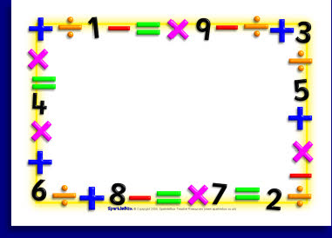

Auchenharvie Academy
Mathematics Department


Information Booklet

Why National 4 Mathematics?

The aim of the course is to enable you to build on your previous mathematical experience. The course contains many mathematical techniques which you will find useful in everyday life. In addition, simple abstract mathematical concepts are introduced at this stage. The study of mathematics provides you with many valuable skills and is often very helpful when you are seeking employment.
Course Outline
The course is divided into three units. Some topics that are included in the course are shown below.

Unit 1 – Expressions and Formulae
- Algebra
- Shape
- Statistics
Unit 2 - Relationships
- Equations
- Trigonometry
- Pythagoras

Unit 3 - Numeracy
- Fractions
- Percentages
- Information handling
- Problem solving

Assessment

The course is assessed by Unit Tests and an Added Value Unit which replaces an external exam at the end of the year. To gain an overall award you must pass all unit tests and the Added Value Unit. You will be awarded either a pass or a fail.

Unit Tests

When you complete a unit you will sit a test. If you fail an outcome in the test you are allowed one more attempt at the questions you answered incorrectly. In some cases an alternative mixed question paper may be used but your teacher will always explain what is expected of you. The pass mark is 60%

Homework

You will be required to become more responsible for your own learning. Homework will be issued on a regular basis and it is expected that you complete it on time. If you are absent, then when you return, you will be expected to find out what work you missed.

Calculator

You are expected to bring a scientific calculator with you when you come to maths.

ICT

Your teacher may put homework and

revision materials on “Show my homework”
an app you can download to your phone,
tablet or PC. You can also access it via Glow.

Next Steps in Learning
After passing National 4 you can progress to National 5.

Words of advice from pupils who have studied National 4

“Listen to your teacher and ask for help”
“Actually try”

“Keep looking at your notes”

“Study every night, it’s going to pay off”

