Auchenharvie Academy

Numeracy Policy



A
Common Approach

Contents

Topic | Page
Aims and Introduction | 3
Numeracy Theme | 4
Development of Numeracy & Departmental Guidelines | 5
Links between Numeracy and other Curricular Areas | 6-7
Liaison with Associated Primary Schools & Evaluating the Policy | 8
A Common Approach | 9
Place Value | 10
Basic Calculation Vocabulary | 11
Basic Number Operations Addition | 12
Basic Number Operations Subtraction | 13
Basic Number Operations Multiplication | 14-16
Basic Number Operations Division | 17-19
Fractions, Decimals and Percentages | 20-22
Rounding | 23
Estimating | 24
Conversion of Units | 25-27
Time Calculations | 28-29
Speed, Distance and Time | 30
Ratio and Proportion | 31
Statistics – Data Analysis | 32-33
Statistics – Graphs and Charts | 34-38
Probability | 38
The National Numeracy Progression Framework | 39-42
Appendix 1 | 43-46
Appendix 2 Numeracy Skills from benchmarks June 2017 | 47-48

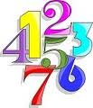

All teachers have responsibility for promoting the development of numeracy. With an increased emphasis upon numeracy for all young people, teachers will need to plan to revisit and consolidate numeracy skills throughout schooling.
Building the Curriculum 1

Our aim is to raise the attainment of all pupils by seeking to develop their numeracy skills by consistent and accurate application across the curriculum.

Introduction

Numeracy is a fundamental life skill.

Being numerate involves developing a confidence and competence in using number that
allows individuals to solve problems, interpret and analyse information, make informed
decisions, function responsibly in everyday life and contribute effectively to society. It gives
increased opportunities within the world of work and sets down foundations which can be built upon through life-long learning.

Whilst Numeracy is a subset of Mathematics, it is a core skill which permeates all areas of
learning, allowing pupils the opportunity to access the wider curriculum.

Numerical skills can be consolidated and enhanced when pupils have opportunities to apply and develop them across the curriculum. Poor numerical skills hold back pupils’ progress and can lower their self-esteem. It is therefore important that all teachers look for opportunities to develop and reinforce numeracy skills within their own activities and through inter-disciplinary projects and studies.

The teaching of numeracy is the responsibility of all staff and the school’s approaches should be as consistent as possible across the curriculum.
All teachers should consider pupils’ ability to cope with the numerical demands of everyday life and provide opportunities to:

- Handle number and measurement competently, mentally, orally and in writing
- Use calculators accurately, effectively and appropriately
- Interpret and use numerical and statistical data represented in a variety of ways.

Numeracy Themes

The Numeracy outcomes are based around the following themes.
- Estimation and rounding
- Number and number processes
- Fractions, decimal fractions and percentages
- Money
- Time
- Measurement
- Data and analysis
- Ideas of chance and uncertainty

It is useful to understand why some learning outcomes are designated Numeracy and
others Mathematics. Numeracy outcomes are those which promote the development of the
number-based skills that are needed regularly by everyone in their lives.

To illustrate this, consider fractions. Some aspects of fractions have been identified as
numeracy skills and others as Mathematics. For example, most people will have the need to find a fraction of an amount and, for this reason; this skill has been considered as numeracy. On the other hand, few people regularly need to add or subtract fractions, and therefore this aspect of fractions will sit within Mathematics.

Similarly, some aspects of information handling have been included within the numeracy
outcomes, whilst others will be covered within the Mathematics outcomes. Almost daily,
people have the need to find information. Additionally, we are bombarded with data, through advertising and the media, which we must evaluate for robustness and accuracy and interpret for meaning. Because of this, the sourcing and interpretation of data has been included within the Numeracy outcomes. Whilst it is important that we all have an understanding of how statistics are used to convey information, for most of us, making statistical calculations is not a frequent necessity. Similarly, few of us are required to produce graphs on a regular basis.
Calculating statistical information and presenting data graphically are therefore included as
important Mathematics outcomes.

Development of Numeracy

It is important to note that in any mixed ability class pupils will be at a variety of stages in their level of Numeracy. It cannot be assumed that all pupils in a class will have the skill required to tackle a particular piece of number work. Even if a skill, has been taught in the Mathematics Department many pupils will find it difficult to transfer their knowledge to a new context.
It will always be better to teach the required skill or at least check that it is present before asking pupils to use it in the lesson.

In order to reduce confusion and improve understanding and retention it is important that all teachers teaching numeracy skills use the same methods.

Departmental Guidelines

As a teacher if you help children to acquire proficiency skills in numeracy the outcome should be numerate pupils who are confident enough to apply their knowledge and understanding to tackle mathematical problems without going immediately to teachers or friends for help.

Approaches

- Have the highest expectations of the students to ensure that the numerical content is of a high standard

- Discourage students from writing down answers only and encourage them to show their numerical working out within the main body of their work.

- Encourage the use of estimation particularly for checking work.

- Encourage students to write mathematically correct statements.

- Recognise that there is never only one correct method and students will be encouraged to develop their own where appropriate rather than be taught 'set' ways.

- Allow and encourage students to 'vocalise' their maths - a necessary step towards full understanding for many students.

- Help students to understand the methods they are using or being taught - students gain more and are likely to remember much more easily if they understand rather than are merely repeating by rote.

- Encourage pupils to use non-calculator methods whenever possible.

- Encourage students to use the correct language.

- Encourage pupils to use ICT to enhance their learning. Appendix 1

Links between Numeracy and other Curricular Areas


Technical & Design

These areas rely on pupils being able to measure and use spatial skills and the properties of shapes including the use of symmetry. Designs may require enlarging or reducing.


Health and Wellbeing
Athletics requires the understanding of measurements including time, speed, height, length and distance. In other areas of PE ideas of time, position, movement, symmetry and direction are required.
In HE the use of ratios may be required in the context of modifying recipes and there is also the need to use time and calculations involving money.



Languages

Lessons may provide non-fiction texts in which mathematical information in the form of graphs, tables or charts may need to be interpreted and explained.
In Library lessons the Dewey classification is an excellent application of decimal ordering.

In French and Spanish the pupils investigate time-zones, do on line-shopping from French and Spanish websites and conduct surveys using frequency tables, bar and line graphs.


Sciences

Almost every scientific experiment or investigation is likely to require some mathematical skills in classifying, counting, measuring, calculating, estimating and recording in charts, tables or graphs. Science will provide a wide range of situations in which numeracy skills will be required in real life contexts.


Computing and Business Education

Within Business Education pupils will learn to budget effectively including the use of spread sheets as part of personal finance. Computing requires pupils to use a variety of methods to solve number problems in familiar context involving binary scale and conversion of units.


Social Subjects

In History and Geography pupils may collect data by measuring or counting and record results in the form of charts, tables or graphs. They will also need to interpret data presented in the form of charts and graphs. Historical ideas require an understanding of time and timelines similar to the number line.
Map skills require the understanding of coordinates and ideas of angles, directions, positions,
scale and ratios.


Expressive Arts

Music and Numeracy share aspects of structure and form, patterns and rhythm. As a result of learning in music, pupils understand and apply concepts related to number, such as themes, patterns, repetition, variation, counting, rhythm, phrasing, sections, round and canon.
Visualisation skills developed in Art & Design provide a foundation for developing number relationships, pattern appreciation and spatial awareness. As a result of learning in Art & Design, pupils understand and apply concepts related to space and measurement, such as size, scale, length, distance, volume and time.

In Drama numeracy is used to work out: budgets, break-even points, profit and loss forecasts for theatre projects (imaginary or real), ticket sales etc. It is also used for upscaling measurements /dimensions for sets/costumes/props.

Skills Development
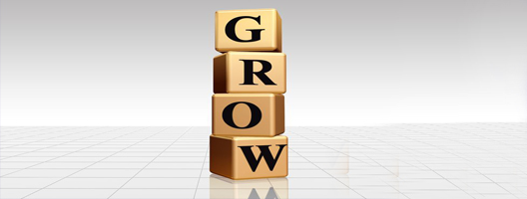
Skills development promotes confidence in Numeracy through a variety of tasks. Pupils develop their knowledge of personal finance and the terminology used. They complete a variety of budgeting and enterprise tasks.
Pupils are also expected to apply their problem solving skills when challenged with team building exercises.

ASDAN

In Asdan the pupils learn about the different bills they have to pay, if living

independently, and the various methods for paying for these. They also compare
the cost of living in rented accommodation as opposed to buying their own home
and paying a mortgage. The students learn to furnish a virtual flat and
keep within their budget.

RMPS

Timelines and dates are used frequently in the history of religion whilst comparing the ages of faiths. Data and analysis skills are employed during class surveys and investigations calculating percentages, for example, of people in a given Faith.
In Philosophy of Religion the concept of probability is explored and used to determine the chances of ideas and happenings e.g. the existence of God; the theory of evolution; or other religious concepts.
Liaison with Cluster Primary Schools

This document will form the basis for discussions with our cluster schools with a view to finding a common approach not only across faculties but across each of the Cluster Primary Schools.

Evaluating the Policy

After one year the Faculty Head of Mathematics and Numeracy will check, via a questionnaire organised by the working group, that staff are operating the policy and seek information on any changes required.

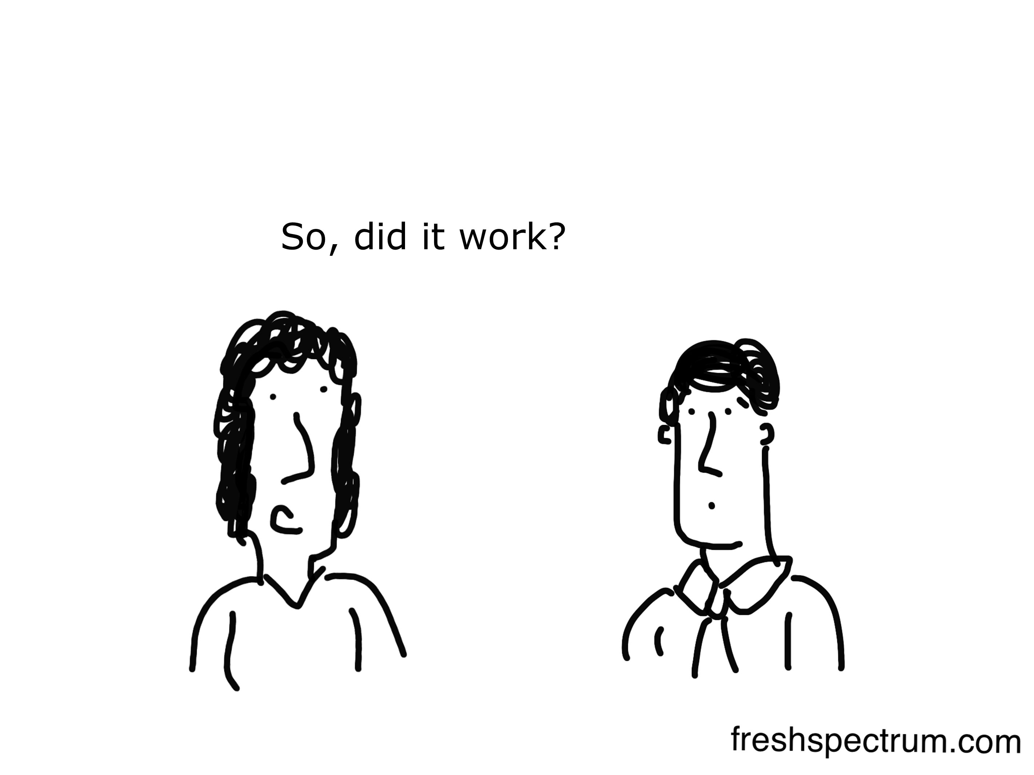

A Common Approach

The Numeracy policy was formed to establish a common methodology and language across the school and address any difficulties or inconsistencies between departments in order to improve attainment and to facilitate effective learning and teaching.

By developing a common language and methodology for teaching numeracy and providing guidance on the correct use of mathematical language it aims to support teachers of numeracy.

It is hoped that use of the information in this booklet may lead to a more consistent approach to the use and teaching of Numeracy topics across the whole school and consequently, an improvement in progress and attainment for all learners.

Place Value

The concept of place value should be applied in working with the four basic number processes: addition, subtraction, multiplication and division.

At Second Level we expect learners to explore decimal fractions and the function of the decimal point

Use concrete materials such as pizza (one whole) cut into 10 equal parts (each having a value of one tenth).

Recorded as: units . tenths
1 . 0 one whole
0 . 1 one tenth

The value headings can be used initially to illustrate the value of a digit. Learners should understand that whole numbers are positioned to the left of the decimal point and decimal fractions are positioned to the right of the decimal point.

Learners should use the concept of place value in application of the four basic number processes including the role of the decimal point and how it acts in application.

Learners should explore the effect of moving digits one place to the left, when multiplying by 10, and how the value is altered. This should then be extended to include multiplying by 100 and 1000 and a rule determined.

Learners should then explore the effect of moving digits one place to the right, when dividing by 10, and how the value is altered. This should then be extended to include dividing by 100 and 1000 and a rule determined.

As a memory aid, the number of zeros indicates the number of places to be moved. e.g.

multiply/divide by 10 – the ten has one zero so move digits one place.
multiply/divide by 100 – the hundred has two zeros so move digits two places.

Through time and investigation learners may develop their own rules consistent with Place Value.

In Physics they tend to use the following:
nano =10⁻⁹
micro=10⁻⁶
milli = 10⁻³
kilo= 10³
mega=10⁶

Basic Calculation – Vocabulary

Addition (+)  - sum of  - more than  - add  - total  - and  - plus |  | Multiplication (x)  - multiply  - times  - product  - lots of  - sets of  - multiplied by
Equals (=)
- is equal to
- same as
- makes
- will be
Subtraction (-)  - less than  - take away  - minus  - subtract  - difference between |  | Division (÷)  - divide  - share  - split  - splitting into equal groups of  - divided by  - quotient

We Do Not…

Use the word ‘sum’
as a general descriptor for the
above ‘calculations’ as
this suggests
addition

Basic Number Operations - Addition

At Second Level we expect learners to

- solve problems involving whole numbers and decimal fractions using a range of methods while sharing their approaches and solutions with others
- understand number line extends to include numbers less than zero and investigate how they occur and are used
- continue to develop money management through cost comparison and determine what they can afford to buy

This should include

- adding mentally for 2 digit whole numbers and beyond, in some cases involving multiples of 10 and 100
- adding, without a calculator, for 4 digits with at most 2 decimal places
- adding, with a calculator, for 4 digits with at most 2 decimal places
- adding in practical applications of number, money and measurement
- adding in applications of money up to £20
- giving payment and change using decimals up to £20
- adding mentally for 2 digit numbers including decimal
- adding, with a calculator, for any number of digits with at most 3 decimal places
- adding decimals to 3 places in applications of measurement
- adding positive and negative numbers in applications such as rise in temperature

At Third Level we expect learners to

- continue to recall number facts and use them accurately in calculations
- use a variety of methods to solve number problems in familiar context and communicate clearly processes and solutions
- continue to use numbers less than zero to solve simple problems in context

This should include

- adding mentally for 2 digit numbers including integers
- adding, without a calculator, for 4 digits including integers and decimals
- adding with a calculator for whole numbers, decimals and integers with any number of digits with at most 3 decimal places
- adding in practical applications of number, money and measurement.

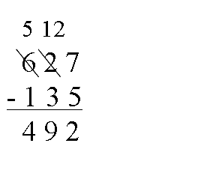
Basic Number Operations - Subtraction

We Do Not…

Borrow and pay back.
We use decomposition

At Second Level we expect learners to

- solve problems involving whole numbers and decimal fractions using a range of methods while sharing their approaches and solutions with others
- understand number line extends to include numbers less than zero and investigate how they occur and are used
- continue to develop money management through cost comparison and determine what they can afford to buy.

This should include

- subtracting mentally for 2 digit whole numbers and beyond, in some cases involving multiples of 10 and 100 and decimals
- subtracting, without a calculator, for 4 digits with at most 2 decimal places (progressive examples)
- subtracting, with a calculator, for 4 digits with 2 decimal places progressing to 3 places
- subtracting in applications of number, money and measurement
- subtract positive and negative numbers in applications such as change in temperature
- say “negative 4” for -4. In science they often refer to a temperature as “minus”, but would not do so within a mathematics class.

- 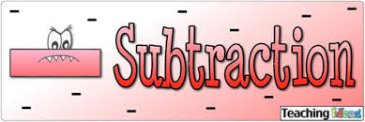
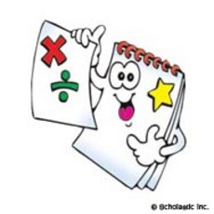

Basic Number Operations - Multiplication

At Second Level we expect learners

- to explore the context in which problems involving decimal fractions occur and solve related problems using a variety of methods
- to have explored the need for rules for the order of operations in problems which involve successive number calculations

The order for teaching multiplication of decimals is

- multiplication of units and tenths, no carrying
e.g. 1 · 3
x 2
2.6

2. multiplication of units and tenths, with carrying
e.g. 2· 4
x 3
1
7.2
3. multiplication of tens, units and tenths with carrying
e.g. 1 2· 5
x 4
1 2
5 0 . 0

4. multiplication of hundreds, tens, units and tenths with carrying
e.g. 124 · 5
x 6
1 2 3
7 4 7 . 0

Learners should explore
- multiplying by 10 and looking for a rule for it
- the pattern which occurs when calculations are done.

E.g. 12 x 10 = 120 162 x 10 = 1 620 210 x 10 = 2 100

A learner’s response of “you add a zero when you multiply by 10” would be an acceptable rule at this stage.
Learners further explore the pattern which occurs for decimal multiple by 10.

 | 2 | . | 3 |  |  | 4 | . | 6
X |  | 1 | 0 |  | X |  | 1 | 0
2 | 3 | . | 0 |  | 4 | 6 | . | 0
 |  | ⬅ |  |  |  |  | ⬅

Discuss the patterns of the answers, then establish a rule for multiplying by 10, you must emphasise the digit shift.

- To multiply by 10, we move each digit one column to the left.
- Tenths digit moves into units column, units digit moves into the tens column and we place a zero into the tenths column.
- Emphasise that add a zero rule will only work if a whole number is multiplied by 10.

Through time and investigation learners may develop their own rules such as moving the point a certain number of places. This may aid all learners and in particular those who require visual aids. Although mathematically incorrect it may support learning.

At Second level we expect learners to

- multiply 4 digit numbers with at the most 2 decimal places by a single digit
e.g. 24 · 51 x 6.
- complete many of the examples with money and length.
e.g. £ 2 ∙ 36 x 4 5 ∙ 25m x 7
- use a calculator for calculations to second decimal place.
- enter amounts of money into the calculator correctly, e.g.

For money For length
27p = £ 0 ∙ 27 2m 34 cm = 2 ∙ 34 m
9p = £ 0 ∙ 09 56 cm = 0 ∙ 56 m

At Third Level we expect learners to

- continue to recall number facts quickly and accurately within calculations
- use a variety of methods to solve number problems in a familiar context, clearly communicating the process and solutions
- multiply 4 digit numbers with both 1 and 2 decimal places.
This was introduced at Second Level, therefore this is revision before moving on to numbers with 3 decimal places.

The order for teaching multiplication of decimals is

- multiply numbers with one decimal place, using order described in Second Level.
- multiplication of numbers with 2 decimal places, using order and method described in Second Level.
After discussing the rule for multiplying by 10, establish rule for multiplying by 100 and
1 000 after looking at examples learners explore the pattern which occurs when calculations are done

- Multiplying by 100, move each digit 2 places to the left.
- Multiplying by 1 000, move each digit 3 places to the left.

Remember to emphasise that
- adding two or three zeros when multiplying by 100 or 1000 rule will only work if a whole number is multiplied by 100 or 1000.

Again, through time and investigation learners may develop their own rules such as moving the point a certain number of places. This will aid all learners and in particular those who require visual aids. Although mathematically incorrect it does support learning.

We Do Not…
write £ and p together
like 9p is not £0. 09 p.

Basic Number Operations - Division

At Second Level we expect learners to explore the context in which problems involving decimal fractions occur and solve relate problems using a variety of methods.
This should include
- dividing H t U by a single digit at the initial stage of Second Level and then Th H t U by a single digit
- mentally dividing tenths by a single-digit number e.g. 4.2 ÷ 2
- dividing 4 digit numbers with at the most 1 decimal place in written form e.g.
235 ∙ 6 ÷ 2.

The order for teaching division of decimals is

- mental division of tenths by a single digit e.g.
6 tenths divided by 2 equals 3 tenths or 0·3
recording it as 0 · 6 ÷ 2 = 0 · 3.
- division of units and tenths, no carrying/exchange e.g.
4 ∙ 8 ÷ 4.
- division of units and tenths with carrying/exchange e.g.
5 ∙ 6 ÷ 2.
- division of tens, units and tenths with carrying/exchange e.g.
53 ∙ 9 ÷ 7 65 ∙ 2 ÷ 4.
- division of whole numbers, answers in tenths e.g. 19 ÷ 5 = 3 ∙ 8.
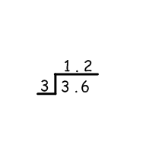
- learn the rule for dividing by 10

How we divide:

- Calculations are set out horizontally. 3.6 ÷ 3
- Decimal point is placed in a box on its own.
- Decimal point always lines up in question and answer: one above the other. It is fixed and never moves the digits around it moves.
- When dividing we start at the left and work our way towards the right.
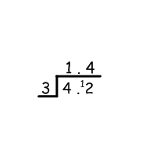

The division algorithm
This is an extension to whole number division.

Using 4 · 2 ÷ 3 but written in the format

- Start by putting the decimal point in the correct place in the answer space
- Divide the units first. 4 units divided by 3 equals 1 unit and 1 left over. Exchange your 1 unit for 10 tenths, which makes 12 tenths.
- Divide the tenths. 12 tenths divided by 3 equals 4 tenths.

In physics division is set out vertically.

Division of Whole Numbers answering in tenths
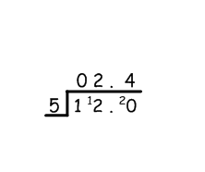
We expect learners to know that a whole number can be changed into a decimal by adding a decimal point and a zero, e.g.
12 is the same as 12 · 0
45 is the same as 45 · 0
Whole numbers encountered in division can become decimals if a remainder is found and the calculation continued as follows:
12 ÷ 5 should be recorded as 12 · 0 ÷ 5

Rule For Dividing By 10
Learners explore the pattern which occurs when calculations are carried out.
135 ÷ 10 = 13.5 264 ÷ 10 = 26.4
Discuss the pattern of the answers, then establish the rule for dividing by 10: you must emphasise the digit shift.

- To divide by 10, we move each digit one column to the right.
- Units digit moves into the tenths column, tens digit moves into the unit column and hundreds digit moves into the tens column.
- Divide 4 digit numbers with at most 2 decimal places by a single digit.

Many of the examples will use money and length
e.g. 16.34 ÷ 2 £ 3. 24 ÷ 3 4. 15 m ÷ 5

At Third Level we expect learners to

- continue to recall number facts quickly and accurately within calculations
- use a variety of methods to solve number problems in a familiar context, clearly communicating the process and solutions.
- mentally divide tenths by a single-digit number
- divide 4 digit numbers with at the most 1 decimal place in written form
e.g. 235 ∙ 6 ÷ 2.
- divide numbers with 2 decimal places, using order and method described
e.g. 14∙22 ÷ 3 £100∙00 ÷ 8 123∙45m ÷ 5.
- divide by a two digit number by using long division algorithm
- use the rule for dividing by 10 and extend and establish a new rule for 100. This should include numbers with 2 decimal places and dividing by 100.

Remember
Through time and investigation learners may develop their own rules such as moving the point a certain number of places. This will aid all learners and in particular those who require visual aids. Although mathematically incorrect it does support learning.

Discuss the pattern when dividing by 10, then establish the rule for 100: emphasise the digit shift e.g.

- To divide by 10, we move each digit one column to the right.
- Tens digit moves into the units column, units digit moves into the tenths column, tenths digit moves into the hundredths column,
e.g. 15 ∙ 6 ÷ 10 = 1 ∙ 56.

Discuss the pattern when dividing a number by 100,
e.g. 1235 ÷ 100 = 12 ∙ 35
678 ÷ 100 = 6 ∙ 78

Establish the rule of moving each digit 2 places to the right.
Discuss how this would work for numbers with decimal places; establish that the rule remains the same no matter which number you are dealing with.

You must emphasise the digit shift e.g.

- To divide by 100, we move each digit two columns to the right
- Hundreds digit moves into the units column, tens digit moves into the tenths column, units digit moves into the hundredths column, e.g. 156 ÷ 100 = 1 ∙ 56
- If a number is single digit or a double digit, emphasise the need to fill the empty columns with a zero, e.g.
30 ÷ 100 = 0 ∙ 30

Remember
Through time and investigation learners may develop their own rules such as moving the point a certain number of places. This will aid all learners and in particular those who require visual aids. Although mathematically incorrect it does support learning.



Fractions, Decimals and Percentages

At Second Level we expect learners to show the equivalent forms of simple fractions, decimals and percentages and use preferred form when solving a problem and explain their method choice. These should also be carried out in relation to everyday contexts and use calculations to solve related problems.
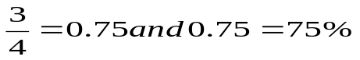e.g. .

Converting fractions to decimals

To convert a fraction to a decimal you divide the numerator, top number, by the denominator, bottom number.
e.g. numerator/denominator
⅔ =2÷3=0.667

The following is a list of simple common equivalences that learners should learn:

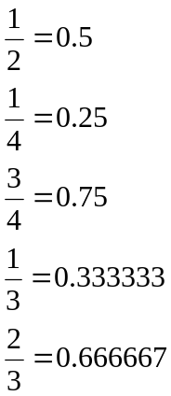

The fractions one third and two thirds are recurring decimals and if written as 0.33 and 0.67 are rounded to two decimal places. We normally say that a third as a decimal is 0.3 recurring or repeating and two third is 0.6 recurring or repeating

Notation for recurring numbers:

1 .
3 ˭ 0.3

In Science you would never use recurring numbers.

Converting a decimal back to a fraction

To change from a decimal to a fraction, it is important to read the decimal correctly, to write the initial fraction, then simplify it.
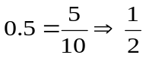
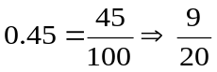0.5 means 5 tenths therefore
0.45 means 45 hundredths therefore
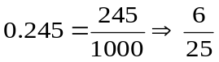0245 means 245 thousandths therefore

Converting a fraction to a percentage

To convert from a fraction to a percentage, we must divide the numerator by the denominator and then multiply by 100.
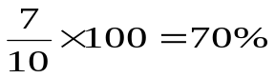e.g.

Converting a percentage to a fraction

To convert from a percentage to a fraction, we divide it by 100, which enables us to write it as a fraction, and then simplify it.
e.g. 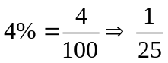 divide top and bottom by 4
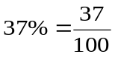 to fully simplify

Converting a decimal to a percentage

To change a decimal to a percentage we multiply the decimal by 100.

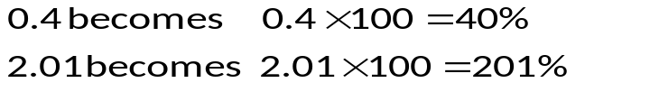e.g.

Converting a percentage to a decimal

To convert from a percentage to a decimal we divide the percentage by 100.
e.g. 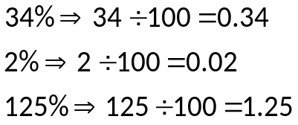

Percentages bigger than 100 do exist and in particular for percentage increase and calculating values after percentage has been added e.g. VAT included and you want to calculate value before VAT was added.

At Third Level we expect learners to carry out calculations using a wide range of fraction, decimals and percentages, using their answers to make informed choices for real-life situations.

At Fourth Level we expect learners to choose the most appropriate form of fractions, decimals and percentages to use when making calculations mentally, in written form or using technology then use their solutions to make comparisons, decisions or choices.

WORKED EXAMPLES

1. Find 36% of £200

100% is £200 OR 200÷ 100x36
10% is £20 =£72
30% is £60 (10%x 3)
5% is £10 (10% ÷ 2)
1% is £ 2 (10% ÷ 10)
We Do Not…
use the % button on the calculator because of inconsistencies between models

36% is £72 (30% + 5% + 1%)

2. Express two fifths as a percentage
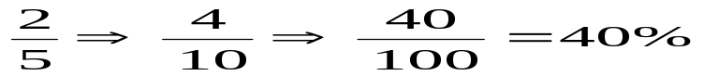

3. You buy a car for £5000 and sell it for £3500 what is the percentage loss?

Loss = £5000 – £3500 = £1500
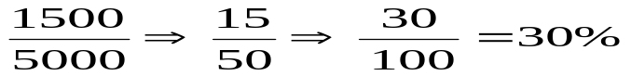

4. Increase £350 by 15%

15% of 350 = 350 ÷ 100 x 15 = £52.50

To find the increase then add on for the new total £350 + £52.50 = £402.50

5. Paul’s train fare has increased by 10%. The new cost is £8. 25. What did his fare cost price before the increase?

Old Price | + | Rise | = | New Price | Calculators could be used.
100% | + | 10% | = | 110% | Calculators could be used.
 |  | 110% | = | £8. 25 | Calculators could be used.
 |  | 1% | = | £8. 25 ÷ 110 | Calculators could be used.
 |  | 1% | = | 0.075 | Calculators could be used.
 |  | 100% | = | £7. 50 | Calculators could be used.

Rounding

At Second Level we expect learners to use their knowledge of rounding to routinely estimate the answer to a problem, then after calculating, decide if their answer is reasonable and share their finding with others.

This should include
e.g 74 to the nearest 10 → 70
386 to the nearest 10 → 390

347.5 to the nearest whole number → 348
347.5 to the nearest 10 → 350
347.5 to the nearest 100 → 300

At Third Level we expect learners to round a number to an appropriate degree of accuracy having taken into account the context of the problem.

e.g 7.51 to 1 decimal place → 7.5
8.96 to 1 decimal place → 9.0

3.14159 to 2 decimal places → 3.14
3.14159 to 3 decimal places → 3.142
3.14159 to 3 significant figures → 3.14

We always
round up
for
5 and above

In Physics you will talk about “degree of precision” instead of degree of accuracy.

Estimating

At Second Level we expect learners to use their knowledge of sizes or places to assist them.

e.g. bag of crisps = 30g
bag of sugar = 1kg
area of an envelope = 80 cm² (8 x 10)
Volume of lemonade bottle = 1 litre

area of a whiteboard = 4m² area of work surface = 6m²
diameter of 1p = 15mm height of a kitchen unit =700mm

In real life, measurements of length are
used in a variety of ways: Millimetres - mm
e.g. DIY shops, worktop heights for
kitchen units, lengths of wood, etc
Centimetres – cm
e.g. clothes, curtains, body measurements etc
square metres – m²
e.g. carpet, tiles, flooring etc

Conversion of units

At Second Level we expect learners to
- use the common units of measurement, convert between related units of the metric system and carry out calculations when solving problems.
- investigate its impact on the world, past, present and future.
- have worked with others to explore, and present our findings on, how mathematics impacts on the world and the important part it has played in advances and inventions.
Worked Examples
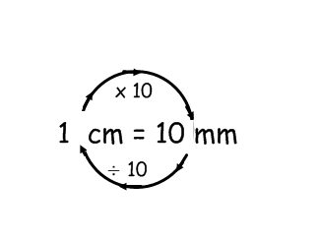
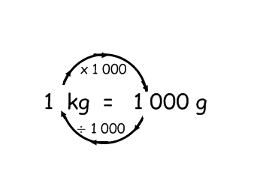
At second level (early) we expect learners to know that:-

1 minute = 60 seconds
1 cm = 0.01 m
1kg = 1000 g
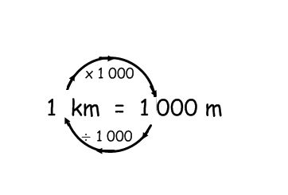
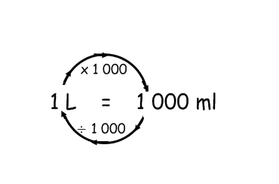
1 g = 0.001 kg
1l = 1 000ml
1ml = 0.001 l
1l = 1 000 cm³
1 ml = 1 cm³
1cm = 10 mm
1 mm = 0.1 cm
1000 m = 1 km

Learners will use the following to convert units:

Time

Minutes to seconds – multiply the number of minutes by 60 to get total number of seconds, e.g. 3 minutes 50 minutes
3 x 60 seconds = 180 seconds 50 x 60 seconds = 3 000 seconds

Seconds to minutes – divide the number of seconds by 60 to get number of minutes, e.g. 360 seconds 6000 seconds
360 ÷ 60 = 6 minutes 6 000 ÷ 60 = 100 minutes

Weight

Kilograms to grams – multiply the number of kilograms by 1 000 to get grams,
e.g. 5 kg 3.25kg
5kg x 1 000 = 5 000g 3.25 kg x 1 000 = 3 250g

Grams to kilograms – divide the number of grams by 1 000 to get kilograms,
e.g. 4 000g 1 576 g
4 000g ÷ 1 000 = 4kg 1 576 ÷ 1 000 = 1∙576kg or 1kg 576g
Length

Millimetres to centimetres – divide the number of millimetres by 10 to get the number of cm, e.g. 57mm 160mm
57 ÷ 10 = 5∙7cm 160 ÷ 10 = 16 cm

Centimetres to millimetres – multiply the number of centimetres by 10 to get the number of mm, e.g. 56cm 9.7 cm
56 x 10 = 560mm 9∙7 x 10 = 97mm

Kilometres to metres – multiply the number of kilometres by 1 000 to calculate the number of metres,
e.g. 5 km 3km 560m
5 x 1 000 = 5 000m Change to a decimal first 3km 560m = 3∙560km
3∙560 x 1 000 = 3 560 m

Metres to kilometres – divide the number of metres by 1 000 to calculate the number of kilometres, e.g. 350m 15 000m
350 ÷ 1 000 = 0∙350km 15 000 ÷ 1 000 = 15 km

At the Second Level (late), learners will be expected to know that:-
1 tonne = 1 000kg
1 inch (1in) = about 2½cm
1 foot (1ft) = about 30cm
1 pound (1lb) = about ½kg
1 pint = about ½litre
1 gallon = about 4 ½ litres

For Home Economics and for future life skills the following are more accurate conversions:-
1 litre = 1.75 Pints/Fluid Ounces
1kg = 2.2 Pounds/Ounces

Learners will use the following rules to convert units of weight.

Weight

Pounds (lbs) to kilograms – divide the number of pounds (lbs) by 2 to calculate the number of kilograms (not exact answers), e.g.
16 lbs 56 lbs
16 ÷ 2 = about 8kg 56 ÷ 2 = about 28 kg

Kilograms to pounds – multiply the number of kilograms by 2 to calculate the number of pounds (lbs) (answer will not be exact), e.g.
18kg 162kg
18 x 2 = 36 lbs 162 x 2 = 324 lbs
Kilograms to tonnes – divide the number of kilograms by 1 000 to calculate the number of tonnes, e.g.
450kg 6 700kg
450 ÷ 1 000 = 0∙450 tonnes 6 700 ÷ 1 000 = 6∙7 tonnes

Tonnes to Kilograms – multiply the number of tonnes by 1 000 to calculate the number of kilograms, e.g.
7 tonnes 90∙5 tonnes
7 x 1 000 = 7 000 kg 90∙5 x 1 000 = 90 500kg

Volume

Pints (pt) to litres – divide the number of pints by 2 to calculate the number of litres (not exact answers), e.g.
16 pints 200 pints
16 ÷ 2 = 8 litres 200 ÷ 2 = 100 litres

Litres to pints – multiply the number of litres by 2 to calculate the number of pints (not exact answers), e.g.
5 litres 75 litres
5 x 2 = 10 pints (approx) 75 x 2 = 150 pints (approx)

Gallons to Litres – multiply the number of gallons by 4∙5 to calculate the number of litres (answers will be approximate) e.g.
10 gallons 26 gallons
10 x 4∙5 = 45 litres 26 x 4∙5 = 117 litres

Litres to Gallons – divide the number of litres by 4∙5 to calculate the number of gallons (answers will be approximate) e.g.
9 litres 54 litres
9 ÷ 4∙5 = 2 gallons 54 ÷ 4∙5 = 12 gallons.

Time Calculations

At Second Level we expect learners to

- make time calculations while using and interpreting paper and electronic time-tables and schedules for planning events and activities
- carry out practical tasks and investigations for timed events and explain which units of time would be appropriate to use
- use simple time periods to make an estimate of how long a journey would take using there knowledge of the link between time, speed and distance.

At Level 3 we expect learners to use simple time periods to work out how long a journey will take, the speed travelled or the distance covered, using their knowledge of the link between time, speed and distance

- convert between the 12 hour and 24 hour clock e.g. 2327 = 11.27pm.
- calculate duration in hours and minutes by counting up to the next hour then on to the required time
- convert between hours and minutes e.g multiply by 60 for hours into minutes.

Worked Examples
How long is it from 0755 to 0948?
0755 0800 0900 0948
(5 mins) (1 hr) (48 mins)

We Do Not…

Teach time as a subtraction.
Total 1 hr 53 minutes.

Change 120 seconds into minutes
There are 60 seconds in a minute
120 seconds = 120 ÷ 60 = 2 minutes

Change 6 minutes into hours
There are 60 minutes in an hour
6 minutes = 6 ÷ 60 = 0.1 hours

Change 48 hours into days
There are 24 hours in a day
48 hours = 48 ÷ 24 = 2 days
Time Calculations

Change 21 days to weeks
There are 7 days in a week
21 days = 21 ÷ 7 = 3 weeks
We Do Not…

Put a point in 24 hour time.

Change 104 weeks into years
There are 52 weeks in the year
104 weeks = 104 ÷ 52 = 2 years

Change 12 hour to 24 hour clock time

am = ante-meridian pm = post meridian

Converting 12 hour to 24 hour Times

8.00am 0800 hrs (times remains the same)
11.00pm 2300 hrs (add 12 to the hours)

- There are always four digits in 24 hour time

How many years from 89BC until 123AD
- BC = Before Christ (Before the year 0 when Jesus Christ was born)
- AD = Anno Domini (After the year 0 when Jesus Christ was born)

89BC 0 123AD
89years 123years Total 89 + 123 = 212 years

Speed, Distance and Time

At Third and Fourth Level we expect learners to use the link between speed, distance and time to carry out related calculations.

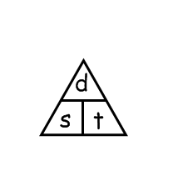
Worked Examples
How long will it take to travel 6km at a speed of 3km/h?

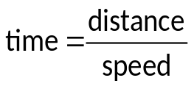Time = Distance ÷ Speed
Time = 6 ÷ 3
Time = 2 hours

What is the speed when the distance travelled is 70km and the time taken is 2 hours?

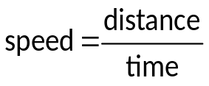Speed = Distance ÷ Time
Speed = 70 ÷ 2
Speed = 35km/h

What distance will be travelled if the speed is 5 km/h and the time taken is 3 hours?

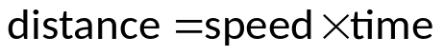Distance = Speed x Time
Distance = 5 x 3
Distance = 15 km

In Physics the letter
v is used for speed instead of s.

Ratio and Proportion

At Third Level we expect learners to show how quantities that are related can be increased or decreased proportionally and apply this to solve problems in everyday life.


WORKED EXAMPLES

1. a) The ratio of square to triangles b) The ratio of circles to squares.
2 : 1 4 : 2
2 : 1

2. In a class the ratio of girls to boys is 2 : 5. How many boys are there if there as 16 girls? Girls : Boys
2 : 5
8 x 16 : 40 x 8

At Fourth Level we expect learners to use proportion to calculate the change in one quantity caused by a change in a related quantity and solve real-life problems.

WORKED EXAMPLES:

Direct Unitary Method

If 5 bananas cost 80 pence, then what do 3 bananas cost?
Bananas cost (pence)
5 → 80
1 → 80 ÷ 5 = 16
3 → 16 x 3 = 48

Inverse Unitary Method

The journey time at 60 mph is 30 minutes, so what is the journey time at 50mph?
Speed (mph) Time (minutes)
60 → 30
1 → 30 x 60 = 1800 minutes
50 → 1800 ÷ 50 = 36 minutes

Statistics - Data Analysis

Type of Data
Discrete data can only have a finite or limited number of possible values, things that can be counted. Number of learners in a class is an example of discrete data.

Continuous data can have an infinite number of possible values within a selected range, things that are measured. e.g. temperature, height, length.

Data which is non-numerical e.g. favourite TV programme, favourite flavour of crisps, favourite colours.

Tally Chart/Frequency Table

At First Level we expect learners to collect information in a number of ways and to sort it in a logical, organised way using their own and other’s criteria.
A tally chart is used to collect and organise data before representing it in a graph or chart.
The example below is the number of hours exercise taken by a class in a week.

Number of hours exercise | Tally | frequency
1 | ll | 2
2 | llll ll | 7
3 | llll lll | 8
4 | lll | 3
5 | llll | 5
 | Total | 25

At Fourth Level we expect learners to compare numerical information in real-life contexts by using the mean (average), median, mode and range of sets of numbers.
This should include

- Analyse ungrouped data using a tally table and frequency column or ordered data set
- Calculate range of a data set. This is used in both maths and biology
- Range = Maximum value – Minimum value, as in biology
- Calculate the mean (average) of a data set
- Use a stem and leaf diagram
- Calculate the mean (average) from grouped data
- Find the median – the middle of an ordered data set
- Find the mode – the most common value of a data set
- Obtain these values from an ungrouped frequency table.

Statistics - Data Analysis

At Second Level onwards we expect learners to collate, organise and communicate the results of investigations and surveys in an appropriate way using an extended range of table, charts, diagrams, graphs and available technology.

Stem-and-leaf diagram
A stem-and-leaf diagram is another way of displaying discrete or continuous data. A stem-and-leaf diagram needs a title, a key and should be ordered. It is useful for finding the median and mode. If we have two sets of data to compare we can draw a back-to-back stem-and-leaf diagram.

The following marks were obtained in a test marked out of 50. Draw a stem and leaf diagram to represent the data.

3, 23, 44, 41, 39, 29, 11, 18, 28, 48.

Split the data into a stem and a leaf. Here the tens part of the test mark is the stem. The units part of the test mark is called the leaf.

Unordered stem-and-leaf diagram Ordered stem and leaf diagram.

Stem and leaf showing test marks out of 50
0 | 3
1 | 1 8
2 | 3 9 8
3 | 9
4 | 4 1 8
0 | 3
1 | 1 8
2 | 3 8 9
3 | 9
4 | 1 4 8

1| 8 means 18 out of 50 1| 8 means 18 out of 50
n = 10 n = 10

Statistics – Graphs and Charts

At all levels we expect learners to

- use a pencil and a ruler
- give the graph a title
- label both the x and y axes
- label the bars in the centre of the bar (each bar has an equal width)
- label the frequency (up the side) on the lines not on the spaces
- make sure there are even spaces between the bars and leave a space between the first bar and the y axis
- use, where appropriate, computer packages
- When using a graduated axis, the intervals must be evenly spaced.

In addition to the above we expect learners

- at Second Level and Third Level to display data in a clear way using a suitable scale, by choosing appropriately from an extended range of tables, charts, diagrams and graphs making effective use of technology.

Bar Graph Worked Examples:

This should include bar graphs with appropriate scale used for frequency:
- in single units and discrete information
- in multiple units and discrete information
- in simple fractions or decimals and continuous data that has been grouped.
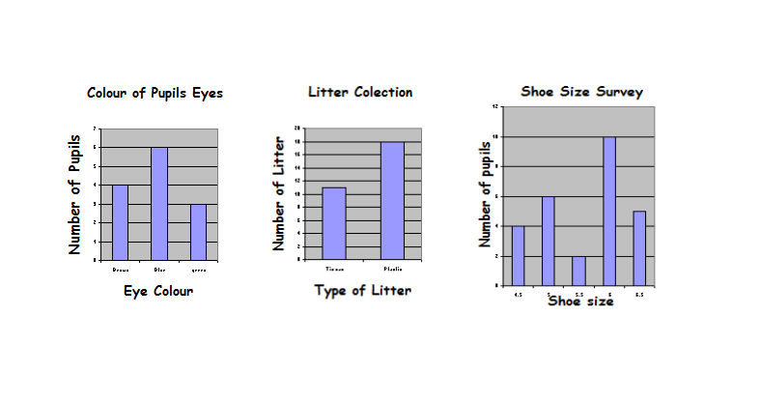
A Bar Chart is a way of displaying discrete or non-numerical data. They can be drawn both vertically and horizontally.

First Level Second Level Third Level

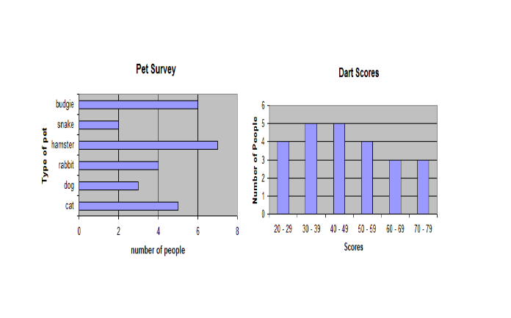
Second Level Third Level

Line Graphs Worked Examples:

At all levels we expect learners to
- use a pencil and a ruler
- give the graph a title
- label both the x and y axes
- choose an appropriate scale for the axes to fit the paper
- number the lines not the spaces
- plot the points neatly (using a cross or dot)
- fit a suitable line

This should include

- if necessary, to make use of a jagged line to show that the lower part of a graph has been missed out. This is called a staggered zero. This is not used in Biology or Physics.
- the use of scattergraphs which should include line of best fit and correlation.

In science they use these techniques but there are slight differences in terminology

- Physics use a line or curve of best fit so do Maths at National 5 and Higher levels.
- Chemistry and Biology join the points (crosses or dots) on the graph

Second and Third Level

The distance a gas travels over time has been recorded in the table below:
Time (s) | 0 | 5 | 10 | 15 | 20 | 25 | 30
Distance (cm) | 0 | 15 | 30 | 45 | 60 | 75 | 90

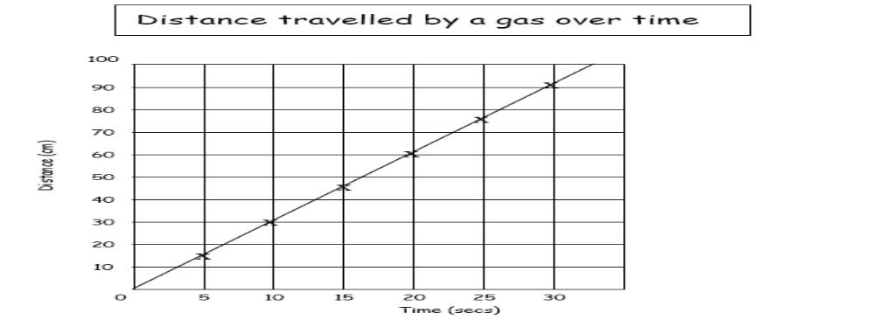

In Physics, s is used instead of secs for seconds.

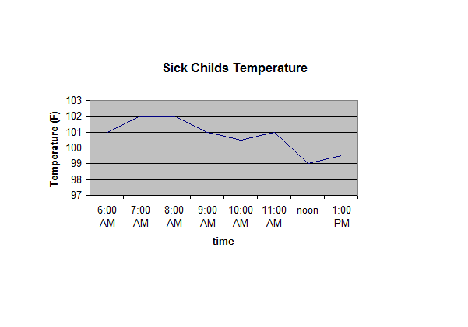
Second and Third level

Correlation in scatter graphs is described in qualitative terms. In physics the word “relationship” is used instead of correlation.

e.g.
Negative correlation - “The warmer the weather, the less you spend on heating”
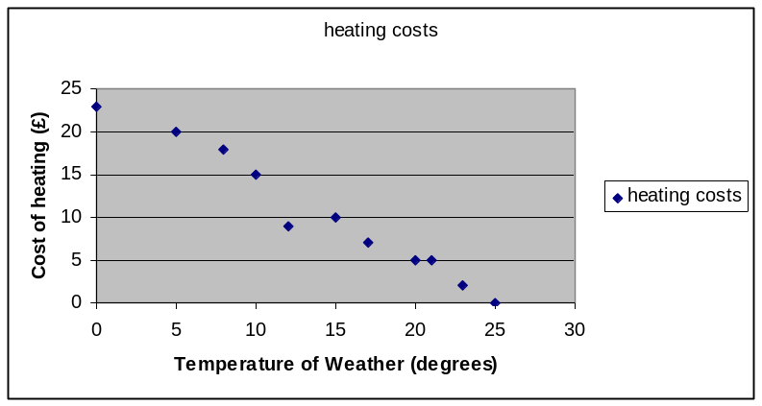
This is sometimes referred to as “inversely proportional”.

Positive correlation- “The more people in your family, the more you spend on food”
This is sometime referred to as “directly proportional”.

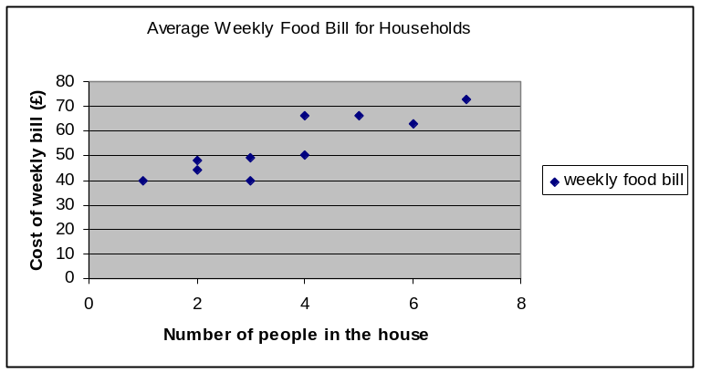

Pie Charts Worked Examples:

At all levels we expect learners to
- use a pencil and a ruler
- label all the slices or insert a key as required
- give the pie chart a title

In addition to the above we expect learners to
- construct pie charts involving simple fractions or decimals
- construct pie charts of data expressed in percentages
- construct pie charts of raw data

Third Level  40% of pupils travel to school on the bus, 25% walk, 20% by car and 15% cycle.  Draw a pie chart to display this data.  10% of 360º = 36º  5% of 360º = 18º |  | Third Level  20 pupils were asked “What was their favourite subject?”  The responses of the pupils were 6 liked Maths, 4 English, 3 Science and 7 Art.  Draw a pie chart to display this data.  360˚ ÷ 10 = 18˚  Maths 6 6 x 18º = 108º  English 4 4 x 18º = 72º  Science 3 3 x 18º = 54º  Art 7 7 x 18º = 126º
  Car 20%  Cycle15%  Walk25%  Bus 40% | 2 x 10%=2x36 º = 72º  3 x 5% = 3x18 º =54º  5 x 5% = 5 x 18º = 90º  4 x 10% = 4 x 36º = 144º
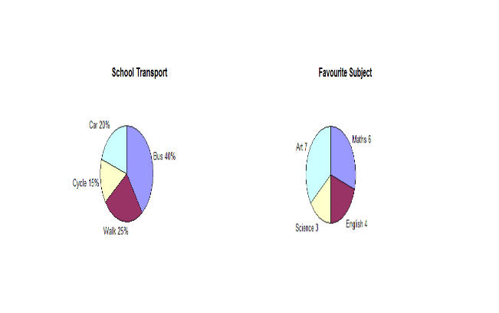

After constructing simple pie charts by hand learners should be encouraged to use suitable computer packages, e.g. excel, to construct pie charts from raw data.

At Fourth Level we expect learners to select appropriately from wide range of tables, charts, diagrams and graphs when displaying discrete, continuous or grouped data.

Probability

At Second Level we expect learners to conduct simple experiments involving chance and communicate predictions and findings using vocabulary of probability.

At Third Level we expect learners to find the probability of a simple event happening and explain why it should be considered when making choices.

Probability can be expressed as a fraction, decimal, percentage or ratio. We find probability as a fraction by using the following:

P (event) = Number of Favourable outcomes
Total number of possible outcomes

At Fourth level we expect learners to apply probability to determine how many times an event will occur and use the information to predict, risk assess and make decisions.

The National Numeracy Progression Framework

This resource has been created to deepen practitioners' knowledge and understanding of progression within the experiences and outcomes for numeracy and mathematics. It aims to support planning by identifying key milestones that learners should know before moving on to the next stage of learning. It is important that all departments audit their courses on a regular basis to ensure that the proper numeracy progression is being made.
The whole document can be found on the Education Scotland website.
The progression routes milestones are found below for the following topics:
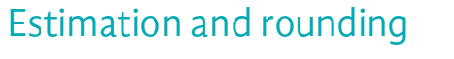
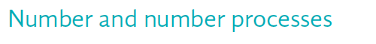
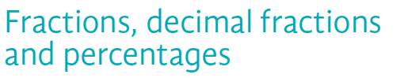
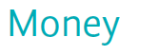
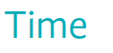
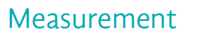

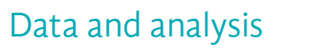

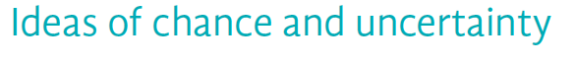

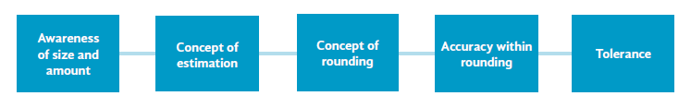

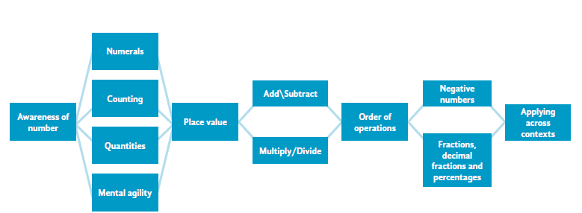

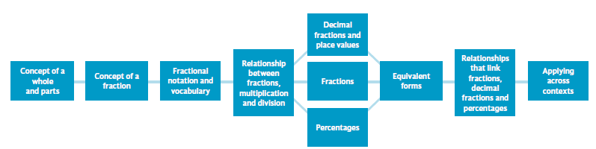

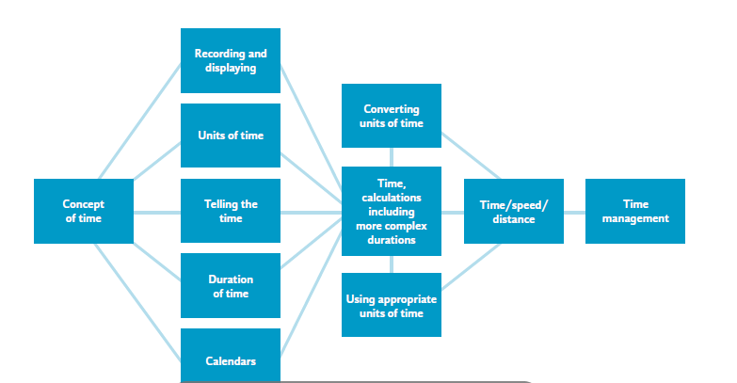
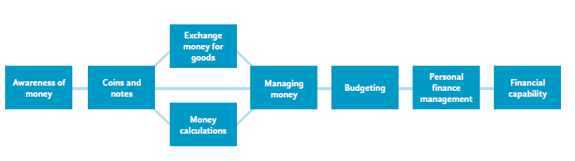

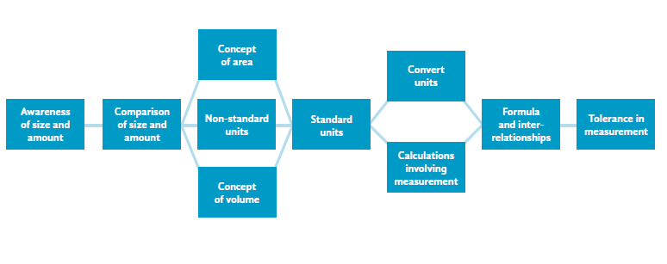

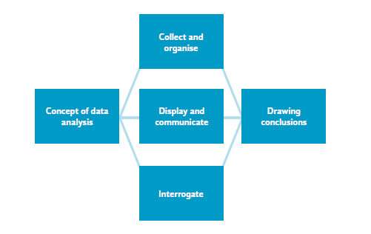

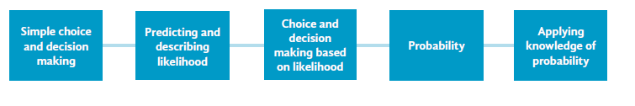
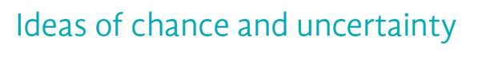

Numeracy Across the Curriculum
Subject Specific Identified Numeracy Activities Across the Curriculum

The Faculty leader of Mathematics and Numeracy will ask each faculty to provide three samples of Level 3 work produced in their faculty twice a year- December and May. This will be held centrally to showcase Numeracy across the curriculum.

Appendix 1 shows examples of where Numeracy is used in subjects. This list is not exhaustive and will be added to throughout the year.

Appendix 1
Curricular Area | Organiser | Experience  and Outcome | I Can Statement | Activity
Health and Wellbeing | Number and Number Processes | MNU 3-03a | I can use a variety of methods to solve number problems in familiar contexts, clearly communicating my processes and solutions. | Score keeping, team and competition organisation and results recording.
Health and Wellbeing | Measurement | MNU 3-11a | I can solve practical problems by applying my knowledge of measure, choosing the appropriate units and degree of accuracy for the task and using a formula to calculate area or volume when required. | Pupils complete assessment booklets measuring and recording personal results/placing for events in the athletics block.
Science | Measurement  Estimation and rounding | MNU 3-11a  MNU 3-01a  MNU 3-01b | I can solve practical problems by applying my knowledge of measure, choosing the appropriate units and degree of accuracy for the task and using a formula to calculate area or volume when required.  I can round a number using an appropriate degree of accuracy, having taken into account the context of the problem.  I can use a variety of methods to solve number problems in familiar contexts, clearly communicating my processes and solutions. | Pupil complete activity on reading volumes accurately using correct scales and units from measuring cylinders.  From experimental results, students are asked to calculate an average where often rounding is applied.
Curricular Area | Organiser | Experience  and Outcome | I Can Statement | Activity
HE | Fractions, decimal fractions and percentages. | MNU 3-08a | I can show how quantities that are related can be increased or decreased proportionally and apply this to solve problems in everyday context. | Learner measures and is aware of ratio/proportion of quantities for recipes. Recorded in pupil log.
Social Subjects | Number and Number processes | MNU 3-03a | I can use a variety of methods to solve number problems in familiar contexts, clearly communicating my processes and solutions. | Pupils complete an exercise on scale from GeogScot 1 as part of their OS map skills unit applying multiplication/division to solve problems.
Science | Data and Analysis | MNU 3-20a | I can work collaboratively, making use of technology, to source information presented in a range of ways, interpret what it conveys and discuss whether I believe the information to be robust, vague or misleading. | Faculty produced S2 problem solving assessment for individual learner completion where learner interprets information from bar graphs and draws conclusions.  Numeracy constantly assessed in homework tasks.
Social Subjects | Data and Analysis | MNU 3-20a | I can work collaboratively, making use of technology, to source information presented in a range of ways, interpret what it conveys and discuss whether I believe the information to be robust, vague or misleading. | Faculty produced task sheet for individual learner completion. Pupils collect weather data for one week and process information into various graphs, charts and tables.
Curricular Area | Organiser | Experience  and Outcome | I Can Statement | Activity
Computing and Business | Money | MNU 3-09b | I can budget effectively, making use of technology and other methods, to manage money and plan for future expenses. | Learner produced spread sheet created in personal finance section.
Social Subjects | Data and Analysis | MNU 3-20a | I can work collaboratively, making use of technology, to source information presented in a range of ways, interpret what it conveys and discuss whether I believe the information to be robust, vague or misleading. | Learners produce graphs of hot climates using data from hot desert area climate data and interpret and draw conclusions from graph.
HE | Estimation and Rounding  Number and Number processes | MNU 3-01a  MNU 3-03b | I can round a number using an appropriate degree of accuracy having taken into account the context of the problem.  I can continue to recall number facts quickly and use them accurately when making calculations. | Learner costs recipes/ingredients to make batches. Recorded in pupil log.
Technologies | Estimation and rounding  Fractions,  decimal fractions and percentages | MNU4-01a  MNU 3-08a | Having investigated the practical impact of inaccuracy and error, I can use my knowledge of tolerance when choosing the required degree of accuracy to make real life calculations.  I can show how quantities that are related can be increased or decreased proportionally and apply this to solve problems in everyday contexts. | Orthographic  projection/  isometric drawing/mug tree/jewellery stand/trinket box.  CAD inventor  (Computer aided drawing and modelling tasks).
Curricular Area | Organiser | Experience  and Outcome | I Can Statement | Activity
Computing and Business | Number and Number processes | MNU 3-03a | I can use a variety of methods to solve number problems in familiar contexts, clearly communicating my processes and solutions. | Faculty produced homework and assessment on binary code where learners apply knowledge conversions of units and binary base 2.
HE | Fractions, decimal fractions and percentages. | MNU 3-08a | I can show how quantities that are related can be increased or decreased proportionally and apply this to solve problems in everyday context. | Learner measures and is aware of ratio/proportion of quantities for recipes. Recorded in pupil log.

Appendix 2



