Numeracy Newsletter 6

S1/S2 March Numeracy Puzzle

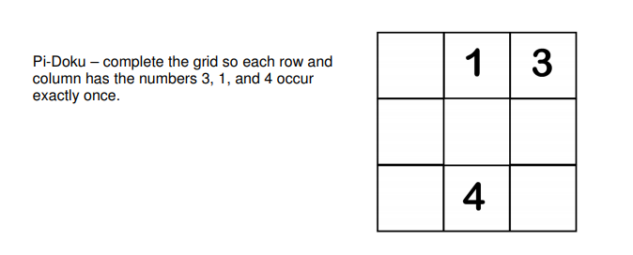
S3/S4 March Numeracy Puzzle

Puzzle of the month winner
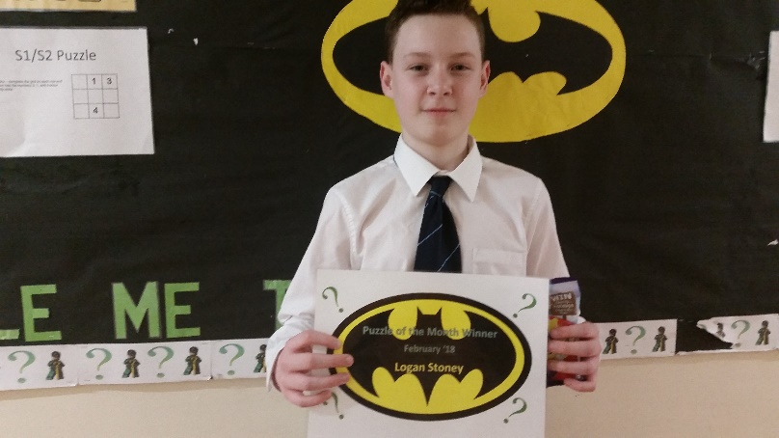
Congratulations to Logan Stoney 1A1
Advance Notice
In May I will be looking for three pieces of pupils work at Level 3 for my numeracy across the curriculum portfolio.

Careers Education and Numeracy
During May and June the Faculty will be hosting visits from Santander and Asda in order to show the pupils where numeracy is used in real life.
Santander will be looking at how to open a bank account, the type of accounts, overdraft, standing orders, direct debits and the meaning of APR.
Asda are concentrating on stock control and best buy.
Will give updates nearer the time, and if interested in attending any of the sessions you will be made very welcome.
Spot the problem

Benchmark of the Month
MNU 2-09a The pupils can compare costs and determine whether they can afford it given a certain budget.
MNU 3-09a The pupils can choose the best value for their personal situation and can justify their choices.

If you have any questions about numeracy please come and see me.
Maureen Fletcher

