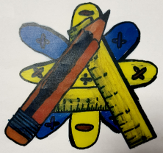
Numeracy Newsletter 5

S1/S2 February Numeracy Puzzle
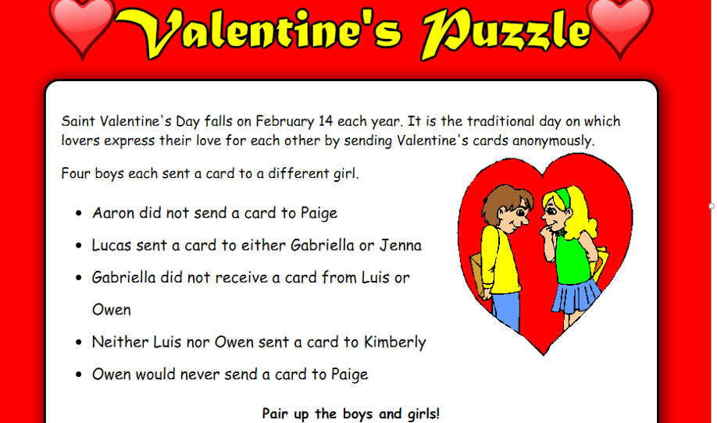

S3/S4 February Numeracy Puzzle  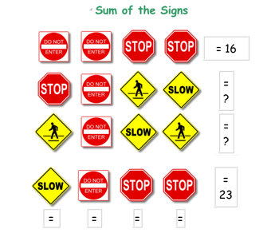 | January Numeracy Puzzle winners are Natasha Sim 2P1and Lee Wainwright 3P2  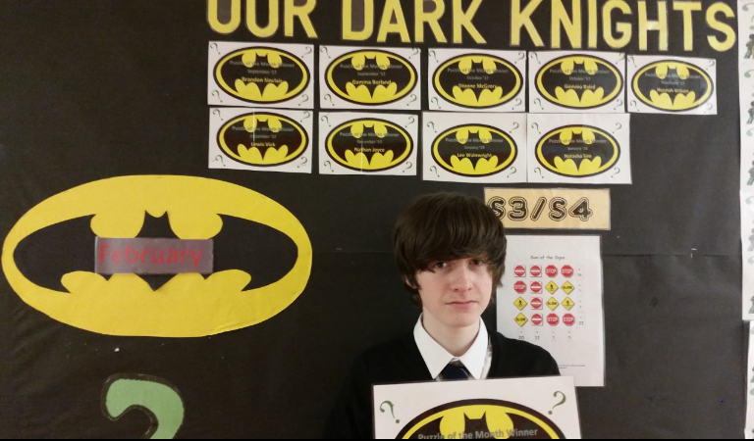
Maths Camp

Mrs Eagleson, Mr Denny and myself are taking 20 senior pupils to Arran for the weekend from 9th to 11th of March. We will showcase photographs in the next newsletter. We will be doing lots of number work and sporting activities. It will be
FUN(Honest)!

Advance Notice
Guess what’s happening on March the 14TH?

Watch out for a variety of activities to celebrate this important date in our calendar.

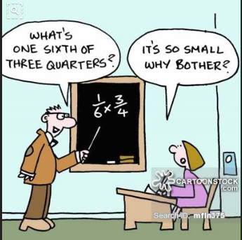
Standardised Testing

All S3 pupils will be sitting an online numeracy test in May. They will be sitting it in groups of 12. This test has been set by the government to evaluate each student’s progress. The test should last no more than 50 minutes.
I am sure that all of our students will understand its importance and not treat it like the student in the cartoon.
Benchmark of the Month
MNU 2-04a The pupils can order numbers less than zero and locate them on a number line.
MNU 3-04a The pupils can use their knowledge of numbers less than zero to solve problems in context.

If you have any questions about numeracy please come and see me.
Maureen Fletcher

