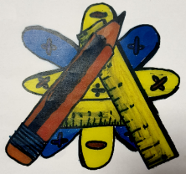
Numeracy Newsletter 4

S1/S2 January Numeracy Puzzle
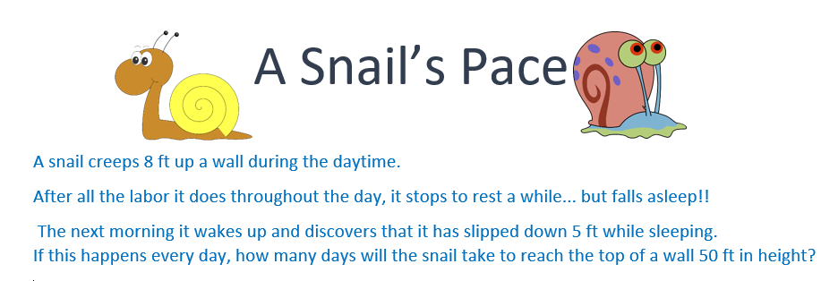
S3/S4 January Numeracy Puzzle  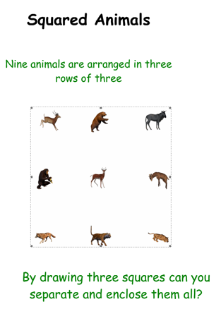 | December Numeracy Puzzle winners are Nathan in 3A2 and Lewis in 1P1.  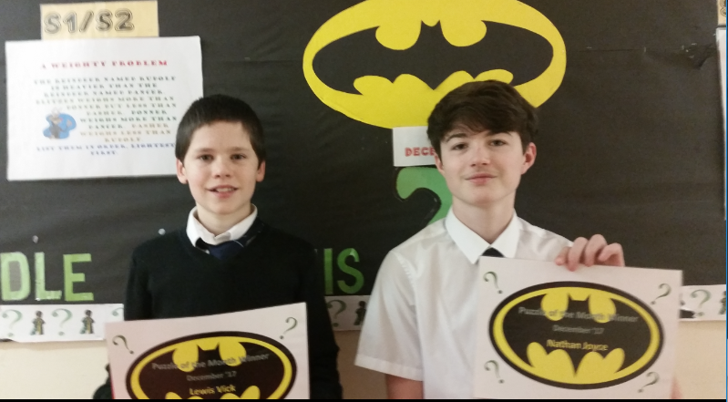
Remember all S1/S2 pupls have a sumdog login. Please encourage them to use it at home. | Thought for the day/Benchmark of the month  Rounding decimal fractions  Level 2  Must be able to round to up to two decimal places.  Level 3  Round to three decimal places  Level 4  Rounds to a specified number of significant figures.
Education Scotland
On the 23rd of January -Key messages
- In many schemes of work what is missing is the application of learning- this is where holistic assessments are useful.
- Assessment should be planned when a block of work is organised.
- You don’t need to assess every benchmark but major organisers should not be missing.
Evidence gathered to show whether or not a pupil has achieved a level could come from:
- Observing day to day learning from within/outwith the classroom
- Coursework
- Learning conversations
- Planned periodic assessment
- Information from Scottish National Standardised assessments.
It was suggested that staff should keep pupils jotters as they were a good source of evidence. I am not sure how practical that would be.

Education Scotland judges whether or not holistic assessments are good by asking the following questions:
- Do the E’s and O’s link concepts appropriately?
- Are they taken from a range of organisers?
- Is the question at an appropriate level?
- Does this question enable the teacher to gather evidence of learning against the E’s and O’s?
- Will the question require the learner to draw on a range of learning?
- To what extent does the question promote higher order thinking skills?
- Are breadth, challenge and application evident?
- Does the learner evidence meet the requirements of the question?
- Is feedback appropriate?
- Would it be helpful to the learners?
- Are the next steps appropriate and do they consider progress, breadth, challenge and application?
I thought that it was important that I passed on what I had learned from my work with the National Improvement Framework.

If you have any questions about numeracy please come and see me.
Maureen Fletcher

