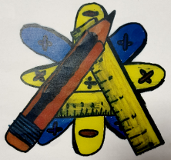
Numeracy Newsletter 3

S1/S2 December Numeracy Puzzle
S3/S4 December Numeracy Puzzle  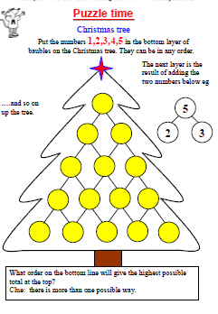 | November Numeracy Puzzle winner is Hannah in 1A2  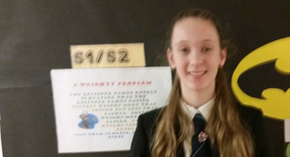
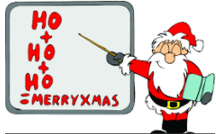 | Thought for the day/Benchmark of the month  Information Handling  Level 2  Collects, organises and displays data accurately in a variety of ways including through the use of digital technologies eg. creating surveys, tables, bar graphs, frequency tables and simple pie charts and spreadsheets  Level 3  Organises and displays data appropriately in a variety of forms eg Compound bar and line graphs and pie charts.  Level 4  This is using grouped data.
Education Scotland
This month I have been writing holistic assessments for level 3 Numeracy for North Ayrshire to send to Education Scotland as examples of good practice. I will be attending a moderation event on the 23rd of January in Edinburgh to evaluate the holistic assessments from other authorities. If any department has produced holistic assessments that incorporate numeracy could they please let me know.

All S1 and S2 pupils have logins for sumdog. Please remember that if you have access to computers in your room you are able to allow them to practice their numeracy using this package. If you want copies of the pupil’s logins please contact me.
This month I have conducted a survey of 72 pupils from S1 to S3 about their use of sumdog. The results were as follows:
- 93% enjoy using Sumdog.
- 92% feel that using it is improving their numeracy skills.
- 81% prefer using the ICT suite to using ipads.
- 74% do realise that their numeracy skills are being tested when they play the games.
- 78% do not use it at home.
- 4% use it in the library at lunch time or after school.
This shows me that we need to inform parents so, that if they have internet at home, they can encourage their children to improve their numeracy skills by practising at home. We also need to encourage S1/S2 pupils to make more use of the facilities in the library.

GEEK ALERT
For the numeracy behind the 12 days of Christmas-follow this link on YouTube.
https://youtu.be/7B9XVYSm80A

If you have any questions about numeracy please come and see me. Merry Christmas
Maureen Fletcher

