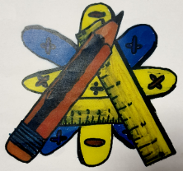
Numeracy Newsletter 2

The cartoon on the right is sometimes how we all feel about number. It’s hard, it’s too difficult, and I didn’t like it when I was at school. It’s our responsibility now as staff to show the pupils where numeracy is used in real life and teach them not to be scared of numbers. We are all expected to help our pupils improve their number skills no matter what subject we teach. | 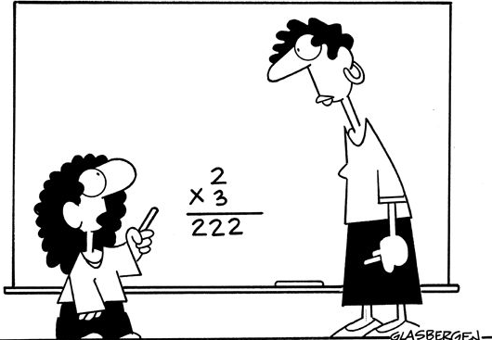
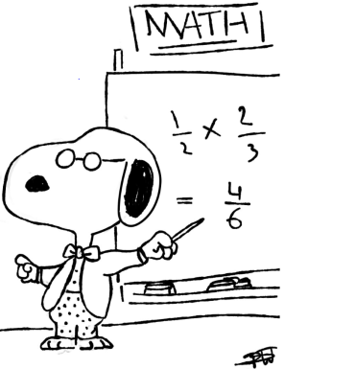 | We don’t want our pupils to be like snoopy and get the basics wrong. Keep up the good work and make numbers count.
Education Scotland
Just wanted to make everyone aware that you can get access to the numeracy hub by:
- Logging into glow
- While in launch pad click App library at top of screen
- Search for numeracy and mathematics hub
- Click on it and add the tile to your dash board.

Here you will find podcasts, examples of holistic assessments, examples of moderation and examples of good practice showcasing numeracy across the curriculum. Looking at this for even 15 minutes would be good CPD.
All S1 and S2 pupils have logins for sumdog. Please remember that if you have access to computers in your room you are able to allow them to practice their numeracy using this package. If you want copies of the pupil’s logins please contact me.
If you have any questions about numeracy please come and see me. Maureen Fletcher

